**CESI Map Creation**

The output files from the CESI WQI Calculator can be used to create local and regional maps with the CESI WQI (.qgs) project file. Open this file and follow the steps below.

**Part 1: Local Map Creation**

1) In the CESI_WQI.qgs project, go to Layer > Add Layer > Add Delimited Text Layer and select the local_entry.csv file that was exported from the R script. Ensure that the Longitude and Latitude columns are set as the X and Y fields. For the spatial index, set the CRS to WGS 84 (EPSG: 4326). Click Add. Right click on the new layer in the layers list and click Export > Save Features As. Set the Format to ESRI Shapefile, and the new CRS to Canada Atlas Lambert (EPSG: 3978). Set the destination as the Map_Creation folder, and name the new file “Local_(year).shp”. Ensure that Add saved file to map is checked and click OK. Remove the original (delimited) layer and keep only the shapefile.

3) Right click on the new point layer and click Properties and navigate to the Style tab. From the top drop down list, select Rule-based. Right click the single entry in the list, and select Refine current rule > Add categories to rule. From the Column drop down list, select “Reg.” and click Classify at the bottom. Highlight the empty record and click Delete. Click OK.

4) Under the Label column, click once on “Reg.” = 0 and wait a moment, then click again to make the field editable. Change the label to Natural. Do the same for “Reg.” = 1 and change this label to Regulated.

5) Right click on the Natural line and select refine by categories again, this time using the OperSched column to distinguish Continuous and Seasonal stations. Click OK and change the labels as above to “Yearly” and “Seasonal”.

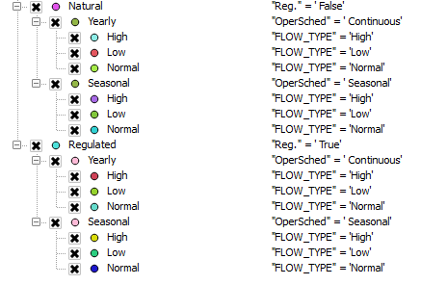6) Right click on the Continuous line and refine by categories once more, this time using the FLOW_TYPE column to differentiate Low, Normal, and High sites. Update the labels in the main Label list. Continue adding categories to all groups and subgroups until your list has all elements as below:

7) You can drag and re-order the categories to Low – Normal – High within each group. If the symbols shown below are not already available in the Style Manager, the Map_symbols.xml file can be imported to automatically load all of the category icons.

*Manual symbol creation*: To change a symbol, double click on the current symbol and use the symbols below (Low: Orange, Normal: Green, High: Blue). Select Simple Marker below Marker in the list on the bottom left, and alter the fill and border of each shape accordingly.

Natural – Yearly: circle, dark grey outline

Natural – Seasonal: circle with transparent centre (increase outline width to 0.6)

Regulated – Yearly: triangle, dark grey outline

Natural – Seasonal: triangle with transparent centre (increase outline width to 0.6)

The resulting list should look like this:

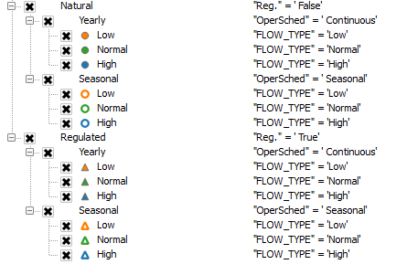

Click OK.

8) Ensure that the Local_(year) shapefile you are working with, the Main Water Bodies and the Pearse Drainage Areas (in that order) are the only active layers by checking them in the Layers Panel. Navigate to the Local_Template composer window (if the composer windows are not open, click Project > Layouts). The legend, title, north arrow, and scale bar should already be in the template. Click the refresh () button at the top and the three relevant layers should appear. Click on the legend and look for Legend Items in the settings bar on the right of the screen. Click the plus sign at the bottom of the window and add your new layer to the legend (and the PDA and MWB if not already in the legend). You can hide the label line (Local_year) by right clicking that line in the Legend Items list and selecting “Hidden”. If there are any blank lines in the legend, you can remove these with the minus sign under Legend Items. You can drag the water and drainage area items to the bottom of the legend.

9) Click on the title and change the text in the box on the right of the screen for the year of analysis. Update the HYDAT version used to create the maps in the text box.

10) Export the map to the output folder for the relevant year with Layout > Export as PDF and then export a second copy as Image and save as .jpg (“Local_(year).pdf/jpg”).

**Part 2: Regional Map Creation**

1) Ensure that the regional map table from the Regional Indicator section of the R script is available in the year’s output folder.

2) Right click on the PearseDrainageAreas layer and select Duplicate. Right click on the new layer and click Export > Save Features As. Set the Format to “ESRI Shapefile”. Set the destination as the Map_Creation folder, and name the new file “Regional_(year).shp”. Ensure that “Add saved file to map” is checked and click OK. Remove the original (copy) layer and keep only the shapefile.

3) Open the regional map spreadsheet in Excel that was produced from the R script, and minimize the window so it can be layered over QGIS. Open the attribute table for the new “Regional_(year)” layer as well and click the pencil button to begin editing, and select New Field from the top tool bar. Name the new field “(year)_class” and set it as a string field with at least 10 characters. Align both tables next to each other on the screen. Sort the Pearse codes columns in both tables so that they are listed from 1 to 25 (PEARSENMB column for the shapefile). In the new field created in the “Regional_(year)” table, type the classification as listed in the regional map spreadsheet’s FLOW_TYPE column until all 25 records are classified. Save your edits and unclick the pencil or right click and Toggle off editing for the layer.

4) Right click on the PDA Regional layer and select Properties > Style. From the drop down list on top, select Categorized and select the new year_class column that you just filled when editing from the second drop down list. Click Classify at the bottom of the window, and highlight and Delete the empty category line.

5) Change the style of each category to the following: Low, orange with dark grey outline, Normal, green with dark grey outline, and High, blue with dark grey outline. Any drainage areas without enough data (N/A’s) can be styled as light grey with a dark grey outline.

6) Ensure that the Pearse Labels, Main Water Bodies, and the new PDA Regional (year) layers (in that order) are the only three layers selected as visible or active in the Layers Panel. Navigate to the Regional_template composer window and click the refresh button to see the selected layers. The north arrow, scale bar, title, legend, and list of regions should already be in the template. Update the legend by clicking on it and making sure Auto Update is not selected. You can now right click and select Hidden or use the minus sign to keep only the layers that are relevant to the map, or use the plus button to add any missing information. You can also use the pencil at the bottom of the legend window to update the names of layers in the legend (MainWaterBodies > Main Water Bodies, etc.). Update the title.

7) Export the map with Composer > Export as PDF and then export a second copy as Image and save as .jpg (“Regional_(year).pdf/jpg”).

8) You can clean the Layers Panel in the main window and keep only the resultant layers with consistent naming to past years for future reference. Save the project.

All components are now complete for the creation of the internal report from the .Rmd file within the CESI WQI R Project.