# Quant notes (PRJ; unmodified version from SM, March 17, 2015):

1. Files are all hardcoded into “simulate_uncertainty.m” in a switch structure. User edits the code to choose the file number to process. This should be changed to a user input GUI to select a directory and multiple files for batch processing. It looks like they may have run as many as 34 different measurements.
2. Looks like mmt2mat has been modified to work for one specific file case. Rather, the modification should be made robust to handle all possible cases (line 73).
3. All checked transects in MMT file are processed unless changed in the code by the user
4. Numerous loops and 215 lines of code to determine WP, WM, WS, and WO from the data structure created by Dave’s MMT2mat. Seems unnecessarily complicated. Also using try/catch loops is not the smartest way to get this done. Lots of overhead there.
5. Extrap results are loaded “Manually”, but there is a hardcoded value of deviation from power-power 1/6 for one file (not sure why).
6. Possible parameters tested for their effect on uncertainty include:
   1. All
   2. Bottom depth
   3. Water velocity
   4. Bottom velocity (boat velocity?, moving bed?)
   5. Temp
   6. Salinity
   7. Draft
   8. Heading
   9. Mag var
   10. Edge distance (left)
   11. Edge distance (right)
   12. Edge velocity (left)
   13. Edge velocity (right)
   14. Extrapolation methods (top and bottom)
   15. Edge coefficient (left)
   16. Edge coefficient (right)
   17. Missing ensembles

Possible others? (pitch, roll, GPS quality, ability to hold edge, moving bed bias, missing bins, lost ensembles, boat speed vs. water speed, TROC of heading)

Code syntax can be improved for clarity

1. Uses 0,1 as switches. Should avoid that and use logicals. There also is probably a better way to structure the code for runtime
2. Transect data is plotted (495-501), this will slow any batch processing down.
3. Can consolidate the if statements for determining starting and ending banks and distances.(523-525)
4. Table is displayed with values for config and edges. This can be removed for bulk processing, but is a good check initially that the file is being read correctly and start and end banks are properly assigned. (538-552). FLE recommends using ASCII talbes for the debug text. We can always put the ASCII results into a file, or GUI log window.
5. A table is displayed with the values of mean error and stdev of error for each parameter. The table is user-editable. This is not appropriate for bulk processing. (556-616)
6. Quant recommends the following values for mean error and stdev of the error for the following quantities:
   1. Draft: mean 0.0; stdev 0.05 m
   2. Left edge: mean 0.0; stdev 10% edge distance
   3. Right edge: mean 0.0; stdev 10% edge distance
   4. heading: mean 0.0; stdev 2 degrees
   5. Mag var: mean 0.0; stdev 2 degrees
   6. Temp: mean 0.0; stdev 2 degrees
   7. Salinity: mean 0.0; stdev 2 ppt
   8. % dev in top and bottom extrap Q: mean 0.0; stdev from extrap3.m
   9. Left coeff % error: mean 0.0; stdev 10%
   10. Right coeff % error: mean 0.0; stdev 10% (value of 10% was obtained by analysing results of Dramais 2011 (Engineering degree thesis) and from the excel worksheet "Error Analysis Spreadsheet Modified 2" that I was given with the project documentation
7. Is 10% edge distance reasonable? Seems like we could get a measure of this, but it would depend on method used (rangefinder, tape, bridge mark, etc.)
8. Is 2 ppt reasonable for salinity? Most sites where salinity is an issue are tidal and likely to have quite variable salinity (from 0 to 30 ppt) depending on the location of the gage relative to the salt wedge.
9. The table displays only on the first transect and not for others even though it is inside the transect loop.
10. If we choose to keep the uncertainty the same for each transect, then 623-659 assignments don’t have to be written for each transect, otherwise they do.
11. The single ping velocity uncertainty from table 5 of the Winriver II user guide (Feb 2007) is used (here is the table from the 2010 WRII UG).

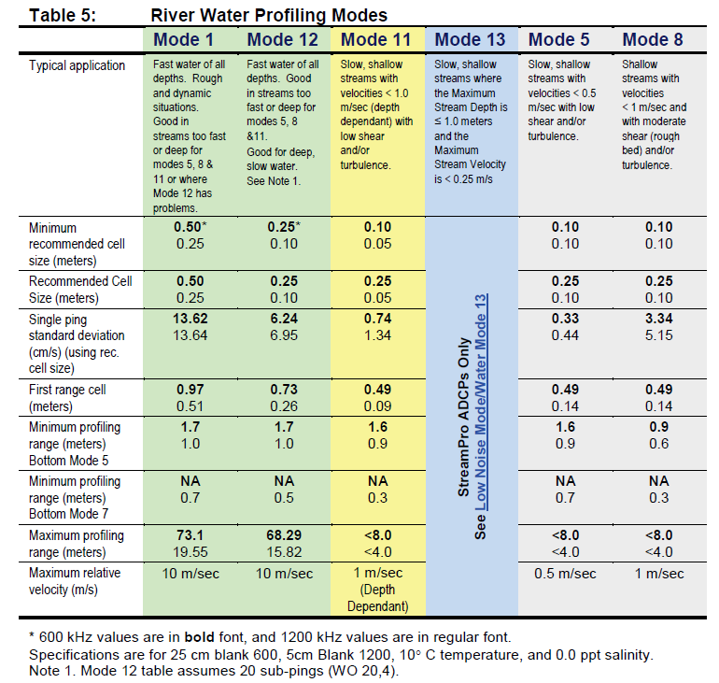

1. StreamPro is taken as 1% +- 2mm, regardless of mode or binsize used. This should be changed to be consistent with Rios.
2. Note that these velocity error estimates are for recommended cell sizes and for water mode 12 it is computed using 20 subpings (very high)
3. This code cannot currently handle RR or Sontek.
4. The velocity error is divided by the squareroot of the number of pings (and subpings) to get the error estimates. We typically have single ping data, so this should not matter. **However, dividing by square root of the number of subpings seems wrong since the mode 12 velocity error was computed using 20 subpings**. The streampro error is not divided by the number of pings or subpings. (693-714)
5. Should we be using a lookup table of stdev of single ping data from WRII for a range of configs (i.e. non standard bin sizes and different subpings in WM12)? Seems more appropriate and more accurate to me. Most of our measurements will be mode 12 and very few will have 20 subpings. FLE: Totally agree. The current approach probably underestimates error for higher ping data (WP), and is not accurate for typical field application subpings (WO), which are usually less than 10 (or even 5).
6. Systematic velocity error is taken as the standard deviation of the error velocity ? (719-721)
7. Bottom track boat speed error is taken as the standard deviation of the bottom track boat velocity (725).
8. Depth error is taken as 2% (Simpson 2001, pg,. 116) (727). This is 4% for an individual beam divided by sqrt(4) for four beams. The 4% comes from Joel Gast (personal comm 1997). For an individual beam, I have read 1% +- 1cm in the latest Rio specs (but no better than 5 cm total); 1% for the streamPro according to the latest specs sheet. Therefore, are we estimating high here?
9. Checks again for GPS on line 774 (did this already, do it once, and save the result, no need to run the expression again).
10. Computes Q using BT, VTG, and GGA (if GPS present) using Dave’s Discharge_sm.m routine. This uses the TRDI method for Q. Should we also include Qrev Q comp?
11. Can clean up code (lines 788-1091) by initializing all vary* parameters to zero and only turning on ones to vary. Right now she sets every one for every case.
12. In MC_Data.m lines 289-294, she has nested loops that run for all ensembles and all cells below sidelobe to set them to nan. Can the matrix be initialized with nans and then populated with good data to keep from running this nested loop? This nested loop runs for each of the 1000 monte carlo simulations.
13. Likewise, in MC_Data.m can we omit loops on lines 279 -283, 311-317, 319-328, 364-369, 376-391 which all loop through every ensemble for every MC simulation? This may same considerable computational time.

Discharge_sm.m also contains a number of loops that step through every ensemble. This is also run for every MC simulation (1000 times) and for every reference (BT,GGA,VTG). If we can reduce the computational time of the discharge computation by finding work arounds for the loops, then we will improve computational time.

1. .Her Discharge_sm.m gives complex numbers on occasion. She did not take the time to figure out why. This should be investigated.
2. Lines 1121-1175 of simulate_uncertainty.m plot the results of the simulations. These can be removed or written to files in the event of batch processing.

FLE: There are many areas in the code where a more efficient use of switches, loops, and logical indexing can probably make huge differences in performance. Judicious use of the code profiler will aid greatly in this process