Initial Project Proposal

Year: 2020 Semester: Fall Project Name: Social Distancing Chess

Creation Date: April 13, 2020 Last Modified: March 3, 2015

Team Members (#1 is Team Leader):

Member 1: Matthew MacLean Email: macleanm@purdue.edu

Member 2: Ian Haggerty Email: ihaggert@purdue.edu

Member 3: Daniel Burger Email: burger5@purdue.edu

Member 4: Fischer Bordwell Email: fbordwel@purdue.edu

1.0 Description of Problem:

In the current era of social distancing we find ourselves in, it becomes increasingly difficult to meet face to face with another person in order to pass the time, whether that be engaging in conversation or playing a game together. Humans crave connections with one another, and with a large percentage of the global human population being quarantined apart from each other, this craving has been illuminated more than ever before.

2.0 Proposed Solution:

Our proposed solution is a pair of chess boards that are able to interface with your phone in order to facilitate long-distance play. Each player would use an app on their phone to connect to their board via Bluetooth. They would then be able to move their pieces on the board to send their move to the other player. The movement of their piece would be registered via an RFID tag located in the physical piece. This movement would be condensed down to chess board notation and sent via the app to the other player’s board, which then moves the piece automatically using electromagnets, enabling them to react to your move.

This kind of interaction would enable players to interact with both another person, and also the physical components of the game board.

3.0 ECE477 Course Requirements Satisfaction

The design used for this project warrants the fabrication of multiple identical chess boards which are capable of both communicating with each other across long distances and moving their own pieces with magnets. The microprocessor associated with each board will be in charge of communication and keeping track of game state, while the PCB on each board will need to handle piece detection and movement.

3.1 Expected Microcontroller Responsibilities

The microcontroller must keep track of board state and interface with a web server for communication with other boards. To do this it must have bidirectional communication with the user’s phone over Bluetooth.

To orchestrate the movement of pieces, the microcontroller must have prebuilt movement protocols which combine movement and activation of the electromagnet. These movements must be carried out without collision with other pieces on the board, and leave pieces in consistent enough places that other piece movements will not interfere with them. It must also interface with sensors to determine the locations of the player’s pieces.

The microcontroller should be able to determine what is and isn’t a valid board state based on previous moves. It should be able to communicate this information to the player’s phone; for example, if a pawn is accidentally bumped by a player’s elbow, it should send the board representation to the player’s phone where a separate application will handle visually communicating the error, as well as how to fix it.

3.2 Expected Printed Circuit Responsibilities

The physical construction of a chessboard which moves pieces on its own warrants the design of a complex PCB to facilitate this behavior. The PCB must be about the size of the board itself, since it needs to move a magnet throughout this whole area. It will also need to position sensors beneath each space on the board, making its physical dimensions paramount to the overall design. Sensors will need to be added for each square of the board at a minimum.

Other responsibilities of the PCB include managing the power system of the product. Early analysis of the design found that a battery-operated chess board would be most convenient for the intended use cases of the board, so the PCB must facilitate battery power as well as provide a low power detection system to sense and communicate this information to the user. In the event that low power is detected, it is desired that the user has enough time to finish their current game. The design of the system should keep this in mind.

Sensor data from the board must be made available to the microcontroller, and the piece movements detected from this data must be communicated to the internet. Since a direct internet connection is unfeasible for most use cases, it is necessary to have a Bluetooth module on the product. A microcontroller with Bluetooth functionality built in should be selected in order to reduce complexity of the PCB.

To allow physical movement of the chess pieces, an electromagnet as well as a movement system needs to be added. This movement system is envisioned to be similar to that of a 3D printer, moving the electromagnet around the board with two degrees of freedom along the x and y axes of the board.

4.0 Market Analysis:

The market for a long-distance chess board is similar to the market for chess, but leans towards players who are more invested in the game than a child walking down a supermarket aisle. For this reason, marketing for the product will be primarily directed towards two primary audiences: adult hobbyists and chess clubs.

The US Chess Federation, the official governing body for chess players in the United States, lists 1188 affiliated clubs [4]. These clubs are full of people motivated to play chess, and seeking competition with one another. Because the product can be used to facilitate competition between clubs as well as within clubs, convincing clubs to purchase and provide the product to its members will be integral to overall success. Seeking partnerships with certain clubs and sponsoring remote competitions using the product can help spark interest in this market. Chess clubs throughout the world should be included in this; the opportunity to play with people outside of one’s own nation is a major draw for the product. Because of this, partnerships outside the umbrella of the US Chess Federation should be sought.

Adult hobbyists are another large potential market for the product. With the United States workforce sitting behind desks more than ever before, returning from a long day in front of a computer to fire up chess.com could seem unappealing to many [5]. Moving pieces on a physical chess board can seem more approachable to casual, working players. Because of this, ease of use should be kept in mind at every stage of the design. Committing to a game against somebody else can be difficult with home responsibilities in mind, so an option to play against bots should be included. (maybe we should mention this in another section and just reference it here) This sector of our market is also likely to belong to chess clubs. Any marketing done towards chess clubs can also be effective in convincing individual members to purchase their own copy of the product for personal use. Those outside of chess clubs may feel more connected to various chess communities by using the product, so it serves their needs as well.

5.0 Competitive Analysis:

Remote chess is not a new idea. In fact, there are many open source projects and even attempted businesses which have gone down the same path. Some go about accomplishing the goal of remote chess in entirely different ways, like chess.com. Others, like “Square Off,” are remarkably similar to the product being proposed here, but use different commercialization methods. Overall, there is a wide variety of other ideas to draw knowledge from, and to compete with.

5.1 Preliminary Patent Analysis: (Matthew)

5.1.1 Patent #1: Electronic game Board Chess

This patent expired many years ago, but it is for essentially the same product, only with technology of the times. Instead of a phone app, it connects to the other unit through a telephone line, which can transmit the movement data to the other system. When it receives a move from the other board, a system of lights under the board indicate where the piece should be moved. Each square is given a specific “code” to be handled by an encoder. When a piece is lifted, the first space is saved, and when the piece is placed, it’s resting place is also saved. When the player is content, they can decide to send their move, which transmits the data to the corresponding decoder of the matching unit.[3]

5.1.2 Patent #2: Board game with Dynamic characteristic tracking

This patent implements a computer system for keeping track of multiple game pieces on a board using software. Each piece placed on the board has a unique RFID tag read by a sensor aimed at the device, and each movement of the individual pieces are kept in history. All of these histories are stored on a connected server being run on a computer wired into the board. This system would be similar to our implementation of RFID tags on the chess pieces to keep track of the movements of each piece. [1]

5.1.3 Patent #3: RFID Chess

This patent details the use of RFID enabled chess pieces used on a chess board with built in sensors. The moves performed by the physical pieces on the board are moved on the computer representation of the game. The computer system keeps track of the movement using Algebraic Chess Notation, similar to how we were planning on sending the moves to the other chess board. The original purpose of this system is to record chess games so that they can be rewatched and analyzed later for practice. [2]

5.2 Commercial Product Analysis: (Fischer)

5.2.1 Commercial Product #1:

Chess.com is the most popular Internet chess server in the world.[1] It is a website that allows users to play anonymously or registered to an account. Their business model is based on a freemium registration plan. The app was launched for Internet browsers in June 2007 and has received a mobile release. The game supports multiple chess variants, such as atomic chess, crazyhouse, and three-check chess. While we don’t plan to implement multiple times of chess games at the moment (only FIDE rules), our implementation involves a physical board which has a significant attraction due to its novelty.

5.2.2 Commercial Product #2:

Square Off Chess Set is a product developed by Square Off that implements long-distance chess on a physical board.[2] It only requires one board, and one user can simply use the app that pairs with it. The app integrates with chess.com, the most popular chess site in the world. While this board offers much of what we plan to implement, chess.com has a freemium model that users are required to interact with while we will implement our own networking solution at no extra cost. This product is protected by patent US3888491A.

5.2.3 Commercial Product #3:

Internet Chess Club (ICC) is a commercial Internet chess server devoted to the play and discussion of chess and chess variants.[3] The site is extremely long-running, having been launched in 1995. ICC runs on a subscription-based business model and offers free trials for its service. The site is marketed towards players of all skills, particularly catering to players that want to improve as it offers tutorials and guides for higher-tier play. Currently, there are no official mobile releases for the project and there is no interaction with physical chess boards.

5.3 Open Source Project Analysis: (Dan)

5.3.1 Open Source Project #1: Arduino & Raspberry PI Chess Computer

<http://chess.fortherapy.co.uk/home/a-wooden-chess-computer/design-ideas-for-easy-to-build-beaglebone-black-chess-computer/>

This chess board is a single unit that allows a player to play against a computer (in this case, a Raspberry PI). The board features real chess pieces for both the player and computer, and the player’s moves are detected and the computer “moves” its pieces by flashing an led on the square of the piece that should be picked up and then flashes the square where the piece should be placed down. It is up to the user to move the computer’s piece appropriately. The large technical hump that this project overcame was the simplification of hardware connections by using 64 reed switches for each square, 4 I/O expanders, and one multiplexer, all connecting to just a few pins on their Raspberry PI. The Pros of this design is that the wiring is made very easy and it has a method of moving an opponent’s pieces (with the help of the player, though). The Cons is that you can only play against a computer if you are playing alone, and there is no connection to the internet to play remotely. We may adapt the use of I/O expanders connected to a multiplexer for our design. This could save us many ports or pins for use in other features. This project appears to be fully open source, and at most would require credit to the creator, one copyright was found saying “Copyright Maxchess 2016”.

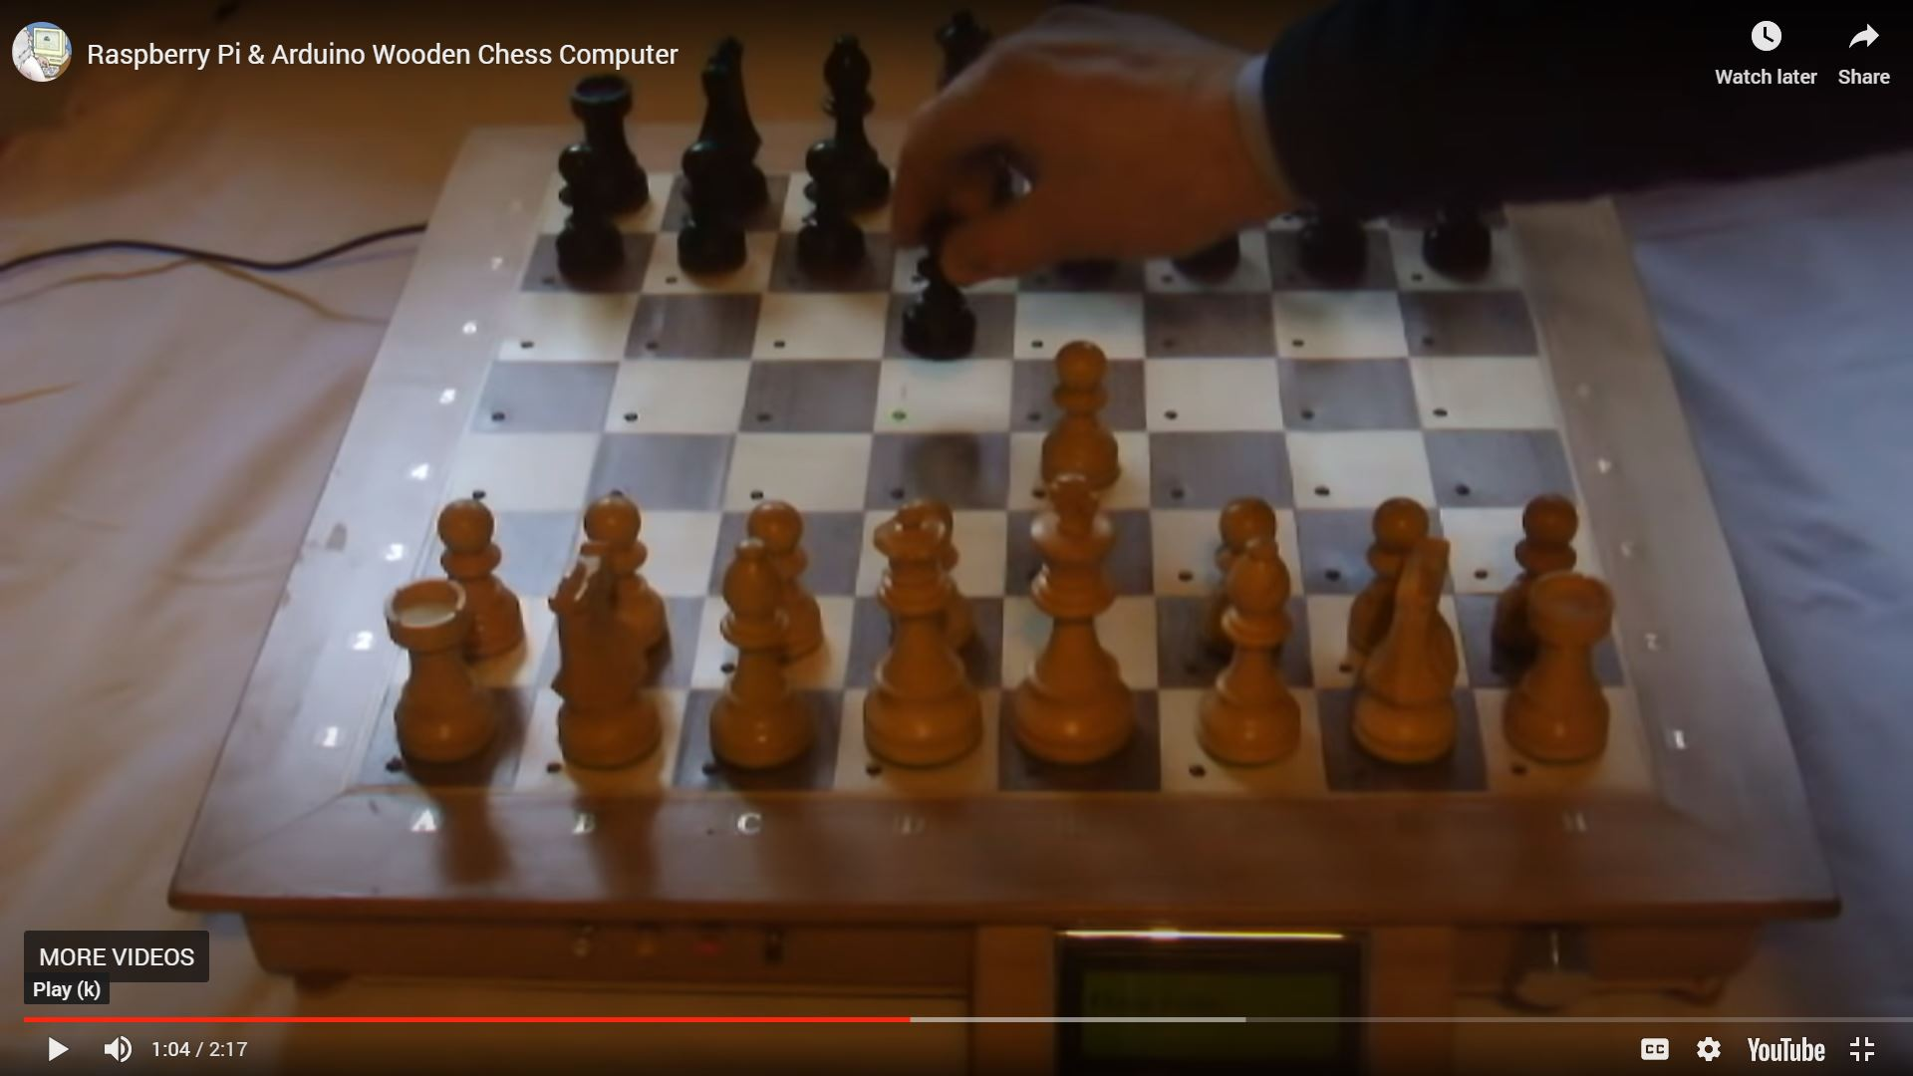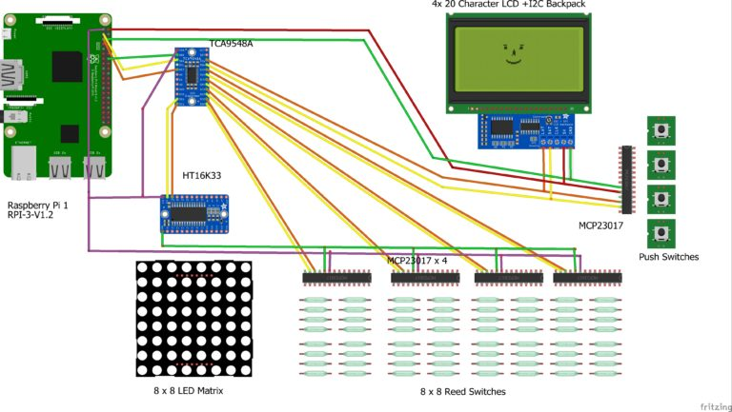

5.3.2 Open Source Project #2: SolusChess (Sensory USB Chessboard) & SolusChess Bluetooth

<https://sites.google.com/site/bergersprojects/reedcb>

<https://sites.google.com/site/bergersprojects/reedcb/bt>

The SolusChess is a chess board that emulates a keyboard (wired or bluetooth) to any device that can connect to a keyboard. This would allow the player to connect the board and play any digital version of chess that accepts keyboard input in chess notation. The chess pieces are detected using reed switches on each square. The whole device is run through a small microcontroller (and in the bluetooth version, a bluetooth HID keyboard controller), the teensy++ 2.0. There is no piece recognition, but as long as no illegal moves are made, the board can remember what pieces are which based on initial positions. The Pros of this board is that it offers an easy way to connect to any device that could connect to a keyboard, which is a simple solution to how to communicate between a player’s device and the board. The Cons of this board is that there is no communication from the device to the board about the opponent’s pieces, and that the player would have to move the opponent’s pieces themself according to how the virual game of chess is going on their device. Another con is no prevention of illegal moves. This project has no license or copyright place on it, and the creator encourages people to make their own sensory chessboard and share their builds with them.

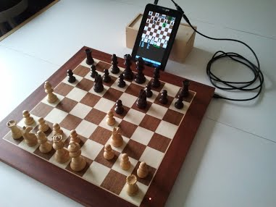

5.3.3 Open Source Project #3:

<https://people.ece.cornell.edu/land/courses/ece4760/FinalProjects/s2008/eaj24_wpb3/eaj24_wpb3/index.html>

*Creative Commons Attribution-Noncommercial-Share Alike 3.0 License*

This project includes two chess boards that enable two players to play each other across any distance, as long as they both have internet access. Each player has their board where they move their own pieces, and an NTSC television that displays their moves as well as their opponent’s pieces and moves. Piece movement detection is done through reed switches on each square and each player’s moves are communicated to the other’s via TCP/IP communication through the internet. The game board checks each player’s moves legality and operates the general game of chess through C code, and handles the TCP/IP communication portion through Matlab code that imports Java. The Pros of this project is that it achieves long distance chess playing between two human players through the internet. It also is smart enough to recognize illegal moves, preventing cheating from either player. The Cons are that this board is mostly displayed on a TV, and that you do not see both you and your opponent’s pieces on the same board. This also means that both players must have access to an NTSC TV to play each other (unlike our design which would require a cell phone, but in today’s age it is extremely rare to find someone who does not own a smartphone). This work is licensed under a Creative Commons Attribution-Noncommercial-Share Alike 3.0 License.

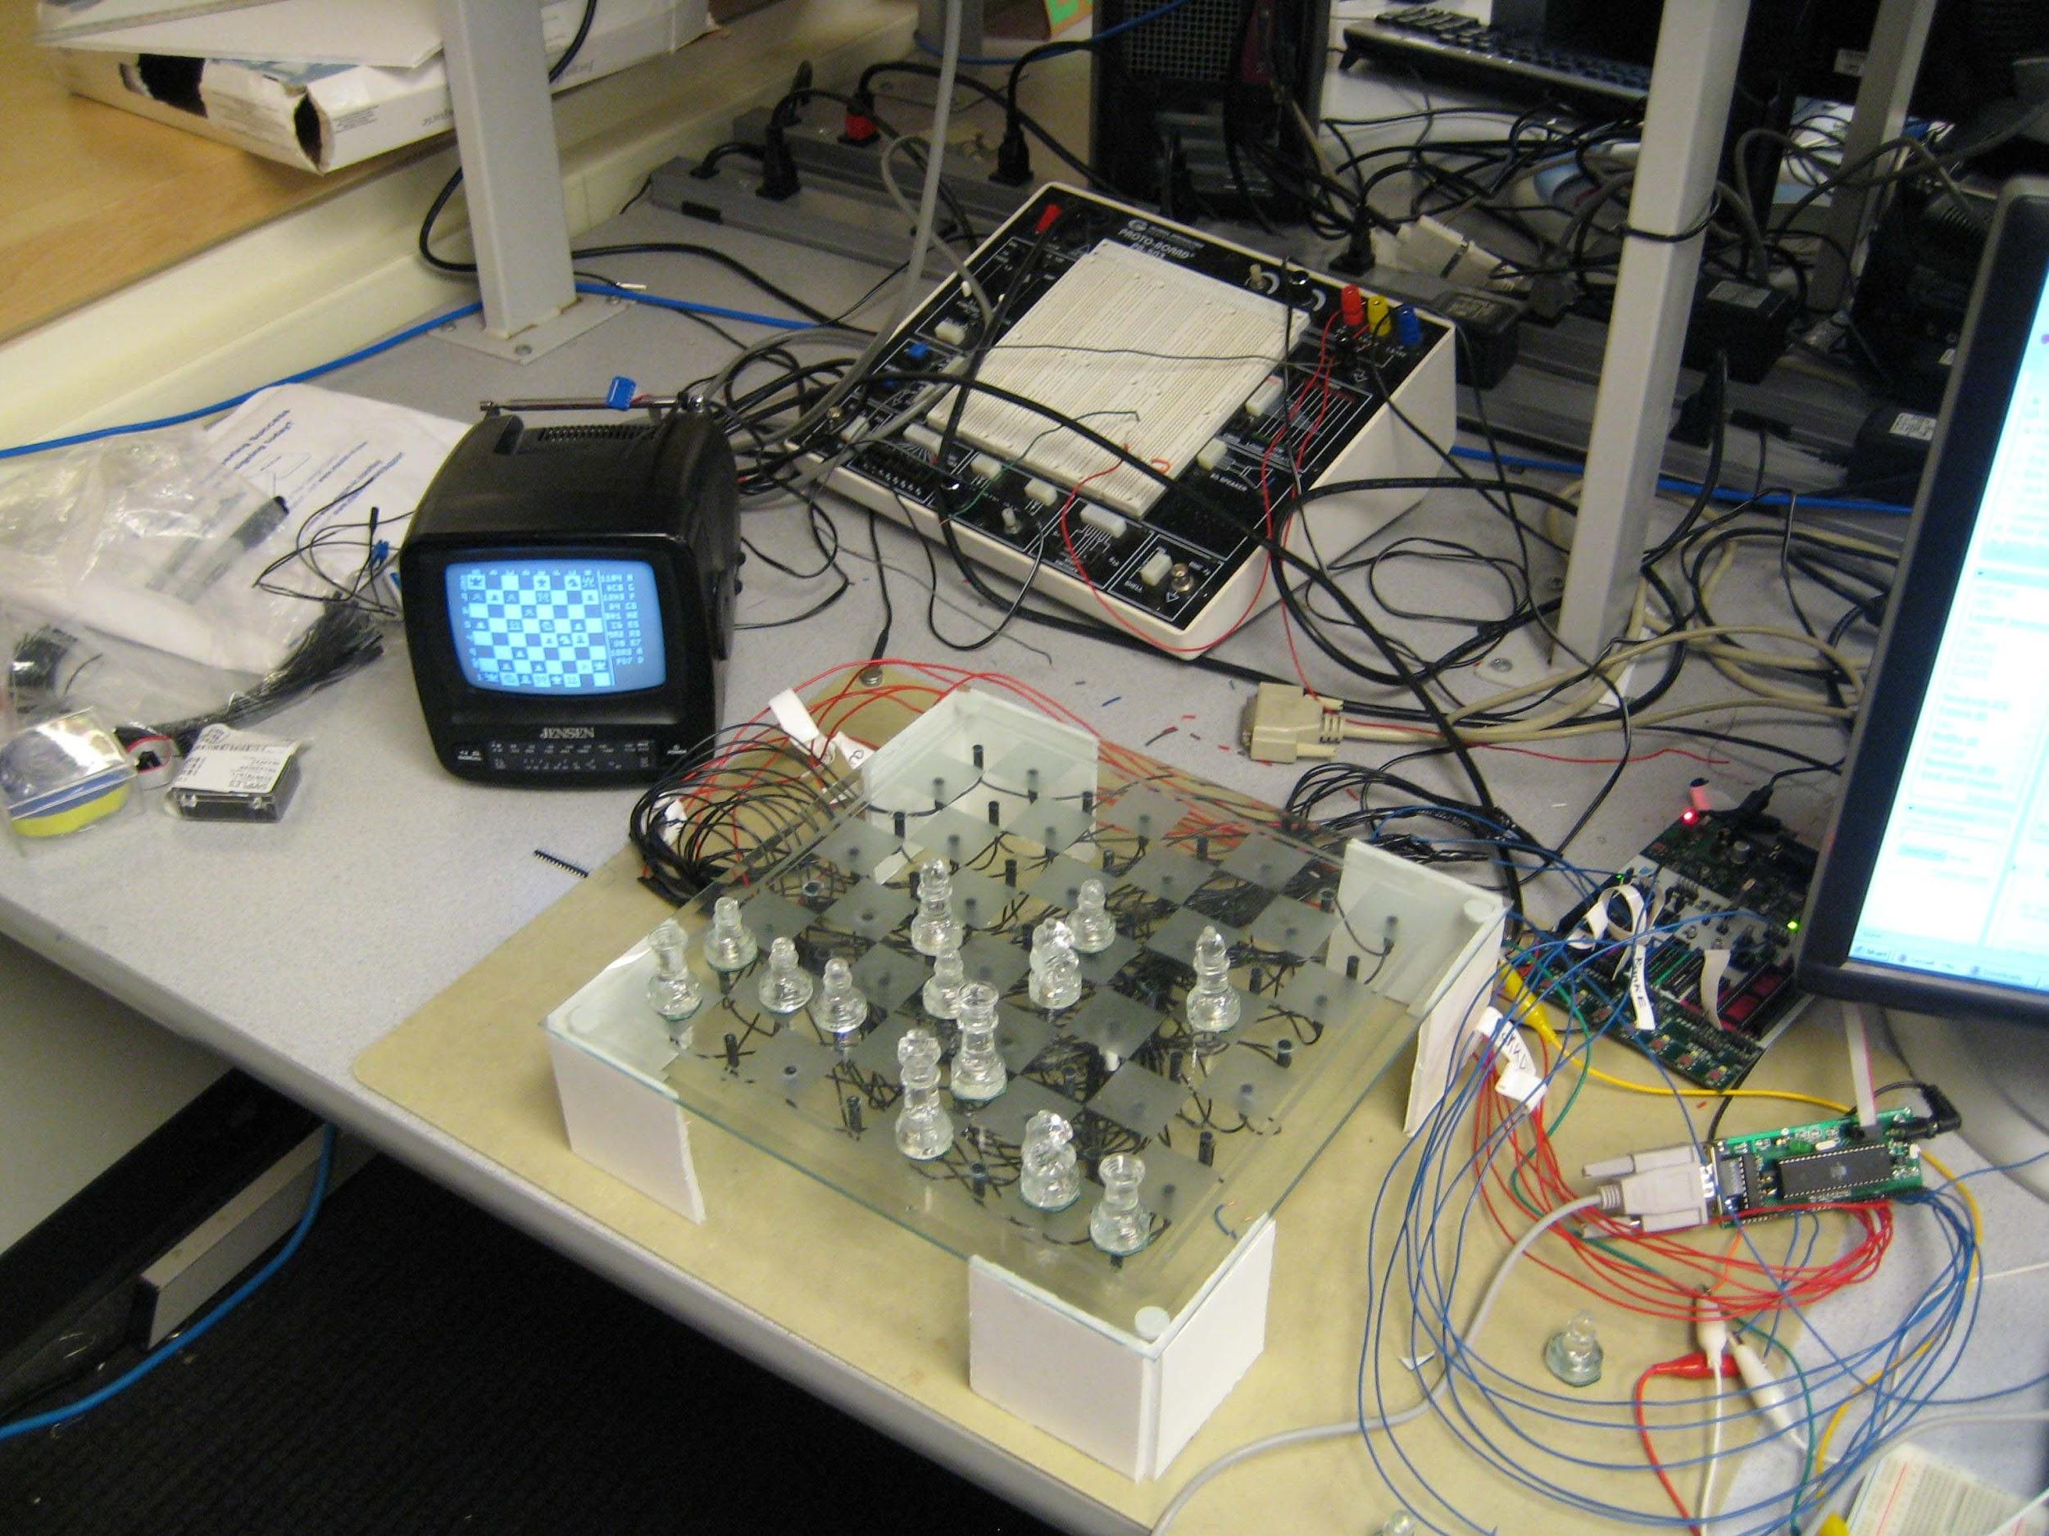

6.0 Sources Cited:

Board game with dynamic characteristic tracking, by M.M. Maharbiz, T. Morichau-Beauchant, and S. Jaqua. (2019, Oct. 29). U.S. Patent Appl. 20180071615A1 [Online]. Available: **https://patents.google.com/patent/US20180071615A1/en?q=remote+game+board&oq=remote+game+board**

Chess pieces operatively arranged to communicate with a sensory chessboard and a chess set comprising the chess pieces and sensory chessboard, by R. Socorregut. (2019, Jun. 25). U.S. Patent Appl. 20190314715A1 [Online]. Available: **https://patents.google.com/patent/US20190314715A1/en?q=RFID+chess&oq=RFID+chess**

Electronic game board system, by G. D. Beinhocker and J. S. Galinato (1970, Apr. 7). U.S. Patent 3654392 [Online]. Available: https://patents.google.com/patent/US3654392?oq=remote+chess+board

[4] U.S. Chess Federation - Affiliate Search. [Online]. Available: http://www.uschess.org/assets/msa_joomla/AffiliateSearch/. [Accessed: 30-Apr-2020].

[5] N. Fisher, “Americans Sit More Than Anytime In History And It's Literally Killing Us,” Forbes, 07-Mar-2019. [Online]. Available: https://www.forbes.com/sites/nicolefisher/2019/03/06/americans-sit-more-than-anytime-in-history-and-its-literally-killing-us/#73aada55779d. [Accessed: 30-Apr-2020].

Appendix 1: Concept Sketch (Dan)

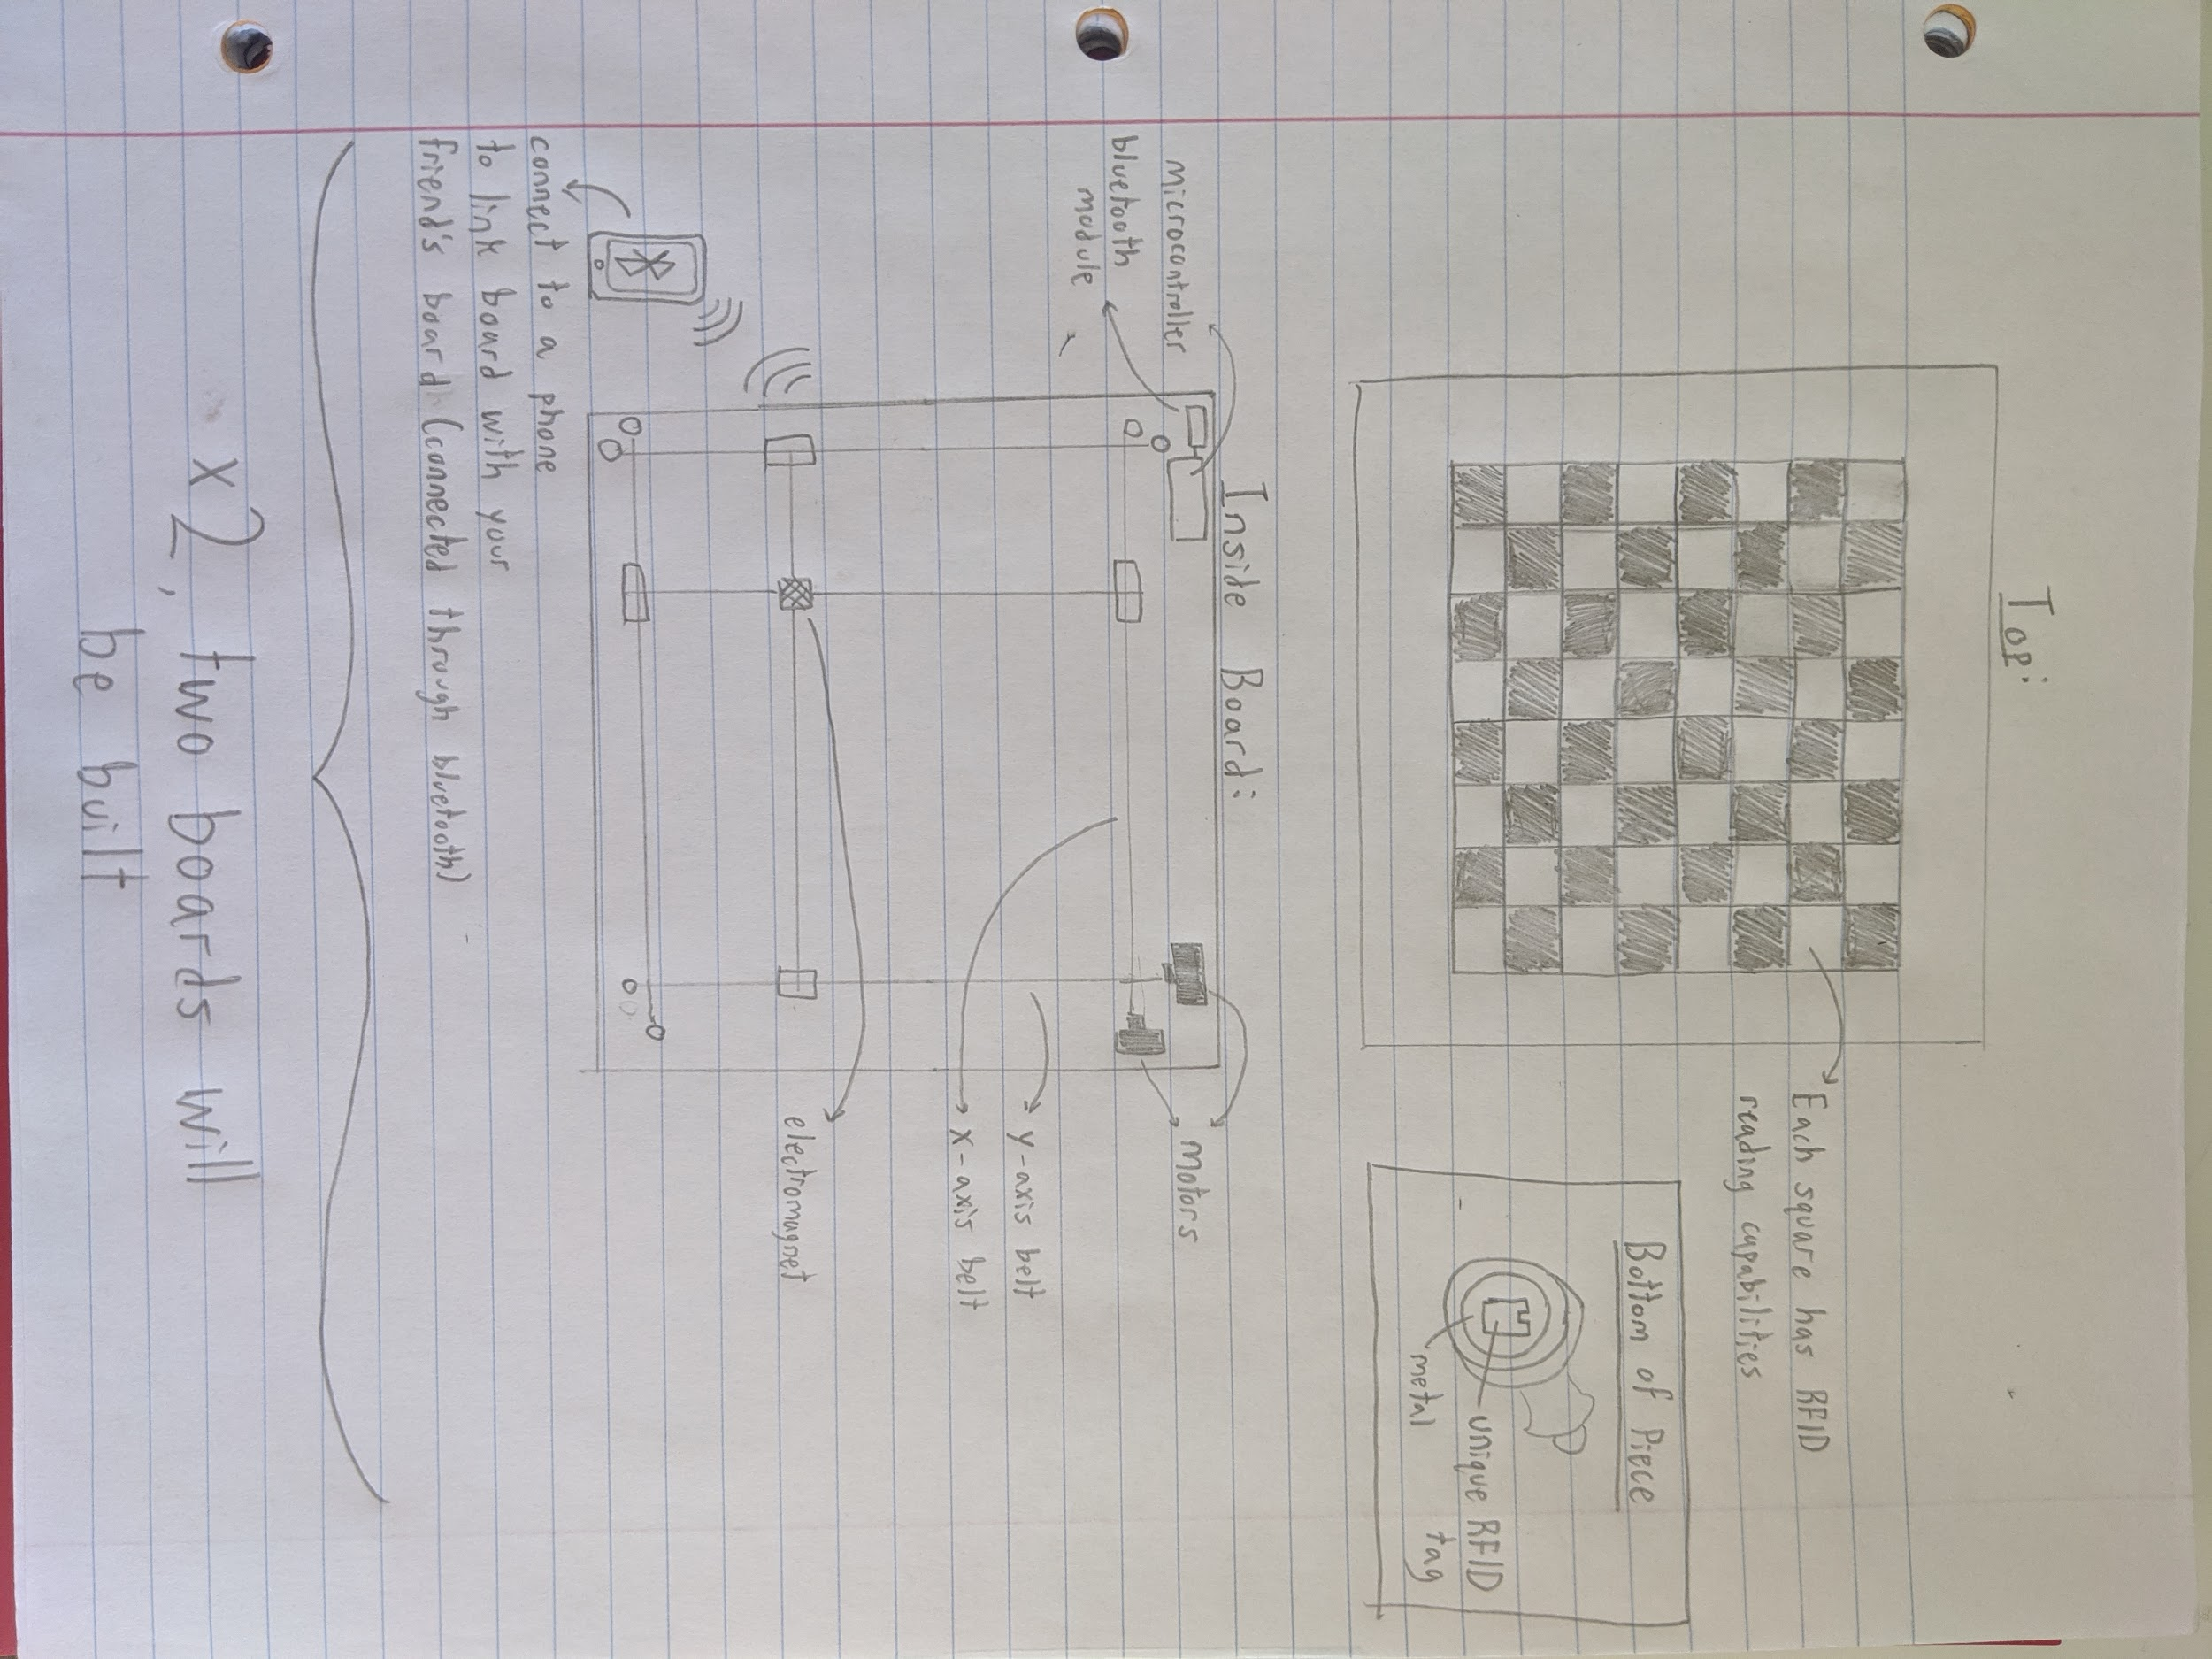

1. "Chess.com: A Social Networking Site For…Well You Can ...." 8 Jul. 2007, <https://techcrunch.com/2007/07/08/chesscom-a-social-networking-site-forwell-you-can-probably-guess/>. Accessed 27 Apr. 2020.
2. "Square Off - World's Smartest Chess Board by ... - Kickstarter." 22 Oct. 2019, <https://www.kickstarter.com/projects/infivention/square-off-worlds-smartest-chess-board-relaunched>. Accessed 27 Apr. 2020.
3. "Meek or Masterly, A Challenger Awaits - The New York Times." 26 Jul. 2001, <https://www.nytimes.com/2001/07/26/technology/meek-or-masterly-a-challenger-awaits.html>. Accessed 27 Apr. 2020.