Component Analysis

Year: 2020 Semester: Fall Team: 22 Project: Social Distancing Chess

Creation Date: 9/10/2020 Last Modified: 9/10/2020

Team Members (#1 is Team Leader):

Member 1: Matthew MacLean Email: macleanm@purdue.edu

Member 2: Ian Haggerty Email: ihaggert@purdue.edu

Member 3: Daniel Burger Email: burger5@purdue.edu

Member 4: Fischer Bordwell Email: fbordwel@purdue.edu

Assignment Evaluation:

|  |  |  |  |  |
| --- | --- | --- | --- | --- |
| **Item** | **Score (0-5)** | **Weight** | **Points** | **Notes** |
| **Assignment-Specific Items** | | | | |
| **Analysis of Component 1** |  | x2 |  |  |
| **Analysis of Component 2** |  | x2 |  |  |
| **Analysis of Component 3** |  | x2 |  |  |
| **Bill of Materials** |  | x6 |  |  |
| **Writing-Specific Items** | | | | |
| **Spelling and Grammar** |  | x2 |  |  |
| **Formatting and Citations** |  | x1 |  |  |
| **Figures and Graphs** |  | x2 |  |  |
| **Technical Writing Style** |  | x3 |  |  |
| **Total Score** |  | | |  |

5: Excellent 4: Good 3: Acceptable 2: Poor 1: Very Poor 0: Not attempted

General Comments:

*Relevant overall comments about the paper will be included here*

IMPORTANT NOTE: The Bill of Materials is a separate document and should be downloaded and filled out for another assignment. The Bill of Materials is to be submitted separately, per the course calendar (possibly on a different week), and will graded collectively with this assignment.

1.0 Component Analysis:

The primary hardware components of our design include the Microcontroller, Screen, Bluetooth Transceiver, Multiplexers, and Hall Effect Sensors. As the heart of the design, the Microcontroller handles all of the signals being sent to and from the other subsystems, keeping track of the player's board and sending it over Bluetooth to the phone. The Screen acts as a source of information for the User, informing them of the opponents moves, as well as their own possible moves. The Bluetooth Transceiver will send and receive board state information from the paired smartphone, handling short distance transmission between phone to board. The multiplexers allow us to have all of the sensors and signals necessary for a 64-square chess board without requiring 64 separate ADCs for the Hall Effect sensors, which in turn are required to read the magnetic polarity of each piece to keep track of the piece’s team. These sensors will couple with the software running on the Microcontroller to maintain a layout of the board as the magnetic readings change. A description and breakdown of the selection of each component follows below.

1.1 Microcontroller and Development Board

As the heart of the design, the Microcontroller chosen will need to be able to handle every task we throw at it. Because of the heavy software requirements of this project, we decided initially to pursue a development board with an STM32 microcontroller on it, as all members of the team have experience with this family. This would allow us to quickly get subsystems up and running. Because of availability and power, we decided that our two main contenders were the STM32F0 and STM32F4. The Discovery development boards provide an easy to use platform for our development purposes, and being able to get them straight from ST results in reliable quality in the product.

|  |  |  |
| --- | --- | --- |
| **Feature** | **STM32F0[9]** | **STM32F4[10]** |
| RAM | 8 KB | 192 KB |
| Flash Memory | 64 KB | 1 MB |
| UART | 2x | 6x |
| SPI | 2x | 3x |
| ADC | 1x, 12-bit | 3x, 12-bit |
| Price | $8.96 | $19.50 |
|  |  | CHOSEN |

The main systems we will need for this design are ADC, SPI, and UART, which both boards support to a large enough degree that the design would work. Additionally, despite the significantly lower RAM and Flash Memory, the STM32F0 would indeed have enough storage to adequately handle all of the calculations and data required for running a game. However, for development purposes, we have chosen to use the higher power STM32F4. The higher number of SPI/UART/ADC subsystems will allow for greater testing capability, and the larger storage will allow for flexibility of the software during the development phase, before the data structures have been fully optimized. Though a final product would be able to comfortably use the STM32F0 with no problems, its limitations might come into play during the early stages of product development.

1.2 Analysis of Component 2: (Screen)

The choice of screen for the project is key to deciding how the user interacts with and gains information from the board. Higher-level user interface concerns are generally more important than the electrical characteristics of these screens, but with the powerful STM32F4 microcontroller family, it is expected that we will have enough computing power to drive any of the selected screens, especially with the low computational intensity of other project components.

The QT154H2201 is a 240x240 LCD display. Its square resolution is appealing since it mirrors the layout of the chessboard, unlike many rectangular screen equivalents. Since a chess board is 8 squares wide and tall, this allows essentially 30x30 pixel squares to depict a piece within any given square (ignoring square boundaries), which is enough for a low-res piece graphic. This screen would be ideal for a user interface which depicts the board itself. The screen could indicate moves through animations, alternate-colored moved pieces. It could also show alternate-colored “ghost pieces” at move options when the user is considering a piece.

The SSD1325 screen kit is a 128x64 OLED display. This choice is less ideal for portraying the board, but the crisp contrast of the OLED display makes “vintage” graphics look really good, as pictured below. By carefully constructing the user interface with graphics like this in mind, it should be possible to make a charming user interface without rendering the entire chess board. It could also display extra information such as device state, bluetooth state, and a scoreboard based on piece values. This information is higher value compared to repeated board state information.

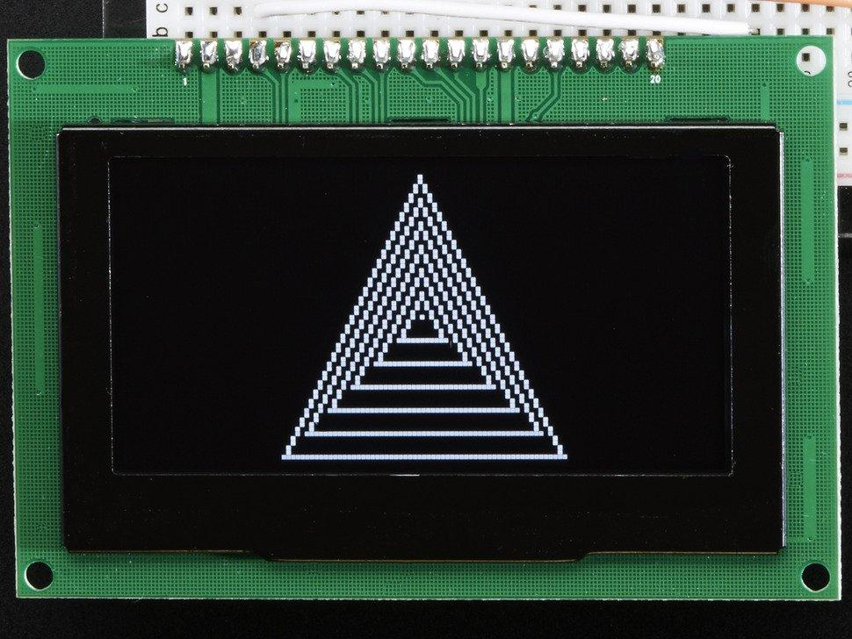

**Figure 1: An SSD1325 example graphic [8]**

Since both display options are sold by Adafruit, a hobbyist website, there are voltage steppers provided which allow the displays to be driven from a 5V board. This will make developing for the boards overall faster and easier. They are also both well within our necessary temperature ranges.

OLED displays are hard to read in the sunlight, but since the product is expected to be powered from a wall outlet without batteries, there is not expected to be much direct sunlight shining into the LED screen. Additionally, since the chess board fits in the same space when rotated by 90°, it is possible for the user to rotate the board to make the screen more readable.

We want to provide a polished, professional user interface which is not just text. However, rendering the entire board and having animations for different scenarios is not very useful, since the screen will be directly in front of the real chess board anyway. If the user doesn’t expect to receive new information from the display because it just depicts the chess board, they will be less likely to look at it to receive important new information. Because of this, we have selected the SSD1325 display, with the intent to show graphics which provide information about the game state, as well as about the device status.

|  |  |  |
| --- | --- | --- |
| **Feature** | **QT154H2201 [7]** | **SSD1325 [8]** |
| Display Type | TFT LCD | OLED |
| Resolution | 240x240 RGB | 128x64 Monochrome |
| Frame Rate | 80 Hz | Programmable (110 Hz by default) |
| Voltage | 3 V | 3.3 V |
| Operating Current | 65 mA (max) | 40 mA |
| Operating Temperature | -20-+70 ℃ | -40-+85 ℃ |
| Price | $20 | $50 |
|  |  | CHOSEN |

1.3 Analysis of Component 3: (Bluetooth)

Bluetooth is a feature added to this project for the sake of convenience more than anything. Each player will have a chess board, connecting to it with their phone via Bluetooth to begin a game of chess. The player’s moves are sent from the board to their phone, and the opponent’s moves are sent from the phone to the board. This could be achieved by plugging their phone into the board with a cable, but nowadays most smartphones are limited in ports. Many different smartphones require different connection standards such as lightning bolt, USB-C, and Micro-USB as well.

Enabling a Bluetooth connection will provide the players with a more seamless and less limited game of chess with their phone still handy to charge, keep in their pocket, or simply have it further away from the board while still in the Bluetooth range. This meant we needed a Bluetooth module that was reliable in its connection but did not need an extremely long range. Speed wasn’t a huge consideration since a chess game is typically played at a leisurely pace.

We found the HC-05 and HC-06 Bluetooth modules to be the most common and widely used in the world of hobbyists so we set out to compare all the differences in features of the two. Ultimately we decided on the HC-05 because it can communicate as a master or a slave to another device. This does not directly affect the current scope of the project but could come in handy if one day we wanted to modify the boards so that the two could be played against each other via bluetooth from board to board instead of phone to phone.

|  |  |  |
| --- | --- | --- |
| **Feature** | **HC-05 [1]** | **HC-06 [2]** |
| Mode(s) | slave or master | slave |
| Baud Rate | Data: 9600, Command: 38400 | 9600 |
| Operating Current | 30mA | 40mA |
| Range | <100m | <100m |
|  | CHOSEN |  |

1.4 Multiplexer Analysis

Multiple multiplexers are required for the design to accommodate the large amount of hall effect sensors required for each chess board. Since there will be 64 sensors that need to be connected to the Microcontroller, we have decided to implement a 64:1 multiplexer by cascading multiplexers together, with 8 multiplexers leading into a 8:1 multiplexer. This will greatly reduce the required number of pins from 64 to 7. The selection bits for the second layer of multiplexers can be repeated, as only one of them will be in use at any given time, so the value sent to the other 7 is inconsequential. Two options that came up in research are CD4051BE and the SN74LS151N, both manufactured by Texas Instruments.

|  |  |  |
| --- | --- | --- |
| **Feature** | **CD4051BE[3]** | **SN74LS151N[6]** |
| VCC | -0.5-20V | 5V |
| Propagation Delay | 450ns | 25ns |
| Signal Types | Analog and Digital | Digital |
| Unit Price | $0.48 | $0.37 |
|  | CHOSEN |  |

Despite the lower unit price and propagation delay, we will be going with the CD4051BE because it is able to handle both Analog and Digital signals, which will be necessary to accommodate the choice of Hall Effect Sensor.

1.5 Hall Effect Sensor: Analog vs Digital

Since the magnets in the chess pieces will be used to determine how the pieces move during the course of a game, it is very important to provide a good, reliable indication of the presence of a piece. The main decision that came up during this process was whether to receive an analog or digital signal from the sensor. The two most common and affordable components seemed to be the DRV5013 and the DRV5053 Hall effect sensors, both manufactured by Texas Instruments.

|  |  |  |
| --- | --- | --- |
| **Feature** | **DRV5013[4]** | **DRV5053[5]** |
| Signal Type | Digital | Analog |
| Voltage Range | 2.5-38 | 2.5-38 |
| BMax | Infinite | 35 mT |
| Unit Price | $0.30 | $0.68 |
|  |  | CHOSEN |

While the unit price is lower and would not require the use of an ADC, the DRV5053 is ultimately going to be chosen for the project, due to the nature of a digital Hall effect sensor. When dealing with the digital signal, there is no concrete way to measure a lack of magnet near the sensor. The sensor can reliably tell the system the direction of the magnetic field, which is ideal for determining the team of a given piece, but the system goes to an indeterminate state upon the removal of a strong magnetic field. This means that there would be no reliable way to determine when a piece has been removed from the playing field. Thus, the analog component must be used.

2.0 Sources Cited:

[1] Components101. 2020. HC-05 - Bluetooth Module. [online] Available at: <https://components101.com/wireless/hc-05-bluetooth-module> [Accessed 10 September 2020].

[2] Components101. 2020. HC-06 - Bluetooth Module. [online] Available at: <https://components101.com/wireless/hc-06-bluetooth-module-pinout-datasheet> [Accessed 10 September 2020].

[3] Digi-Key. 2020. CD4051BE. [online] Available at: <https://www.digikey.com/short/z2cz2b> [Accessed 10 September 2020].

[4] Digi-Key. 2020. DRV5013AGQLPG. [online] Available at: https://www.digikey.com/short/z2cp9n [Accessed 10 September 2020].

[5] Digi-Key. 2020. DRV5053EAQLPGM. [online] Available at: <https://www.digikey.com/short/z2cpmr> [Accessed 10 September 2020].

[6] Digi-Key. 2020. SN74LS151N. [online] Available at: <https://www.digikey.com/short/z2czf1> [Accessed 10 September 2020].

[7] Adafruit. 2020. ST7789. [online] Available at: [https://www.adafruit.com/product/3787](https://www.adafruit.com/product/3787#technical-details) [Accessed 11 September 2020]

[8] Adafruit. 2020. [online] Available at: <https://www.adafruit.com/product/2674> [Accessed 11 September 2020].

[9] STMicroelectronics. 2020. STM32F051R8. [online] Available at: <https://www.st.com/content/st_com/en/products/microcontrollers-microprocessors/stm32-32-bit-arm-cortex-mcus/stm32-mainstream-mcus/stm32f0-series/stm32f0x1/stm32f051r8.html#overview>. [Accessed 11 September 2020].

[10] STMicroelectronics. 2020. STM32F407/417. [online] Available at: <https://www.st.com/en/microcontrollers-microprocessors/stm32f407-417.html#overview>. [Accessed 11 September 2020].