## Name: _______________

## Netid: _______________

For each problem:

1. Show a screenshot of the problem.
2. Show a screenshot of your original (incorrect) solution.
3. Show a screenshot your corrected solution; include a screenshot of the “all tests passed” window.

For example:

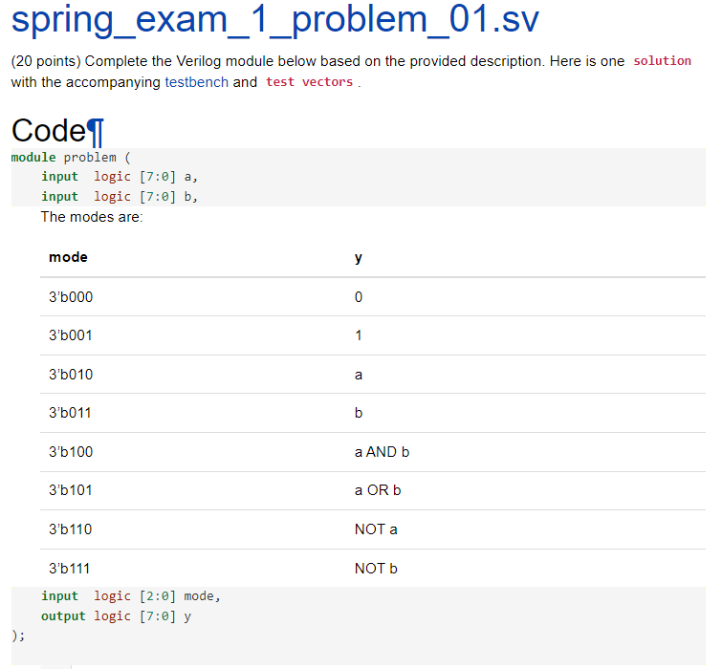

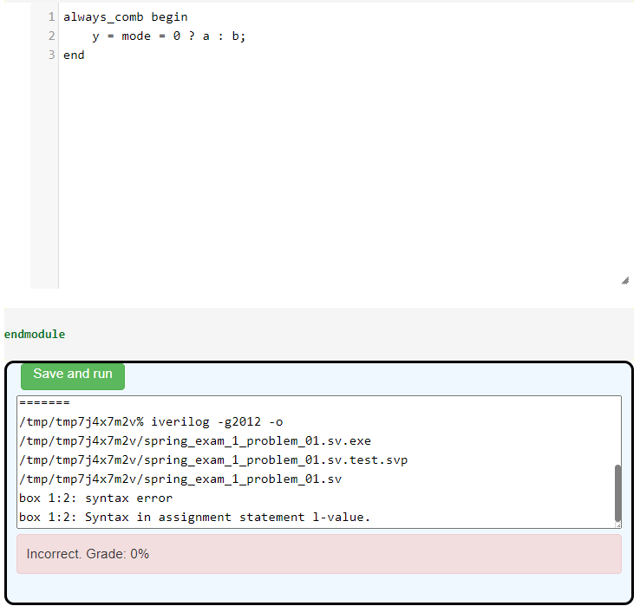

(Note: I blurred the solution – don’t do this in your version!)

