## Assignment1:

Cloning and Buffering

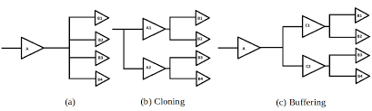

Cloning is where a clock-gate (a special gate in the clock tree that switches of the clock signal to a number of flip-flops to save power when they are not needed) is duplicated so that one clock-gate driving, for example, 40 flip-flops can be "cloned" to become 2 clock-gates driving 20 flip-flops each.  
  
A buffer is a basic electronic gate that serves to strengthen a signal. It is needed when you wish to drive a signal along a long wire, or when you want to drive a signal to very many receiving pins. A single driving gate can only drive a short length of wire and only a small fanout. Buffering is the insertion of buffers to help drive the signal to bigger loads.

Cloning vs Buffering

Cloning is a good when the a gate want to connect to the far-apart gate. because the propagation delay is very large, With cloning, we can deliver multiple signals at the same time; so this techniques can be used for clock tree. the Cloning is preferred when we want to distribute the load of ICG cells.

buffers don’t increase the upstream capacitance of the gate which is helpful in terms of delay and dynamic power; Buffering can be used to fix hold time violation by inserting extra delay and thus buffer can adjust arrival time. Buffer can shield downstream capacitance. So buffer is always used in improving data slops, as repeaters

## Assignment2:

Width Downsize(upsize) VS power swap to low voltage

Target: decrease energy consuming

Width Downsize:

Advantage: change the energy consumption efficiently, no slack violations

Disadvantage: leakage current increases because the capacitance increase

power swap to low voltage

advantage: less leakage current, don’t need to change the layout and circuit

disadvantage: sometimes it will have slack violations,

Assignment 3:

