Team 203

Garret Vanhoy

ECE 372

November 13, 2015

Preliminary Design Review

**Theory**

Since the winner of the competition is based on the team that can acquire the most points by traversing the path, our team has decided to implement a design that focuses on traversing the track. The design will be based on a mostly defensive strategy and build that will allow our robot to traverse the track efficiently while avoiding contact with other robots. The robot will be controlled and directed using the IR sensor that will keep it on the path. The main components of the robot (the microcontroller, wires, board) will be protected by an enclosed shell around those components. The additional sensor that will be used in our design is a range detector. This detector will allow for our robot to scan the field in front of it, and detect if there is another bot nearby. Using this information we can decide on what course of action to take next (slow down to avoid contact, try to speed past the other bot, etc.). The overall design will incorporate defensive techniques, paired with a protected robot, in order to maximize the number of points earned.

**Hardware Design**

|  |  |  |  |  |
| --- | --- | --- | --- | --- |
| **Part Name** | **Part Number** | **Cost** | **Source** | **Purpose** |
| 1M Potentiometer | **A0013** | **$1.00** | **Stock Room** | **IR** |
|  |  |  |  |  |

**Software Design**

Given the additional complexity of this project when compared to previous labs, the focus of the software design for the final is on scalability. This being said, we have decided to build the software in a way that enables both easy isolation of robot subsystems, and allows for easy modification of robot behavior at a high level. To do this we have decided to implement a state machine that carries out high level tasks in main.c, and lower level tasks controlled by sub-state machines. Additionally, structuring our code in this manner should allow for easy debugging.

This being said, the high level state machine will have states that that run tasks similar to the following: track line, check for robot, avoid obstacle etc. These tasks will then be defined as their own state machine in their corresponding .h and .c file.

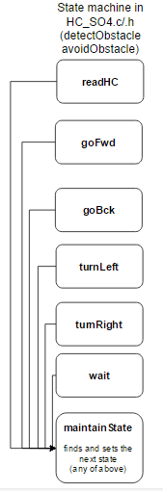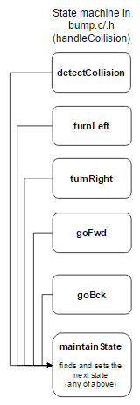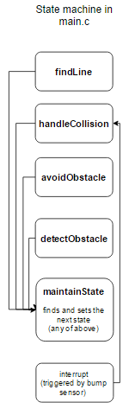The state machine to the right describes the high level state machine that we will be implementing in main.c. As described previously in this document, the states findLine, handleCollision, avoidObstacle, and detectObstacle in the main.c state machine will be located in separate files. The descriptions of these state machines are depicted by the diagrams below. Additionally, the diagram shows files that the state machines are in will be listed in. Each state will call a function that carrys out an action for example: the turnLeft state will call a function turnLeft() that makes the robot turnLeft. The readHc state will call a function readHc() that reads from the sensor. The same goes for all of the other states.

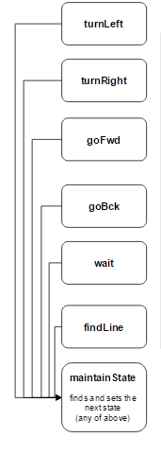

Functions in pwm.c/.h

void initPWM();

Initialize the PWM for the motors and configure the pins for the robot.

void setMotorsIdle();

Sets motors to Idle.

void setMotorsBackward(int s);

Sets the motors to move in reverse with a speed of s.

void setMotorsForward(int s);

Sets the motors to move forward with a speed of s.

void setMotorsLeft(int s);

Stets the left motor to move forward with a speed of s, and right motor to stop.

void setMotorsRight(int s);

Sets the right motor to move forward with a speed of s, and left motor to stop.

void motorPiviotLeft(int s);

Sets the left motor to move forward with a speed of s, and the right motor to move backward with a speed of s.

void motorPiviotLeft(int s);

Sets the right motor to move forward with a speed of s, and the left motor to move backward with a speed of s.

void motorFindLine(int s);

Makes the robot move in a pattern that attempts to find a line.

Functions in ir.c/.h

void initIR();

Initialize the IR sensors and configure the pins for the robot.

void printIR();

Read from the IR sensors and write to the LCD.

int readIR();

Read from the IR and return an integer that can be decoded into the values read from each IR sensor.

int trackLine();

A state machine, as described above, that enables the robot to track a line. irStateType parseIRData(int data);

Parse the data returned from the readIR() function, and return a state that the trackLine() state machine can use.

Functions in HC_S04.c/.h

int readHC();

Read data from the hc-S04 sensor, return an int with the read information.

void initHC();

Initialize the hc-S04 sensor and the pins it connects to.

handleHC();

A state machine that controls the operations related to reading from the hc-S04 sensor.

hcStateType parseHCData(int data);

Parse the data returned from the readHC() function, and return a state that the handleHC () state machine can use.

**Testing Design**

The testing for this design will be done in a modular and step-wise fashion. In doing so we can assure all the parts that will be connected to the robot work individually. Once the robot starts to be assembled more tests can be performed to ensure parts work when implemented together.

**Test 1: IR Sensors**

The purpose of this test is to ensure the functionality of the IR sensor and the pins that it will be connected to.

The first part of this test involves determining if the pins that the IR sensor will be connected to are functioning properly. In order to do this each pin was first mapped as an input. Then, the functions: printIR(), testIR() were used to read the values on the four IR pins and display those values onto the LCD. When nothing is connected to the pins the expected output on pins 31,32,33,34 respectively is “0000” since all the pins are reading logic low. In order to test each pin, the pins were individually connected to logic high using a jumper. When the pin is connected to high a 1 should be displayed onto the LED. For example, when pin 32 is connected to logic high the LCD should display “0100”.

The second part of the test is to ensure the IR sensor itself works. Since the pins and the LCD display function were tested for correctness in the previous part of the test, the functionality of the IR sensor will be able to be tested fully now. In order to do this the IR sensor was connected to pins 31,32,33,34 and first pointed at an all-white surface. The expected reading display on the LCD for this setup is “0000” since the IR sensor should not be causing the pins to be logic high. The next step is to face the IR sensor at an all-black surface. The expected reading display on the LCD for this setup is “1111” since the IR Sensor should be causing the pins to be logic high.

**Test 2: IR Potentiometer Tuning**

The purpose of this test is to tune the potentiometers so that the values read by the IR sensor are as close to logic low (1.0V) and logic high (3.75V) as possible. In doing so the IR sensor will not have to use the ADC converter.

The first step in performing this test is to connect power to the input of the IR board and connect the oscilloscope to the output of the IR board. The oscilloscope is setup to read the voltage coming off the of IR board output, this voltage is what needs to be as close as possible to logic low and logic high given a white or black surface respectively. The process of tuning the potentiometer involved flashing the black and white surfaces in front of the IR sensor and adjusting the potentiometer so that the voltage readings were close to logic high and logic low. The value of the potentiometer was read and recorded using the Digital Multi Meter. This process was chosen as opposed to working out the resistance value by hand because it provides more accurate results that can be seen on the oscilloscope.

Attached images show the voltage readings for black and white IR sensor readings.

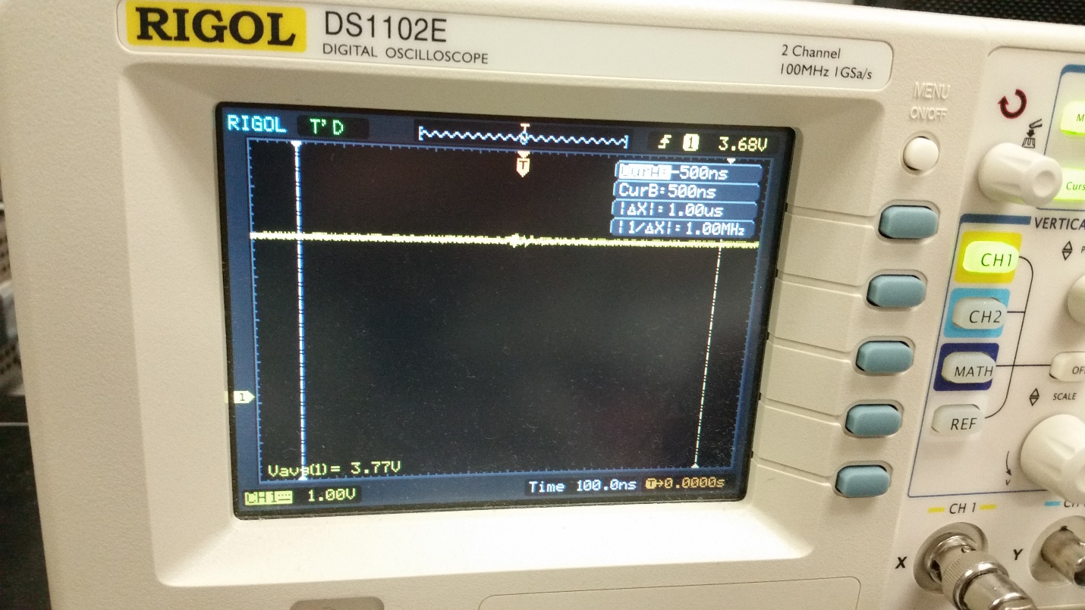

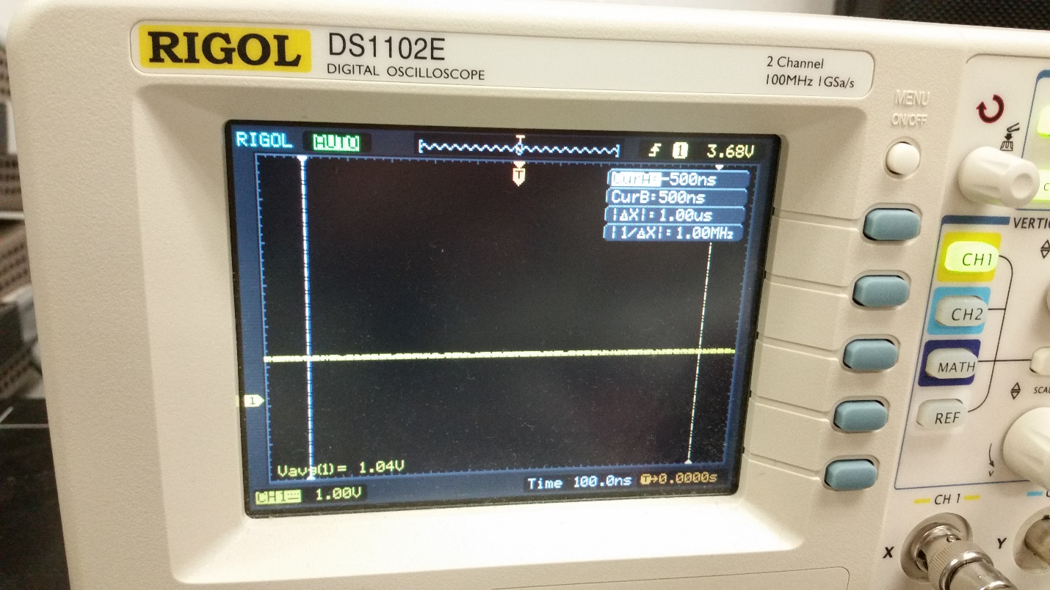

**Test 3: Testing Motor Functions**

The purpose of this test is to ensure that all the different motor functions are properly controlling the motors. The reason this test is needed is because several different motor functions have been written that all serve a different purpose in terms of controlling the movement of the robot, and since any can be used for the competition every function needs to be tested.

In order to test the motor functions (setMotorsRotate, setMotorsSweepForward, setMotorsSweepBackwards, setMotorsForward, setMotorsBackwards) the functions were called with different hardcoded values for the input (ADCBufferValue). The robot was then programmed using these hardcoded values and the results of the motors were observed. For example the setMotorsSweepForward function was tested by calling it with an input of 400. The expected result is for the right motor to move forward at full speed while the left motor moves forward at about 80% speed. The code for testing this function can be found in the testMotorFunctionality() function.

**Test 4: Testing the Range Detector**

The purpose of this test is to ensure that the newly acquired sensor (the range detector) works properly. The reason this test is necessary is because the range detector will be used to control the states of the motors and it must be tested independently of the motors to ensure it is working correctly.

In order to perform this test the range detector will be connected to the microcontroller and the values will be read in using ADC (FIX ME). AN object will be moved in front of the sensor and then the distance the object is from the sensor will be varied. The values being read from the sensor will then be displayed onto the LCD using a previously tested function for printing onto the LCD. The values will be tested against an actual measurement of the distance from the object to the sensor using a measuring tape so the accuracy and precision of the sensor can be obtained.