# Lab 1 Report Example

|  |  |
| --- | --- |
| Team Information  **Lab number:** 1.  **Date:** 10/2/15.  **Team Members:** Abigail Francis, Jonathan Hawkins, Brandon Lipjanic, Pierce Simpson  **Team Number/Name:** 203, PB&J | Team Member Responsibilities  **Software Design:** Jonathan  **Hardware Design:** Abigail  **Quality Assurance:** Brandon |

**Systems Integrator:** Pierce

# Hardware

## Part 1

Draw the schematics or create a table detailing the connections for Part 1 of Lab 1. An example of the level of detail expected is provided.

|  |  |  |  |  |  |  |  |  |  |  |  |  |  |  |  |  |  |  |  |  |  |  |  |  |  |
| --- | --- | --- | --- | --- | --- | --- | --- | --- | --- | --- | --- | --- | --- | --- | --- | --- | --- | --- | --- | --- | --- | --- | --- | --- | --- |
| Expansion  Board J  10 | | | | | | | | | | | | | | | | | | | | | | | | | |
| 59 | 57 | 55 | 53 | 51 | 49 | 47 | 37 | 35 | 33 | 31 | 29 | 27 | 25 | 23 | 21 | 19 | 17 | 15 | 13 | 11 | 9 | 7 | 5 | 3 | 1 |

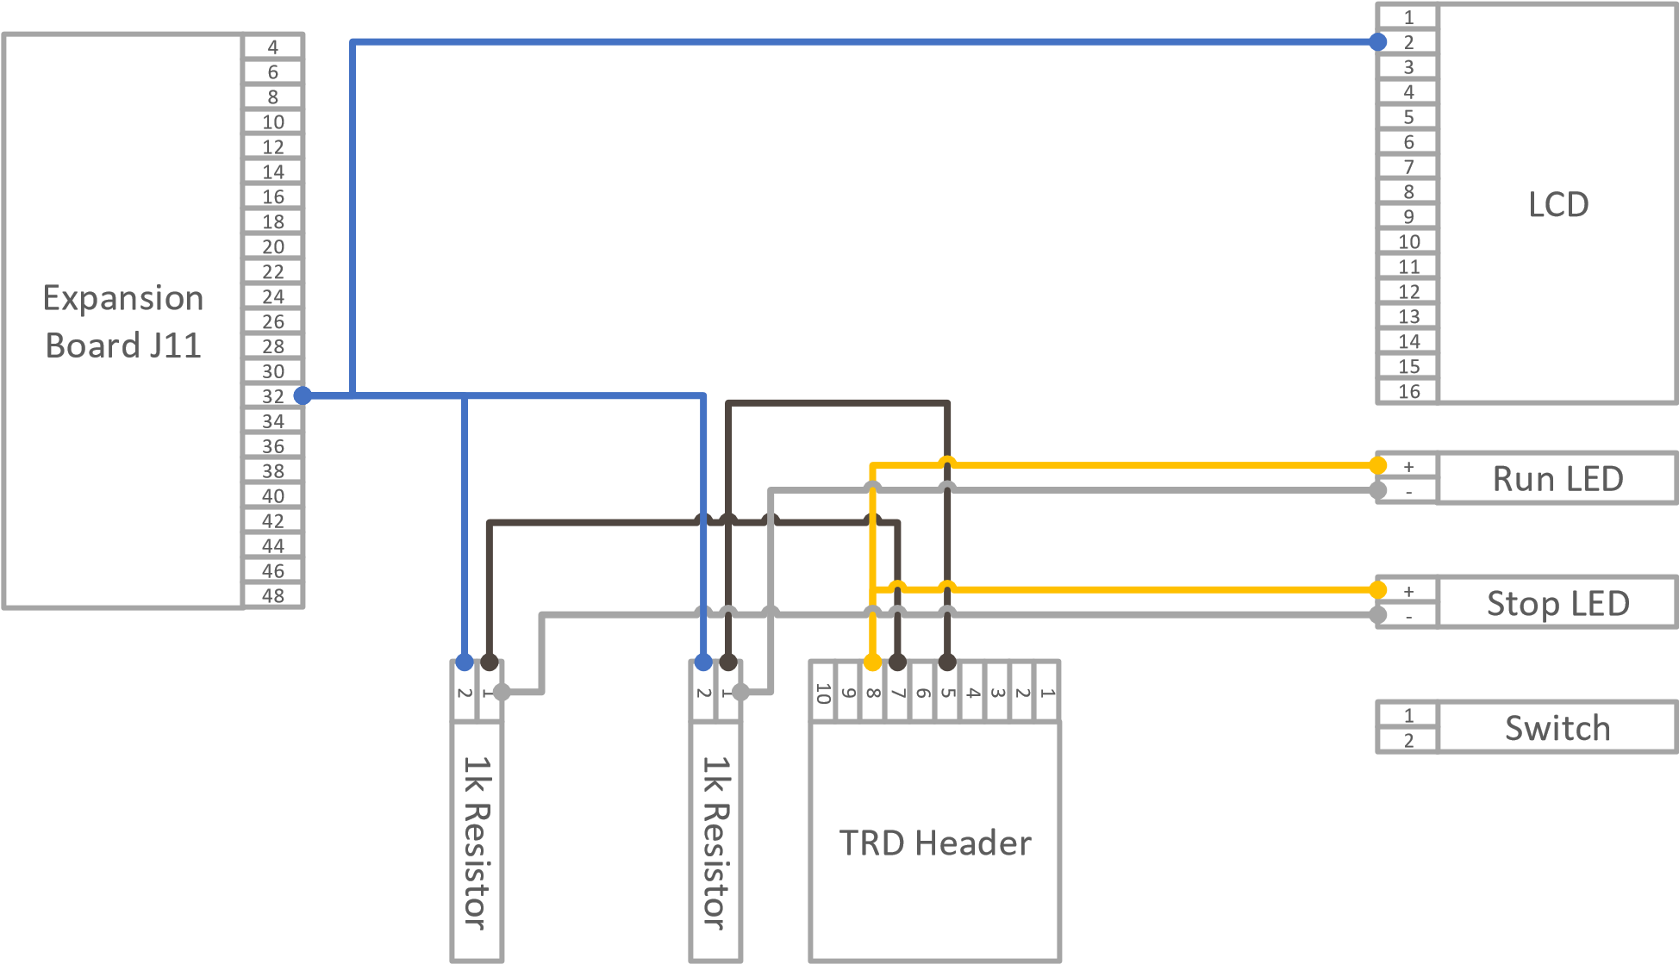

## Part 2

Draw the schematics or create a table detailing the connections for Part 1 of Lab 2. You can choose to use a table or use a diagram.

## Part 3

Draw the schematics or create a table detailing the connections for Part 3 of Lab 1. You can choose to use a table or use a diagram.

# Tests

## Part 1

List the tests and their outcomes that you intend to do based on the Lab 1 procedures. **Also include any pictures, screenshots, or schematics involved with each test.** Describe the name of the test, the tool you intend to use, and a description of the test. Do this for each part in Lab 1.

|  |  |  |  |
| --- | --- | --- | --- |
| **Test Name** | **Tool** | **Description** | **Outcome** |
| Continuity Test | Digital Multimeter | Test all wire connectors, solder joints, and wire-wraps for continuity |  |
| Power Test | Digital Multimeter | Test that any created circuits have power correctly flowing |  |
| Grounding  Test | Digital Multimeter | Test that any switches connected to  ground actually ground a powered circuit |  |
| Component  Test | Digital Multimeter | Test that appropriate pins on the switch are connected |  |

For the software tests you have created **include code in the D2L submission.** However, your outcomes should be well-documented here. There is not time for your code to be tested once it is turned in. Therefore, make effort to show clearly what kind of test you did and what its outcome was. Take screen shots and include them here if you must.

|  |  |  |  |
| --- | --- | --- | --- |
| **Test Name** | **Input** | **Description** | **Outcome** |
| timerTick Test |  | Test that timerTick indeed ticks at the correct interval |  |
| displayTime Test | “10000” | Test that this function assigned the appropriate register to “10:00:00.” |  |
| Register Test |  | Test that the register configurations for the timer work. |  |

Part 2 Part 3

# Software

## Code

Please include all of your documentation in the submitted code. Please also submit your code with the test code made by Quality Assurance.

## Version Control

Include a screen shot of your commit history.