# Lab 2 Report

## Team Information

**Lab number:** 2

**Date:** 10/16/2015

**Team Members:** Abigail Francis, Jonathan Hawkins, Brandon Lipjanic, Pierce Simpson

**Team Number/Name: 203/PB&J** Team Member Responsibilities

**Software Design:** Brandon

**Hardware Design:** Jonathan

**Quality Assurance:** Pierce

**Systems Integrator:** Abigail

# Hardware

### Part 1 Schematic

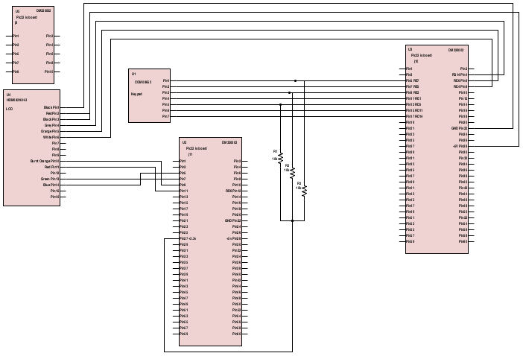

Please see PDF attached with lab report submission.

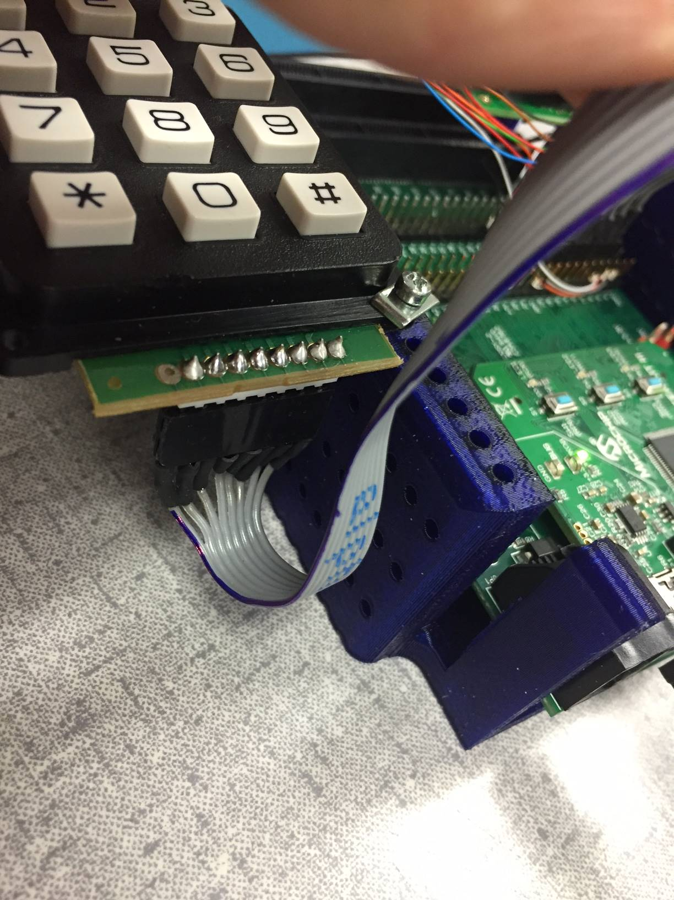

The cable created for part 2 is a grey ribbon cable with 8 cables. Molex connectors were crimped onto the end of each cable. One side plugs into the header of the keypad and the other side plugs into the appropriate pins shown on the above schematic. The cable corresponding to pin 1 has a blue stripe. The 8th cable is unused.

# Tests

|  |  |  |  |  |  |  |  |  |
| --- | --- | --- | --- | --- | --- | --- | --- | --- |
|  | |  |  |  |  |  |  |  |
| Table 1 |  |  |  |  |  |  |  |  |
| Test # | Test Name | Method | Software req'd | Expansion board row pin | Expansion board col pin | Button | Probe/Keypad pin | Tools req'd |
| P1-1 | Connectivity on the connector and the header attached to the keypad | Test the resistance of each key press with multimeter. Should be high Z before press and low Z after |  |  |  | 1 | (+/3 , -/2) | DMM |
|  |  |  | 2 | (+/1 , -/2) | 2x probes |
|  |  |  | 3 | (+/5 , -/2) |  |
|  |  |  | 4 | (+/3 , -/7) |  |
|  |  |  | 5 | (+/1 , -/7) |  |
|  |  |  | 6 | (+/5 , -/7) |  |
|  |  |  | 7 | (+/3 , -/6) |  |
|  |  |  | 8 | (+/1 , -/6) |  |
|  |  |  | 9 | (+/5 , -/6) |  |
|  |  |  | * | (+/3 , -/4) |  |
|  |  |  | 0 | (+/1 , -/4) |  |
|  |  |  | # | (+/5 , -/4) |  |
| P1-2 | Pulldown of column pins shorted to row pins | Short column pins to row pins on expansion board one at a time each with jumper cables and measure column pin voltage on the oscilloscope | Write all row pins low in software | J10 7 | J10 5 |  |  | Oscilloscope |
| J10 11 | J10 9 |  |  | 1x Scope probe |
| J10 15 | J10 13 |  |  | 1x M/M jumper cable |
| J10 17 |  |  |  |  |
| P1-3 | Check correctness of keypad datasheet | During test P1-1, verification of pin assignments in keypad datasheet will be apparent |  |  |  |  |  |  |
| P1-4 | Check configuration of pins |  | Check all tristate registers, port registers, and latch registers are assigned and working correctly by writing a testbench in software. |  |  |  |  |  |
| P1-5 | Check timer for delay | Check timing on oscilloscope. |  |  |  |  |  |  |
| P1-6 | Evaluate LCD working | Visually check LCD is printing values correctly. |  |  |  |  |  |  |
| P2-1 | Passcode database check | Check 2 passcodes are valid. Attempt to enter wrong passcodes to verify invalidity. Verify set code works by ** method. | Precode 2 passcodes into passcode database array. |  |  |  |  |  |

Figure 1

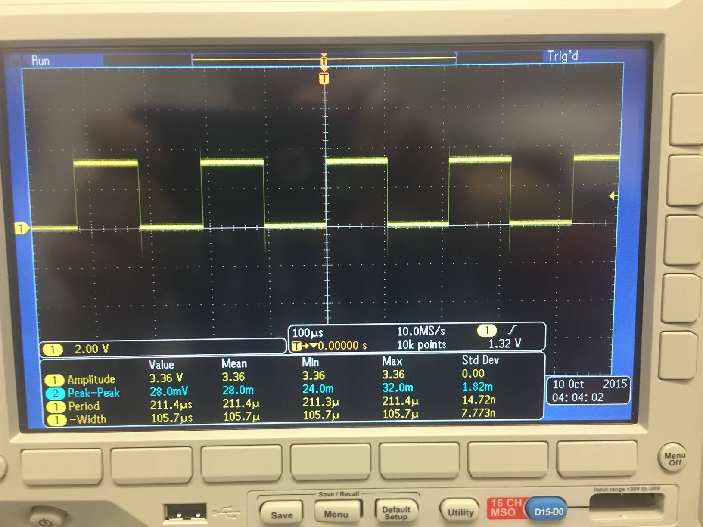

Timer delaying as close as we could get it. Confirms P1-5

Figure 2

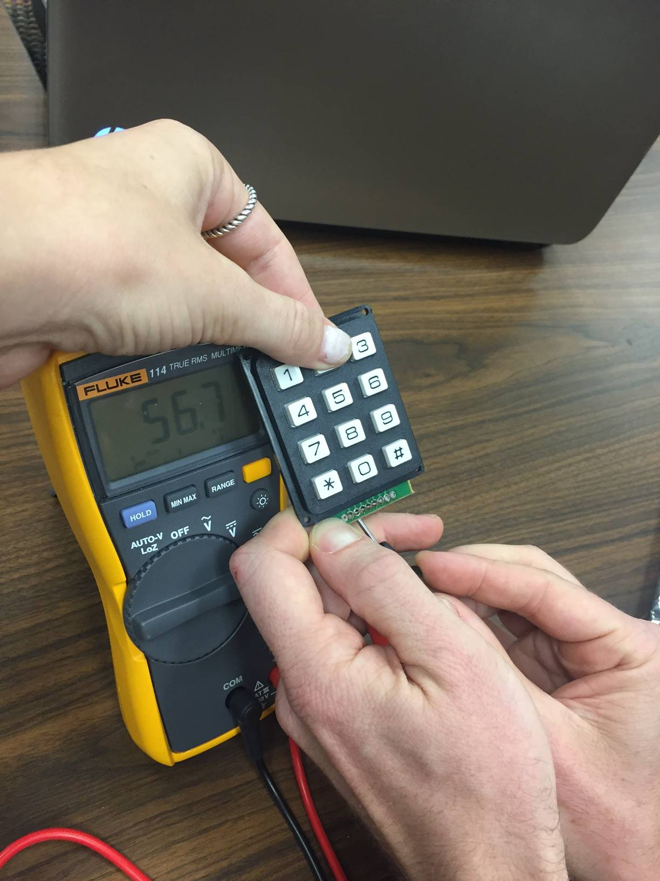

Figure 2 shows P1-1 is verified. By association, P1-3 is verified by verification of P1-1. Multimeter shows low impedance when switches are pressed.

Figure 3a

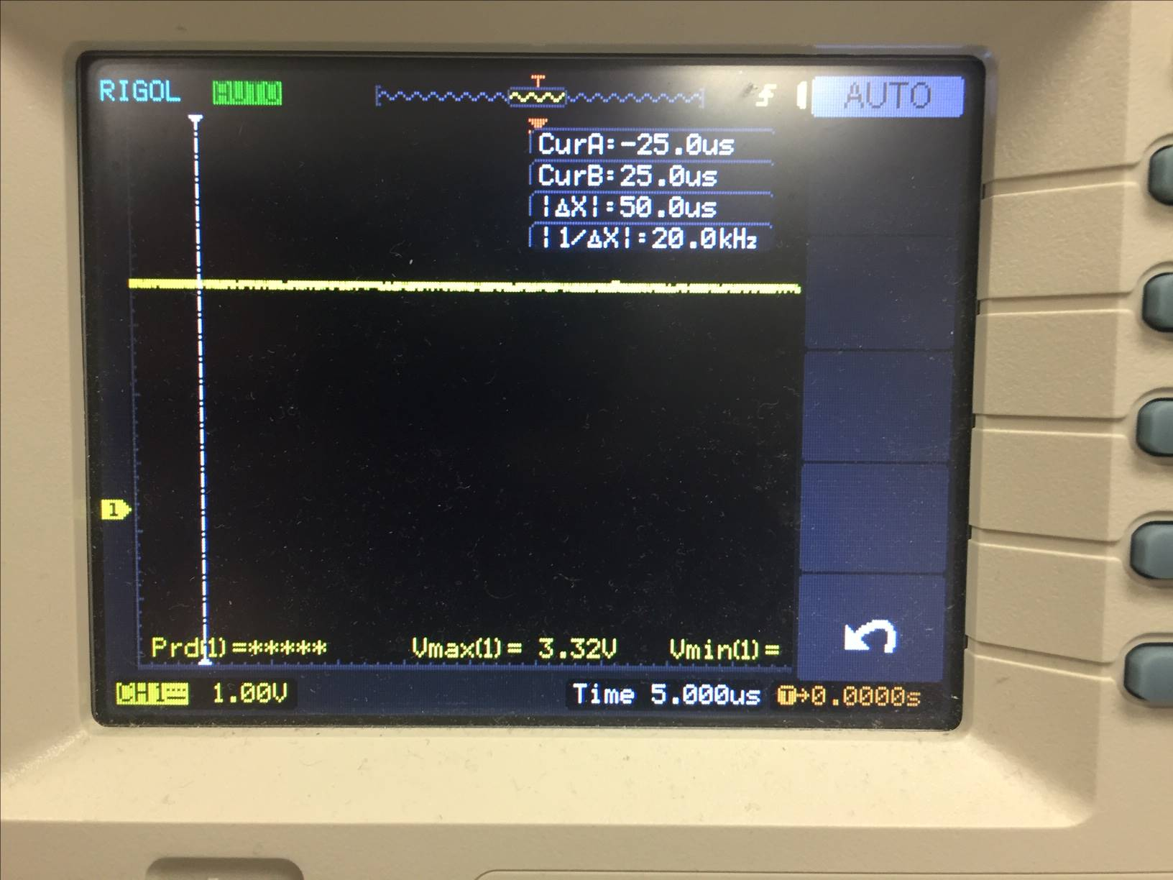

Figure 3b

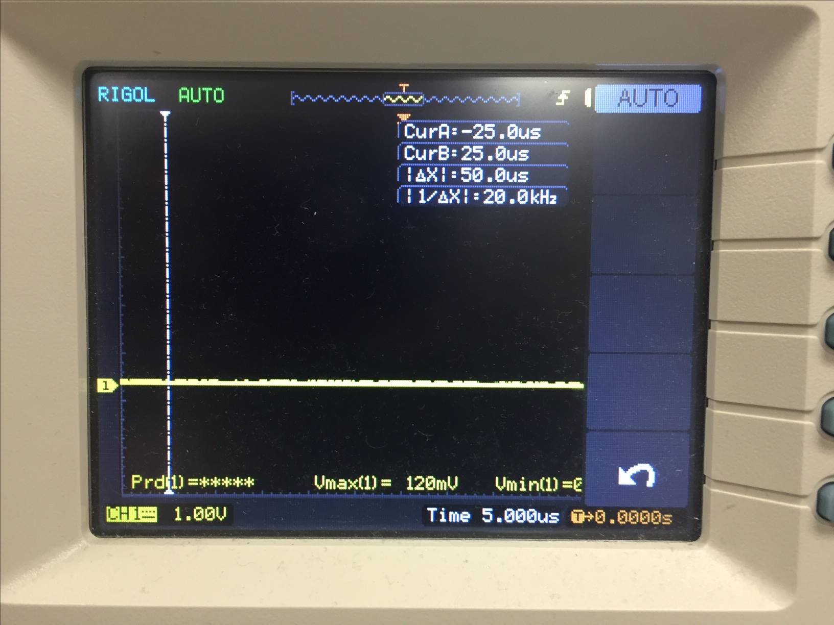

Figures 3a and 3b confirm that that ODC outputs are pulling down inputs when they are shorted (P1-2). The following is code used to test this:

//Tests that ODC output pins will pull down the input pins when shorted

void testKeypad(void){

ROW1 = LOW;

ROW2 = LOW;

ROW3 = LOW;

ROW4 = LOW;

}

Figure 4

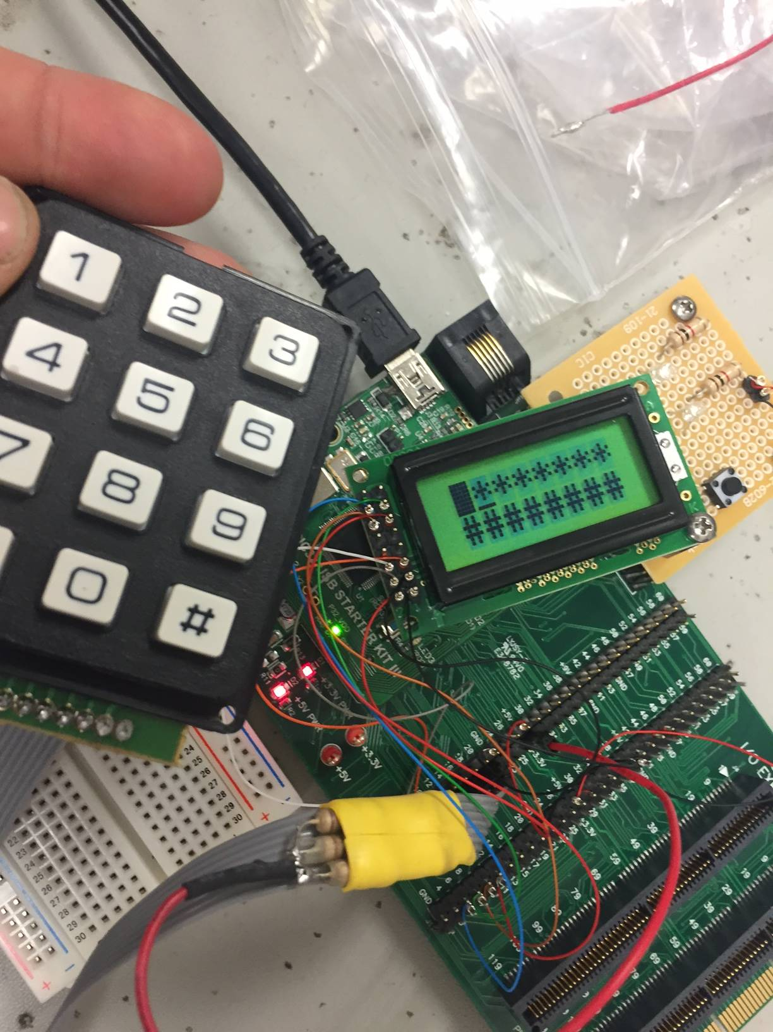

Final connection of LCD and keypad with ribbon cable. Note the heatshrink holding the external pullup resistors. Confirms test P1-6.

Test P2-1:

#ifdef TEST

int flag = 0;

//Precode 2 passwords into password array and test if working

for (i = 0; i < 2; i++) {

for (j = 0; j < wordLen-3; j++) {

if (flag == 0) {

passWord[i][j] = j;

} else {

passWord[i][j] = j + 1;

}

}

flag++;

}

#endif

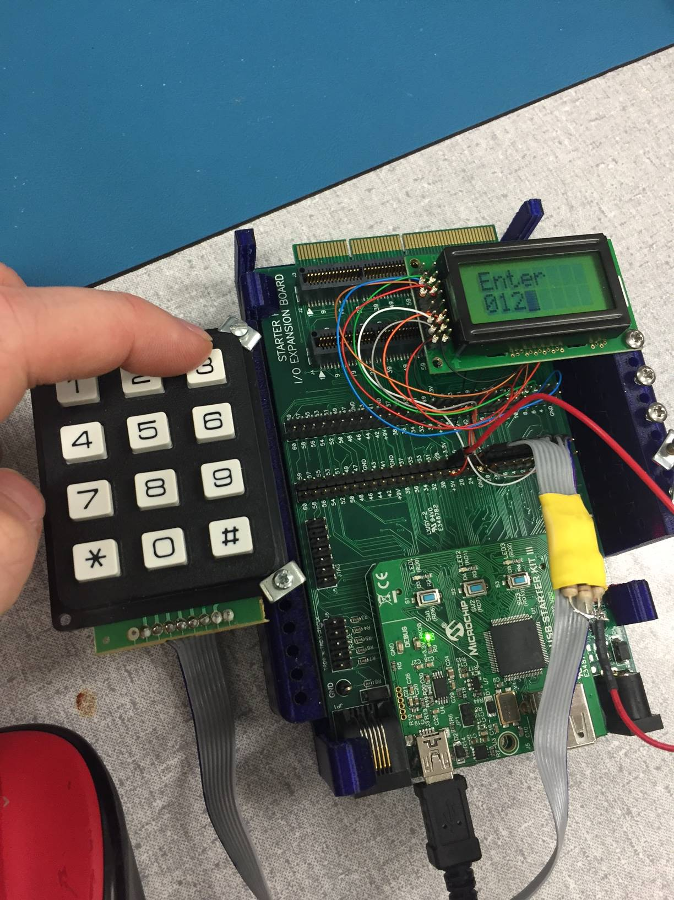

Testing that hardcoded ‘0123’ works

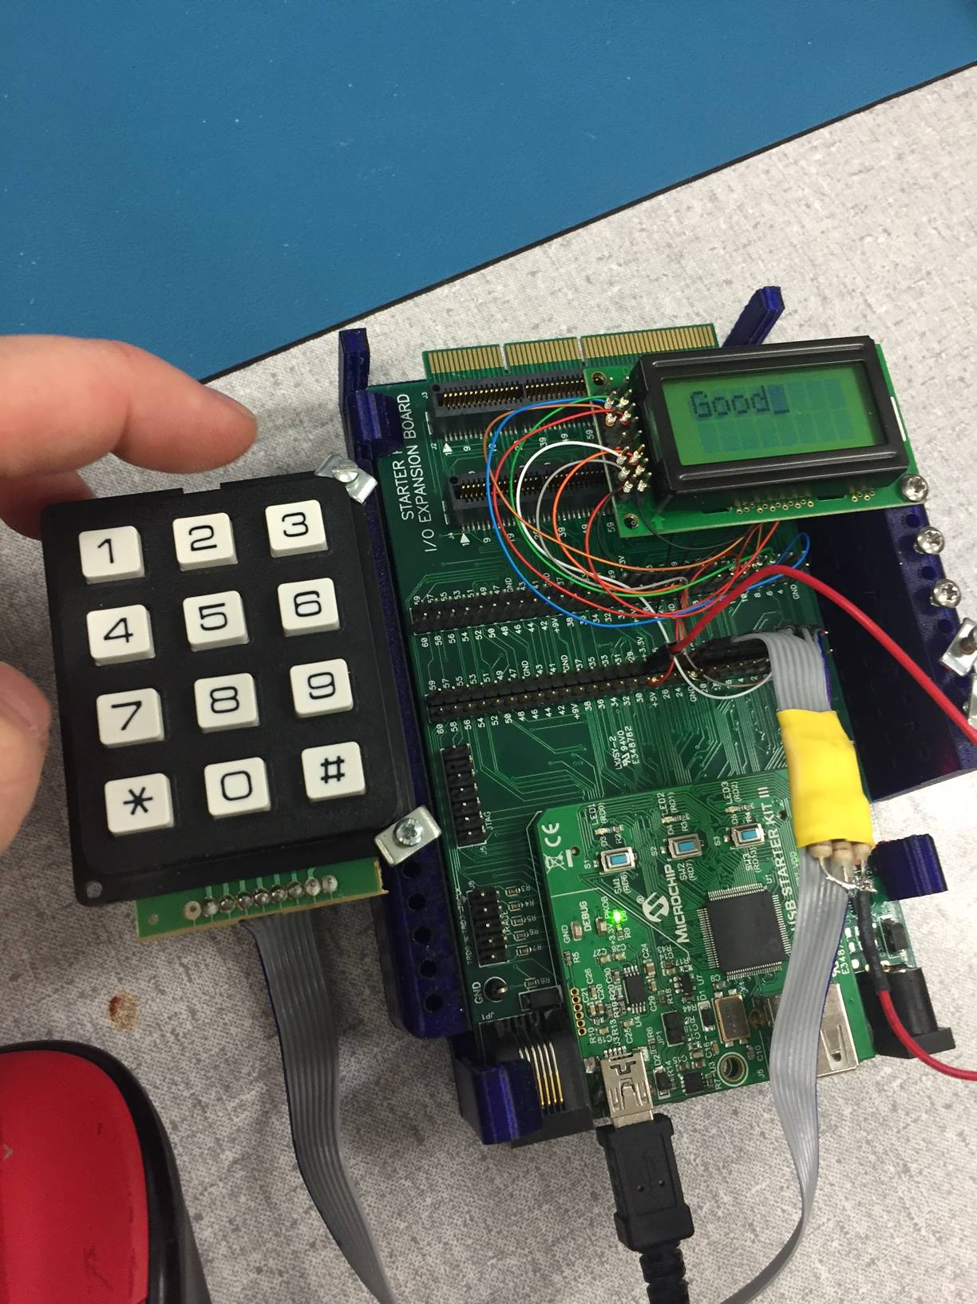

Testing that hardcoded ‘0123’ works. Confirmed

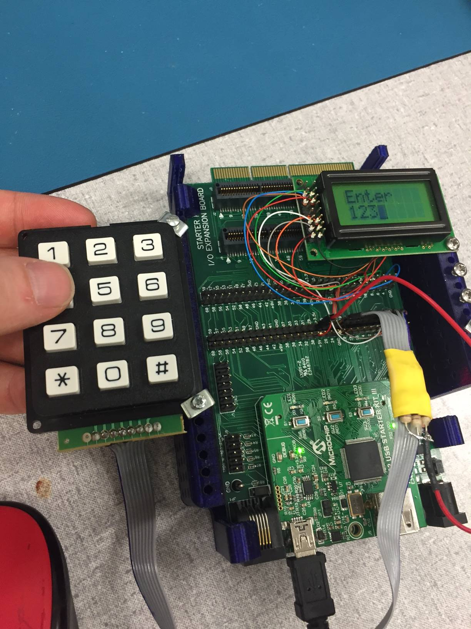

Testing that hardcoded ‘1234’ works

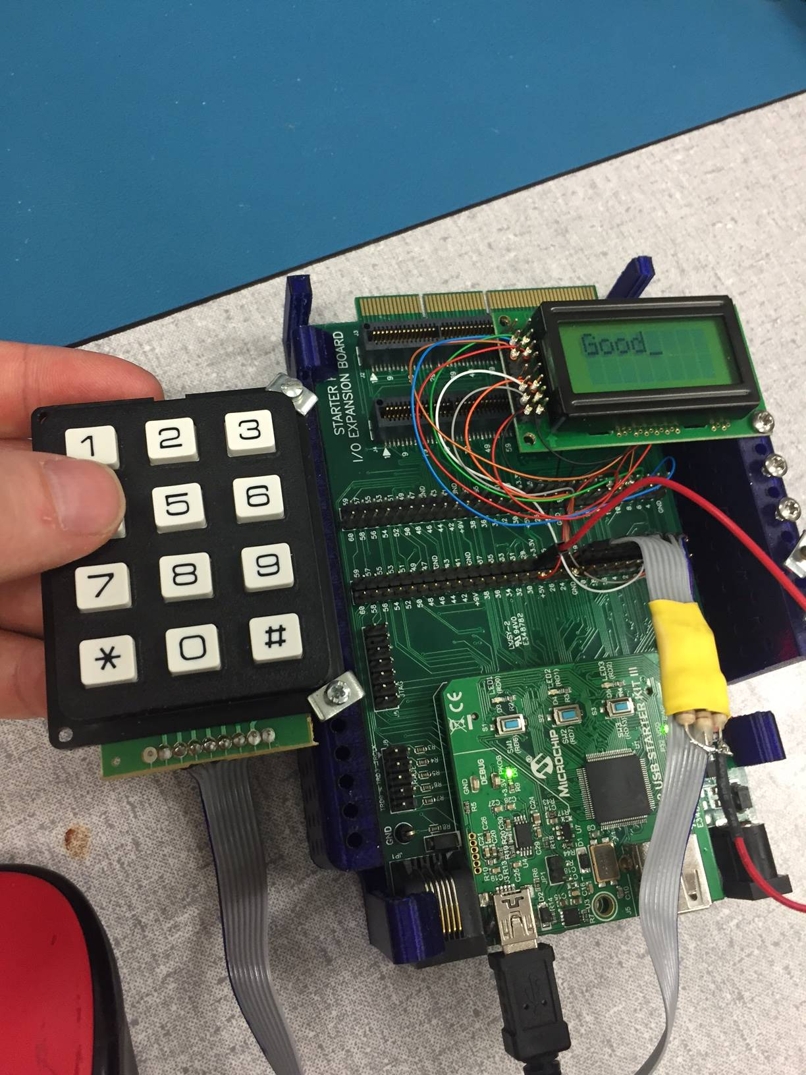

Testing that hardcoded ‘1234’ works.

Test P2-1 works.

The following pictures confirm Part 2 is completely working:

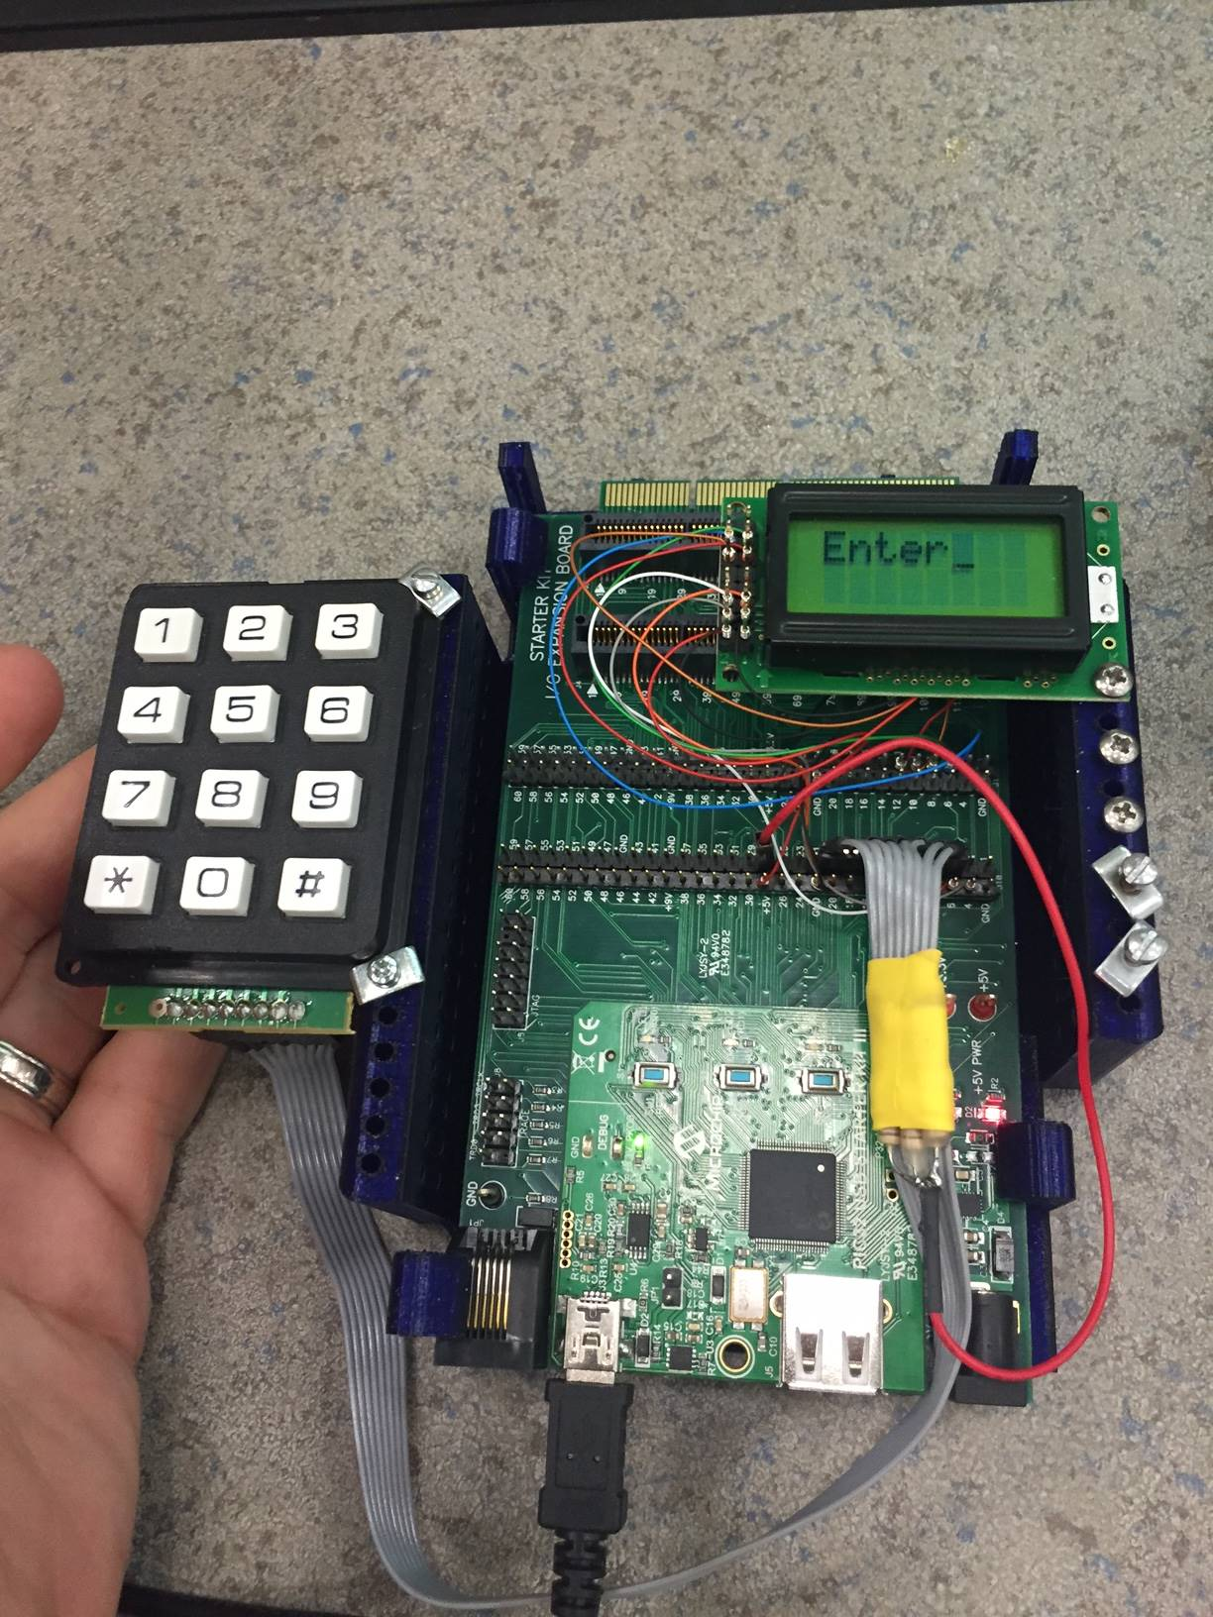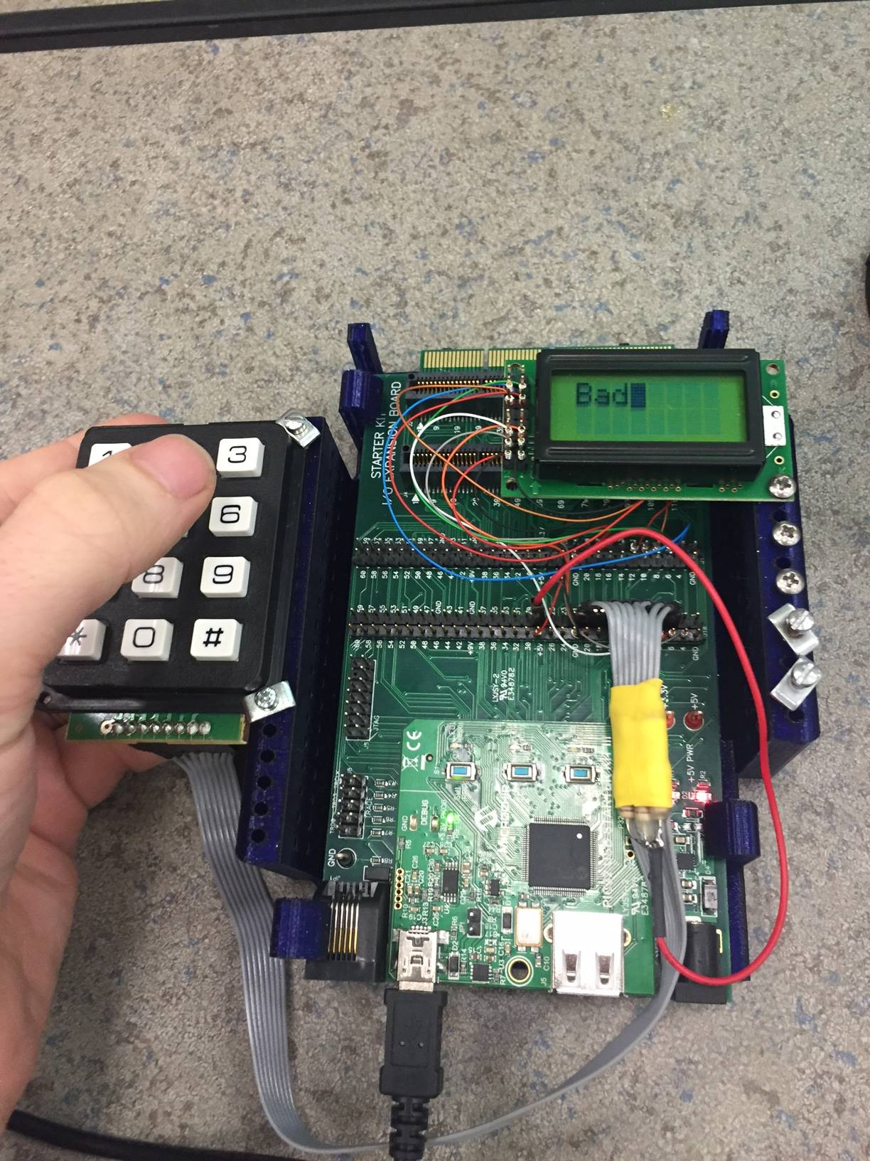

Entering bad password

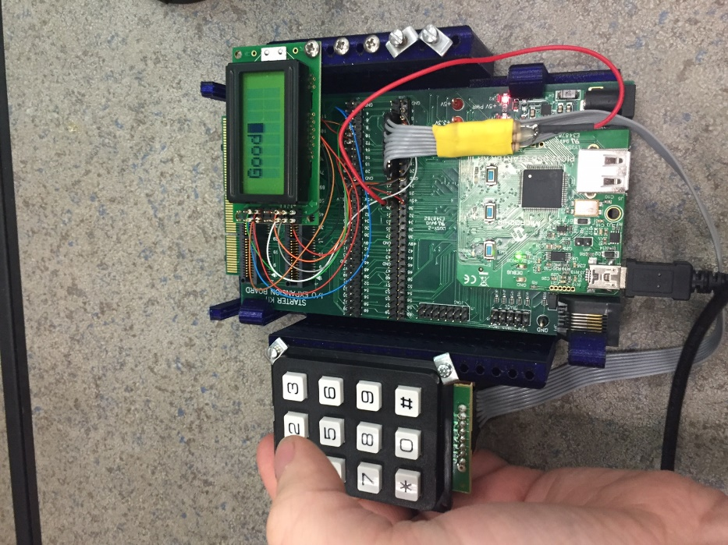

Entering good password

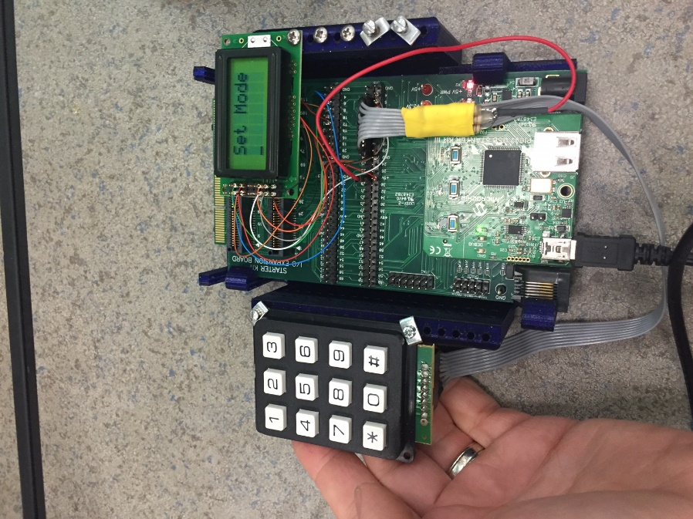

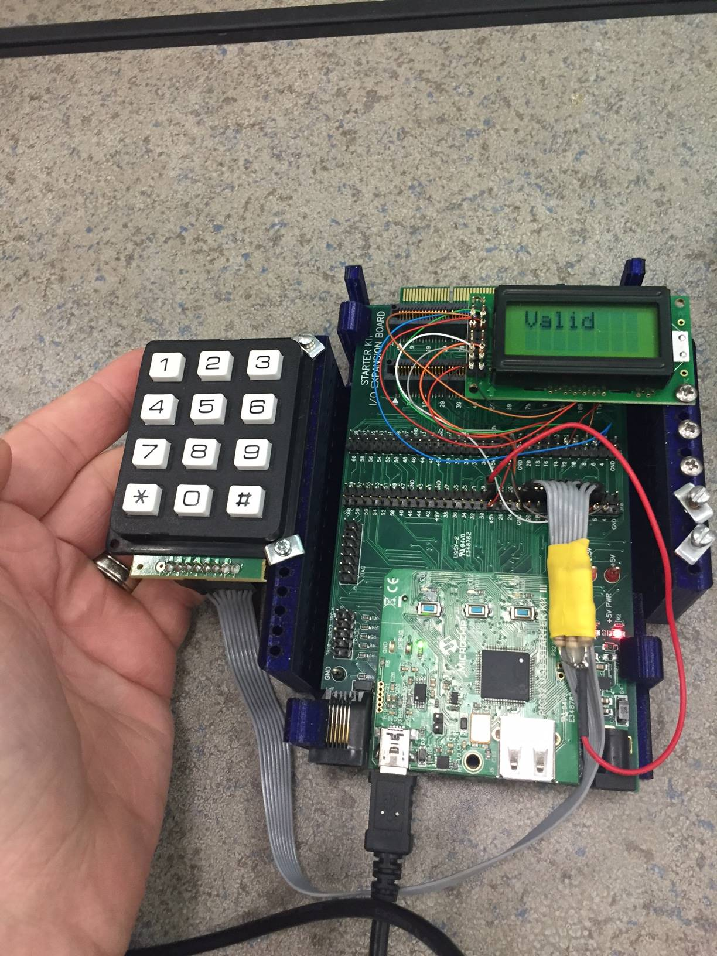

Entering new password in set mode

Working lab confirms test P1-4 works.

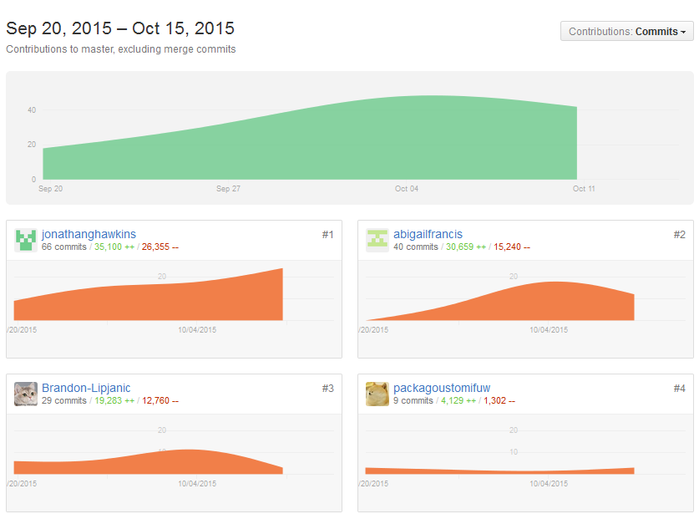

Commit history. THIS IS A LIE. See next plot.

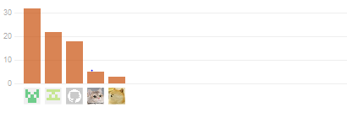

In order from left to right: Jonathan Hawkins, Abigail Francis, Pierce Simpson, Brandon Lipjanic, and Pierce Simpson again. Pierce’s commits were temporarily being done from the wrong email account.