# Lab 3 Report

## Team Information

**Lab number:** 3

**Date:** 10/29/2015

**Team Members:** Abigail Francis, Pierce Simpson, Brandon Lipjanic, Jonathan Hawkins

**Team Number/Name: PB&J (203)** Team Member Responsibilities

**Software Design:** Brandon Lipjanic

**Hardware Design:** Jonathan Hawkins

**Quality Assurance:** Pierce Simpson

**Systems Integrator:** Abigail Francis

**Wiki Creator:** Click here to enter text.

# Hardware

### Part 1

Draw the schematics or create a table detailing the connections for Part 1 of Lab 3. An example is provided.

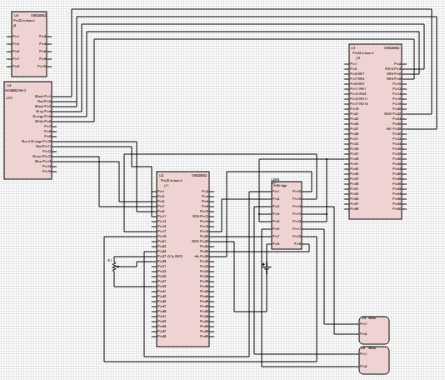

### Part 2

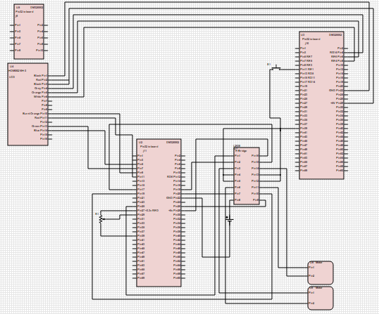

**Include a picture of any cables constructed for this lab.**

# Tests

### Part 1

|  |  |  |  |  |  |  |  |  |
| --- | --- | --- | --- | --- | --- | --- | --- | --- |
| Test # | Test Name | Method | Software req'd | Expansion board row pin | Expansion board col pin | Button | Probe/Keypad pin | Tools req'd |
| P1-1 | Potentiometer functionality | Test the variable resistance of the potentiometer using DMM |  |  |  |  |  | DMM |
|  |  |  |  |  | 2x probes |
| P1-2 | Test H-bridge and motors | Hook up H-bridge Vs to DC power supply. Hook up function generator inputs to H-bridge. Hook up motors to H-bridge. |  |  |  |  |  | DC supply |
|  |  |  |  | Function generator |
|  |  |  |  | 4x alligator clips |
|  |  |  |  | Male to male jumpers |
| P1-3 | Test output-compare modules | Hook oscilloscope up to output compare pins on expansion board and test duty cycle. |  |  |  |  |  |  |
| P1-4 | Check speed control of motors with software function |  | Check all tristate registers, port registers, and latch registers are assigned and working correctly by writing a testbench in software. |  |  |  |  |  |
| P2-1 | Test all connections | Use DMM to test all connections |  |  |  |  |  | DMM |

List the tests and their outcomes that you intend to do based on the Lab 3 procedures. **Also include any pictures, screenshots, or schematics involved with each test.** Describe the name of the test, the tool you intend to use, and a description of the test. Do this for each part in Lab 3.

For the software tests you have created **include code in the D2L submission.** However, your outcomes should be well-documented here. There is not time for your code to be tested once it is turned in. Therefore, make effort to show clearly what kind of test you did and what its outcome was. Take screen shots and include them here if you must.

### Part 2

# Software

### Code

Please include all of your documentation in the submitted code. Please also submit your code with the test code made by Quality Assurance.

### Version Control

Include a screen shot of your commit history.