# Weekly Report

Nathaniel Dusciuc

Week 3

10/12/17

## What I did:

I ordered Hall Effect Sensors.

I started a GitHub repository.

I tested the Hall Effect Sensor by passing a magnet in front of the sensor. The output was sent to an inverting op amp circuit with a gain of 69. I found that the Hall Effect Sensor gives a nice clean DC output whenever the magnet eclipses the sensor’s face.

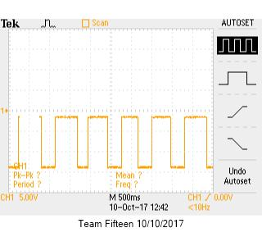

I wanted to see how the sensor would perform at different distances from the magnet. I connected the sensor to a skateboard truck and connecting a neodymium magnet to the skateboard wheel.

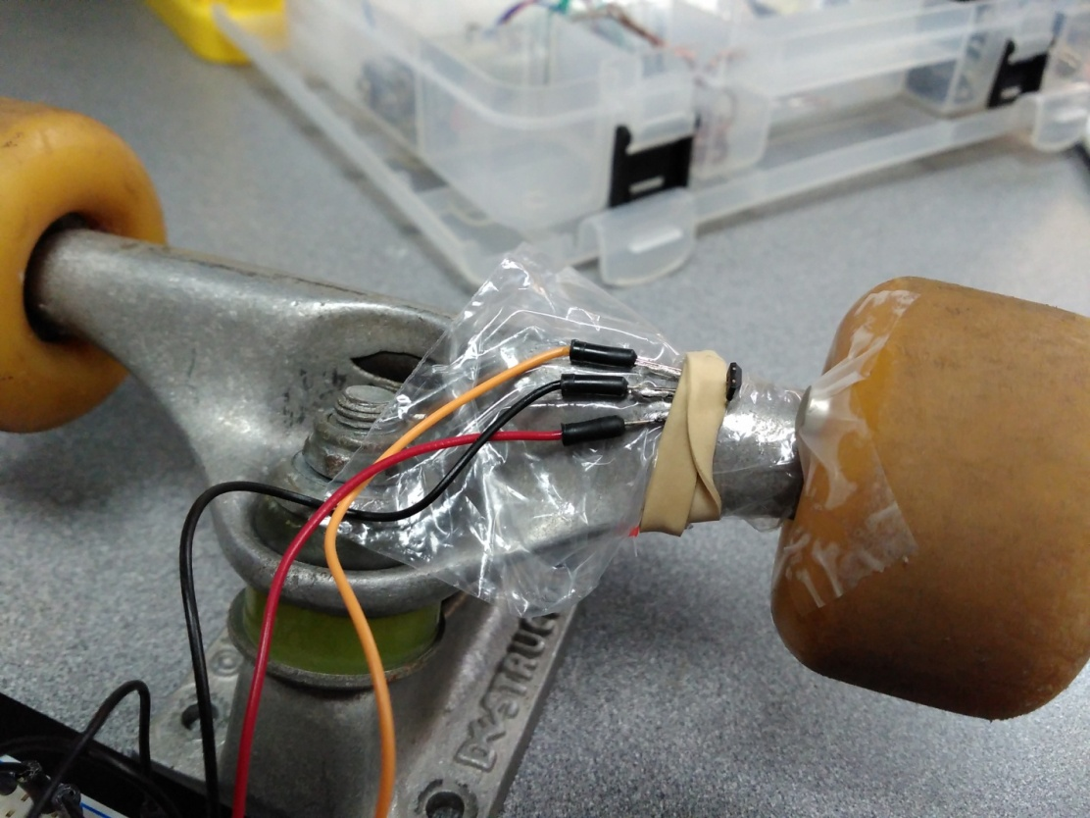

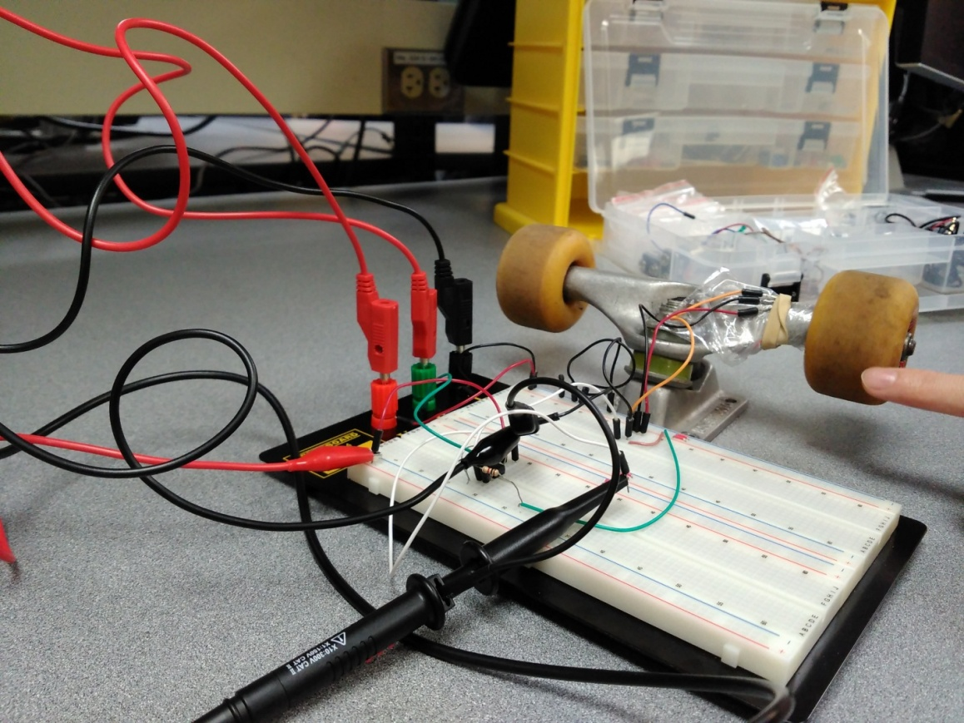

## Problems:

When I spin the wheel fast the output does not pickup each rotation. The output on the oscilloscope only shows a couple of square pulse. The oscilloscope and the op amp should be able to handle up to the MHz range of frequency so the issue must be that the Hall Effect sensor is not reacting fast enough.

## Tasks:

First – Verify that the speed limitation is actually caused by the Hall Effect Sensor.

If yes, then find a faster sensor that will be able to handle up to 150Hz.

Say we have a small wheel with a 6in circumference and we travel at 50mph.

$$\frac{50 mi}{hr}*\frac{5280 ft}{1 mi}*\frac{12in}{1ft}*\frac{1 rotation}{6in}*\frac{1 hr}{3600 sec}=\frac{146.7 rotations}{1 sec}≈150Hz$$

## Update:

After discussing with Mr. Greenberg we found that we needed to connect the Hall Effect Sensor to Vcc with a pull-up resistor. This did not solve our timing issue. We looked closer at the datasheet and found that since the sensor is an ultra-low power device it periodically goes into a sleep state to save power. We suspect this is the reason it is not picking up high frequencies.

Regardless, we tried another sensor, the US5881LUA. It worked perfectly!

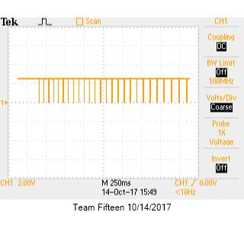

The oscilloscope capture shows every rotation of the wheel even at high speeds. We are confident this sensor will work.