ECE 421
Project 3

Christina Ho
Lindsay Livojevic
Jonathan Ohman

1) What is your definition of an object?
An object is an entity represented by a class, which can contain attributes and methods that the object can perform.

2) What strategies should be deployed in terms of accepting input (i.e. the large number of objects.)?
Input should be constrained to conform to the limitations of iteration, and exit gracefully in event of an error. Certain operating systems have lower thread limits than others, and so that may be a concern as well.

3) Is your sort generic? What sorting criterion does your system use? Is this criterion flexible; i.e. changeable by the user at the point of execution? What limitations have you placed upon legal sorting criteria? To make it reusable to other people, how should we include it into the Ruby Class hierarchy?
The system uses a sorting criterion that can be specified in the used by a passed-in block of code to substitute for the standard comparator methods. The limitations on the sorting criteria follow logically from the nature of the objects to sort, in that the code cannot sort on data not present in the object, and may sort unpredictably if the code is not reflexive and commutative.

4) In reality we have a uniprocessor system, describe “equationally” what is happening to your solution as you increase the concurrency (e.g. produce a regression model (remember regression from Statistics) of processing time against the number of threads. Your solution can be modeled as a program which: (1) has a component which produces threads; and (2) a set of threads which undertake the same (small) task. This is in essence the basis of stress testing (discussed in ECE 322)
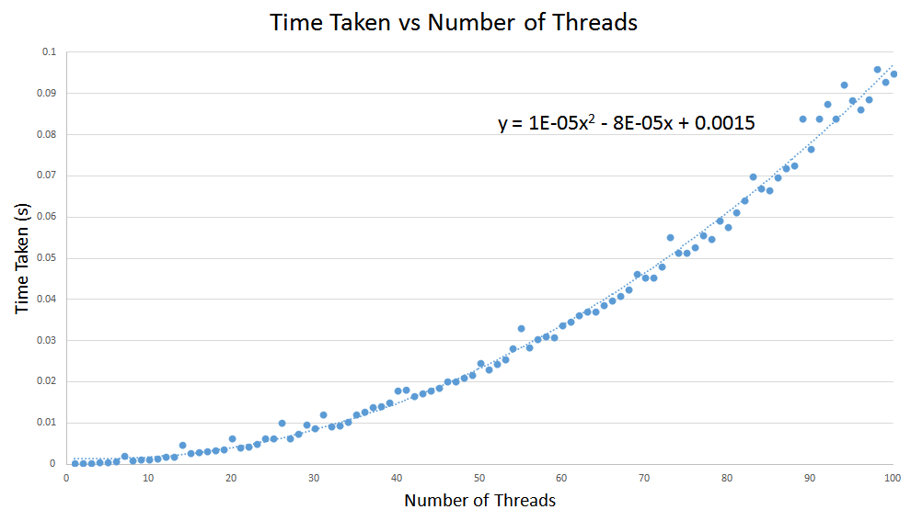
The runtime of the program has a square relationship with the number of threads spawned. This likely owes to the fact that the linear stress of the threads’ identical tasks is compounded by the necessary processing for concurrency scheduling. A constant time is also present, which can be attributed to the thread-producing program.

5) Concurrent systems tend to crash frequently – what approach to exception handling have you devised? Consider the content of the library at:
http://c2.com/cgi/wiki?ExceptionPatterns; which are applicable to this problem? Is Module Errno useful in this problem? What components of the Ruby exception hierarchy are applicable to this problem? Discuss in detail your strategy for exception-handling.
Since Module Errno’s purpose is to map system errors to Ruby exception classes it is unlikely to be too useful to us since there are no system errors that we should explicitly handle.
Our approach to exception handling follows the pattern “LetExceptionsPropogate”. We use begin/ensure blocks to ensure that we clean up after ourselves in the case of exceptions.
Errors of the exception hierarchy that were of specific interest to us really only included the Timeout::Error.

6) What differences exist between thread-based and process-based solutions? How has this impacted the design of your solution?
When one process spawns multiple threads, they share the memory space of the process spawning them, whereas distinct processes have their own copies of all data unless shared memory is explicitly initialized. As such, it has been imperative for our threads to be strictly scheduled when accessing data so that race conditions may be avoided.

7) Do you have any race-condition or task synchronization concerns about your solution? How do we tidy-up a multi-threaded program, if stopped mid-execution?
There were some tasks synchronization concerns. When calling merge, if we passed the 3 arrays as references it is incredibly likely that one thread would rearrange part of the array that another thread might be dependant on. To solve this problem we will examine the algorithm and find the critical points at which we must pass deep copies of the arrays.
Task synchronization is not as large of a concern. We will simply force a thread to wait until it’s dependant tasks are complete using thread.join.
To handle cleaning up the threads in our program we will use a variable that will be passed by reference to all methods that create new threads. In the case that this variable becomes set each method will see this and will stop its execution as soon as possible. This variable will be set when the program is interrupted.

8) As discussed in CMPUT 301: What is configuration management? What is version control? Are you using either concept? If “yes”, describe your process and any tool support what you utilize – illustrate your process with regard to Assignments 1 and 2; if “no”, justify your decision.
Configuration management is only implemented in that the contracts for the code remain relatively constant, but for projects with very short development cycles and relatively straightforward functionalities like this one, version control and more involved configuration management is not as necessary.

9) Briefly Explain:
a. What is refactoring (as discussed in ECE 325 / CMPUT 301)?
Refactoring is the process when code structure is changed to be more readable, efficient, and maintainable, but does not change the functionality or outward behavior.
b. Are you using refactoring in your development process? Justify your answer?
Yes. As development proceeds, certain structural decisions are revealed to be more sensible than others, and when this happens, we make sure to refactor our code to make development more convenient.
c. If “yes”, give examples, minimum of 2, of the refactoring “patterns” that you used in Assignment 1
In one case, we noticed that the per-element matrix operations such as matrix addition and per-element multiplication all operated on the same code structure, and so the methods were implemented by having them call a common “combine” method. Similarly, several matrix types are simply sub-types of others, and so certain matrix initializers were made to call more general initializers rather than having copies of code (for example, unit(n) calling scalar(n,1), since an identity matrix is a scalar matrix of value 1).

