**Requirements Document**

<UT EID>

The objective of this lab is to perform a PCB layout for an embedded system. You are asked to create a PCB layout for an embedded system that implements an analog signal generator.

The user inputs must include:

1. a momentary switch (to change modes)
2. a reset switch
3. a potentiometer (to set frequency and/or amplitude)

The output of the system must include:

1. one analog output (with an op-amp in voltage follower mode)

The debugging features must include:

1. three power test points (battery, 3.3V, and GND)
2. two analog test points (DAC output and signal output)
3. one logic analyzer connector (eight appropriately connected digital signals)
4. one heartbeat LED
5. one power LED

The system will be powered with a single 3.7V 2600mAh battery.

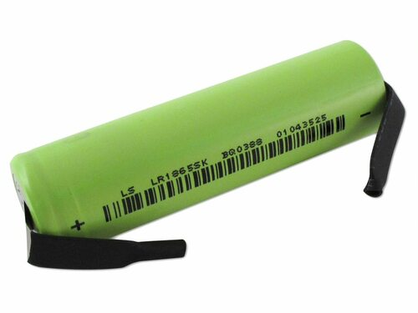

*Figure 6.1: Tenergy Li-on 18650 Cylindrical 3.7V 2600mAh Flat Top Rechargeable Battery.*

*Weight: 46.5±1 g, Height: 65.2mm, Diameter: 18.4mm.*

Requirements for the schematic include:

1. no dangling pins
2. meaningful net names
3. grounds are tied, voltage levels are specified
4. versioning comment (what was changed from base schematic to v0.1.1)
5. passes ERC

Requirements for the PCB include:

1. no ground pour (still should have an understanding of what a ground pour is)
2. component references are visible and positioned well
3. silkscreen text is useful
4. no auto-routing
5. 45-degree angles (miters)
6. all signals are routed and make sense
7. an attempt has been made to separate power, analog, and digital signals
8. board has a board name, designer, date, TA/section, and version number
9. passes DRC



*Figure 6.4: Top and bottom of PCB layout for a TM4C123 system (Lab 6 does not include a ST7735).*

You will deliver two pieces of paper (the top and bottom of your PCB) glued to cardboard and mount it within an enclosure.

Possible enclosures include:

1. Hammond 1593Y
2. PacTec XP
3. Serpec 151

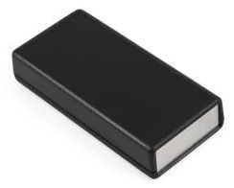

*Figure 6.2: Hammond 1593Y, PacTec XP, and Serpec 151 enclosures*

You will complete a **BOM** (bill of materials) and calculate the cost of manufacturing your embedded system. You will perform power budget estimations. The operator buttons and LEDs will be placed directly on the PCB but positioned so they protrude from the box.

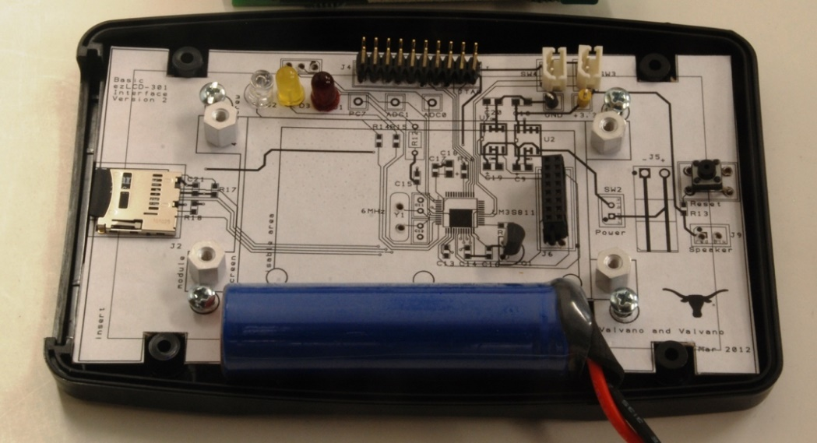

*Figure 6.3: Mockup for an LM3S811 system using a PacTec enclosure*