ECE 445L Lab 8

PCB Layout for an Embedded System

This laboratory assignment accompanies the book, [*Embedded Systems: Real-Time Interfacing to ARM Cortex M Microcontrollers, ISBN-13: 978-1463590154*](https://www.amazon.com/Embedded-Systems-Real-Time-Interfacing-Microcontrollers/dp/1463590156), by Jonathan W. Valvano, copyright © 2021.

# Table of Contents

Table of Contents 1

Team Size 1

Goals 2

Review 2

Starter Files 2

Required Hardware 2

Lab Overview 2

Preparation 2

Procedure 3

TA and Professor Review 6

Lab Checkout 7

Lab Report 7

Deliverables 7

Analysis and Discussion Questions 7

Extra Credit 7

Other Stuff 8

# Team Size

The team size for this lab is **4**.

# Goals

* Layout a PCB design for your embedded system.
* Integrate embedded subsystems together.

# Review

* Data sheets for your microcontroller.
* Data sheets for your hardware components.

# Starter Files

* Starter project:
  + Final project sw and hw template provided in the GH Classroom repo.

# Required Hardware

There is no required hardware for this lab outside of the restrictions for the final competition provided further in the document.

# Lab Overview

In Lab 8, you will finalize the design of your embedded system. Taking the schematic developed from Lab 7, you will convert your electrical design into a PCB design that will be fabricated for your final project submission in Lab 11. Ideally, you and your team will go through multiple cycles of the design process to identify bugs, refine the design, and reduce project risk. However, given the limited time of this class you will only have one pass. One way to reduce your design risk is by performing integration tests that verify that your design will work as expected for the final prototype.

# Preparation

1. At this stage, you should have finalized your system design, a Bill of Materials (BoM), and a schematic that has been demonstrated to work standalone via unit tests. Your schematic in your KiCAD project should pass ERC and have a footprint assigned to every component.
2. Take your finalized schematic and import it into the PCB editor.
3. **Place the components on the PCB** and arrange them such that it meets your teams’ requirements, including:
   1. **Expected board outline:** what is the size and shape of your PCB and how does it mount to your mechanical enclosure and/or systems?
   2. **Expected user inputs:** where is the user expected to interface with any sensors or actuators?
   3. **Design for test:** are the test points or high-risk circuitry easily reachable and debuggable?
   4. **Design for manufacturing:** are the components oriented in positions that make it easy to solder and assemble?
4. **Receive approval** from your TA that your parts placement is satisfactory.

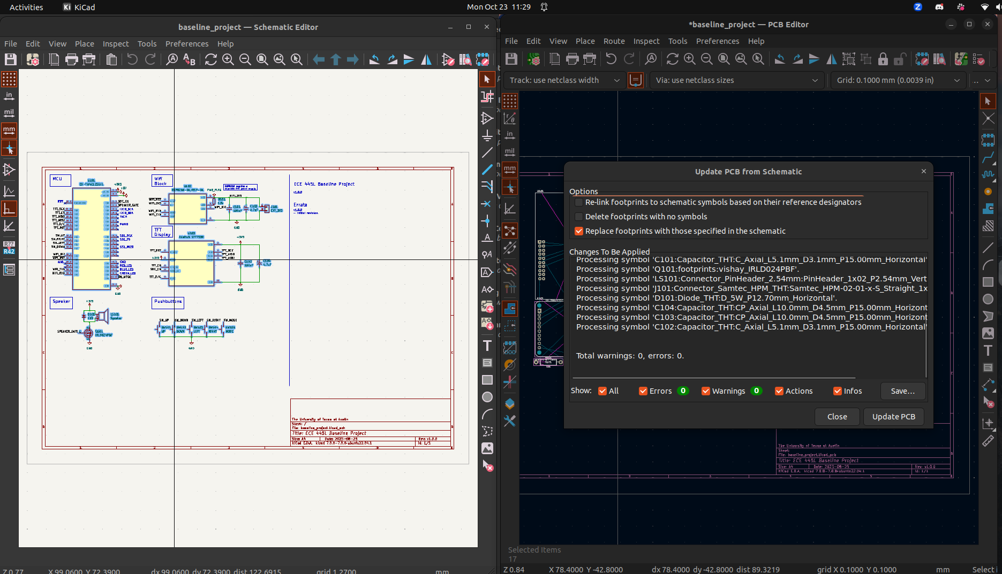

Figure 8.1. Importing Footprints to PCB Editor.

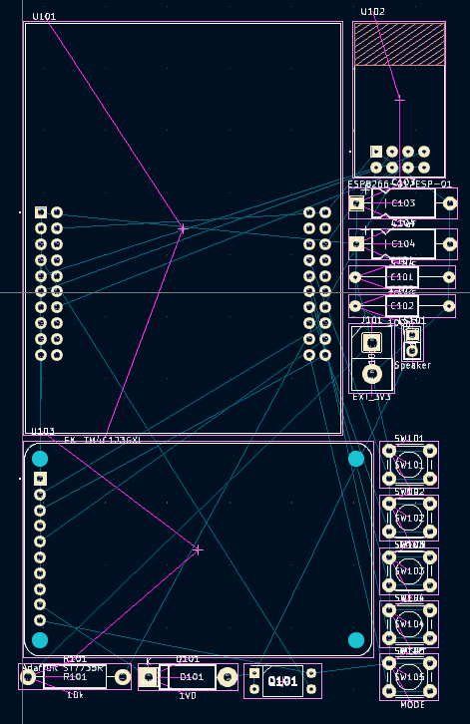

Figure 8.2. Imported Footprints in PCB Editor.

# Procedure

1. **Perform PCB layout** using KiCAD. Make sure that the design passes DRC. Ensure that the following silkscreen is added to the PCB:
   1. Team names, UTX_FALL_2023, TA’s name, project name.
   2. Test point and debug labels.
   3. Assembly labels (e.g. dot for first pin of IC).
2. **Install the JLCPCB Fabrication Toolkit plugin** from the KiCAD project menu and use the plugin in the PCB editor. When generated, it should open a browser window to a folder with the production files.

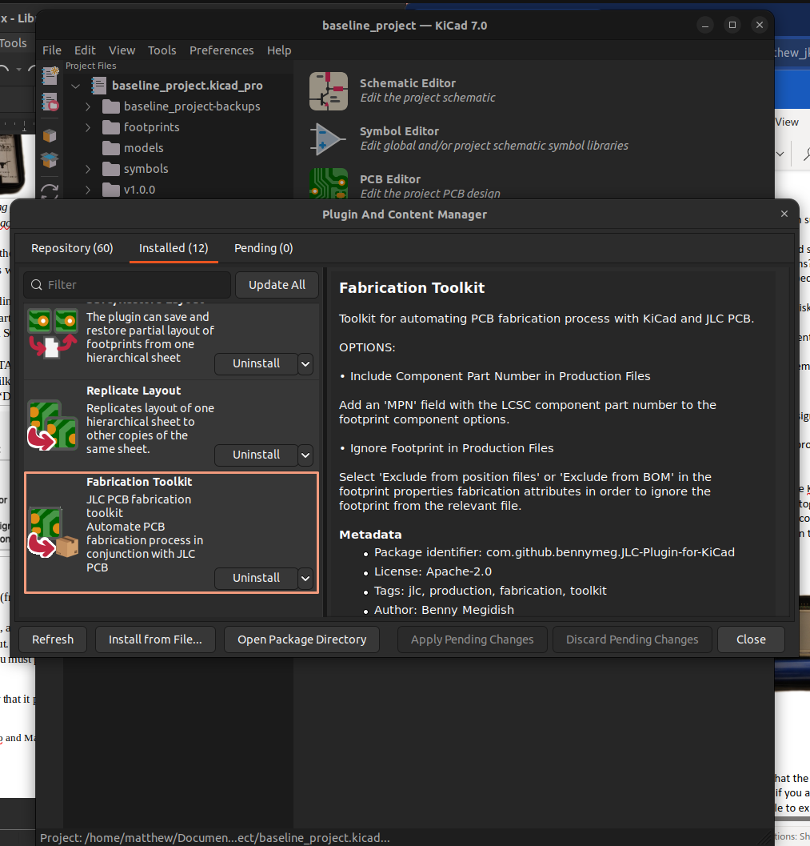

Figure 8.3. JLCPCB Fabrication Toolkit Plugin.

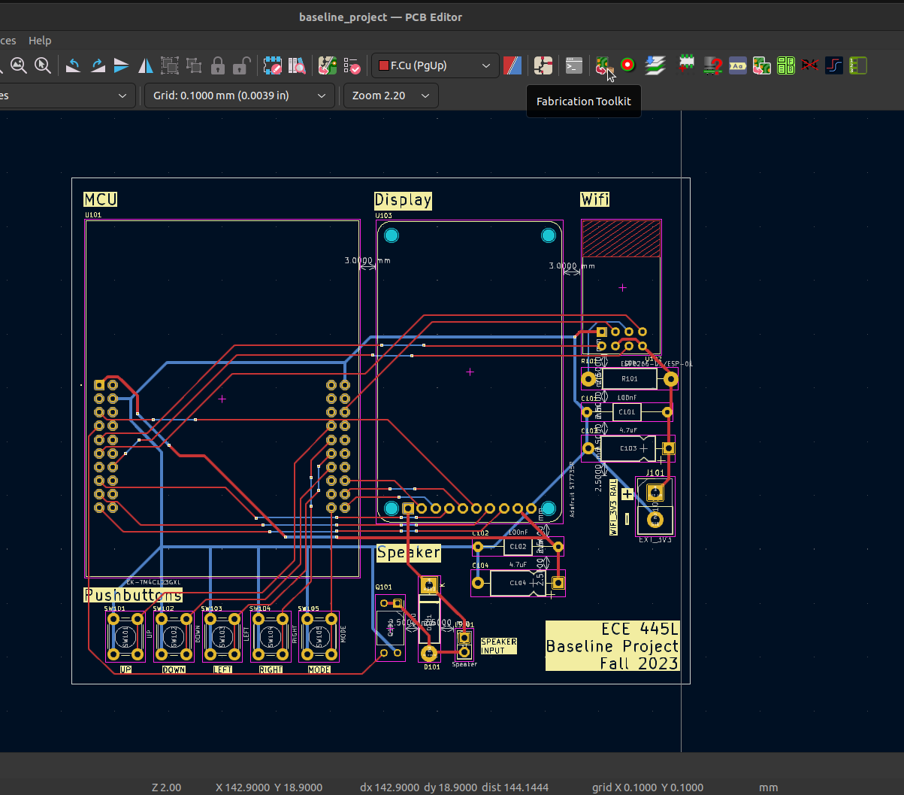

Figure 8.4. JLCPCB Fabrication Toolkit Plugin (PCB Editor).

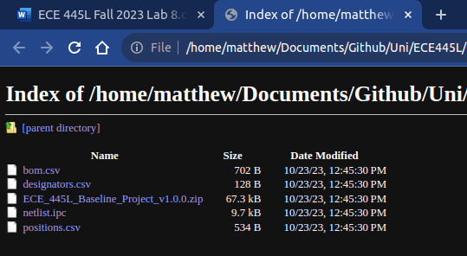

Figure 8.5. JLCPCB Fabrication Outputs.

1. **Go to the JLCPCB site** and provide the zip file when asked to upload gerbers. Verify that the board loads properly in the viewer and the dimensions and costs are not unexpected.

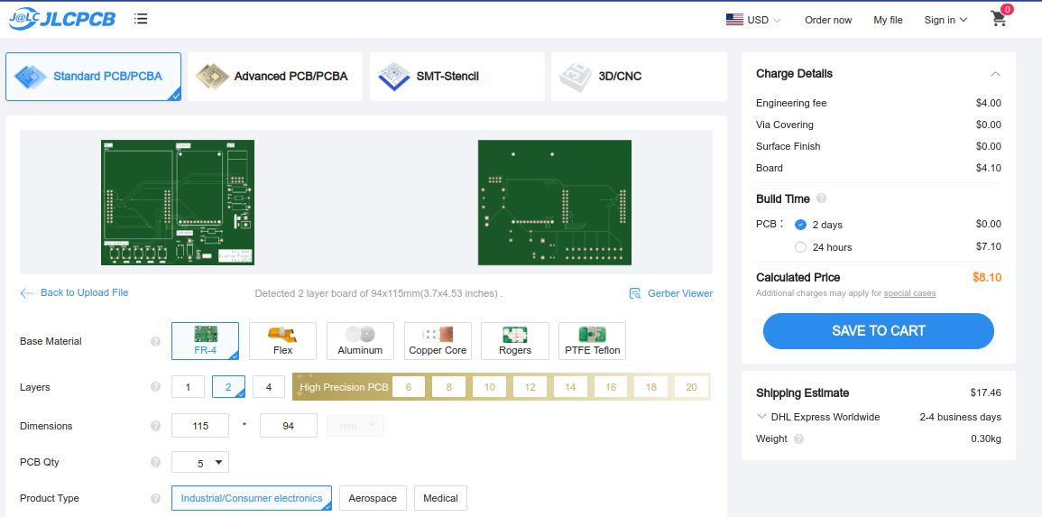

Figure 8.6. JLCPCB Upload.

1. **Print out the PCB** on paper and glue the two pieces together. Punch and drill holes to place components on the simulated “PCB”. Verify that all components fit in the spaces allocated for them. Presumably you have had somebody to design the enclosure by now.

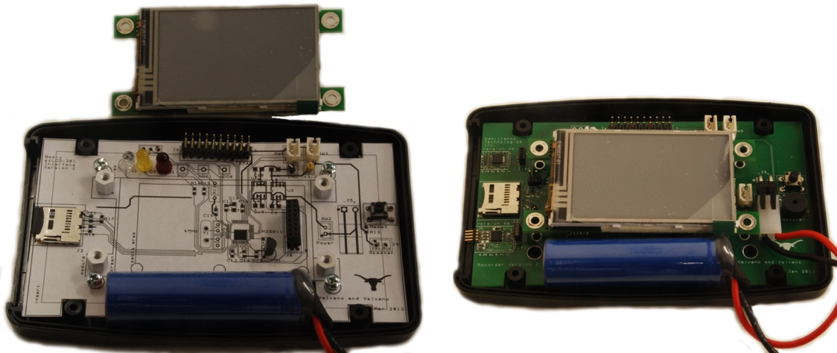

Figure 8.7. Simulated PCB.

1. **Write integration tests** to confirm that your subcircuits work together without breaking functionality. E.g. for Lab 4, a unit test may verify if your UART communication works between TM4C and ESP; an integration test may verify if a button press results in the correct UART message being sent from TM4C to ESP.

# TA and Professor Review

Students shall submit their preliminary PCB schematic and layout to Canvas under a known assignment name by 9 AM, Friday, October 27th for TAs and professors to review for any issues and to provide final feedback no later than Saturday, October 28th. The final PCB schematics and layouts shall be due to Canvas under a known assignment name by 10 AM, Tuesday, October 31st for ordering and submission.

# Lab Checkout

1. Open your project in KiCAD and demonstrate that the layout is complete and passes DRC.
2. Explain how the system will be powered. Even if you are using the TM4C LaunchPad, you still are required to have a regulator. You should be able to explain how the regulator works.
3. Demonstrate that your breadboard circuit of the system is functional and there are no major design flaws that may show up in the PCB.
4. Explain your testing procedure for when the PCB arrives. This needs to be a list of 4 or 5 steps, detailing the bottom-up construction and test procedures. Each step will include hardware to be built, software to be written, debugging tools to be used, and expected results to be collected.
5. Show any connectors, I/O devices, or other devices that will connect to the PCB. Explain how they will be powered and communicate with your system.
6. Show that the simulated PCB has correct sizing of the components and that it fits within the enclosure.

# Lab Report

## Deliverables

1. Objectives (final requirements document)
2. Hardware Design
   1. KiCAD schematic and pcb (leave in Github Classroom).
3. Software Design
   1. System design diagram of the modules created
   2. Unit and integration tests written (leave in Github Classroom under a sw/tests folder).
4. Measurement Data
   1. Deliverable 1: Total cost of system, parts + pcb.

## Analysis and Discussion Questions

No discussion and analysis questions are required for this report.

# Extra Credit

You may receive up to 25% extra credit for Labs 7, 8, and 11. This may be performed at any point during the labs to receive the credit.

1. (5 points) Have at least 1 member of your team complete 3-D printing or laser cutting training in the Texas Invention Works. There are sign-up sheets for training on the 0 floor of the Texas Invention Works.

2. (10 points) Use a TM4C123 chip in your design in addition to the launchpad. You will need to add the component to the PCB yourself (symbol, footprint, model), and will need to ensure that it is Launchpad redundant (e.g. if the chip fails, the LaunchPad can be plugged in and used).

3. (10 points) Validate at least two performance metrics of your system from the following list:

◦ CPU utilization (thread profile) measured separately for each module.

◦ Ping latency with Wi-Fi

◦ Maximum execution time for ISRs

◦ DAC or ADC sampling jitter

◦ Signal to noise ratio (SNR)

You must also provide a short write up (~1 paragraph, 1-2 sentences ea.) for each of the metrics validated describing:

◦ How you performed this measurement,

◦ Does the measurements meet your system’s requirements,

◦ And what sources of errors may affect your measurement.

# Other Stuff

If you want to learn much more about PCB design (details beyond what is needed for ECE445L, but awesome if you wish to create PCBs professionally), Matthew Yu created two playlists with many hours of educational material.

<https://www.youtube.com/playlist?list=PLqUBXn7oPxmxXZYo1X_91ucJfMEAJdrzt> (PCB Design)

<https://www.youtube.com/playlist?list=PLqUBXn7oPxmzVwcAnNQxI12CLg_SvGdOF> (PCB Backlog)