ECE 445L Lab 5

12-bit DAC, SPI, Music player, audio amplifier

This laboratory assignment accompanies the book, [*Embedded Systems: Real-Time Interfacing to ARM Cortex M Microcontrollers, ISBN-13: 978-1463590154*](https://www.amazon.com/Embedded-Systems-Real-Time-Interfacing-Microcontrollers/dp/1463590156), by Jonathan W. Valvano, copyright © 2021.

# Table of Contents

Table of Contents 1

Team Size 1

Goals 2

Review 2

Starter Files 2

Required Hardware 2

Lab Overview 3

Requirements Document 7

Preparation 10

Procedure 11

Deliverable 1 12

Deliverable 2 12

Deliverable 3 12

Deliverable 4 12

Deliverable 5 12

Deliverable 6 13

Lab Checkout 13

Lab Report 13

Deliverables 13

Analysis and Discussion Questions 14

Extra Credit 14

# Team Size

The team size for this lab is **2**.

# Goals

* Understand Digital to Analog Converters (DACs) and voltage references,
* Create a simple SPI/SSI interface,
* Design data structures to represent music,
* Develop systems to play sounds.

# Review

* Search <http://www.ti.com/> for a data sheet on the TLV5618CP 12-bit DAC,
* Valvano Section 6.2 on periodic interrupts using the timer,
* Valvano Section 7.5 on SSI interfacing,
* Valvano Section 8.4 on DAC parameters and waveform generation.

# Starter Files

* Example projects:
  + PeriodicTimer0AInts_xxx project,
  + Max5353_xxx Excel files starting with *dac_*.
* Starter project:
  + Lab 5 template provided on the GH Classroom repo.
  + LM4041 voltage reference design XLSX in resources folder.

# Required Hardware

|  |  |  |  |
| --- | --- | --- | --- |
| Parts | Datasheet | Price | Source (**price source)** |
| EK-TM4C123GXL | [EK-TM4C123GXL datasheet](https://github.com/ECE445L/ECE445L-Lab5/blob/main/resources/TM4C_Datasheet.pdf) | $16.99 | **TI** |
| 8Ω or 32Ω speaker | N/A | N/A | EER Checkout Desk |
| Resistors and capacitors | N/A | N/A | EER Checkout Desk |
| Switches | N/A | N/A | EER Checkout Desk |
| TLV5616CP 12-bit DAC | [TLV5616 datasheet](https://github.com/ECE445L/ECE445L-Lab5/blob/main/resources/part_datasheets/tlv5616.pdf) | $9.61 | EER Checkout Desk  Or **Mouser**, Digikey |
| LM4041CILPR shunt diode | [LM4041C datasheet](https://github.com/ECE445L/ECE445L-Lab5/blob/main/resources/part_datasheets/lm4041c.pdf) | $0.78 | EER Checkout Desk  Or **Mouser**, Digikey |
| TPA731D audio amp | [TPA731 datasheet](https://github.com/ECE445L/ECE445L-Lab5/blob/main/resources/part_datasheets/lm4041c.pdf) | $2.54 | EER Checkout Desk  Or **Mouser**, Digikey |
| MC34119 (discontinued) | [MC34119 datasheet](https://github.com/ECE445L/ECE445L-Lab5/blob/main/resources/part_datasheets/mc34119.pdf) | N/A | EER Checkout Desk |

# Lab Overview

Most digital music devices rely on high-speed digital to analog converters (DACs) to create the analog waveforms required to produce high-quality sound. You will interface a 12-bit DAC and use it to create a sine-wave output. You will interface a TI TLV5616 12-bit DAC to an SSI port. Please refer to the DAC data sheets for the SPI synchronous serial protocol. During testing, the output of the DAC will be connected to a voltmeter, an oscilloscope, or a spectrum analyzer. You are allowed to use any DAC chip you want, if it runs on a single +3.3V supply and has an SSI interface.

Many DACs, such as the TLV5616, require a reference voltage. A stable 1.50V reference can be created using a reference chip such as the LM4041C. The LM4041CILPR is an adjustable shunt reference that can be powered from the +3.3V supply and requires three external resistors to create the 1.50V reference. Look up in the TLV5616 data sheet to find how much current the DAC needs on its REF input. In the data sheet you will find the input impedance Rin of the REF pin, you can calculate this load current IL = 1.5V / Rin. Next, look up page 8 of the LM4041CILPR data sheet to find IZ (80 µA) and VREF (1.233V). Current through R1+R2 will be IREF =VREF/(R1+R2). Select R1 and R2 to set the reference output.

VZ = VREF (1 + R2 / R1) = 1.50V

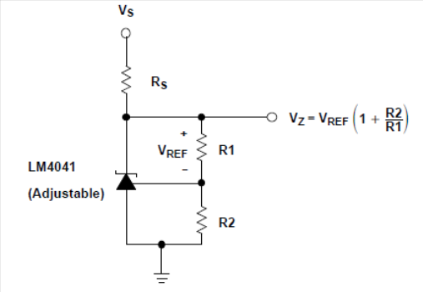

Figure 5.1. Shunt voltage reference

The RS resistor in Figure 5.1 (Figure 14-3 of the [datasheet](https://github.com/ECE445L/ECE445L-Lab5/blob/857eec15afeb5871c7a20e70286310ff80c41f41/resources/part_datasheets/lm4041c.pdf)) sets the available current for the shunt reference. Make RS ≤ (3.3 - VZ) / (IL + IREF + IZ). The TLV5616 has no digital data output, and the data sheet shows which pins to use for an SPI interface. Decide which TM4C123 pins you will connect to DIN, SCLK, and CS bar (active low) of the TLV5616.

There is an excel sheet in the resources folder of the repo that you may use to help with the design process.

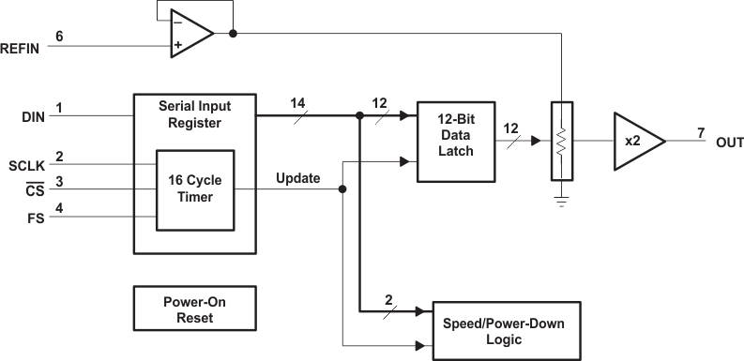

Figure 5.2. Block diagram of the DAC interface for the TLB5616. See the [datasheet](https://github.com/ECE445L/ECE445L-Lab5/blob/857eec15afeb5871c7a20e70286310ff80c41f41) to find which pins connect to DIN, SCLK, and CS bar.

You will use an audio amplifier to convert the DAC analog output to the two pins of the speaker, as shown in Figure 5.3. It doesn’t matter what range the DAC is, if there is an approximately linear relationship between the digital data and the speaker current. To do this you will have to run the amplifier in its linear range. The performance score of this lab is not based on loudness, but sound quality. The quality of the music will depend on both hardware and software factors. The precision of the DAC, the linearity of the audio amp, the frequency response of the audio amp and the dynamic range of the speaker are some of the hardware factors. Software factors include the DAC output rate and the complexity of the stored music data. Consider using either the TPA731 or MC34119 when designing the audio amp, choosing RF and RI so the gain is one or less than one (gain = 2 * RF / RI). Select a ceramic capacitor for CI with a range of 0.1 to 0.47 µF. CB should be tantalum with a range of 1 to 4.7 µF. CS should be ceramic with a range of 0.1 to 0.47 µF. You can power the MC34119 or TPA731 with either +3.3V or +5V, however a +5V supply will have better performance and louder sound. NOTE: You will need to determine what to do with the shutdown signal.

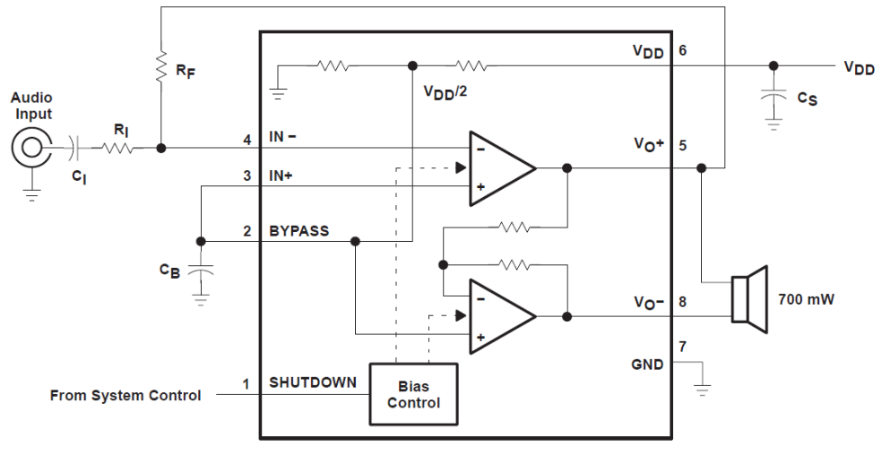

Figure 5.3a. The TPA731 is one way to convert DAC voltage into speaker current (ground SHUTDOWN).

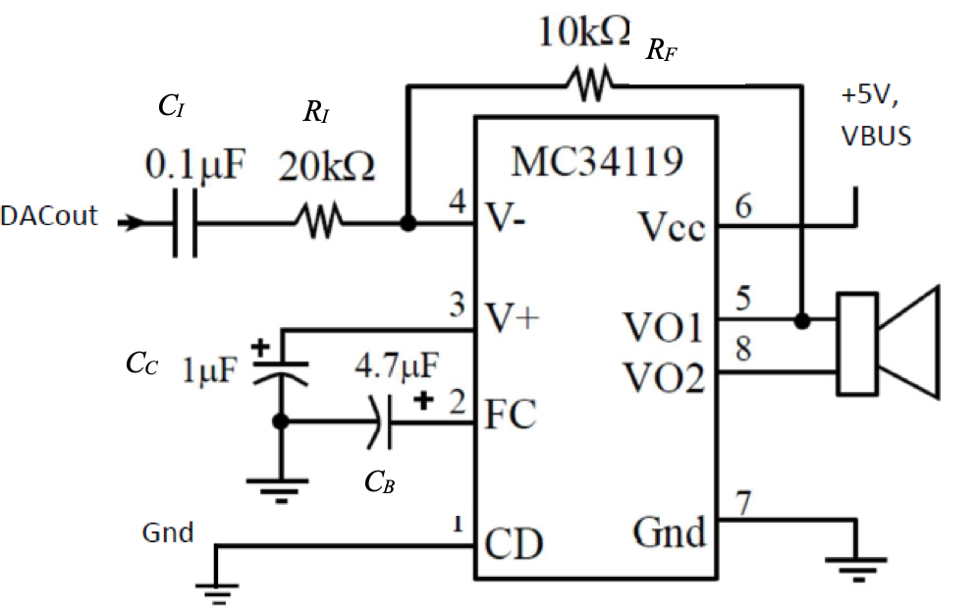

Figure 5.3b. The MC34119 is another way to convert DAC voltage into speaker current (ground CD).

The SSI module must be written at a low level, like the book.

If you output a sequence of numbers to the DAC that form a sine-wave, then you will hear a continuous tone on the speaker, as shown in Figure 5.4. The loudness of the tone is determined by the amplitude of the wave. The pitch is defined as the frequency of the wave. Table 5.1 contains frequency values for the notes in one octave. The frequency of each note can be calculated by multiplying the previous frequency by $\sqrt[12](https://github.com/ECE445L/ECE445L-Lab5/blob/857eec15afeb5871c7a20e70286310ff80c41f41/2)$. You can use this method to determine the frequencies of additional notes above and below the ones in Table 5.1. There are twelve notes in an octave, therefore moving up one octave doubles the frequency.

|  |  |
| --- | --- |
| Note | Frequency |
| C | 523Hz |
| B | 494Hz |
| B♭ | 466Hz |
| A | 440Hz |
| A♭ | 415Hz |
| G | 392Hz |
| G♭ | 370Hz |
| F | 349Hz |
| E | 330Hz |
| E♭ | 311Hz |
| D | 294Hz |
| D♭ | 277Hz |

Table 5.1. Fundamental frequencies of standard musical notes. The frequency for A is exact.

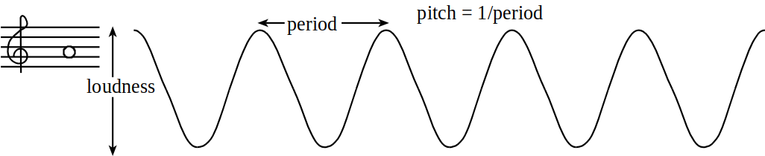

Figure 5.4. A sine-wave generates a pure tone.

Figure 5.5 illustrates the concept of timbre. You can define the type of sound by the shape of the voltage versus time waveform. Brass instruments have a very large first harmonic frequency.

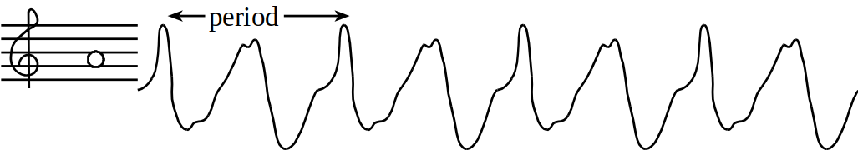

Figure 5.5. Timbre of a A node.

The tempo of the music defines the speed of the song. In 2/4, 3/4, or 4/4 music, a beat is defined as a quarter note. A moderate tempo is 120 beats/min, which means a quarter-note has a duration of 1/2 second. A sequence of notes should be separated by pauses (silences) so that each note is heard separately. The envelope of the note defines the amplitude of the note over time. A very simple envelope is illustrated in Figure 5.6.

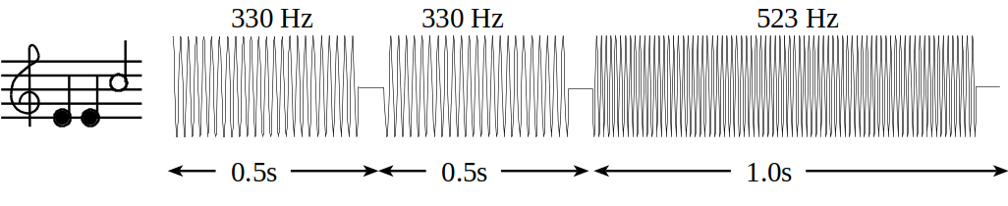

Figure 5.6. You can control the amplitude, frequency and duration of each note (not drawn to scale).

The smooth-shaped envelope, as illustrated in Figure 5.7, causes a less staccato and more melodic sound. The ARM Cortex M4 has plenty of processing power to create these types of waves.

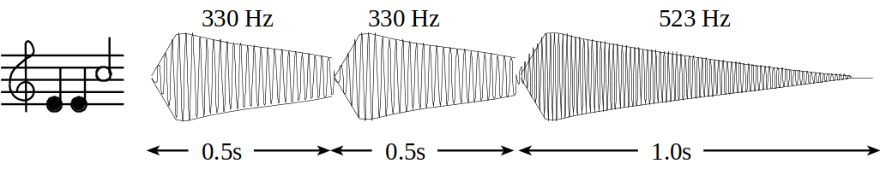

Figure 5.7. The amplitude of a plucked string drops exponentially in time.

A chord is created by playing multiple notes simultaneously. When two piano keys are struck simultaneously both notes are created, and the sounds are mixed arithmetically. You can create the same effect by adding two waves together in software, before sending the wave to the DAC. You can produce this effect by using two interrupts and adding two waves together in software. Figure 5.8 plots the mathematical addition of a 262Hz (low C) and a 392Hz sine wave (G), creating a simple chord.

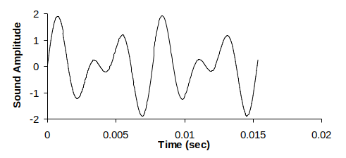

Figure 5.8. A simple chord mixing the notes C and G.

## Requirements Document

As always, feel free to adjust the syntax and format of your requirements document as you think appropriate. The goal of the document is to provide a clear an unambiguous description of what the project does. A copy or a template of this document is provided in the github classroom repository.

1. Overview

1.1. Objectives: Why are we doing this project? What is the purpose?

The objectives of this project are to design, build and test a music player. Educationally, students are learning how to interface a DAC, how to design a speaker amplifier, how to store digital music in ROM, and how to perform DAC output in the background. Your goal is to play your favorite song.

1.2. Process: How will the project be developed?

The project will be developed using the TM4C123 board. There will be two or three switches that the operator will use to control the music player. The system will be built on a solderless breadboard and run on the usual USB power. The system may use the on board switches or off-board switches. A hardware/software interface will be designed that allows software to control the player. There will be at least three hardware/software modules: switch input, DAC output, and the music player. The process will be to design and test each module independently from the other modules. After each module is tested, the system will be built and tested.

1.3. Roles and Responsibilities: Who will do what? Who are the clients?

EE445L students are the engineers and the TA is the client. Students are expected to make minor modifications to this document in order to clarify exactly what they plan to build. Students are allowed to divide responsibilities of the project however they wish, but, at the time of demonstration, both students are expected to understand all aspects of the design.

1.4. Interactions with Existing Systems: How will it fit in?

The system will use the TM4C123 board, a solderless breadboard, and the speaker as shown in Figure 5.1. It will be powered using the USB cable. You may use a +5V power from the lab bench, but please do not power the TPA731/MC34119 or the speaker with a voltage above +5V.

1.5. Terminology: Define terms used in the document.

Definitions for the terms SSI, linearity, frequency response, loudness, pitch, instrument, tempo, envelope, melody and harmony can be found in the textbook. (Note to students: add any addition terms you feel are needed)

1.6. Security: How will intellectual property be managed?

The system may include software from TivaWare and from the book. No software written for this project may be transmitted, viewed, or communicated with any other EE445L student past, present, or future (other than the lab partner of course). It is the responsibility of the team to keep its EE445L lab solutions secure.

2. Function Description

2.1. Functionality: What will the system do precisely?

If the operator presses the play/pause button the music will play or pause. If the operator presses the play/pause button once the music should pause. Hitting the play/pause again causes music to continue. The play/pause button does not restart from the beginning, rather it continues from the position it was paused. If the rewind button is pressed, the music stops and the next play operation will start from the beginning. There is a mode switch that allows the operator to control some aspect of the player. Possibilities include instrument, envelope or tempo. (Note to students: if you use the internal switches you could rename the switches SW1 and SW2 to match the switches you use) (Note to students: specify exactly what your mode button does.)

There must be a C data structure to hold the music. There must be a music driver that plays songs. The length of the song should be at least 30 seconds and comprise of at least 8 different frequencies. Although you will be playing only one song, the song data itself will be stored in a separate place and be easy to change. The player runs in the background using interrupts. The foreground (main) initializes the player, then executes while(1){} do nothing loop. If you wish to include LCD output, this output should occur in the foreground. The maximum time to execute one instance of the ISR is xxxx (note to students: replace the xxxx with the performance measure of your solution). The maximum sampling jitter is yyyy (note to students: replace the yyyy with the performance measure of your solution). You will need public functions Rewind, Play and Stop, which perform operations like a cassette tape player. The Play function has an input parameter that defines the song to play. A background thread implemented with output compare will fetch data out of your music structure and send them to the DAC. Again, feel free to change the functional description to match your design.

There must be a C data structure to store the sound waveform or instrument. You are free to design your own format, as long as it uses a formal data structure (i.e., struct). The generated music must sound beautiful utilizing the SNR of the DAC. Although you only have to implement one instrument, it should be easy to change instruments.

2.2. Scope: List the phases and what will be delivered in each phase.

Phase 1 is the preparation; phase 2 is the demonstration; and phase 3 is the lab report. Details can be found in the lab manual.

2.3. Prototypes: How will intermediate progress be demonstrated?

A prototype system running on the TM4C123 board and solderless breadboard will be demonstrated. Progress will be judged by the preparation, demonstration and lab report.

2.4. Performance: Define the measures and describe how they will be determined.

The system will be judged by three qualitative measures. First, the software modules must be easy to understand and well-organized. Second, the system must employ an abstract data structures to hold the sound and the music. There should be a clear and obvious translation from sheet music to the data structure. Backward jumps in the ISR are not allowed. Waiting for SSI output to complete is an acceptable backwards jump. Third, all software will be judged according to style guidelines. Software must follow the style described in Section 3.3 of the book (note to students: you may edit this sentence to define a different style format). There are four quantitative measures. First, the SNR of the DAC output of a sine wave should be measured. Second, the maximum time to run one instance of the ISR will be recorded. Third, you will measure the maximum jitter of the DAC outputs. Fourth, you will measure power supply current to run the system. There is no particular need to optimize any of these quantitative measures in this system.

2.5. Usability: Describe the interfaces. Be quantitative if possible.

There will be three switch inputs. The DAC will be interfaced to an 8-ohm or 32-ohm speaker. (note to students: you could use either an 8-ohm or 32-ohm speaker)

2.6. Safety: Explain any safety requirements and how they will be measured.

If you are using headphones, please verify the sound it not too loud before placing the phones next to your ears.

3. Deliverables

3.1. Reports: How will the system be described?

A lab report described below is due by the due date listed in the syllabus. This report includes the final requirements document.

3.2. Audits: How will the clients evaluate progress?

The preparation is due at the beginning of the lab period on the date listed in the syllabus.

3.3. Outcomes: What are the deliverables? How do we know when it is done?

There are three deliverables: preparation, demonstration, and report.

# Preparation

Preparation is performed before the W/TH lab session.

1. Edit the requirements document to reflect your design. The requirements document is fluid and we expect it to change as you develop your solution and discover what works and what doesn’t. You are allowed to modify the requirements document.
2. Draw the circuit required to interface the DAC to the TM4C123 SSI port. Include signal names and pin numbers. The bypass capacitor on the +3.3V supply of the DAC should be 0.1 µF. Draw the circuit required to interface two or three push button switches. Design the audio amplifier that runs on the +5V power from the VBUS. You will include in the report the final circuit diagram of your system, drawn with KiCAD.

You will find the TLV5616CP, TPA731D, and LM4041CILPR symbol, footprint, and model files on Mouser and/or SnapEDA. For the MC34119, you will want to look at online tutorials to make your own symbol for the chip based on the datasheet.

1. Collect all the external parts needed including TLV5616, LM4041, MC34119, resistors and capacitors. You do not need to construct the circuit as part of the preparation.
2. Write the two header files for three low-level device drivers: DAC, switches. Define at least two functions for the SSI/DAC interface and two functions for the switch interface. Write DAC.h and Switch.h.
3. Design the data structure you will use to store the song. This includes the struct, data type, and the array. This does not include the actual constants needed to define the song.
4. Find the sheet music for the song you plan to play.
5. Find one or two boxes you can cut up to hold the speaker. E.g., a pop tart box and/or small cereal box.

A “syntax-error-free” software is required as preparation. The TA will check off your listing at the beginning of the lab period. You are required to do your editing before lab. The debugging will be done during the lab. Document clearly the operation of the routines. *Figure 5.89 shows one possible data flow graph of the music player.

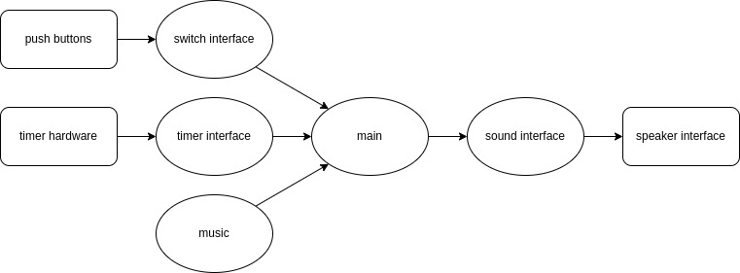

Figure 5.9. Data flows from the memory and the switches to the speaker.

Figure 5.10 shows a possible call graph of the system. Dividing the system into modules allows for concurrent development and eases the reuse of code.

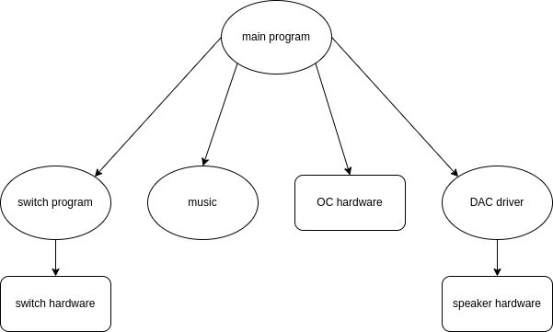

Figure 5.10. A call graph showing the three modules used by the music player.

# Procedure

Procedure is performed during the W/TH lab session.

1. Write the C file for the DAC interface. Look very carefully at the four Freescale SPI modes possible. Only one of these four modes matches exactly the shape and polarity of the clock needed by the TLV5616. The function DAC_Init() initializes the SSI protocol, and the function DAC_Out() sends a new data value to the DAC. Create separate DAC.h and DAC.c files. Write a second low-level device driver for the two or three switches, creating separate Switch.h and Switch.c files.
2. Design and write the music device driver software. Create separate Music.h and Music.c files. Place the data structure format definition in the header file. For example, you could implement a Music_Play() function that takes as an input parameter a pointer to a song data structure. Add minimally intrusive debugging instruments to allow you to visualize when interrupts are being processed.
3. Build the SSI/DAC hardware including voltage reference. Use simple main programs to debug the SSI/DAC interface. Experimentally measure the DAC output versus digital input for 8 different digital inputs. Compare the measured data with the expected values. Calculate resolution, range, precision and accuracy of the DAC.
4. Write and debug the music system. Cut up a box, placing the speaker inside, and notice how much better it sounds. Pins 5 and 8 will have the sound signal, but these two signals will be 180 degrees out of phase (so the difference between pins 5 and 8 will be AC sound, with DC=0), as shown in Figure 5.11. Using a dual channel scope measure the outputs on pins 5 and 8 (like Figure 5.11).
5. 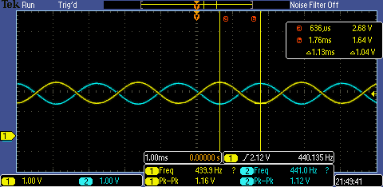

## *Figure 5.11. Two channel recording of pins 5 and 8. DC component is 2.14V, peak to peak is 1.16V (amplitude of the sound), and the frequency is 440.135 Hz.*

## Deliverable 1

Show digital and analog data measurements. Calculate resolution, range, precision and accuracy of the DAC.

Using an oscilloscope and spectrum analyzer, measure and include images of the time-domain and frequency-domain outputs from your system outputting a note at one frequency, like Figure 8.35 in the textbook. Using the spectrum, calculate SNR (ratio of the sinewave output to the largest noise component).

## Deliverable 2

Using a spectrum analyzer, measure amplitude versus frequency (show plot), and calculate SNR (in dB and equivalent number of bits, ENOB) of the electrical output of the op amp.

## Deliverable 3

Using debugging instruments, measure the maximum time required to execute the periodic interrupt service routines. Create a debugging profile to measure the percentage processor time required to play the song. Adjust the interrupt rate to guarantee no data is lost. Use your Lab 2 code to measure jitter of the DAC output.

Show the maximum execution time to run the ISR. Include a logic analyzer plot used to profile the system. Calculate percentage time in ISR.

## Deliverable 4

Show the results of the maximum jitter for the ISR. If the jitter is not 0, give the reasons why.

## Deliverable 5

Remove the USB cable and carefully power your system using a lab power supply connected to the +5V line. Set the voltage to +5V and measure the required current to run the system with and without playing music, in addition measure the RMS voltage on the +5V line, which is a measure of power line noise. Take a measurement with and without the music playing. Double check the positive and negative connections before turning it on. If you are at all unsure about this measurement, ask your TA for help

Measure the 5V current with and without sound. Measure the RMS noise on the 5V line.

# Lab Checkout

The lab checkout is performed during the M/T lab session.

You should be able to demonstrate the three functions as described in the requirements document. The TA will ask you to connect your DAC output to an oscilloscope and spectrum analyzer, and ask you questions about the frequency spectrum of your output. You should be prepared to discuss alternative approaches and be able to justify your solution.

# Lab Report

The lab report shall be submitted by the Friday after the M/T lab session.

## Deliverables

1. Objectives (final requirements document)
2. Hardware Design
   1. Detailed circuit diagram of all hardware attached to the TM4C123 drawn with Eagle
3. Software Design
   1. If you organized the system different than Figure 5.8 and 5.9, then draw its data flow and call graphs
4. Measurement Data
   1. Deliverable 1
   2. Deliverable 2
   3. Deliverable 3
   4. Deliverable 4
   5. Deliverable 5
   6. Deliverable 6

## Analysis and Discussion Questions

Give short 1 or 2 sentence answers to these questions.

1. Briefly describe three errors in a DAC.
2. Calculate the data available and data required intervals in the SSI/DAC interface. Use these calculations to justify your choice of SSI frequency.
3. Why did you use Freescale mode 1 and not mode 0 (bits 7,6 of SSI1_CR0_R)?
4. How is the frequency range of a spectrum analyzer determined?
5. Notice the audio amplifier had a voltage gain of 1. Why did we not simply drive the speaker directly from the DAC? In other words, what purpose is the TPA731/MC34119?

# Extra Credit

You may (for a +5% bonus) create multiple sine-waves at the same time. This way, you can play music containing melody and harmony. For this bonus you will use two sine-wave generators and add them together in hardware or software; be careful not to overflow and cause clipping. You will need three interrupts: one for outputting the sine-wave for the melody, one for outputting the sine-wave for the harmony, and a third to interpret the music (updating the frequencies and envelopes for the other two.) You will have to add the two sine-waves together in software.

You may (for another +5% bonus) create sine-waves with envelopes like Figure 5.7. To get extra credit, these envelopes must have shapes that sound pretty and are independent of pitch. Notice in Figure 5.7 that the decay slope of the envelopes for 330 and 523 Hz are the same. i.e. The envelopes are not frequency dependent. A sinusoidal envelope sounds like the bowing action on a violin.

You may (for another +5% bonus) develop a technique to support multiple notes with a single timer. In general, develop and implement a technique that allows more notes than timers.