RSLK-2.02 July 2024

Major components

* Either TM4C123 or MSPM0G3507 LaunchPad
* Romi chassis, 2 motors, 2 tachometers
* 3 analog connectors for GP2Y0A21YK0F or GP2Y0A41SK0F
* 4 bump sensors on front
* TOF TF-Luna UART
* ESP8266
* SSD1306 OLED
* Solderless breadboard as a spoiler

Components to go on spoiler.

* LCD (SPI)
* LEDs
* Anything I2C

**Pololu Parts needed**

1 - Romi Chassis Kit 3500 to 3509

4 - KW11-2 Bump switch 1404

2 - Romi motors 3675

**Construction plan**

LaunchPad from TI

Parts from Pololu

Parts from Mouser

Parts from Amazon

JLCPCB with assembly of surface mount parts

Hand solder through hole parts

**Power configurations with TM4C123 LaunchPad**

When debugging with USB cable connected

LaunchPad jumper inserted

LaunchPad switch to DEBUG

LaunchPad LP3.3V jumper removed

LaunchPad LP 5V jumper removed

6 Ni-MH batteries inserted

7.2V power switch on or off as needed (motors, tach, ESP, OLED, IR, TFluna)

When running stand alone (USB not connected or USB switch in DEVICE)

LaunchPad jumper inserted (debugger needs power even if not debugging)

LaunchPad LP 3.3V jumper removed

LaunchPad LP 5V jumper removed

6 Ni-MH batteries inserted

7.2V power switch on

When debugging with USB cable connected just sensors and ESP8266, no tach, no motors

LaunchPad jumper inserted

LaunchPad switch to DEBUG

LaunchPad LP 3.3V jumper inserted

LaunchPad LP 5V jumper inserted

NO Ni-MH batteries

7.2V power switch on or off does not matter because no batteries

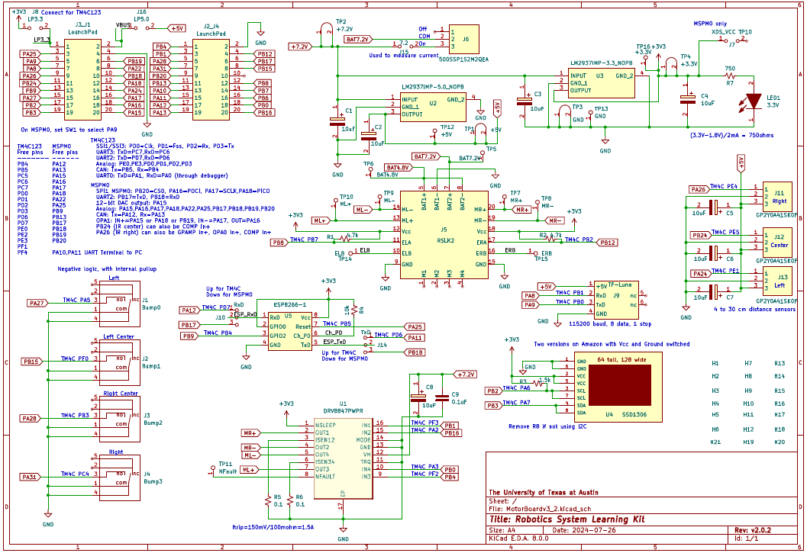

**// Bump switches**

**// TM4C MSPM0**

**// PA5 PA27 Left, Bump 0,**

**// PF0 PB15 Center Left, Bump 1,**

**// PB3 PA28 Center Right, Bump 2**

**// PC4 PA31 Right, Bump 3**

**// Motor**

**// TM4C MSPM0**

**// PF2 PB4 Motor_PWML, ML+, IN3, PWM M1PWM6**

**// PF3 PB1 Motor_PWMR, MR+, IN1, PWM M1PWM7**

**// PA3 PB0 Motor_DIR_L,ML-, IN4, GPIO 0 means forward, 1 means back**

**// PA2 PB16 Motor_DIR_R,MR-, IN2, GPIO 0 means forward, 1 means back**

**// tachometer**

**// TM4C MSPM0**

**// PB7 PB8 ELA T0CCP1**

**// PB2 PB12 ERA T3CCP0**

**// ERB and ELB not connected**

**// SSD1306 I2C OLED**

**// TM4C MSPM0**

**// PA6 PB2 SCL I2C clock**

**// PA7 PB3 SDA I2C data**

**// IR analog distance sensors**

**// TM4C MSPM0**

**// PE4 PA26 Right Ain9**

**// PE5 PB24 Center Ain8**

**// PE1 PA24 Left Ain2**

**// TF Luna TOF distance sensor**

**// TM4C MSPM0**

**// PB1 PA8 TxD microcontroller sensor RxD pin 2**

**// PB0 PA9 RxD microcontroller sensor TxD pin 3**

**// LaunchPad pins**

**// PF4 S2 negative logic switch**

**// PF0 S1 negative logic switch (shared with Bump 1)**

**/* Vcc should be connected to RSLK 3.3V (not debugger)**

**/------------------------------\**

**| chip 1 8 |**

**| Ant 2 7 |**

**| enna processor 3 6 |**

**| 4 5 |**

**--------------------------------**

**Set #define for UART2 (PD) and Reset PB5**

**ESP8266 TM4C123 MSPM0 (UART selected by jumper)**

**1 URxD PD7 PB17 UART out of TM4C123, 115200 baud**

**2 GPIO0 +3.3V for normal operation (ground to flash)**

**3 GPIO2 PB4 PB9**

**4 GND Gnd Gnd GND (70mA)**

**5 UTxD PD6 PB18 UART out of ESP8266, 115200 baud**

**6 Ch_PD chip select, 10k resistor to 3.3V**

**7 Reset PB5 PA25 Software can issue output low to cause hardware reset**

**8 Vcc regulated 3.3V supply with at least 70mA**