ECE 445L Lab 5 Audio Player
  - 12-bit DAC, SPI, Music player, audio amplifier
This laboratory assignment accompanies the book, Embedded Systems: Real-Time Interfacing to ARM Cortex M Microcontrollers, ISBN-13: 978-1463590154, by Jonathan W. Valvano, copyright © 2026.

Table of Contents
Table of Contents 1
Team Size 2
Goals 2
Review 2
Starter Files 2
Required Hardware 2
Lab Overview 3
Preparation 3
Procedure 7
Deliverable 1 8
Deliverable 2 8
Deliverable 3 8
Deliverable 4 8
Deliverable 5 9
Deliverable 6 9
Deliverable 7 9
Deliverable 8 (10pts Extra Credit) 9
Lab Checkout 10
Lab Report 10

Team Size
The team size for this lab is 2.

Goals
- Understand Digital to Analog Converters (DACs) and voltage references,
- Create an output-only SPI interface,
- Design data structures to represent music,
- Develop systems to play sounds.

Review
- Search for a data sheets on the MCP4921-E/P 12-bit DAC and LM4890M amp,
- ebook Section 3.7 or textbook Section 3.4 on developing modular software
- ebook Chapter 5 or textbook Section 8.4 on DAC parameters and waveform generation,
- ebook Section M.3 or textbook Section 6.2 on periodic timer interrupts,
- ebook Section M.5 or textbook Section 7.5 on SPI interfacing.

Starter Files
- Example projects:
  - TimerPeriodicInts project,
  - Excel files starting with dac_and LM4041design.xlsx.
- Starter project:
  - Lab 5 template provided on the GH Classroom repo.

Required Hardware
Parts | Datasheet | Price | Source (price source)
LP-MSPM0G3507 |  | $18.69 | TI
8Ω or 32Ω speaker | N/A | N/A | EER Checkout Desk
Resistors and capacitors | N/A | N/A | EER Checkout Desk
Switches | N/A | N/A | EER Checkout Desk
MCP4921-E/P 12-bit DAC | MCP4921 data sheet | $2.81 | EER Checkout Desk  Or Mouser, Digikey
LM4890M 1 Watt Audio Power Amplifier | LM4890M  LM4890M data sheet | $1.43 | From TA or Mouser
SOIC 8 to DIP breakout |  |  | From TA
LM4041C12ILP shunt diode | LM4041C datasheet | $0.78 | EER Checkout Desk  Or Mouser, Digikey
You must solder the LM4890 to an SOIC to DIP breakout.
You can use the adjustable LM4041CILPR instead of the LM4041C12ILP (the adjustable is hard)

Lab Overview
Many embedded systems require the generation of analog signals. One example is a digital music player. This device relies on digital to analog converters (DACs) to create high-quality waveforms. In this lab you will use a 12-bit DAC to create a sine-wave output.
You will interface a Microchip MCP4921 12-bit DAC to an SPI port. Note that you are allowed to use any DAC chip you want if it runs on a single +3.3V supply and has an SPI interface. Additionally, you will create a voltage reference circuit because most DACs require a voltage reference. Once the DAC can produce an analog signal based on commands from the MSPM0 it will be time to interface an LM4890 audio amplifier to drive a speaker.

Preparation
Preparation is performed before or during the W/TH lab session.
- Requirements Review
  - Refresh your knowledge of audio waveforms. It is recommended that you read ebook Chapter 5.
  - Read the requirements document included in the Lab05Report. Be prepared to answer questions about what you are implementing to the TA’s.
    - What are the minimum requirements for the system?
    - What opportunities for extra features exist?
  - Understand that you can and should edit the requirements document to reflect your design, and to solidify the team’s understanding of what the lab’s goals are.
  - Understand that the performance score of this lab is NOT based on loudness, but sound quality. The quality of the music will depend on both hardware and software factors.
    - Hardware factors include the precision of the DAC, the linearity of the audio amp, the frequency response of the audio amp and the dynamic range of the speaker.
    - Software factors include the DAC output rate, the complexity of the stored music data, the jitter of the DAC output, and the signal the software generates.
- Software Setup
  - Understand that in this lab you will create an SPI module and drivers for the DAC. These drivers like most code in this class, MUST be written at a low level.
  - Create the two header files DAC.h and Switch.h. Define at least two functions for the SPI/DAC interface and two functions for the switch interface.
  - Design the data structure you will use to store the song. This data structure should minimally contain notes and their duration, but can include additional information such as rests, envelopes, instruments, or other data to reproduce the song.
    - Find the sheet music that you would like to play and consider how this sheet music would be represented in your data structure.
    - Consider how you would include the actual constants needed to define the song.
Consider the system call graph and data flow graph. A “syntax-error-free” software is required as preparation. The TA will check off your listing at the beginning of the lab period. You are required to do your editing before lab. The debugging will be done during the lab. Document clearly the operation of the routines in the header file. Figure 5.1 shows one possible data flow graph of the music player.
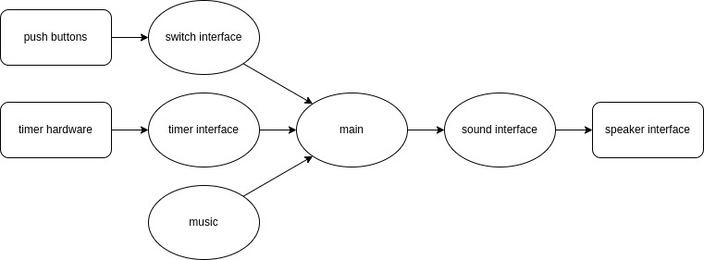
Figure 5.1. Data flows from the memory and the switches to the speaker.
Figure 5.2 shows a possible call graph of the system. Dividing the system into modules allows for concurrent development and eases the reuse of code.
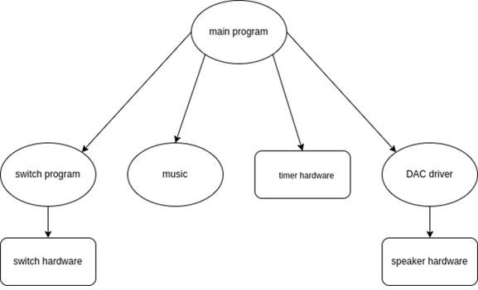
Figure 5.2. A call graph showing the three modules used by the music player.
- Prepare the schematic
  - Obtain the DAC chip for this lab. The MCP4921 has no digital data output, and the data sheet shows which pins to use for an SPI interface. Choose which MSPM0 pins you will use for SDI, SCK, and CS bar (active low). Decide what you will you do with LDAC pin? See the PINCH tab of MSPM0_Pins_AssignmentsLab5.xlsx. Figure 5.3 shows the block diagram of the DAC.
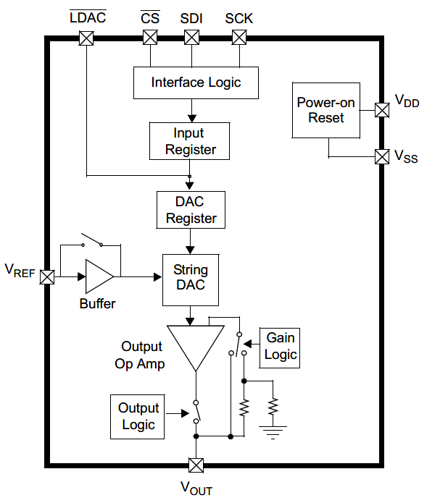
Figure 5.3. Block diagram of the DAC interface for the MCP4921.
  - You must draw a rough draft of the circuit for this lab in KiCad. You will find the MCP4921, LM4890, and LM4041C12ILP symbol, footprint, and model files in the hardware folder, or on websites such as Mouser and SnapEDA. To begin you should start by adding these parts to your schematic, then continue reading to see how to wire your circuit. Your schematic will include:
    - Bypass capacitors for ICs on their power pin(s) sized appropriately (i.e., 0.1uF)
    - A DAC and its relevant SPI, reference, and output pins connected properly
    - A voltage reference circuit and its configuration resistors
    - An audio amplifier and its required passive components powered by VBUS
    - Two or more buttons as required.
    - Relevant signal names and pin numbers.
- Hardware Setup
  - Be prepared to show your TA that you can assemble the hardware for this lab; Before leaving prep, you must collect all hardware needed to perform this lab as listed below:
    - A DAC, such as the MCP4921
    - A voltage reference, such as the LM4041C12ILP
    - A class AB LM4890 audio amplifier, SOIC to DIP breakout, 8 male-male pins
    - A speaker, either 8 or 32 Ohms
    - Additional resistors, capacitors, and jumpers
    - (Optional) A Pop-Tarts or small cereal box into which to mount the speaker
  - Consider the voltage reference required for this lab. As many DACs need a reference voltage, we must create one. The LM4041C12ILP is a fixed shunt reference. The LM4041CILPR is an adjustable shunt reference that can be used to create a variety of precise reference voltages. The LM4041design.xlsx excel sheet will help the design process. Consider the following for your voltage reference circuit:
    - The reference voltage needed. The 1.255V fixed voltage is ok
    - The maximum current draw of devices requiring the reference voltage
      - HINT: Look up in the MCP4921 data sheet to find how much current the DAC needs on its REF input. In the data sheet you will find the input impedance R_{VREF} of the REF pin. This R_{VREF} can be used to calculate the load current IL = 1.255V / R_{VREF}.
    - The power source for the LM4041C, in this case the +3.3V rail
    - The minimum cathode current of the LM4041C (I_{Z_min} = 80 µA)
    - The feedback voltage of the LM4041C (VREF = 1.233V)
  - If you have the LM4041CI, calculate the resistor values for the reference circuit using the information found in the prior step. Current through R1+R2 will be IREF =VREF/(R1+R2). Select R1 and R2 to set the reference output. VZ = VREF (1 + R2 / R1) = 1.50V. The RS resistor in Figure 5.4 (Figure 14-3 of the datasheet) sets the available current for the shunt reference. Make RS ≤ (3.3 - VZ) / (IL + IREF + IZ).
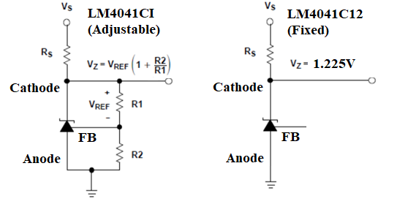
Figure 5.4. Shunt voltage reference
  - Consider the audio amplifier you will use. The audio amplifier is required to increase the strength (Equivalently to reduce the source impedance) of the DAC so that the signal can successfully drive the speaker. This semester we will be using the LM4890. Figure 5.5 shows the LM4890 amplifier interfaced with a speaker and an audio input coming from the DAC. Some hints on constructing your circuit are below.
    - Choose R_{f} and R_{IN} to make the gain about 1. The gain equation is 2*R_{f}/R_{IN}.
      - HINT: The range of the DAC matters less than there being an approximately linear relationship between the digital data and the speaker current. This means that we should choose a gain such that we remain in the linear region, and 1 is a safe choice to do this.
    - C_{IN} should be ceramic with a range of 0.1 µF to 0.47 µF.
    - The high pass cutoff frequency will be 1/(2πR_{IN}*C_{IN})
    - C_{BYPASS} should be ceramic or tantalum with a value about 1.0 µF.
    - C_{S} should be ceramic with a range of 0.22 µF to 1 µF.
    - The LM4890 should be powered with +5V, because the 3.3V regulator on the LaunchPad does not supply enough current to drive the speaker.
    - Refer to the data sheet for more information on passive sizing.
    - NOTE: You will need to determine what to do with the shutdown signal.

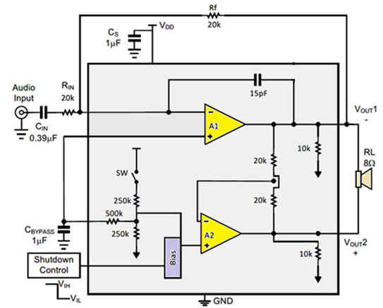
Figure 5.5. The LM4890 is one way to convert DAC voltage into speaker current. V_{DD} is +5V. Choose R1 and R2 to make the gain equal to 1.

Procedure
Procedure is performed during the W/TH lab session.
- Write the C file for the DAC interface. Place the low-level driver code in MCP4921.h and MCP4921.c files. Look very carefully at the four Freescale SPI modes possible. Only one of these four modes matches exactly the shape and polarity of the clock needed by the MCP4921. The function MCP4921_Init() initializes the SPI protocol, and the function MCP4921_Out() sends a new data value to the DAC. Test the DAC using a program like main0. Connect the three SPI pins to a logic analyzer and verify the SPI timing, like Figure 5.6. Notice the MSPM0 changes the data on the falling edge and the MCP4921 latches the data on the rising edge. Notice bit 12 should always be high to turn on the DAC. Run main0 and see the ramp on the scope like Figure 5.7. Run main1 and see the sine wave on the scope like Figure 5.8. Considering the harmonics as noise, using a spectrum analyzer we see the SNR is 60 dB, which is precision of about 10 bits.
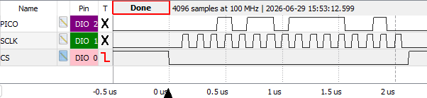
Figure 5.6. Logic analyzer trace showing the 8MHz clock and the 16-bit data.
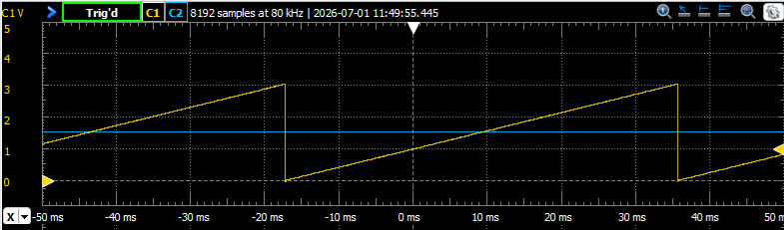
Figure 5.7 Scope trace running main0. C1 is MCP4921 OUT and C2 is reference in.
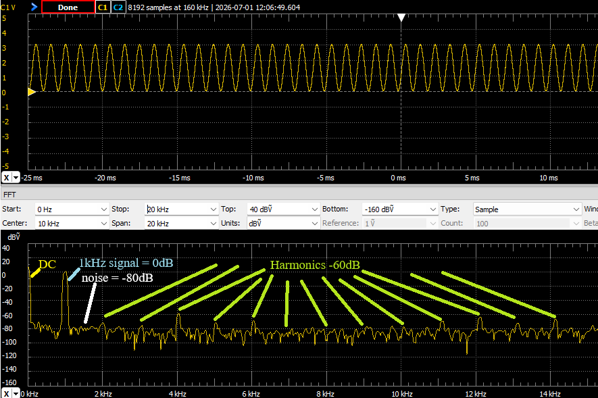
Figure 5.8 Scope trace running main1. C1 is MCP4921 OUT and C2 is reference in.

- Write a second low-level device driver for the two or three switches, placing the implementations in the Switch.h and Switch.c files.
- Design and write the music device driver software, placing the implementations in the Music.h and Music.c files. Place the data structure format definition in the header file. For example, you could implement a Music_Play() function that takes as an input parameter a pointer to a song data structure. Add minimally intrusive debugging instruments to allow you to visualize when interrupts are being processed.
- Build the SPI/DAC hardware including voltage reference. Use simple main programs to debug the SPI/DAC interface. Experimentally measure the DAC output versus digital input for 8 different digital inputs. Compare the measured data with the expected values. Calculate resolution, range, precision, and accuracy of the DAC.
- Solder the LM4890 amp to a breakout board, Figure 5.9, so it can be inserted into a standard solderless breadboard. There are two versions of the breakout board. Using an ohmmeter, confirm which one you have and identify the pinout:
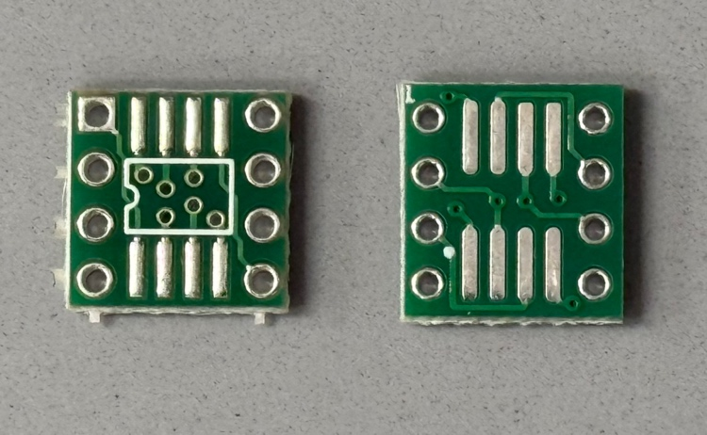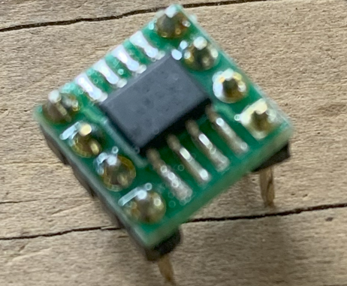
BREADBOARD PIN 1
BREADBOARD PIN 1
IC PIN 1
IC PIN 1
Figure 5.9. Solder the LM4890 onto a breakout board.
- Write and debug the music system. Cut up a box, placing the speaker inside, and notice how much better it sounds. Pins 5 and 8 will have the sound signal, but these two signals will be 180 degrees out of phase (so the difference between pins 5 and 8 will be AC sound, with DC=0), as shown in Figure 5.10. Using a dual channel scope measure the outputs on pins 5 and 8 (like Figure 5.10).
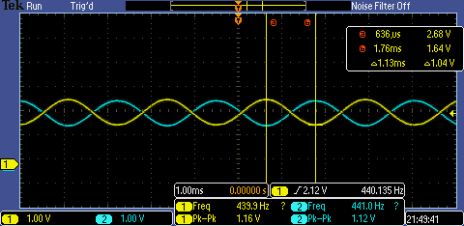
Figure 5.10. Two channel recording of pins 5 and 8. DC component is 2.12V, peak to peak is 1.16V (amplitude of the sound), and the frequency is 440.135 Hz.

Deliverable 1
Using KiCad, create a schematic for your design.

Deliverable 2
If you organized the system differently than those in Figure 5.1 and 5.2, then draw its data flow and call graphs. Otherwise, copy/paste these figures.

Deliverable 3
Configure your system to your system to output a single note at one frequency. Then measure and include images of the following in your report:
- The time-domain output (Using an oscilloscope)
- Frequency-domain output (Using a spectrum analyzer, or the FFT mode of the oscilloscope)
Finally calculate the range, precision, and accuracy of the DAC.
Be sure to include in your report the data measurements and calculated parameters of the DAC.

Deliverable 4
Using the spectrum (Frequency-domain output) from deliverable 3, calculate the SNR of your audio circuit. The SNR is the ratio of the sinewave output to the largest noise component. For more information see ebook Figure 5.2.4 or Figure 8.35 in the textbook. To calculate the SNR:
- Find the peak in the spectrum created by the note and measure its amplitude
- Find the highest non-signal peak in the spectrum (ignore the DC peak)
- If the amplitudes of the peaks are measured in dB, the difference of amplitude of these peaks is the SNR measured in dB. If the amplitude of the peaks are in another unit such as volts or joules, divide the amplitude of these peaks to get the SNR as a ratio.
If you have the SNR in dB, you need to convert it to an SNR as a ratio. Once you have a ratio, convert this into equivalent number of bits (ENOB) of the audio circuit. Record in your lab report the resolution (ENOB) of your audio circuit.

Deliverable 5
Using debugging instruments, measure the maximum time required to execute the periodic interrupt service routine(s). Create a debugging profile to measure the percentage processor time required to play the song. Adjust the interrupt rate to guarantee no data is lost. Include in your report:
- The logic analyzer plots you used to profile the ISR(s) in your system.
- The maximum execution time of every ISR in your system.
- Calculate the percentage of time spent in ISR(s).

Deliverable 6
Use your Lab 2 code to measure jitter of the DAC output. Note that you should measure jitter at the line just before your software outputs data via SPI. Include in your report:
- The measured jitter
- The reason(s) why the jitter is/isn’t zero.

Deliverable 7
Remove the USB cable and carefully power your system using a lab power supply connected to the +5V line. Set the voltage to +5V and measure the required current to run the system with and without playing music, in addition measure the RMS voltage on the +5V line, which is a measure of power line noise. Take a measurement with and without the music playing. Double check the positive and negative connections before turning it on. If you are at all unsure about this measurement, ask your TA for help. Include in your report:
- The total current by the system when it is playing sound
- The total current by the system when it is NOT playing sound
- The RMS noise on the 5V line when it is playing sound.
- The RMS noise on the 5V line when it is NOT playing sound

Deliverable 8 (10pts Extra Credit)
You may (for a +5% bonus) create multiple sine-waves at the same time. This way, you can play music containing melody and harmony. For this bonus you will use two sine-wave generators and add them together in hardware or software; be careful not to overflow and cause clipping. You will need three interrupts: one for outputting the sine-wave for the melody, one for outputting the sine-wave for the harmony, and a third to interpret the music (updating the frequencies and envelopes for the other two.) You will have to add the two sine-waves together in software or in hardware.
You may (for another +5% bonus) create sine-waves with envelopes like ebook Figure 5.1.7. To get extra credit, these envelopes must have shapes that sound pretty and are independent of pitch. Notice in Figure 5.1.7 that the decay slope of the envelopes for 330 and 523 Hz are the same. I.e., the envelopes are not frequency dependent. A sinusoidal envelope sounds like the bowing action on a violin.
Include in your report, which –if any—extra credit deliverables you have done. For each extra credit deliverable, tell what functions in your code were created/modified to achieve the effect.

Lab Checkout
The lab checkout is performed during the M/T lab section.
You should be able to demonstrate the three functions as described in the requirements document. The TA will ask you to connect your DAC output to an oscilloscope and spectrum analyzer, and ask you questions about the frequency spectrum of your output. You should be prepared to discuss alternative approaches and be able to justify your solution.

Lab Report
The lab report shall be submitted by the Friday after the second (W/Th) lab section.
You should complete the Lab05Report.docx file with your data and answers then submit the completed file to Canvas.

