**To: TI, Senior Project Advisors**

**From: Team 04**

**Raymond Montgomery**

**Eric Taylor**

**Date 12/10/2014**

**Subject: System Decomposition 2.0**

**Executive Summary**

The purpose of this project is to provide both hobbyists and professionals with an oscilloscope that they can use for their day to day projects. Current options are fairly expensive in the above $100 range and can be too expensive for the common hobbyist. To make this scope we want to make a BoosterPack for a common TI LaunchPad so the user would just have to buy the BoosterPack and attach it to the LaunchPad to have a high performing scope. The BoosterPack we are designing would consist of a high performance Analog to Digital Converter that can sample at high rates to measure signals up to 6.5MHz, and also include a colored screen. The user then can control the two channels on the oscilloscope with mechanical buttons and knobs attached on the LaunchPad. Overall, the results of this project could be useful to a wide scope of engineers and provide a price under $50 and a reliable measuring tool that they can use on their projects.

Analog Front End Decomposition

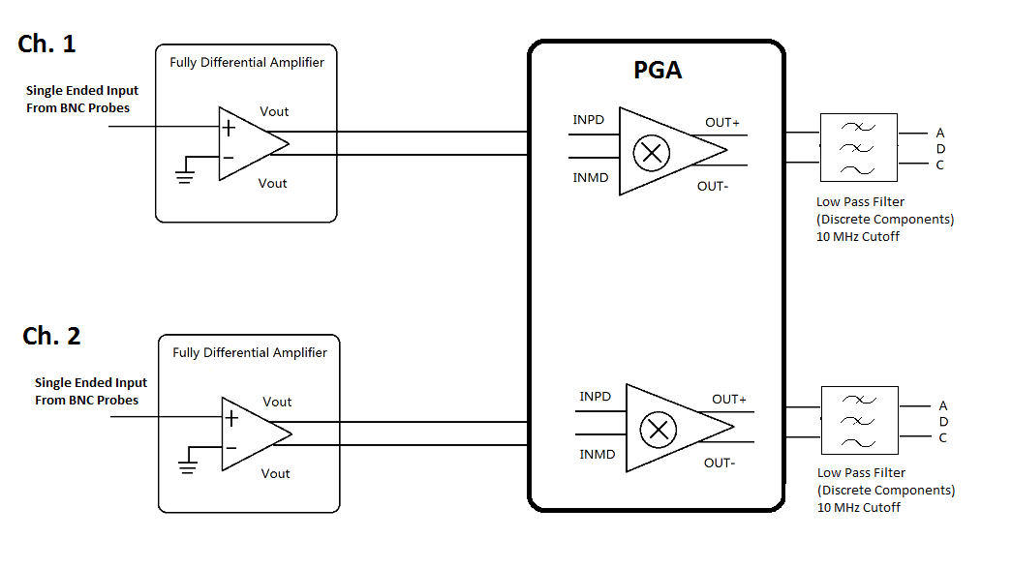

Figure . Functional Diagram

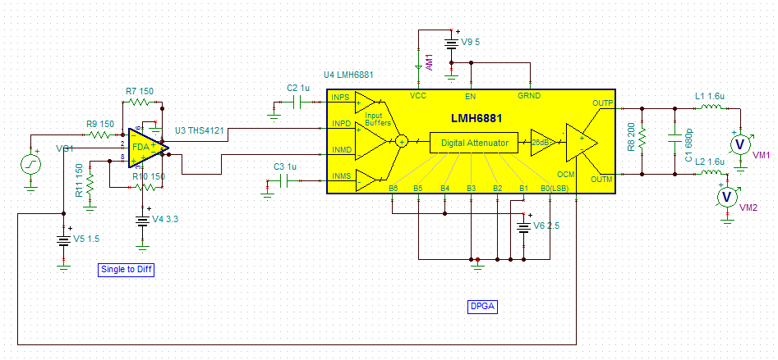

Figure . TINA TI Circuit Showing 1 Channel

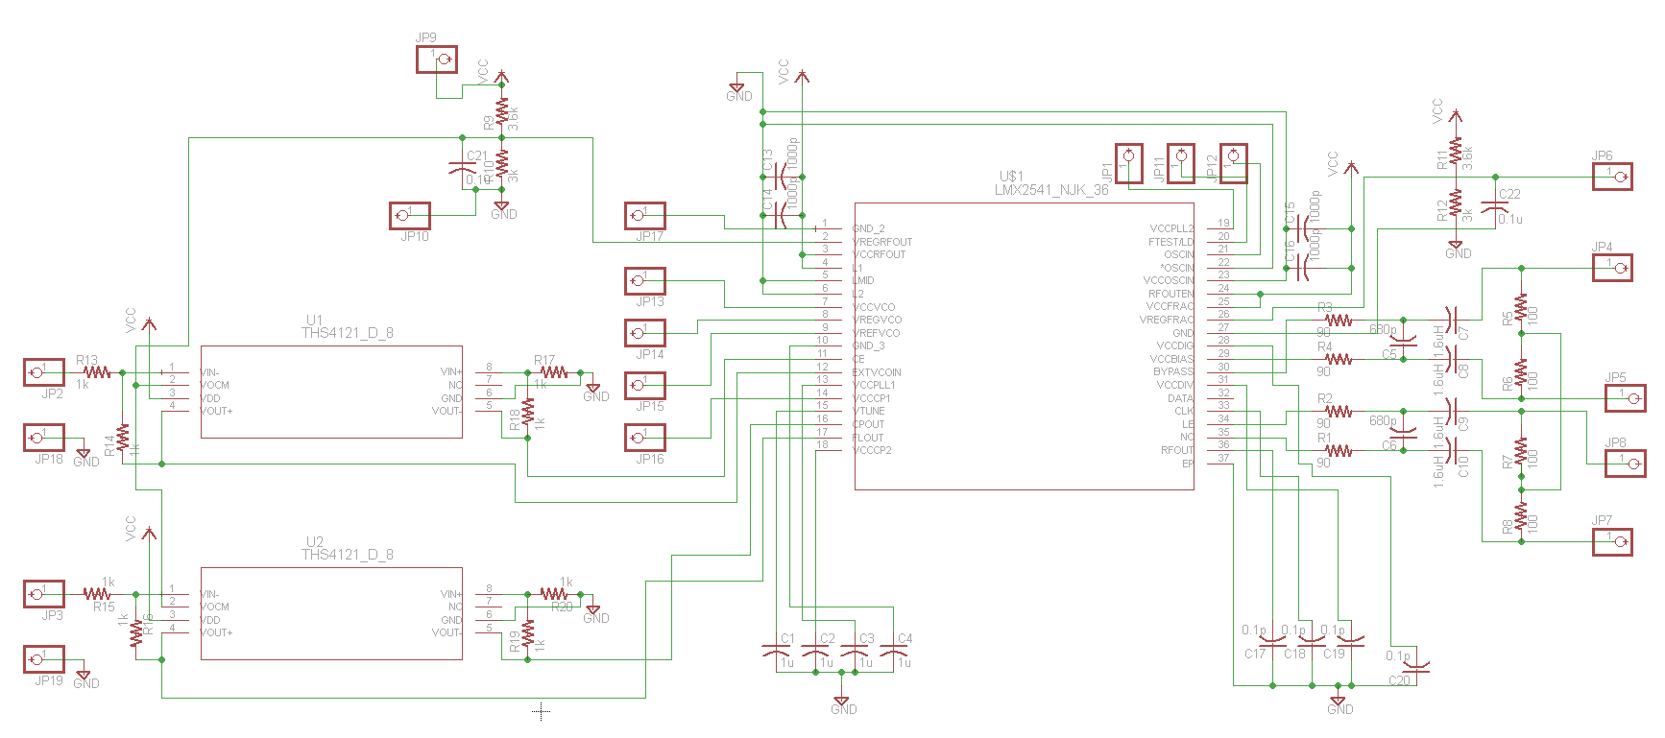

Figure . EAGLE Circuit (NOTE: PART NOT LMH6882 for footprint reasons)

For the Analog Front End, there is a BNC probe inputting the single ended signal. The reason we want the probes is to attenuate the signal by 10x and give the input impedance of 1MOhm. This is done because looking into the buffer there is a known high impedance of 1 Mohm and known attenuation.

Next, we have a fully differential amplifier (THS4121). Because the programmable differential amplifier requires two differential inputs, so we use the THS4121 to transfer the single signal to two differential input signals.

Last we have the dual channel differential PGA (LMH6882). The PGA Amplifies small signals so the ADC can measure the signals with proper resolution. This PGA is controlled by the microcontroller through parallel logic telling how much gain the signal need.

Finally there is a low pass filter to get rid of any noise to the ADC with a cutoff frequency of about 10 MHz.

# Triggering Circuit



Figure 4. Trigger System Diagram



Figure 5. Trigger Implementation Diagram

## TINA TI Diagram

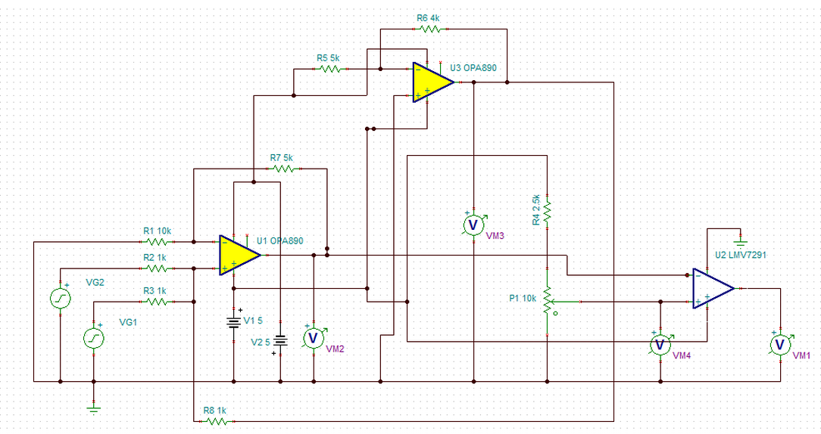

Figure 6. TINA TI diagram of Trigger

## Summary

After a channel receives a signal. The Analog Front End scales the signal down so the op-amps in the Triggering Circuit can manipulate the input signal within the supply voltages. The user controls the potentiometer with a knob, or a similar control structure. The output of the Triggering Circuit is an array of logical values based on the sampling rate of the microcontroller and if there is one logical high in the array then the waveform is displayed. Logical high is an output of 5V and a logical low is an output of 0V.

# ADC Block Decomposition

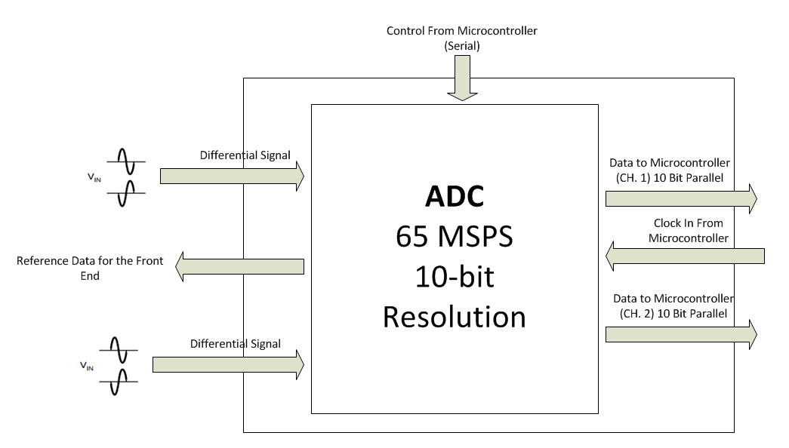

Figure 7. System Diagram of ADC Module

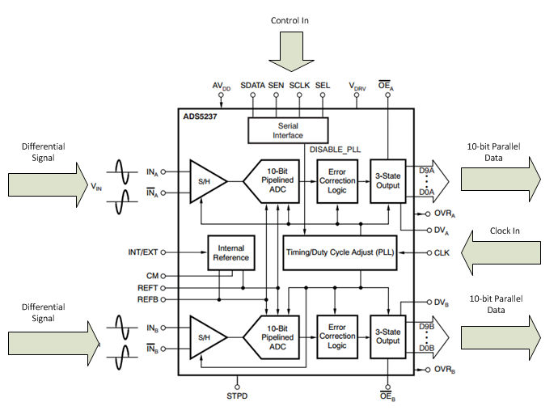

Figure 8. Implementation of ADC

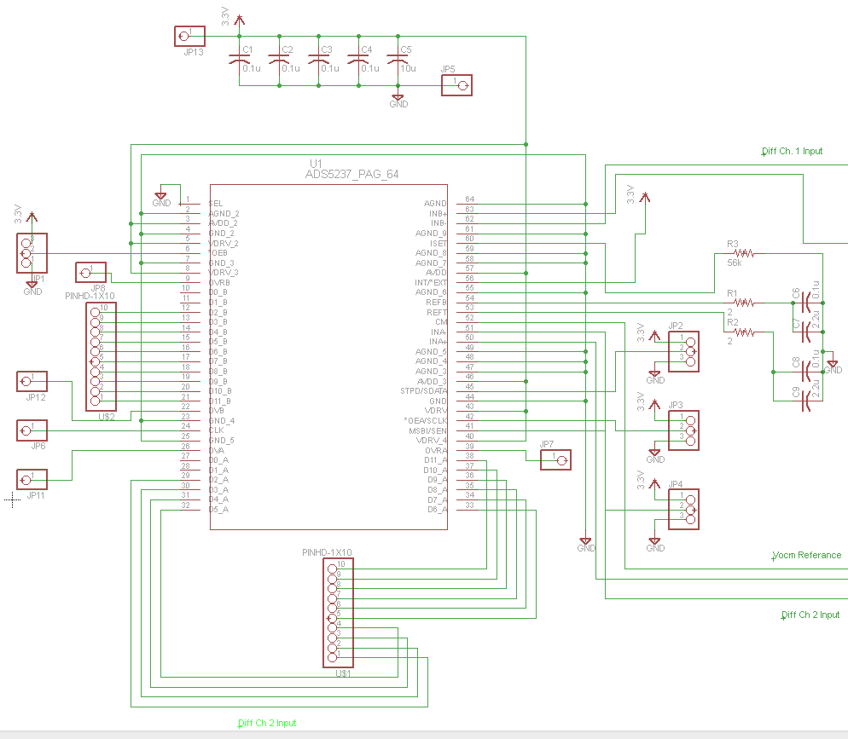

Figure 9. Circuit Diagram of ADC Module

## Summary

For our circuit we are going to use the ADS5237 ADC from TI. This chip is a dual channel, 10-bit resolution ADC that can sample at 65 MSPS. This will enable us to measure signals up to 6.5 MHz. This part has a listed use case for test equipment so that also gives reassurance it would be good to use in this case. The chip requires a clock signal from the microcontroller to tell it when to sample, and the data is sent back to the microcontroller over two 10-bit parallel lines. The analog signal coming in comes from the ADC and needs to be a differential signal within 0 to 2 V peak to peak.

Our ADC will not need serial control for now so it is disabled in the schematic for now.

# Microcontroller Decomposition

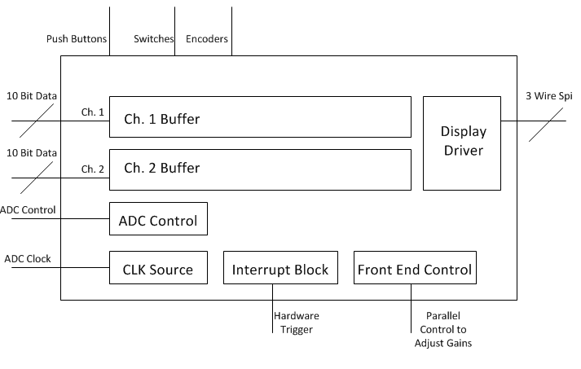

Figure 10. Microcontroller System Diagram

The microcontroller is the center of the project and will hold all of the software. We are using the Tiva C microcontroller that comes on its generic LaunchPad. The microcontroller is responsible for taking in the sampled data through an EPI bus and storing it into a circular buffer. The trigger then tells the microcontroller when to start displaying data from that circular buffer.

Knowing things such as voltage per division and time per division shown on the screen it will also control the sampling rate through increasing/decreasing the clock frequency to the ADCs. It will also control the amplification through the programmable gain amplifier which is a simple parallel interface.

The microcontroller also takes the user input from mechanical controls such as the push button, rotary encoders, and slide switches, and displays data on a LCD display which it will connect to through the built in SPI drivers.

# Display Decomposition

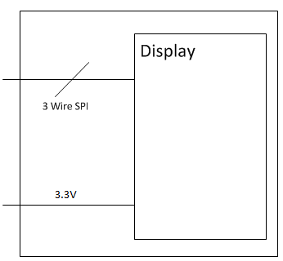

Figure 11. Display System Diagram

The display we are using only needs a 3.3V supply and a 3 wire SPI to communicate with it.

# Mechanical Input Diagram

# 

Figure 12. Input System Diagram

# 

# 

Figure 13. Mechanical Control Implementation

These mechanical interface inputs allow the user to change menus and sub-menus while also toggling options in these menus. The rotary encoder can be used to navigate through lists, the switch can be used for power to the BoosterPack, and the push button can be used to toggle menu options.

# Power Block

For the power block we needed a way to change 5V coming in from the wall to have supply lines of 5V, 3.3V, and -5V. To get the 5V from the wall we are going to use a barrel transformer coming in with a barrel connector to connect it to the board. Then the 5V coming in will power the LaunchPad, and the LaunchPad will make 3.3V for our system. Then we are going to use a TL7660 to just invert the voltage of the 5V line to get a negative 5V reference for some of the trigger and front end components.

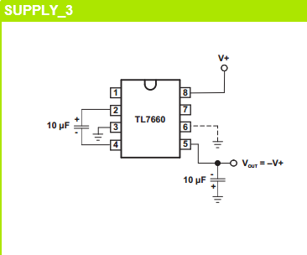

Figure 14. Circuit of getting Negative Referance Voltage

# Validation Matrix

|  |  |  |  |  |  |  |  |  |  |
| --- | --- | --- | --- | --- | --- | --- | --- | --- | --- |
| **Physical Part/Code Block** | ***Analog Front End*** | Modify Signal | **Microcontroller** | **Display** | **Power Circuit** | ***Mechanical Control*** | **Package** | **Triggering Circuit** | ***ADC*** |
| ADS5237 |  |  |  |  |  |  |  |  | F |
| OPA2890 |  |  |  |  |  |  |  | F |  |
| LMH6882 | P | P |  |  |  |  |  |  |  |
| THS4121 | P | P |  |  |  |  |  |  |  |
| ER-TFTM050-2 |  |  |  | F |  |  |  |  |  |
| 612-EG1218 |  |  |  |  |  | P |  |  |  |
| COM-09190 |  |  |  |  |  | P |  |  |  |
| TIVA C Microcontroller |  |  | F |  | P |  | F |  |  |
| TL7660 |  |  |  |  | P |  |  |  |  |

|  |  |  |  |
| --- | --- | --- | --- |
| Part/Code Block | Block | I/Os | Behaviors Implemented |
| ADS5237 | ADC | Modified Signal, Sampled Data | This ADC is able to sample a signal at 65 MSPS at 10 bit resolution. This takes care of sampling. |
| OPA2890 | Triggering Circuit | Filtered , Trigger Signal, Signal | These are general purpose op amps to compare signals to a specified triggering level inputted by the user |
| LMH6881 | Analog Front End | Signal Modified Signal | This is a programmable gain amplifier that allows us to see really small signals. |
|  |  |  |  |
| THS4121 | Analog Front End | Signal Modified Signal | This is what converts the single ended signal into a differential signal. |
| TIVA C Microcontroller | Microcontroller | SPI, Mechanical Input, Sampled Input | The TIVA C microcontroller takes in the samples and user input and uses those to manipulate what is displayed. |
| COM-09190 | Mechanical Control | Mechanical Input | This is a push button switch that allows for user input. |
| 612-EG1218 | Mechanical Control | Mechanical Input | This is a slide switch that allows for user input |
| ER-TFTM050-2 | Display | SPI, User Output | This is the displays that shows data to the user from the microcontroller. |
| TL7660 | Power Block | Powers | This is a CMOS voltage converter and is used to change the 5V line to a -5V line for the OP AMPS in the analog front end. |

# Decision Matrix

|  |  |  |  |  |  |  |  |  |  |
| --- | --- | --- | --- | --- | --- | --- | --- | --- | --- |
| Solution | **Measurement Accuracy** | **Power Consumption** | **Ease of Use** | **User’s Manual** | **Price Limit** | **Upgradeable Programming** | **Signal Measuring** | **Math Functions** | **Total** |
| **TLC5510** | 3 | 6 | 0 | 0 | 6 | 0 | 4 | 0 | 124 |
| **TLC5540** | 3 | 8 | 0 | 0 | 6 | 0 | 7 | 0 | 160 |
| **ADS7251** | 7 | 5 | 0 | 0 | 7 | 0 | 2 | 0 | 133 |
| **ADS4242** | 8 | 8 | 0 | 0 | 1 | 0 | 9 | 0 | 170 |
| **ADS5237** | 6 | 4 | 0 | 0 | 5 | 0 | 9 | 0 | 178 |
| **Weight** | 6 | 3 | 6 | 5 | 8 | 4 | 10 | 4 |  |

The reason we made this selection was because of the focus toward measuring high frequency signals accurately at a relatively low cost. Signal measuring incorporates how many signals the scope can measure and this is measured by seeing how fast the ADC can sample. Both the ADS4242 and ADS5237 have very high sampling rates which allow for measurement in the 10 MHz range, however the ADS5237 is a lot cheaper than its counterpart. Both the ADS4242 and ADS5237 had high resolution (12 and 10 bit respectively) and the ADS4242 did win in this regard. However it wasn’t able to offset the amount it costs. Power consumption is also a consideration, however it is a low one so ADS5237 poor performance in this category was seen as negligible. Overall the ADS5237 was selected because of its high performance while at the same time not being too expensive.

# Black Box Requirements

|  |  |  |  |
| --- | --- | --- | --- |
| **Interaction** | **ID** | **Actors** | **Requirement** |
| Inputted Signal | BBDI-1 | Probes, Signal | The inputted signal must be between +15V and – 15V |
| Inputted Signal | BBDI-2 | Probes, Signal | The inputted signal must be below 7 MHz to be properly sampled and measured. |
| Inputted Signal | BBDI-3 | Probes, Signal | The signal must be able to be attenuated by 10 through the probes. (10x Probes) |
| Adjust Settings | BBAS-1 | USER | The user must be able to measure each channel with cursors. |
| Adjust Settings | BBAS-2 | USER | The user must be able to change the time scale of both channels. |
| Adjust Settings | BBAS-3 | USER | The user must be able to change the voltage scale of both channels. |
| Adjust Settings | BBAS-4 | USER | The user must be able to control mathematical functions. |
| Adjust Settings | BBAS-5 | USER | The user must be able to turn on the BoosterPack using a switch. |
| Assemble | BBA-1 | USER | The use mush only have to attach the BoosterPack to the LaunchPad for it to be functionally operational. |
| Assemble | BBA-2 | USER | The user must plug in the BoosterPack using a barrel connector for t to have power/ |
| Connect to Circuit | BBCTC-1 | USER. Probes | The user must be able to connect the scope to the circuit through the probes. |
| Power | BBPI-1 | Outlet | The outlet must provide 5 V and 2 A to the circuit to power its functionality. |
| Forces | BBPKI-1 | Shipping | The BoosterPack must be tough enough to withstand drops from 5 ft and still be operational. |
| Forces | BBPIK-2 | Shipping | The BoosterPack must be able to withstand forces from shipping |

# White Box Requirements

|  |  |  |  |
| --- | --- | --- | --- |
| **Interaction** | **Req-ID** | **Blocks** | **Requirement** |
| Measuring Signals | WBMS-1 | Triggering Circuit | The input signal should not exceed a bandwidth (BW) of (max BW determined by the GBW). |
| Measuring Signals | WBMS-2 | Triggering Circuit | The signal input to the Triggering Circuit should be scaled down to a range of 0V to 2V. |
| Measuring Signals | WBMS-3 | Triggering Circuit | The potentiometer should be able to use resistance values from 0Ω to 10kΩ. |
| Measuring Signals | WBMS-4 | Triggering Circuit | The output signal should stay within the range of 0V to 5V. |
| Measuring Signals | WBMS-5 | Triggering Circuit | The output signal shape should be logical with a low of 0V and a high of 3.5V (due to op-amp saturation). |
| Measuring Signals | WBMS-6 | Triggering Circuit | The potentiometer should be controlled by the user with an external, mechanical interface. |
| Measuring Signals | WBMS-7 | Triggering Circuit | The output signal should range from 0V to 3.5V (due to op-amp saturation). |
| Measuring Signals | WBMS-8 | Triggering Circuit | The output signal should generate a current in the range of -30mA to 30mA. |