**Homework 1: Errors, Plotting, and Roots (Part 1)**

Problem 1:

**function** **[**error**]** **=** CalculateError**(**true**,** approximate**)**

%

% [absolutRelErr] = CalculateError(true, approx)

%

% Calculates the absolute relative error between two vectors

% Input:

% true -the true/expected value

% Output:

% approx -the calculated value

% Calculates the error using the absolute relative error equation

error **=** abs**((**true **-** approximate**)** **/** true**)** **\*** 100**;**

**end** % End of function CalculateError

Problem 2:

For this part, the errors are computed using the function created before. All the angles are found with their corresponding sines. Then the CalculateError function is used to find the error values.

|  |  |  |  |  |  |  |
| --- | --- | --- | --- | --- | --- | --- |
| x | -0.7854 | -0.7828 | -0.7802 | -0.775 | -0.7749 | -0.7723 |
| sin(x) | -0.7071 | -0.7053 | -0.7034 | -0.7015 | -0.6997 | -0.6978 |
| Absolute Relative Error (%) | 11.0721 | 1.0.9927 | 10.9136 | 10.8349 | 10.7565 | 10.6785 |

% Find the vector of angles from -pi/4 to pi/4 spaced with 600 points

angleVector **=** linspace**((-**pi**/**4**),** **(**pi**/**4**),** 600**);**

% Matrix to hold true sin values of each angle

sineVector **=** zeros**(**1**,** 600**);**

% Matrix to hold absolute relative errors

errorVector **=** zeros**(**1**,** 600**);**

% Iterate through all angle values

**for** i **=** 1**:**600

sineVector**(**1**,** i**)** **=** sin**(**angleVector**(**1**,** i**));** % Finds the sin of each of the angles

errorVector**(**1**,** i**)** **=** CalculateError**(**sineVector**(**1**,** i**),** angleVector**(**1**,** i**));** % Finds the absolute relative error between guess and true

**end**

Problem 3:

a)

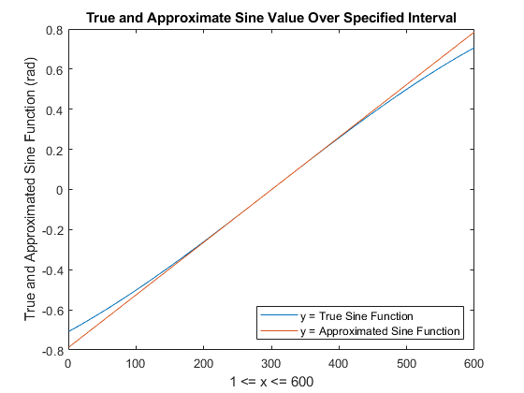

From -.2 to .2, the values of the true and the approximation are equal to each other and their individual lines are almost in distinguishable from each other. The range where this approximation is “good,” therefore, is angles between -.2 and .2 in radians. In degrees, this range is -11.4592 to 11.4592.

b)

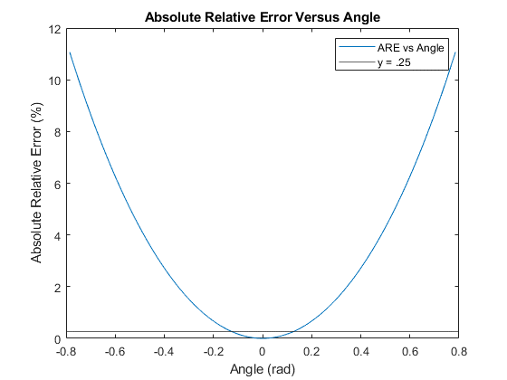

The parabola represents the values in absolute relative error values vs angle values. The linear horizontal line is at .25%. The area below this line represents “good” guesses because of their small error.

c)

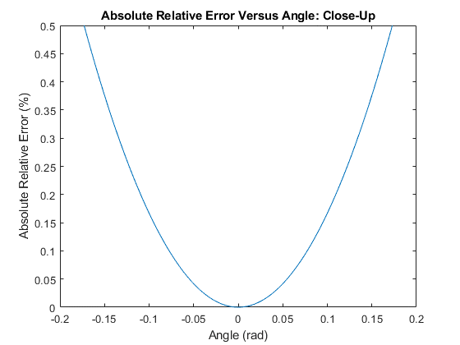

This graph is a zoomed in version of part c. We can see the values on the graph better. Our original statement from part a which claimed the guess is “good” if the angle in radian is between -.2 and .2. It can clearly be seen hear that the error for that range is just over half a percent, so not much.

Problem 4: