Problem 1:

1. Write a function that takes an interval and returns the two points on the x axis used in one iteration of a golden section search

**function** **[**outLower**,**outUpper**]** **=** GoldenRatio**(**inLower**,**inUpper**)**

%function [outLower,outUpper] = GoldenRatio(inLower,inUpper)

% Golden Ratio is a function which returns the two inner values which

% are needed for Golden ration given two intial lower and upper

% bounds

% Inputs: inLower, the lower bound for "x"

% inUpper, the upper bound for "x"

% Outputs:outLower, the lower GR value

% outUpper, the upper GR value

%Follow the formula used in class

dist **=** **(**inUpper **-** inLower**)** **/** 1.618**;**

outLower **=** inUpper **-** dist**;**

outUpper **=** inLower **+** dist**;**

**end**

1. Write a script that calls the function from 2(a) three times, starting with the interval [5,7]. Discard the left-most, right-most, and left-most sections during the three iterations, in order.

%Code for Problem 1

xLower **=** 5**;**

xUpper **=** 7**;**

%Run the first time

**[**outLower**,** outUpper**]** **=** GoldenRatio**(**xLower**,** xUpper**);**

%Throw out the leftmost

xLower **=** outLower**;**

fprintf**(**"First Run: xLower is %.4f and xUpper is %.4f\n"**,**...

xLower**,** xUpper**);**

%Run a second time

**[**outLower**,** outUpper**]** **=** GoldenRatio**(**xLower**,** xUpper**);**

%Throw out the rightmost

xUpper **=** outUpper**;**

fprintf**(**"Second Run: xLower is %.4f and xUpper is %.4f\n"**,**...

xLower**,** xUpper**);**

%Run a third tim

**[**outLower**,** outUpper**]** **=** GoldenRatio**(**xLower**,** xUpper**);**

%Throw out the leftmost

xLower **=** outLower**;**

fprintf**(**"Third Run: xLower is %.4f and xUpper is %.4f\n"**,**...

xLower**,** xUpper**);**

|  |  |  |  |
| --- | --- | --- | --- |
|  | First Run | Second Run | Third Run |
| Lower | 5.7639 | 6.2360 | 6.0557 |
| Upper | 6.2361 | 6.5279 | 6.2361 |

The final bounds are [6.0557, 6.5279].

Problem 2:

1. $(x^{10}-10x^{5}+0.5e^{x}-0.45) d/dx$ = $10x^{9}-50x^{4}+0.5e^{x}$

**function** **[**root**,** numIterations**]** **=** NewtonRaphson**(**intGuess**,** func**,**...

derivFunc**,** error**,** maxNumIterations**)**

%function [root, numIterations] = NewtonRaphson(intGuess, func,...

% derivFunc, error, maxNumIterations)

%

% Function implements the Newton-Raphson open root finding method

% Inputs: intGuess, starting guess for the function

% func, function using to find roots of

% derivFuc, derivative of the function

% error, desired approximate relative error threshold

% maxNumIterations, if reaches this then breaks from func

% Outputs:root, root location

% numIterations, numb of iterations it took to find the root

%Set intial values at the start

numIterations **=** 0**;**

root **=** intGuess**;**

%Loop until maxNumIterations reached

**while(**numIterations **<=** maxNumIterations**)**

%Result of plugging in the root

y **=** func**(**root**);**

%Derivative at the point

yPrime **=** derivFunc**(**root**);**

%Calculate where root would be on a straight line

x **=** root **-** **(**y **/** yPrime**);**

%If it is close to same number calculate just before, assume root found

**if** **(**abs**((**x **-** root**)** **/** x**)** **<** error**)**

root **=** x**;**

**return**

**end**

%Set as current root

root **=** x**;**

**end**

**end**

%Function operating on

func = @(x) x^10 - 10 * x^5 + 0.5 * exp(x) - .45;

%The derivative

derivFunc = @(x) 10 * x^9 - 50 * x^4 + 0.5 * exp(x);

%Set of intial guesses

intGuess = linspace(-3, 3, 600);

%Find roots of each guess

roots = zeros(1, 600);

funcPoint = zeros(1, 600);

for i = 1:600

roots(i) = NewtonRaphson(intGuess(i), func, derivFunc, exp(-6), 100);

funcPoint(i) = derivFunc(intGuess(i));

end

%Make a graph of which root found for each intial guess

figure();

plot(intGuess, roots);

title("Roots Found Based on Different Intial Guesses");

xlabel("Interval of Roots Tested from -3 to 3");

ylabel("Found Root");

hold on;

figure();

fplot(func, [-3 3]);

ylim([-2 2]);

grid on;

title("Function x^1^0 - 10x^5 + 0.5e^x - .45");

xlabel("X Value");

ylabel("Y Result");

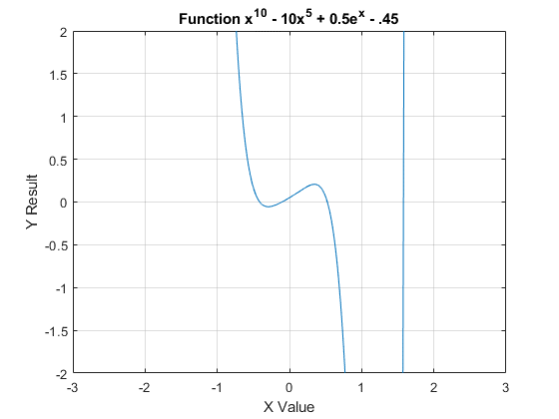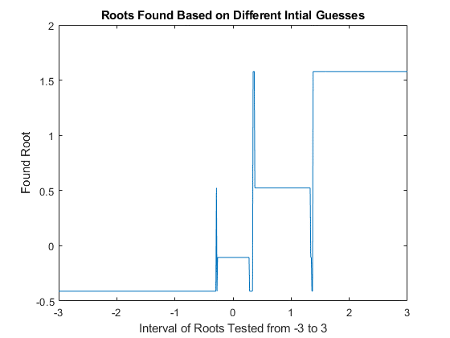

The graph on the left shows the function of which we are trying to find the roots (zeros) of. The graph on the right helps visualize what root each initial guess returned. 600 different initial values were tested on the interval of -3 to 3 to create the graph on the right. Four roots can be identified at -0.41199, -0.10565, 0.52431, 1.5785.

1. Newton-Raphson does not always find the closest root. Near each local minimum or maximum, the closest root may not be found. This is a result of the derivative being flat at those points and therefore going to far in the horizontal direction i.e. moving away from the closest root. A specific example is x at -0.28548 which returns y is 0.52431 even though y at -.41199 or -.10565 would be closer.
2. The root which we will look for with each method is 0.52431. Bisection will be setup using a bound distance of only one extending from .5 to 1.5. There is only one root in this bracket. To be fair, Newton-Raphson will also start at .5. Bisection takes 15 iterations compared to Newton-Raphson taking only 3. Newton-Raphson is able to find to root so much faster because it utilizes the linear shape of the function at .5. In comparison, bisection keeps doing the same thing despite what the graph looks like. This is testing Newton-Raphson under ideal conditions because it works best with a linear graph. I set it up this way because this is the condition when someone would use Bisection. As the graph in c shows, there are spots on the graph where a Bisection would be used over Newton-Raphson like at minimum and maximums.

Problem 3:









The step sizes I picked where very intentional to show three different behaviors of specifically how Forward Euler graphs the function. The first step size was set to 1/8. This function goes to 0 because α = 8 and step size (h) = 1/8. |1 – α*h| < 1 which means the function will decay to 0 with Forward Euler.

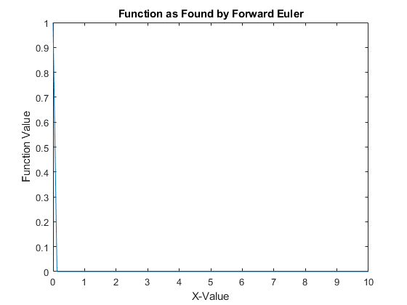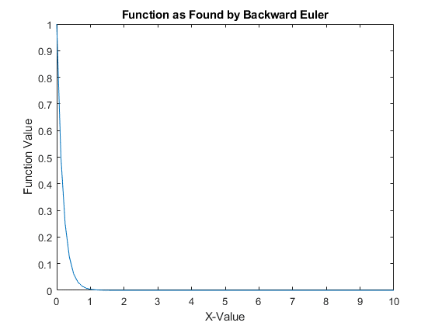

The next step size picked was h = 1/4. The graph will not decay to 0 but is marginally stable because |1 – α*h| = 1 for Forward Euler.

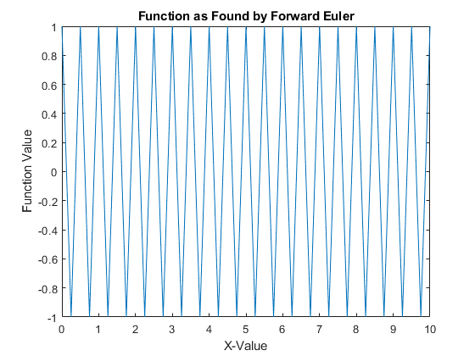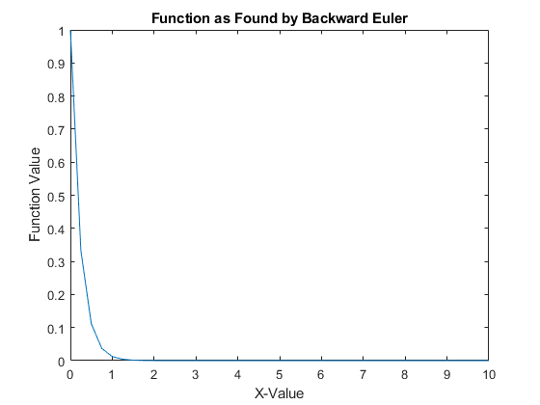

The final step size which I picked was h = 1/2. The graph Forward Euler graph is unstable and goes to infinity. |1 – α*h| > 1 indicates this will happen because Forward Euler is only conditionally stable.

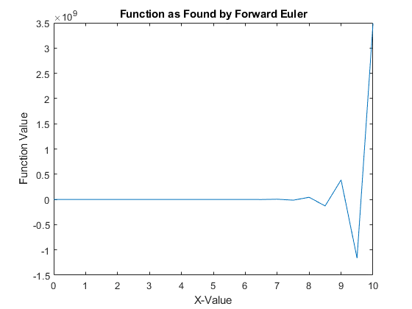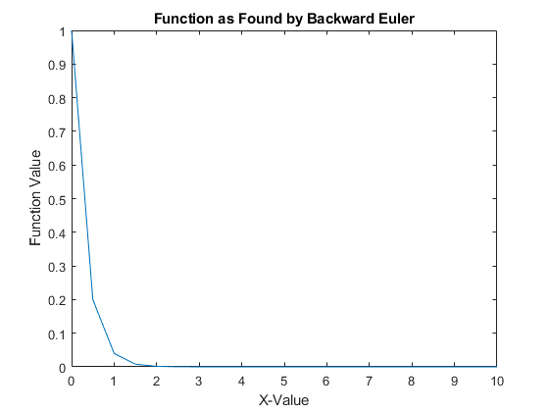

This exercise also shows the unconditionally stable property of Backward Euler. I placed the function result of Backward Euler to the right of each function result of Forward Euler. Each d)

1. Backward Euler graph is stable despite the step size. Overall, the step size mostly effects the resolution of the graph and accuracy of the true function value at each point. Smaller step sizes create a clearer graph, but even a large step size will still build stable graphs. This is the largest difference between Forward and Backward Euler.
2. Forward Euler is significantly faster than Backward Euler. When step size is small, for this particular problem, it is hard to notice so I made the step size equal to 1/1000000. It took 0.691770 seconds to run the Forward Euler function. In comparison, Backward Euler required 25.187988 seconds. Forward Euler is 36.411 times faster for this particular problem. An even more complex problem would further widen this gap.