The output on the screen for the problems

Problem 1:

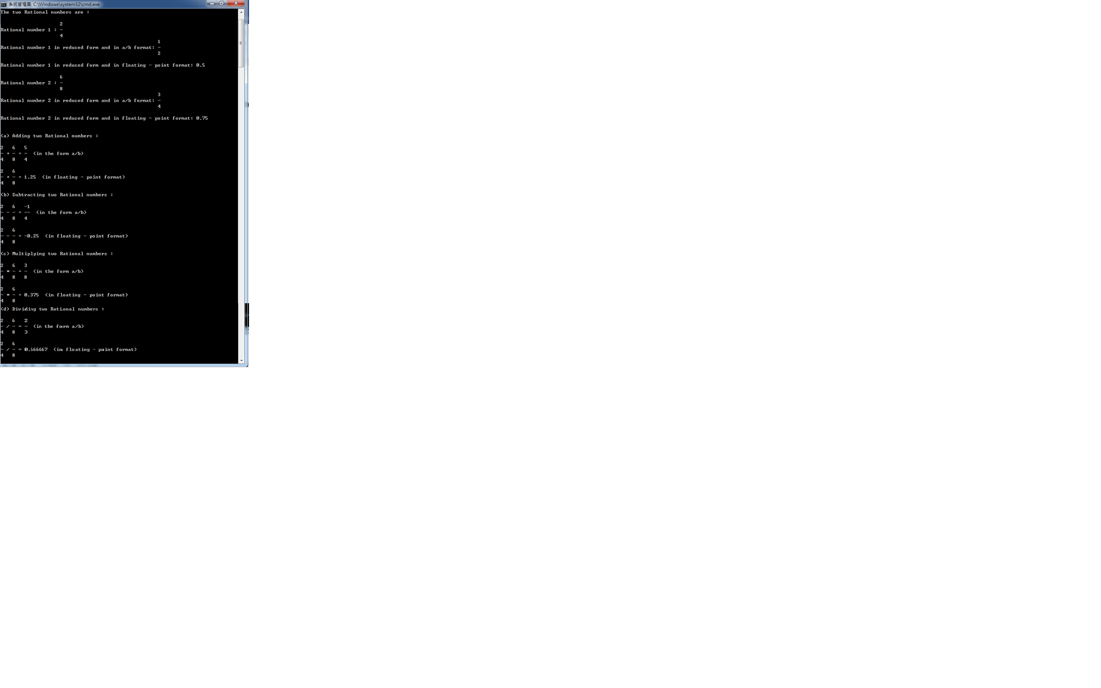

Problem 2:

1. incrementing into next minute

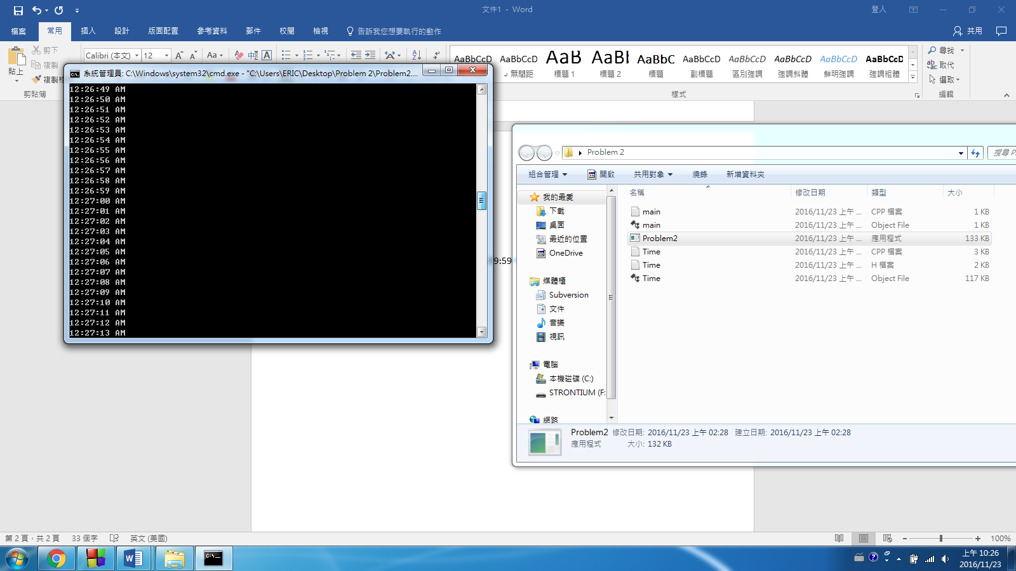

incrementing into next second minute\\\\\\\

incrementing into next minute

1. incrementing into next hour

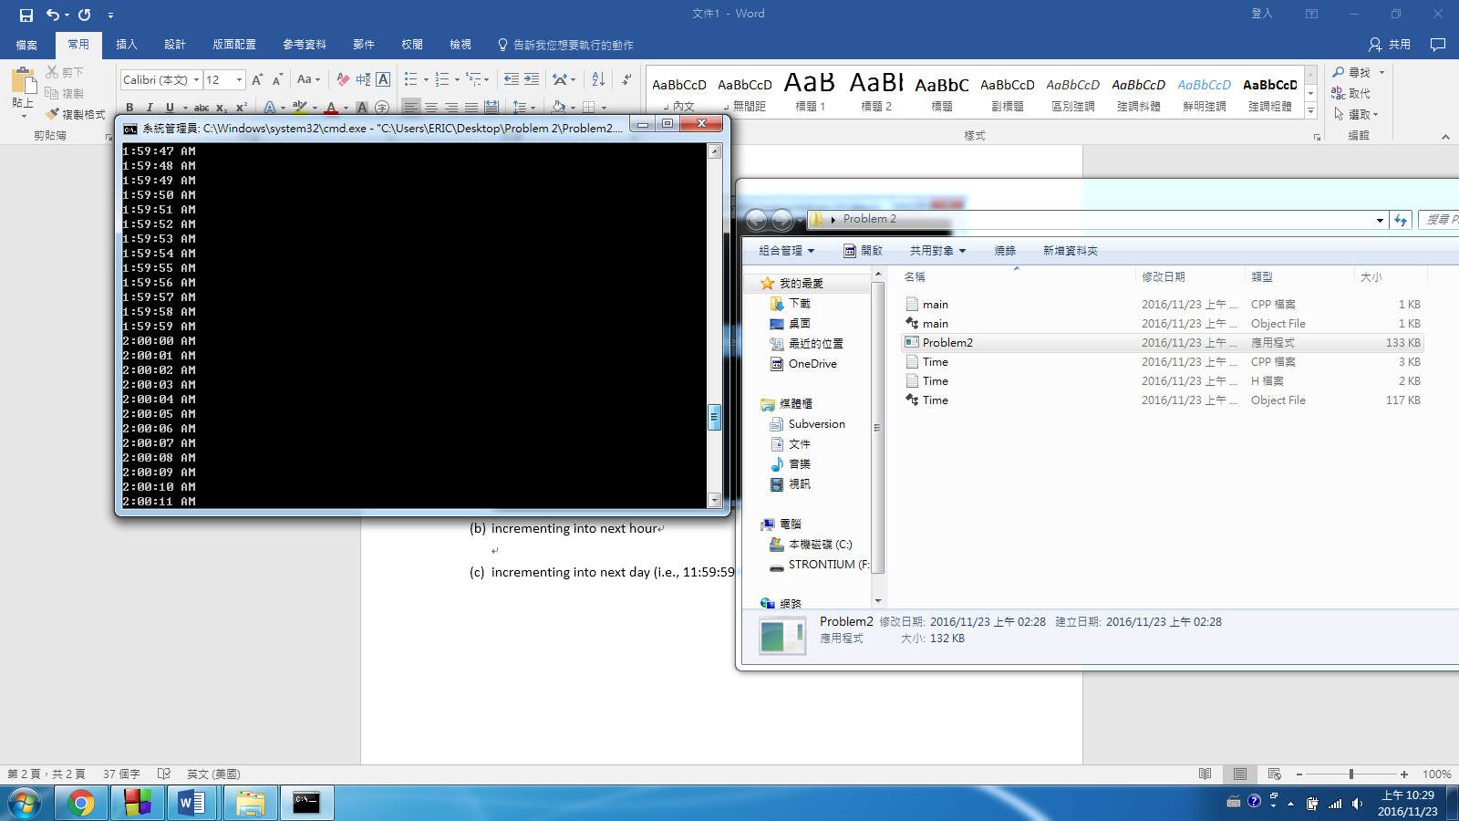

incrementing into next hour

1. incrementing into next day (i.e., 11:59:59 PM to 12:00:00 AM)

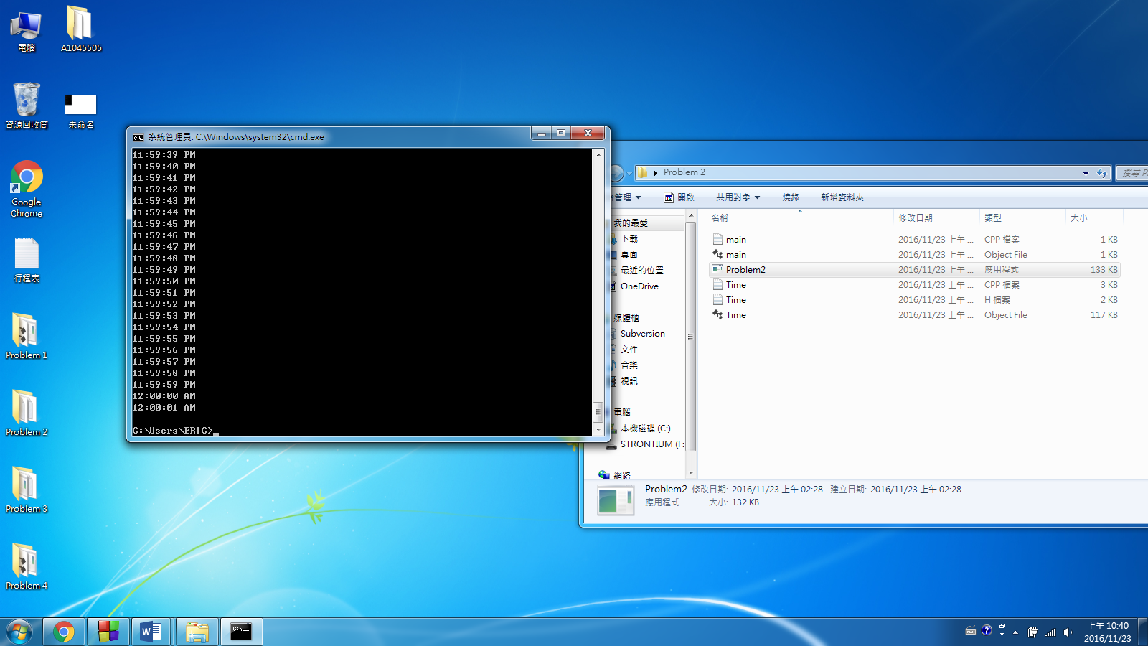

incrementing into next day

Problem 3:

1. incrementing into next month

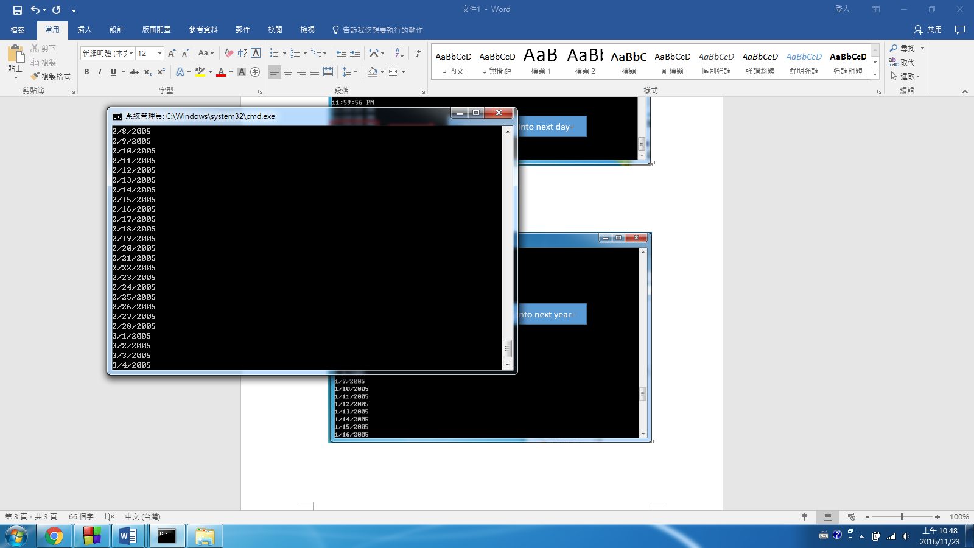

incrementing into next day

incrementing into next month

1. incrememting into next year

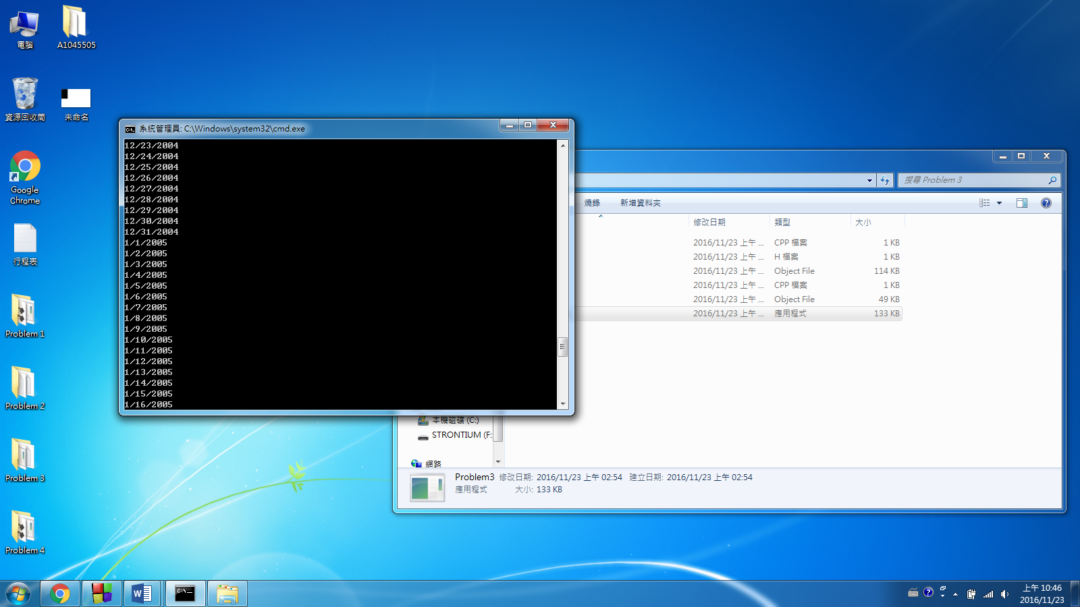

incrementing into next year

Problem 4:

1. incrementing into next day

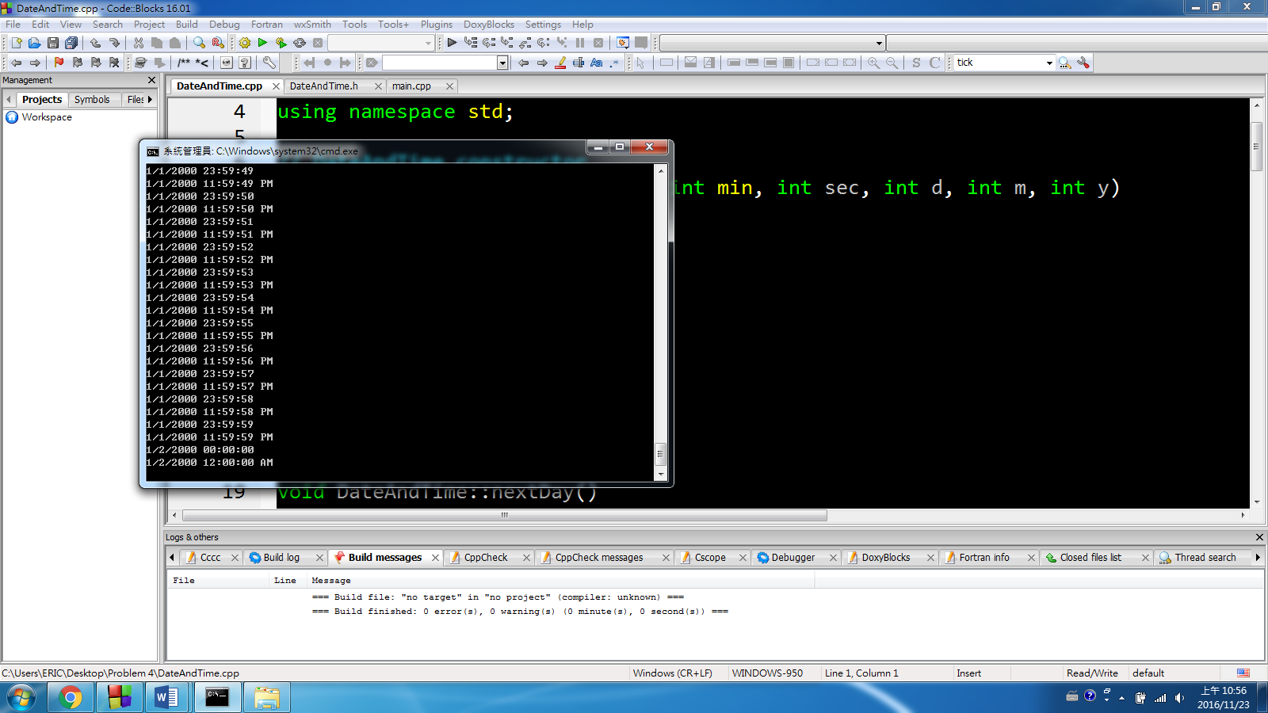

incrementing into next second

incrementing into next day

1. incrementing into next month

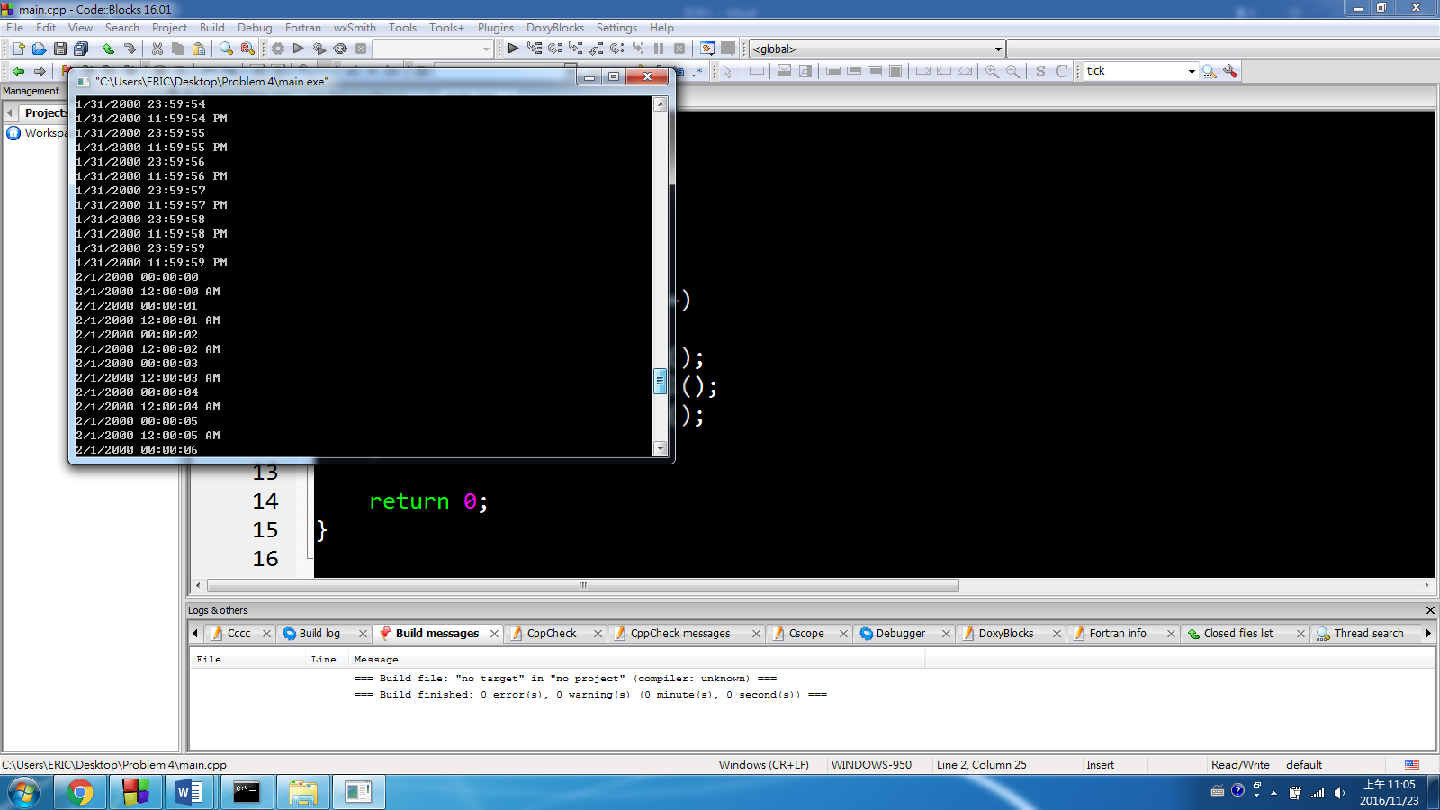

incrementing into next month

1. incrementing into next year

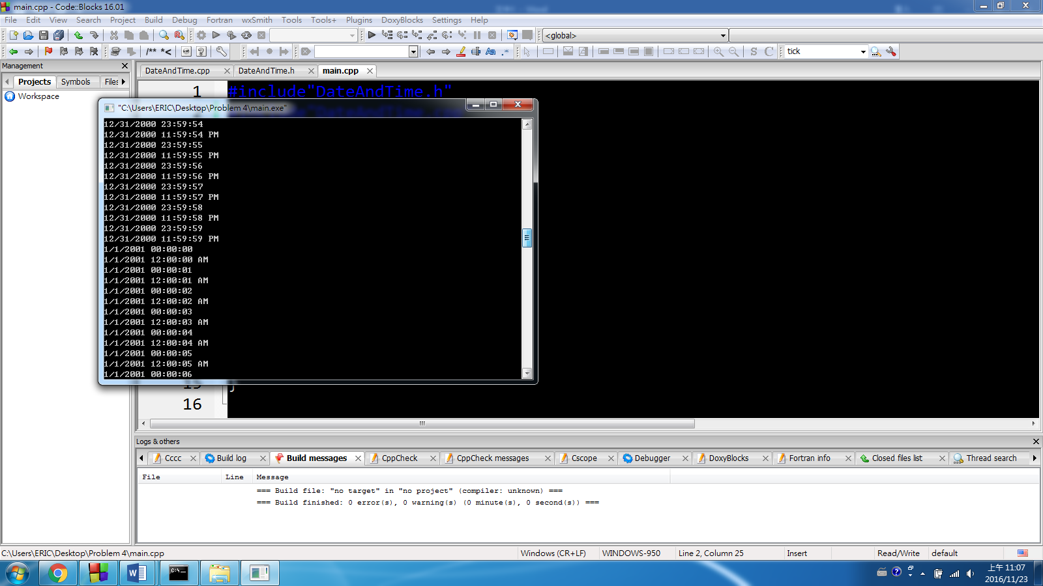

incrementing into next year