*Denoising ECG signal employing a*

*Convolutional-Recurrent Autoencoder and a Chazal’s filter substitute*

Wyctor Fogos da Rocha  
*Departamento de Engenharia Elétrica*  
*Instituto Federal do Espírito Santo  
Vitória, Brazil  
ORCID: 0000-0002-1909-7274*

Maylon Folli  
*Departamento de Engenharia Elétrica*  
*Instituto Federal do Espírito Santo  
Vitória, Brazil  
ORCID: 0000-0002-1645-1112*

Rodrigo Varejão  
*Departamento de Engenharia Elétrica*  
*Instituto Federal do Espírito Santo  
Vitória, Brazil  
ORCID: 0000-0002-1645-1113*

*Abstract*— The diagnostic process of electrocardiography (ECG) is done by acquiring data from the electrical activities of the heart over a period of time. In this process, electrodes are used on the patient's body and connected to a device, which measures the number of pulses per minute. However, the electrodes' connection to the patient's skin can be poorly connected or even have some other problem, which causes noise to be added to the acquired signal. With this, this paper proposes an AutoEncoder model with Convolutional layers to reduce the influence of noise in the recorded signal, and thus reconstruct a signal with minimal distortion. The difference in this work is the replacement of the Chazal filter by the AutoEncoder, varying the influence of noise on the input signal. As a result an average RMSE error of 64.037 % and average SNR of dB was obtained as the noise influence at 100 %.

Keywords — ECG, AutoEncoder, Convolucional, Noise, Chazal’s Filter.

# INTRODUCTION

In the process Electrocardiography (ECG), a diagnostic process based on the non-invasive, efficient and low-cost recording of heartbeats employed against cardiovascular diseases, a major cause of death in the world according to WHO [1]. In it, there are many factors that contribute to the influence of different types of noise, such as poor placement of the electrodes on the patient's body. Usually 10 electrodes are employed, placed on the body in the chest region [2]. As a result of the electrocardiogram process, a graph of the signal of the heart's electrical potential (ECG) [2]. The ECG waveform [9] is almost cyclical in that it repeats itself repetitively. This cycle represented by the ECG signal represents a cardiac cycle, where the frequency value ranges from 0.67 to 5 Hz.

The average cycle signal has five characteristic components: P, Q, R, S, and T, respectively, which correspond to specific events in the period of the cardiac cycle. The period between Q, R, and S has a large peak characteristic of the cardiac cycle, which corresponds to the moment of depolarization of the ventricles. Visual analysis of the QRS period can aid in the diagnosis of associated diseases such as cardiac cyclic.

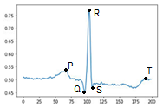

Fig. 1. The five components of the ECG signal.

ECG signals are subject to several factors that aggregate different types of noise and affect both the shape of the signal and the frequency spectrum of the signal [6].

Some of the sources of the noises in the signals, such as:

* Interference from the power supply of the electrocardiogram machine;
* Inappropriate contact of the electrode with the skin;
* Involuntary movements of the patient;
* Impedance of the skin;
* Muscle contraction;
* Respiratory activity.

With this, one of the goals in the process of denoising the ECG signal [8], is to remove possible noise from the signal, in order to keep as much of the ECG signal as possible. The purpose of this paper is to propose a Deep Recurrent Neural Networks (DRNN). This network uses its own database, with data acquisition from 105 patients for 3.8 minutes. With these data 60% were separated for training, 20% for validation and 20% for the final test.

The filtered signals used as parameters were obtained by using the filter proposed by Chazal, where a noise signal was added gradually, with a value of 10% of the maximum amplitude of the analyzed sample of the ECG signal.

This article is structured as follows: Section 2 reviews the existing methods for ECG signal recovery [9] and related applications employing Neural Networks.

In Section 3, the influence of noise on the output signal of the filter proposed by Chazal is discussed. In Section 4, the AutoEncoder model for the noise removal process of the ECG signal. In Section 5, the test results as the final model of AutoEncoder are shown. Section 6 presents the conclusions.

# RELAted WORKS

Different works are proposed as filters to mitigate the influence of noise on the ECG signal [16] and to remove the high-frequency (higher energy) signals [19], due to the low frequency value of the ECG signal. In the literature, several ANN models are proposed, employing convolutional layers or not.

The use of filters such as IIR [13][16] and FIR [16][17], seek to decrease the influence of components such as the frequency of the sampling signal, which has much of the energy of the signal.

Moreover, the use of autoencoders [18] is not only about decreasing the noise in the ECG signal [8].

# PROPOSAL

In this work we propose an autoencoder of deep recurrent network (Deep Convolutional Recurrent Neural Networks - DCRNN) both for the reduction of signal noise on the ECG signal and in the function of the Chazal filter [4], being similar to the deep recurrent networks (Deep Recurrent Neural Networks - DRNN), having as a differential the convolutional layer.

The convolutional layer has as a great differential, the ability to filter the features of the data, which guarantees the recognition of the main characteristics of the data. Although these layers are the most suitable for filtering data, they require a large computational power for training, and it is recommended the use of video cards or even TPUs (Tensor Processor Unit) for the training process of neural networks (Artificial Neural Network - ANN), which makes this layer restricted to certain applications, such as deep neural networks (DNN). When the latter networks have convolutional layers, they are called convolutional neural network (CNN) [7][11][12]. In this project, the TPUs were used in Google Colab, where the code was used with employing sessions with the Jupyter Notebook.

For problems involving data that depend on previous information about the data, neurons are needed that will retain this temporal information. These are Deep Recurrent Neural Networks (DRNN).

A widely used architecture of the latter type of DRNN is the Long Short-Term Memory 1 (LSTM) block [14][15]. This type of block retains temporal information within itself for a period of time, as shown in Fig. 2.

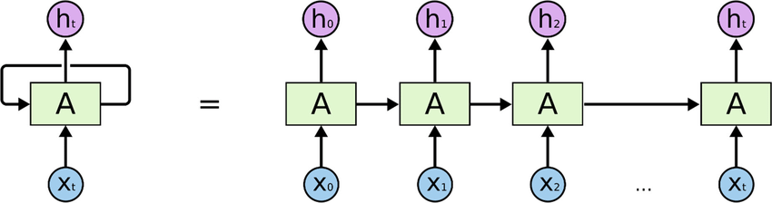

Fig. 1. Schematic of the architecture of LSTM [21].

In this architecture, the input data is applied one at a time and then propagated to the output, with the same size as the input data. This architecture is useful for several works where temporal information is relevant, such as in the use of autoencoders.

In this paper, a Convolutional-Recurrent Neural Network (CRNN) is proposed, in which the convolutional layers part serves to reduce the influence of signal noise and the DRNN part as an autoencoder, as a replacement algorithm for the Chazal filter [4].

The process of signal reconstruction can be visualized in Fig. 3.

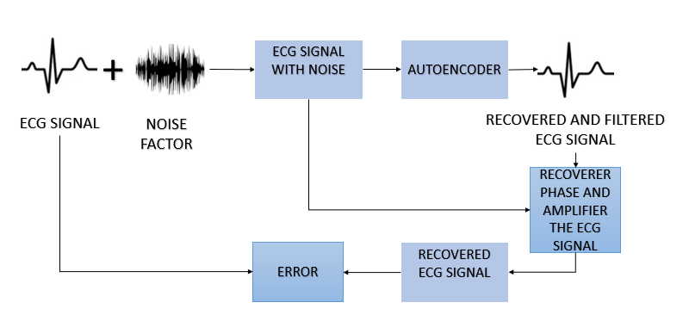

Fig. 2. Schematic of the proposed work.

The noise level is increased gradually, every 10 %, to analyze the influence of noise on the output of the autoencoder.

# EXPERIMENTS

To perform the role of a filter capable of decreasing the influence of noise and low and high frequency signals, convolutional layers and ECG signal reconstruction by signal compression were used.

At the input, a layer with the same size as the ECG signal (140x1) is connected to two blocks with convolutional layers (64 and 32 filters, respectively), which extract the main features of the signals automatically. Soon after, the features are retained in the LSTMs [14][15] over an epoch and have these blocks connected soon after to a concatenation block [17].

In the autoencoder part, the layers are densely connected to each other, and are also connected to a layer with the subtraction operation between the encoder and decoder layers of with the same number of neurons, so that the output has the same size as the input.

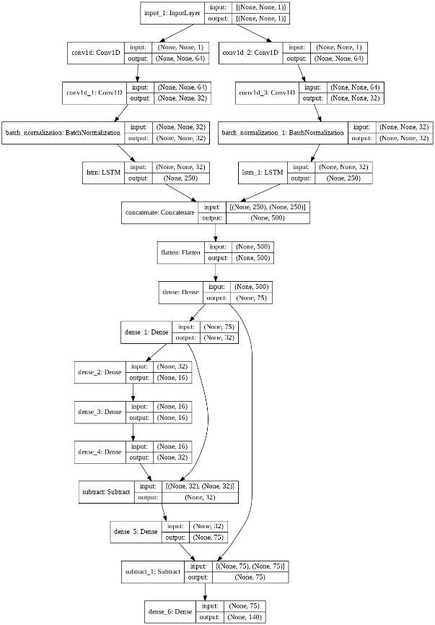

Fig 3. Architecture of the proposed model

Para validação do modelo proposto, para avaliar os resultados, são necessários outros modelos, como:

* Chazal’s Filter.
* DRNN.
* FCNN.
* VANILLA LINEAR.
* VANILLA NLINEAR.
* MULTIBRANCH LANL.
* MULTIBRANCH LANLD.

## Dataset

In order to train ANNs, it was necessary to use a database with a large amount of collected signals that could best represent the collections performed in a practical way.

The QT Database was created to meet this demand, and it was made with the intention of being a reference database containing annotations identified by cardiologists, with a large amount of different ECG morphologies. The database has 105 15-minute recordings, with 2 channels and sampling frequency of 250 Hz. All sampled passages are of normal character, and are audited for gross errors and abnormalities in beat rhythm patterns [17].

From the total records, only excerpts with manual annotation by a cardiologist and reviewed by the author were selected. The final set consists of 216 beats of which 184 are P waves, 216 QRS complexes, and 216 T waves.

## Train Process

To perform the autoencoder training, the data was separated into 60% training, 20% validation and 20% test.

The noise signal was added gradually, every 10 %, in order to be able to visualize how the increasing influence of noise on both the Chazal Filter [4] and the autoencoder removal.

In the process of training the models, the hyperparameters were specified as shown in Table I.

TABLE I. HYPERPARAMETERS USED IN THE TRAINING OF THE MODELS

| Hyper parameter | Employed in our model |
| --- | --- |
| Batch size | 32 |
| Maximum of epochs | 100 |
| Learning Rate | $$5e-5$$ |
| Optimizer | Adaptive Moment Estimation |

Para treinar os modelos de base, cada um deles foram retreinados com base nos hiper-paramêtros da Tabela I.

## Hardware and Software

The components described in Table II were used to develop and train this DCRNN.

TABLE II. TABLE OF THE USED EQUIPMENT

| Equipment | Description |
| --- | --- |
| TPUs | 8 unidades de *Tensor Processor Unit* (Google Colab) |
| Computer | Processador core I5, 16GB RAM, com uma GPU Nvidia GTX 1050TI |

In addition, it is worth mentioning that Tensorflow was used as a framework to develop the models used.

## Evaluation Metrics

To evaluate the model in question, three metrics employed in different works were delivered:

* RMSE.
* PRD.
* SNR.

The RMSE is used to determine the variation between the model's predicted output (reconstructed signal) and the actual output. A smaller RMSE value corresponds to a smaller difference and better performance, and is defined as: $RMSE=\sqrt{\frac{1}{N}×\sum_{n=1}^{N}{(x_{i}-{x^{'}}_{i})}}$ (1)

The second metric employed is PRD [10], which indicates the recovery quality of the compressed signal by measuring the error between the original signal and the resulting signal after reconstruction. A lower PRD represents a better quality of the reconstructed signal. The DRP is expressed by the equation below:

$PRD=\sqrt{\frac{\frac{1}{N}×\sum_{n=1}^{N}{{(x_{i}-{x^{'}}_{i})}^{2}}}{\frac{1}{N}×\sum_{n=1}^{N}{{(x_{i})}^{2}}}}$ (2)

The third metric is the signal-to-noise ratio (SNR) [10][20], which indicates attenuation caused by the autoencoder in the noise abatement process by comparing the reconstructed signal to the original signal.

$SNR_{\text{out }}=10×\log_{10}\left(\frac{\sum_{n=1}^{N}{ }x_{i}^{2}}{\sum_{n=1}^{N}{ }{\left({\hat{x}}_{i}-x_{i}\right)}^{2}}\right) (3)$

It should be remembered that the SNR is given in decibels (dB). Also, xi represents the signal expression of the original data, before the addition of the noise signal.

# RESULTS

The preliminary results showed an RSME error of almost constant value, due to the difference between the output signal between the ECG signal before and after passing through the Chazal filter [4], as can be seen in Figure 4.

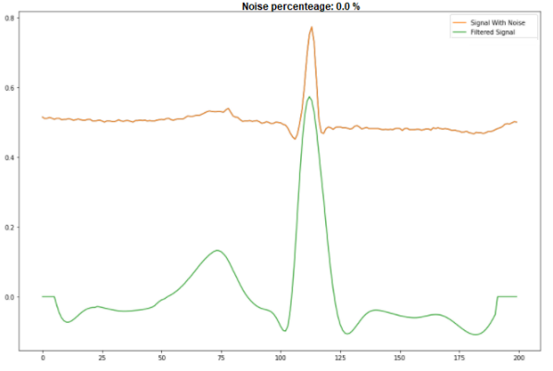

Fig. 4. Input and output signals given by the Chazal filter, without noise.

As the input signal increases in noise level, however, there is a large deformation in the output signal, which makes the signal unusable for analysis, showing that the Chazal Filter [4] has a limitation regarding the influence of noise on its input, as can be seen in Figure 5.

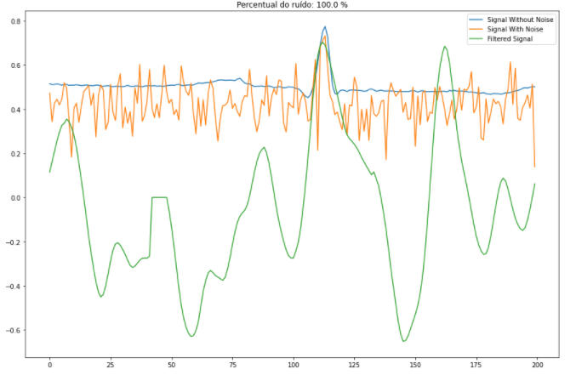

Input and output signals given by the Chazal filter, with the influence of 100 % of the signal noise.

Na Tabela III é visto como a influência do ruído interage e altera o sinal de saída.

TABLE III. COMPARISON BETWEEN THE MODELS AND THE FILTER

| Percentual de ruído | Parâmetros | | |
| --- | --- | --- | --- |
| RMSE (%) | PRD (%) | SNROUT (dB) |
| 0 | 64,657 | 105,2652 | -0,4475 |
| 10 | 64,702 | 106,2784 | -0,4789 |
| 20 | 64,699 | 105,1694 | -0,4378 |
| 30 | 64,370 | 105,6968 | -0,4812 |
| 40 | 63,884 | 105,5604 | -0,4700 |
| 50 | 63,633 | 105,1889 | -0,4394 |
| 60 | 63,633 | 105,6042 | -0,4736 |
| 70 | 63,841 | 104,9298 | -0,4180 |
| 80 | 63,776 | 104,9432 | -0,4191 |
| 90 | 63,592 | 105,0681 | -0,4294 |
| 100 | 63,625 | 105,9954 | -0,5057 |
| **Média** | **64,037** | **105,4273** | **-0,4546** |
| **Desvio Padrão** | 0,4690 | 0,43923 | 0,288 |

Table IV shows the average values for each of the models over the course of training with each of the 10 noise levels increased gradually.

TABLE IV. COMPARISON BETWEEN THE MODELS AND THE FILTER

| Algoritmo | Parâmetros (valores médios com base nas 10 análises) | | |
| --- | --- | --- | --- |
| RMSE (%) | PRD (%) | SNROUT (dB) |
| AutoEncoder proposto | 64.037 | 105.4273 | -0.4546 |
| Filtro de Chazal | 66.136 | 107.486 | 0.867 |
| DRNN | 73.730 | 119.5559 | -1.4126 |
| FCNN | **63.626** | 103.7005 | -0.3138 |
| Vanilla Linear | 64.349 | 104.6091 | -0.3912 |
| Vanilla Não Linear | 63.985 | 103.7120 | **-0.3165** |
| Multibranch LANL | 64.481 | 104.9784 | -0.4195 |
| Multibranch LANLD | 65.857 | 106.4071 | -0.5375 |

However, although the Vanilla Nonlinear model had the lowest attenuation in the output signal and the lowest variance of the reconstruction signal, it had one of the worst errors in the signal reconstruction, as shown in Figure 6.

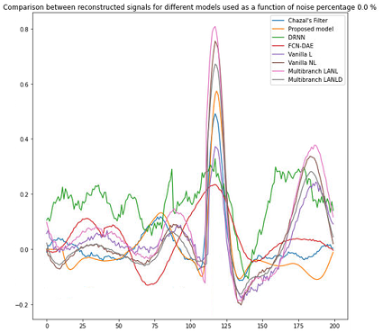

Fig. 5. Input and output signals given by the Chazal filter, with 0 % noise.

For an increase in the noise level, a partial loss in signal reconstruction in the P and T regions can be observed for the Chazal [4], DRNN and the FCNN [7] models, as shown in Figure 7.

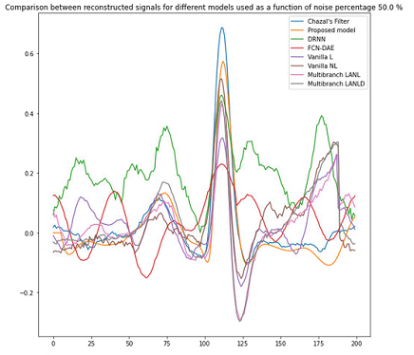

Fig. 6. Input and output signals given by the Chazal filter, with 50 % noise.

Increasing the noise level to 100 %, an almost complete loss of signal reconstruction in the P and T regions can be observed for the Chazal filter [4] and for the DRNN and FCNN models and partial Vanilla L [20], as shown in Fig. 8.

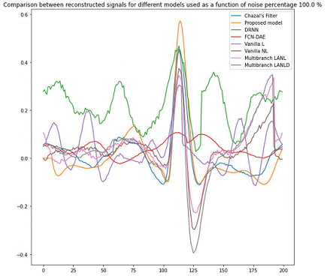

Fig. 7. Input and output signals given by the Chazal filter, with 100 % noise.

In addition, attenuation of the signals can be seen so as not to lose power, or Power Spectral Density 2 (PSD) of the reconstructed signal compared to the signal in the filter, when the signal influence is at 100 %. This can be shown in Fig. 9.

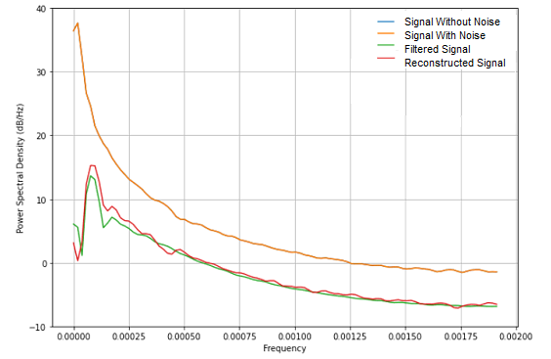

(a)

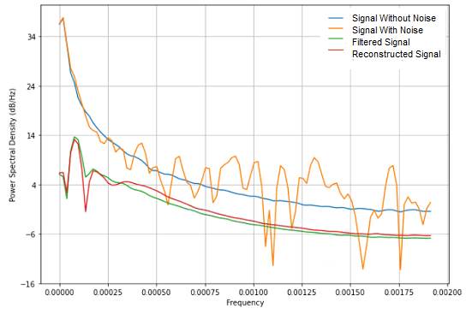

(b)

2 A densidade espectral de energia descreve como a [energia](https://pt.wikipedia.org/wiki/Energia) de um sinal, ou uma [série temporal](https://pt.wikipedia.org/wiki/S%C3%A9rie_temporal), será distribuída com frequência.

Fig. 8. PSD analysis by frequency, with the influence at 0 % (a) and 100 % (b) of the noise signal.

# CONCLUSION

The most recent autoencoder models proposed in the literature, with the advantage of being smaller and presenting a low signal attenuation value, although there is an average variance of 65.028 for the Chazal Filter [4], when it is without the influence of noise. Thus, the final model has a RMSE error of 64.037 %, PRD 105.427 % and SNR - 0.455 dB. Although the PRD value seems high, it can be seen that the reconstruction signal shape did not change much with increasing noise level at the input.

##### ACKNOWLEDGMENTS

##### Thanks to LabTeF (Laboratory of Future Technologies) for providing a computer to access Google Colab.

##### REFERENCES

1. Cardiovascular diseases (cvds). https://www.who.int/news-room/fact-sheets/detail/ cardiovascular-diseases-(cvds). Accessed: 2021-08-25.
2. Non-invasive tests and procedures | american heart association. https:// www.heart.org/en/health-topics/heart-attack/diagnosing-a-heart-attack/ noninvasive-tests-and-procedures. Accessed: 2021-08-25.
3. A. Velayudhan and S. Peter, "Noise Analysis and Different Denoising Techniques of ECG," in IOSR Journal of Electronics and Communication Engineering (IOSR-JECE) , 2016.
4. de Chazal P, O’Dwyer M, Reilly RB. Automatic Classification of Heartbeats Using ECG Morphology and Heartbeat Interval Features. IEEE Trans Biomed Eng. 2004;51:1196–206. PMid:15248536. doi: <https://doi.org/10.1109/TBME.2004.827359>.
5. S. Moein, "An MLP neural network for ECG noise removal based on Kalman filter," in Advances in Computational Biology, New York, Springer, 2010, pp. 109-116.
6. M Sabarimalai Manikandan and Samarendra Dandapat. Ecg distortion measures and their effectiveness. In 2008 First International Conference on Emerging Trends in Engineering and Technology, pages 705–710. IEEE, 2008.
7. J. Long, E. Shelhamer and T. Darrell, "Fully convolutional networks for semantic segmentation", *Proc. IEEE Conf. Comput. Vis. Pattern Recognit. (CVPR)*, pp. 3431-3440, Jun. 2015.
8. H. Shen, D. George, E. A. Huerta and Z. Zhao, "Denoising Gravitational Waves using Deep Learning with Recurrent Denoising Autoencoders," arXiv, vol. 1711, no. 09919, 2017.
9. S. Poungponsri and X.-H. Yu, "Electrocardiogram (ECG) Signal Modeling and Noise Reduction Using Wavelet Neural Networks," in Proceedings of the IEEE International Conference on Automation and Logistics , Shenyang, 2009.
10. Karol Antczak. Deep recurrent neural networks for ecg signal denoising. arXiv preprint arXiv:1807.11551, 2018.
11. Hsin-Tien Chiang, Yi-Yen Hsieh, Szu-Wei Fu, Kuo-Hsuan Hung, Yu Tsao, and Shao-Yi Chien. Noise reduction in ecg signals using fully convolutional denoising autoencoders. IEEE Access, 7:60806–60813, 2019.
12. Olaf Ronneberger, Philipp Fischer, and Thomas Brox. U-net: Convolutional networks for biomedical image segmentation. In International Conference on Medical image computing and computer-assisted intervention, pages 234–241. Springer, 2015.
13. H. K. Jayant, K. Rana, V. Kumar, S. S. Nair and P. Mishra, "Efficient IIR notch filter design using Minimax optimization for 50Hz noise suppression in ECG," in 2015 International Conference on Signal Processing, Computing and Control (ISPCC), Waknaghat, 2015.
14. S. Hochreiter and J. Schmidhube, "Long short-term memory," Neural computation, vol. 9, no. 8, p. 1735–1780, 1997.
15. H. Salehinejad, S. Sankar, J. Barfett, E. Colak and S. Valaee, "Recent Advances in Recurrent Neural Networks," arXiv, vol. 1801, no. 01078v3, 2017.
16. Francisco Perdigón Romero, Liset Vázquez Romaguera, Carlos Román Vázquez-Seisdedos, Marly Guimarães Fernandes Costa, João Evangelista Neto, et al. Baseline wander removal methods for ecg signals: A comparative study. arXiv preprint arXiv:1807.11359, 2018.
17. K. Greff, "LSTM: A Search Space Odyssey," IEEE Transactions on Neural Networks and Learning Systems , vol. 28, no. 10, pp. 2222- 2232, 2016.
18. O. Hernández and E. Olvera, "Noise Cancellation on ECG and Heart Rate Signals Using the Undecimated Wavelet Transform," in International Conference on eHealth, Telemedicine, and Social Medicine, 2009.
19. K Sravan Kumar, Babak Yazdanpanah, and P Rajesh Kumar. Removal of noise from electrocardiogram using digital fir and iir filters with various methods. In 2015 International Conference on Communications and Signal Processing (ICCSP), pages 0157–0162. IEEE, 2015.
20. F. P. Romero, D. C. Piñol, and C. R. Vázquez-Seisdedos, “DeepFilter: An ECG baseline wander removal filter using deep learning techniques,” Biomed. Signal Process. Control, 2021, doi: 10.1016/j.bspc.2021.102992.