**Results**

*Tree phenotype influences local environmental variation*

* PerMANOVA (Table 1)
* NMDS with vectors and points colored by susceptibility (Figure 1)

*Local environmental variation correlates with lichen community variation*

* Mantel
  + r = 0.23 P = 0.005
* Environmental X Community distance plot (Figure 2)

*Phenotype indirectly impacts lichen community variation*

* GLM table (Table 2)
* Barplots of community summary statistics (Figure 3a-c)
* PerMANOVA (Table 3)
* NMDS of community composition (Figure 3d)
* SEM path significances (Appendix 1)
* Path diagram with fit statistics (Figure 4)
* Indicator species analysis (Table 4)

**Tables**

|  |  |  |  |  |  |  |
| --- | --- | --- | --- | --- | --- | --- |
| ENV PerMANOVA | |  |  |  |  |  |
| source | Df | SS | MS | F | P-value | R2 |
| Moth | 1 | 0.85818 | 0.85818 | 21.822 | 0.001 | 0.27338 |
| Residuals | 58 | 2.28095 | 0.03933 | 0.72662 |  |  |
| Total | 59 | 3.13913 | 1 |  |  |  |

Table 1. Table for the PerMANOVA test of moth susceptibility on tree environmental variables.

|  |  |  |  |  |
| --- | --- | --- | --- | --- |
| Abundance GLM | |  |  |  |
| Source | Estimate | SE | t | P-value |
| (Intercept) | 0.638827 | 0.117157 | 5.453 | 1.07E-06 |
| Moth:Tree.pairs | 0.018241 | 0.009333 | 1.954 | 0.0555 |
| Richness GLM | |  |  |  |
| Source | Estimate | SE | t | P-value |
| (Intercept) | 1.32339 | 0.08316 | 15.914 | 2.00E-16 |
| Moth:Tree.pairs | 0.02089 | 0.0057 | 3.664 | 0.000248 |
| Diversity GLM | |  |  |  |
| Source | Estimate | SE | t | P-value |
| (Intercept) | 0.7461 | 0.107432 | 6.945 | 3.63E-09 |
| Moth:Tree.pairs | 0.020523 | 0.008558 | 2.398 | 0.0197 |

Table 2. Tables for the effect of moth susceptibility on lichen community abundance, richness and diversity (Shannon’s Index).

|  |  |  |  |  |  |  |
| --- | --- | --- | --- | --- | --- | --- |
| source | Df | SS | MS | F | P-value | R2 |
| env$Moth:env$Tree.pairs | 1 | 0.8211 | 0.82114 | 2.5772 | 0.034 | 0.04254 |
| Residuals | 58 | 18.4799 | 0.31862 | 0.95746 |  |  |
| Total | 59 | 19.301 | 1 |  |  |  |

Table 3. Table for the PerMANOVA test of the effect of tree phenotype on lichen community composition.

|  |  |  |  |
| --- | --- | --- | --- |
| species | cluster | indicator.value | probability |
| Canros | 2 | 0.6397 | 0.006 |
| Acasup | 2 | 0.6295 | 0.002 |
| Acacon | 2 | 0.4769 | 0.001 |
| Acaobp | 2 | 0.4241 | 0.008 |
| Phydub | 2 | 0.4125 | 0.018 |
| Calare | 2 | 0.2966 | 0.036 |

Table 4. Table for the indicator species analysis.

**Figures**

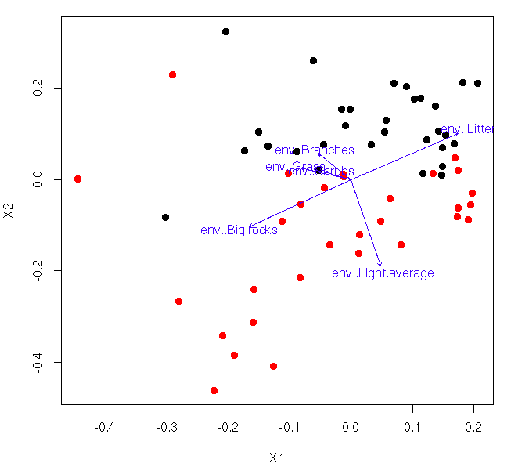

Figure 1. Ordination (NMDS) of individual trees based on their local environmental variables (Black = Susceptible, Red = Resistant). Vectors show the linear correlation of the environmental variables with the ordination axes.

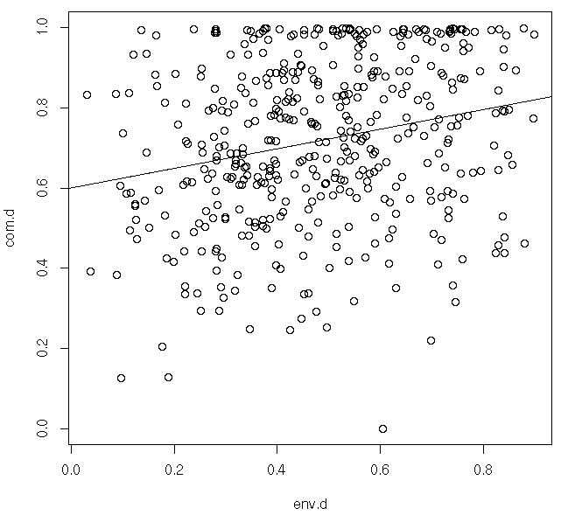

Figure 2. Scatterplot of the correlation between the environmental and lichen community distance values showing that the difference in communities increases with increasing difference in the local environment.

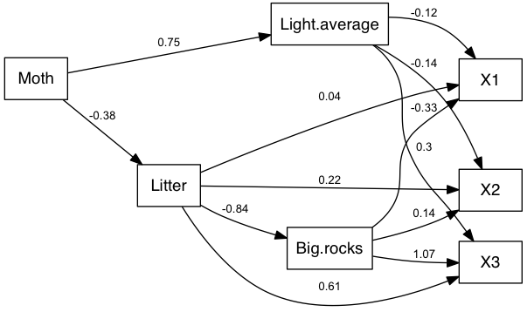Figure 3. Path diagram showing the standardized path coefficients for the SEM.

Appendix 1

|  |  |  |  |  |
| --- | --- | --- | --- | --- |
| Appendix SEM path values |  |  |  |  |
| Estimate | From | To | zvalue | Pr(>|z|) |
| g.1.2 | Moth | Light.average | 8.6365177 | 0.00000 |
| g.1.3 | Moth | Litter | -3.1524416 | 0.00162 |
| b.2.5 | Light.average | X1 | -0.9302163 | 0.35226 |
| b.2.6 | Light.average | X2 | -1.0876265 | 0.27676 |
| b.2.7 | Light.average | X3 | 3.326687 | 0.00088 |
| b.3.4 | Litter | Big.rocks | -11.8483246 | 0.00000 |
| b.3.5 | Litter | X1 | 0.1757412 | 0.86050 |
| b.3.6 | Litter | X2 | 0.9444861 | 0.34492 |
| b.3.7 | Litter | X3 | 3.7988627 | 0.00015 |
| b.4.5 | Big.rocks | X1 | -1.5137398 | 0.13009 |
| b.4.6 | Big.rocks | X2 | 0.6063031 | 0.54431 |
| b.4.7 | Big.rocks | X3 | 6.8117662 | 0.00000 |
| e.1 | Moth | Moth | 5.4313902 | 0.00000 |
| e.2 | Light.average | Light.average | 5.4313902 | 0.00000 |
| e.3 | Litter | Litter | 5.4313902 | 0.00000 |
| e.4 | Big.rocks | Big.rocks | 5.4313902 | 0.00000 |
| e.5 | X1 | X1 | 5.4313902 | 0.00000 |
| e.6 | X2 | X2 | 5.4313902 | 0.00000 |
| e.7 | X3 | X3 | 5.4313902 | 0.00000 |