Facilitation Modulates the Impact of Phylogenetics on Plant-Plant Community Network Structure

Lau M.K., Butterfield B.J., Michalet R., ALPINE PALS

Summary:
- Evolutionary processes are likely to play a significant role in structuring local ecological processes, however it's prevalence in complex communities is not well studied.
- In our study we combine network and phylogenetic tools to assess the influence of evolutionary forces on the dynamics of multi-species plant communities in a world-wide database of alpine plant communities.
- Questions:
  - How does facilitation alter the structure of community-wide covariances?
  - Is there a phylogenetic signal?
  - Does the variance in the phylogenetic signal strength vary with environmental severity?
- Main Findings:
- Significant variation in network structure between cushion and open with the cushion tending to have more relationships among species; however the average number of positive and negative values and the magnitude of the relationships didn't differ.
- There is a significant relationship between phylogenetic similarity and two network structure statistics, but only inside of cushions.
- When controlling for the sampling intensity and the local environmental variation, phylogenetics plays a significant role in determining network structure with a total of 41% of the variation explained.
- These results strongly suggest that facilitation by cushion plants determines the phylogenetic signal in alpine plant communities. This effect could result from the cushion's reduction of environmental variation, providing stabile conditions for species the phylogenetic signal in interactions to influence covariance patterns among species.

The general structure of this summary (including all the results below) seems to suggest a hierarchy of variables: 1) exogenous factors, including climate variables, productivity, the total species or clade pool across cushions and open habitat, and sampling intensity, although only the latter is included; 2) differences in community composition between paired open and cushion plots, including species-based differences (abundance, richness, composition) and phylogenetically-based differences (phylobetadiversity, NRI difference, phylogenetic diversity differences; 3) emergent properties of network structure. Now, why we should care about network structure is unclear. What additional insights does it provide? Does it allow us to predict something about emergent properties at another scale, such as productivity or stability?
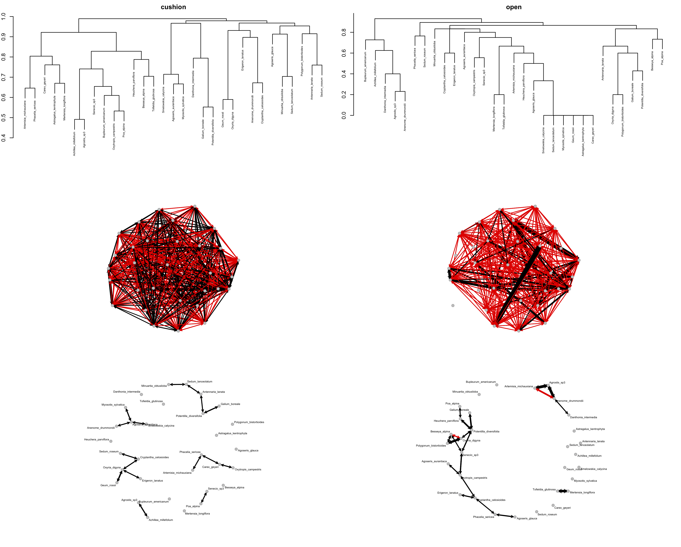

Result 1: The construction of the alpine plant community networks. Distance between species were calculated using Bray-Curtis dissimilarity as would be used to construct clusterings of species groups (top panel set). These distances were then converted to pairwise correlations among species (middle panetl set) and a minimal topology for the network was resolved using the methods of Dyer and Nasson 2004 (lower panel set). Lines represent positive (black) and negative (red) correlations among species. The minimal topology is desirable as it represents the unique relationships among species that are not explained by their relationships with other species. This process was conducted on 77 of the Alpine Plant datasets.
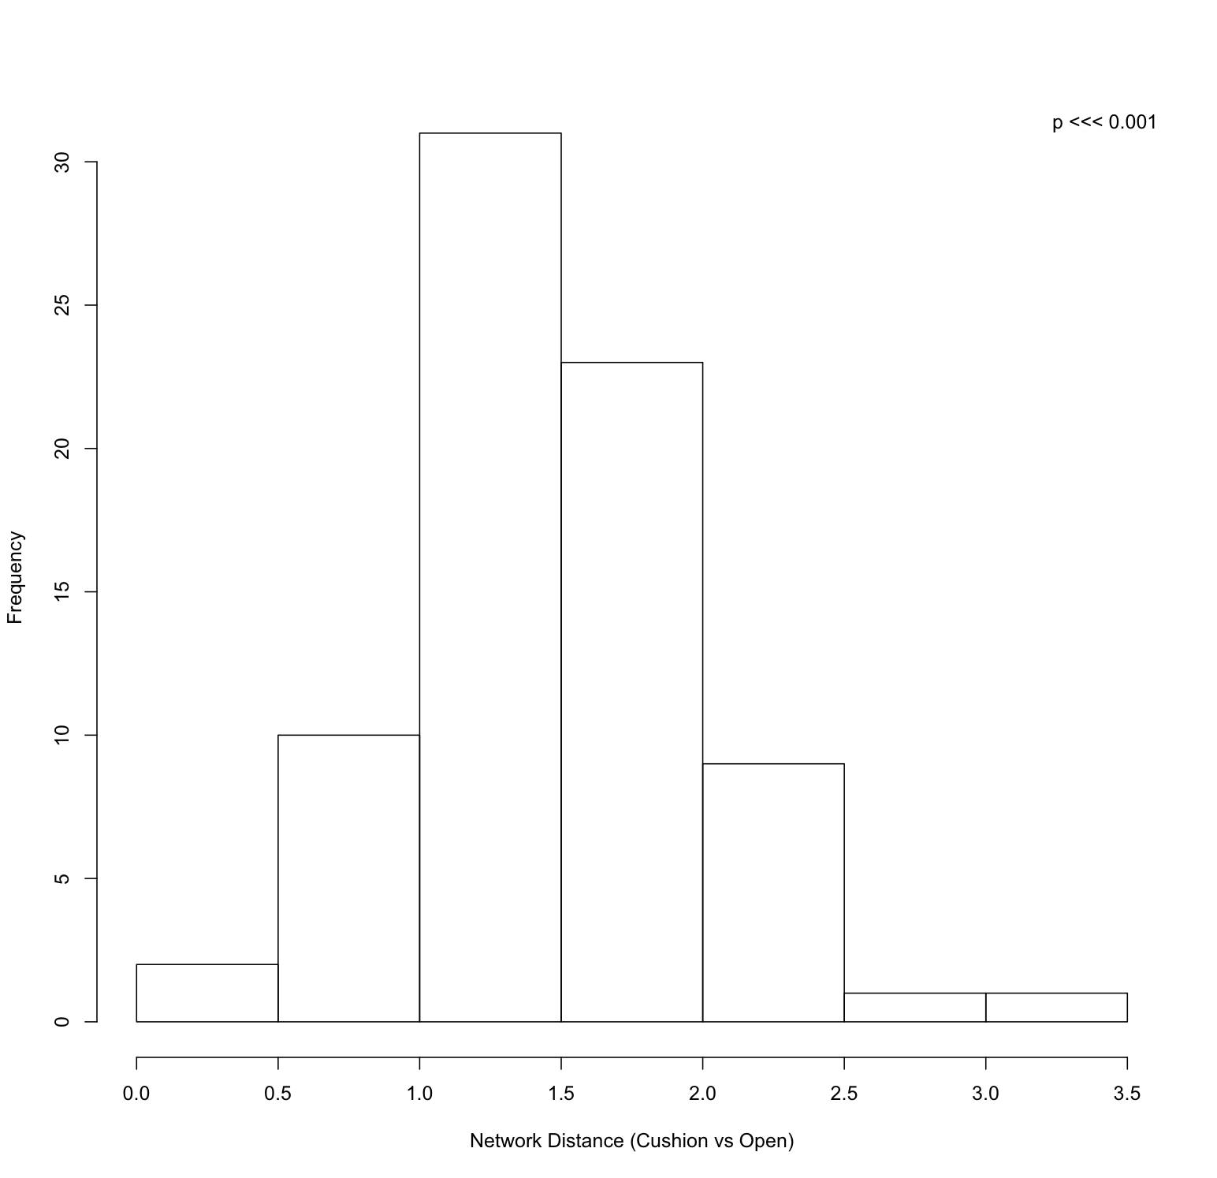

Result 2: To compare the difference in the structure of networks we calculated the Euclidean distance between the Cushion and Open networks. The histogram shows the distribution of the distances which shows a significant difference in the distance between Cushion and Open networks. The overall distance between the two networks tended to be positive. P-value is from a Wilcox signed rank test.
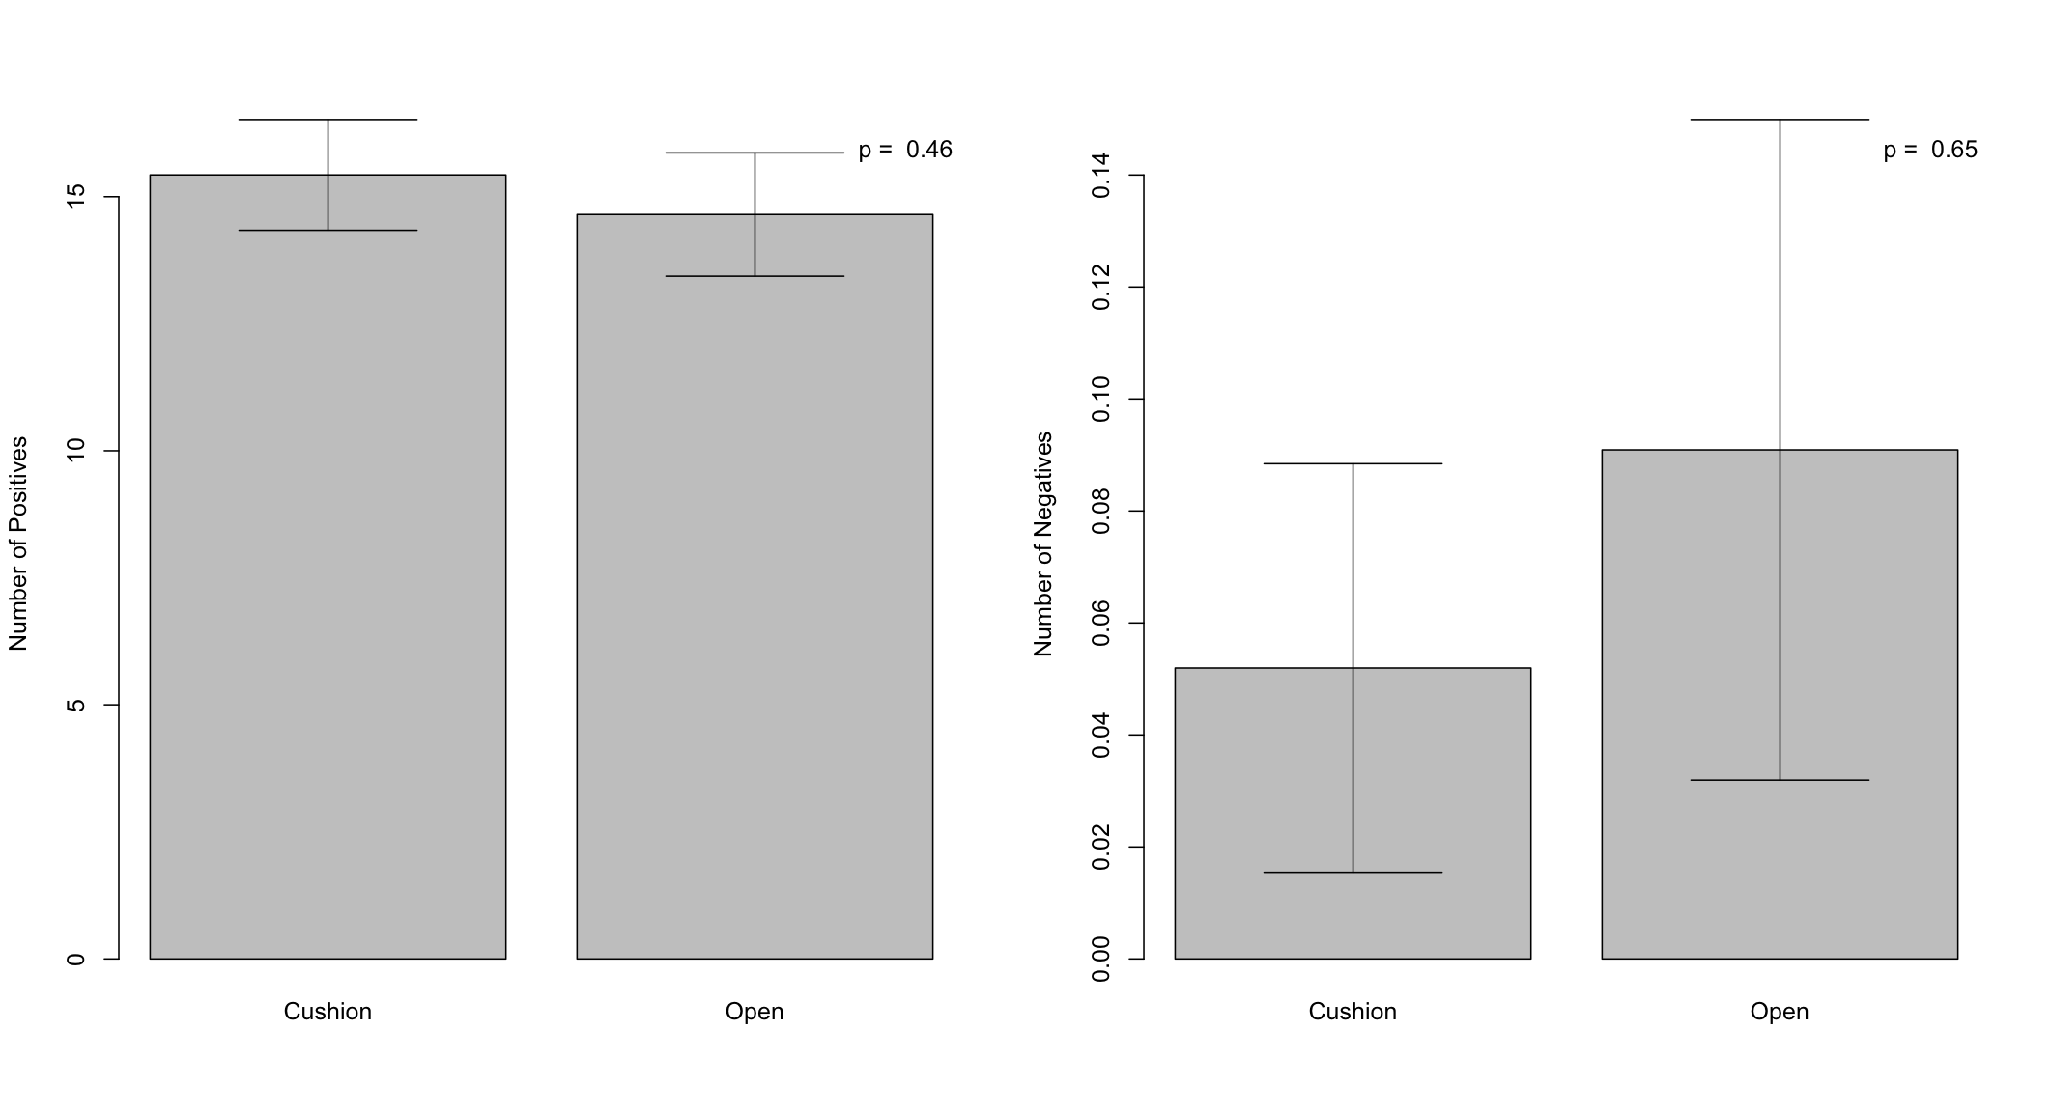

Result 3: To see of the frequency of relationship type (positive or negative) differed between the Cushion and Open, we counted the number of values in the networks both greater and less than zero. There was no significant difference in the number of positive or negative covariances between cushion and open. P-values are from Mann-Whitney U tests.

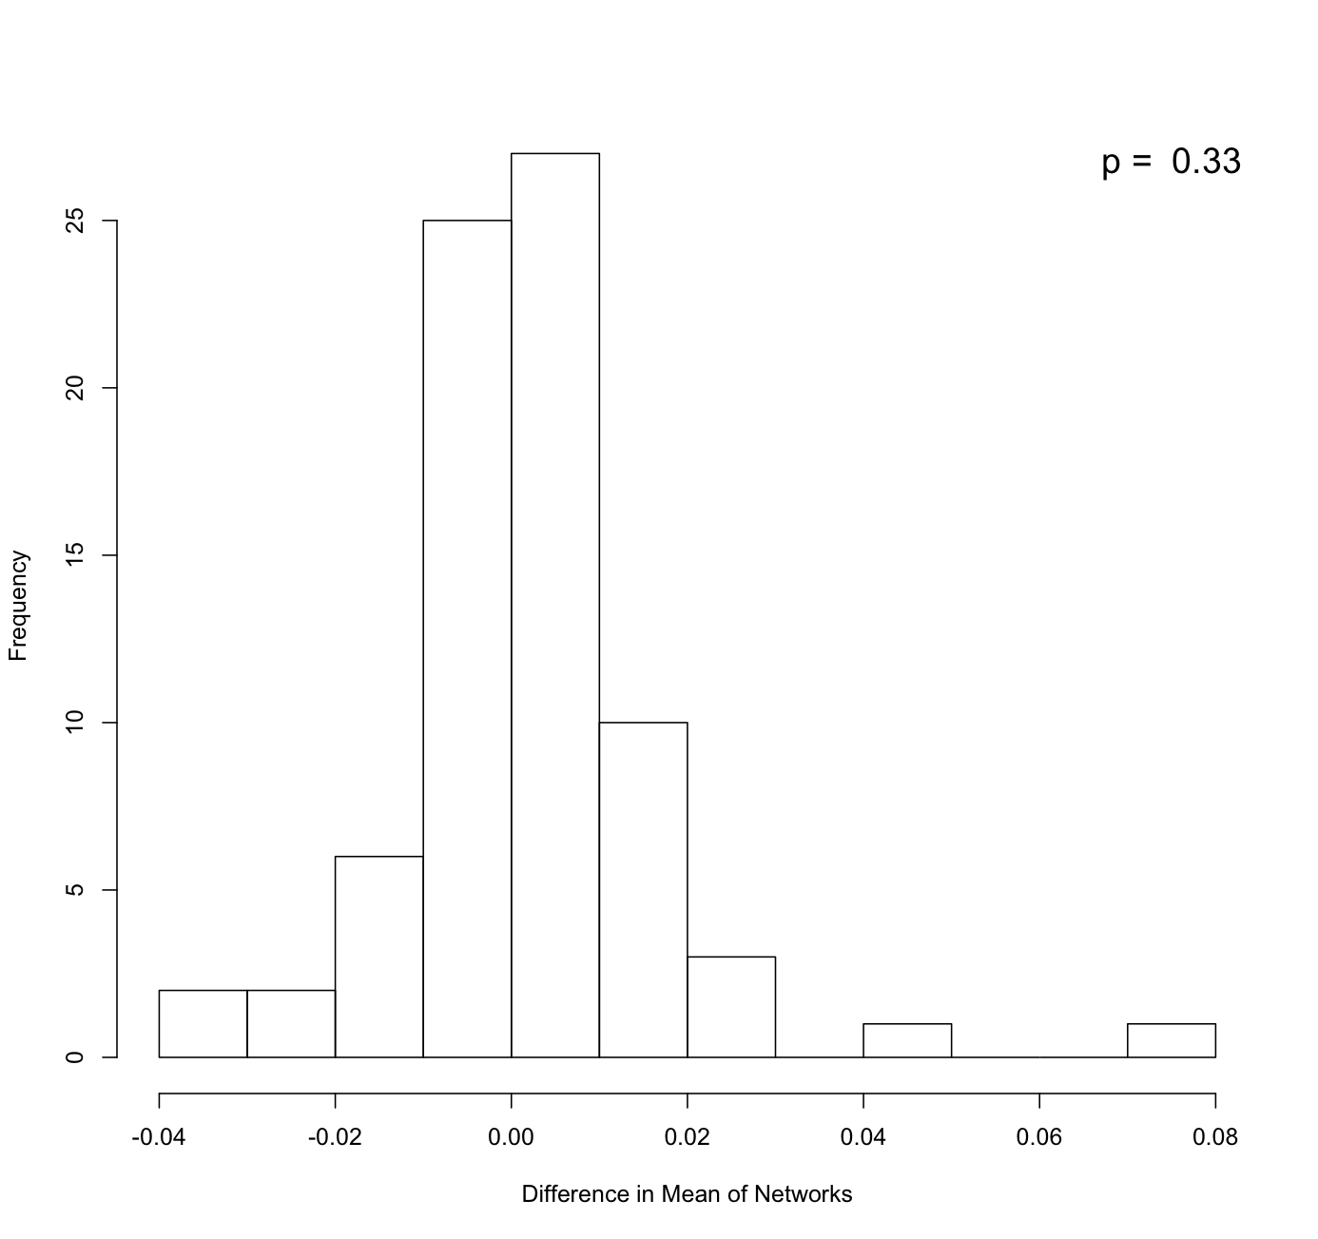

Result 4: As a way to assess whether there was a difference in the magnitude of values we averaged the off-diagonal elements for all networks. No difference in the average magnitudes of the covariances between cushion and open networks. P-value is from a Wilcox signed rank test.

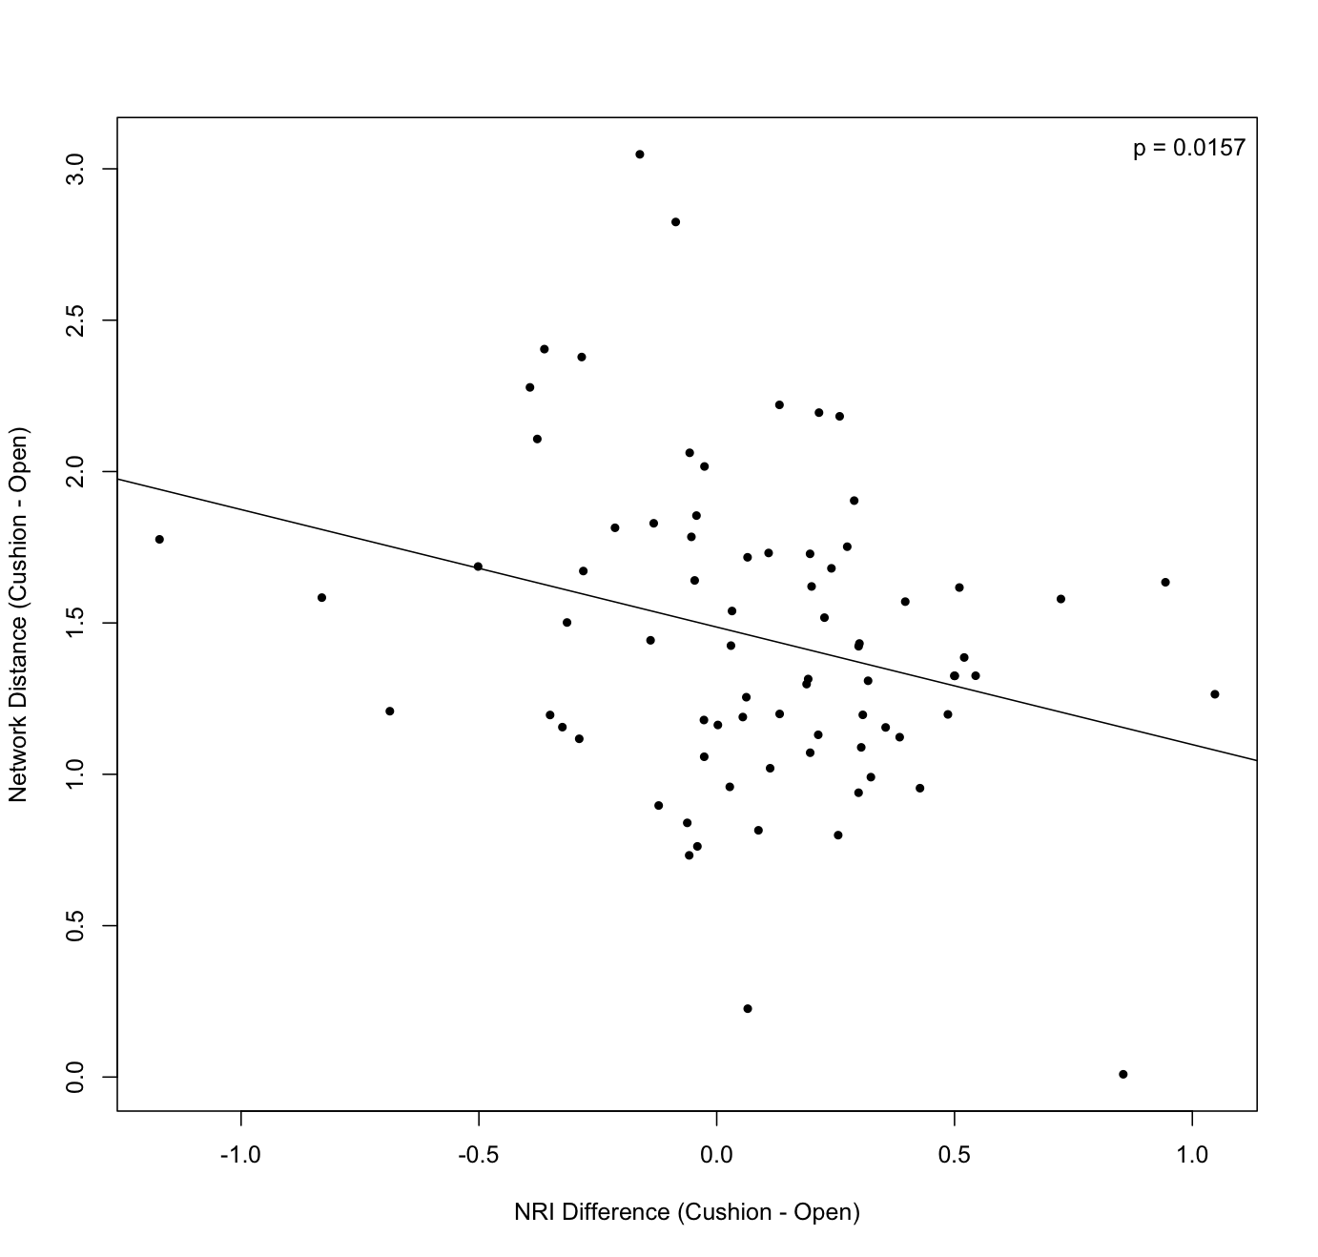

Result 5: To assess the influence of phylogenetic signal we correlated the differences in the Net Relatedness Index (NRI), calculated as the inverse of the mean pairwise phylogenetic distances between species, and the network distance (Cushion - Open). We found a significant correlation between the two. P-value based on a GLM using a Gaussian distribution (equivalent to a parametric regression).
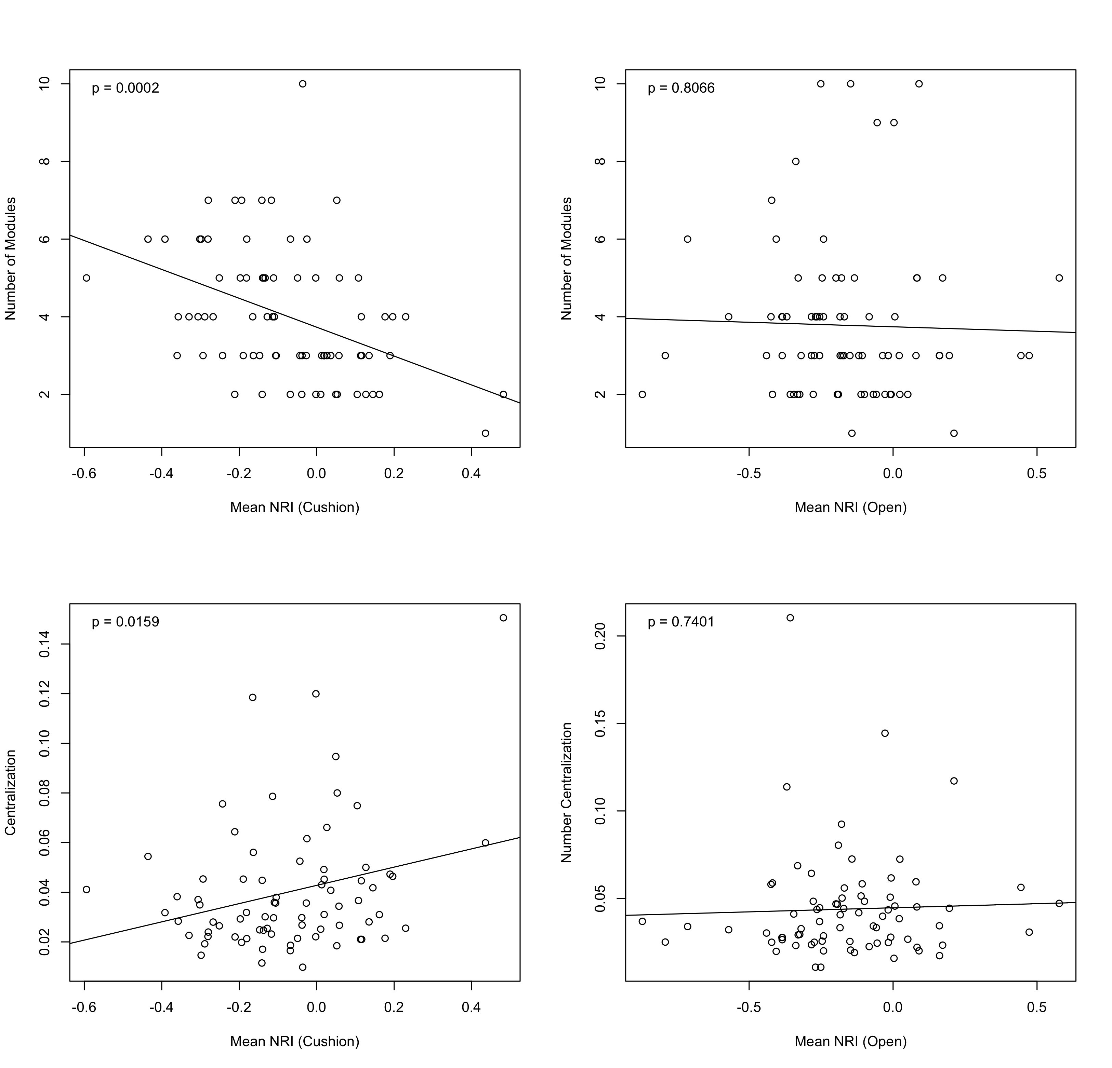

Result 6: To assess the specific structural effects of phylogenetics, we examined the relationships between NRI (see result 5) and two network metrics: number of modules and centralization. Modules represent groups of species within each network where the connections within the group are greater than with other groups as determined by a random walk algorithm. The centralization is a measure of the dominance of the network by one species. We found that there were significant relationships between NRI and the two network structural metrics for the Cushion networks, but not for the Open. P-values are from GLMs (see result 5).

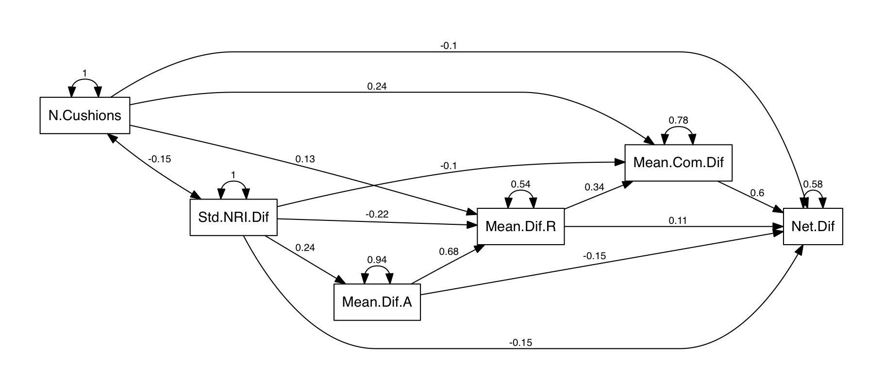

Result 7: We used Structural Equation Modeling to resolve a potential mechanism for the effects of the cushion on the phylogenetic signal in the network structure. By using the SEM framework we were able to isolate the direct and indirect effects of variables on the differences between values inside the Cushions and in the Open. First, this allowed us to account for the unequal sampling among sites (N.Cushions) and isolate the unique variance explained by our main variables of interest. Second. by using the differences between Cushion and Open values, we could account for the pair-wise sampling design and reduce the impact of local environmental variation. Last, by including the three ecological variables (Mean.Dif.A = difference in abundance, Mean.Dif.R = difference in richness, Mean.Com.dif = Bray-Curtis dissimilarity of the presence-absence converted community matrix) we could potentially resolve the ecological determinant of the phylogenetic signal. The model showed good fit to the data as assessed by a X² test of goodness of fit where a high p-value indicates no difference between the model predicted and the observed values (X² = 3.6232, DF = 3, p = 0.30513). A large amount of variance in the Network Difference (= Net.Dif) was explained by the SEM (R² = 0.41). Note that NRI (= Std.NRI.Dif) primarily influenced Network Differences through it's indirect effects on the ecological variables.

