Global effects of foundation species on biodiversity in alpine ecosystems equal the effects of climate

Understanding the fundamental drivers of local and regional biological diversity is one of the fundamental goals of ecology and evolution, not least because biological diversity has substantial (if complex) effects on the functioning of ecosystems and the services they provide (Isbell et al. 2011, Allan et al. 2011). However, our understanding of the factors that control diversity is limited by the logistical and conceptual difficulties of scaling ecological processes that occur at local scales to patterns that are manifest at regional scales (Ricklefs 2008, Harrison & Cornell 2008, Brooker et al. 2009). The complexity of ecological interactions makes it difficult to extrapolate from studies at small scales to ecosystem, landscape, and regional scales (Walther et al. 2002), and recent attempts at upscaling have suggested that neutral processes are predominant at regional scales (Hubble 2001, Shipley et al. 2006). The corollary to this is that local-scale biological interactions play a minor role relative to the effects of climate and historical process as fundamental drivers of large-scale patterns of species diversity (Ricklefs 2004, 2008). However, interactions among species clearly affect the generation of diversity through evolutionary processes (Benton 2009), are key to local scale diversity (Tilman 1997, Allesina & Levine 2011), and appear to sustain regional scale diversity (Harrison & Cornell 2008, Valiente-Banuet et al. 2006, Valiente-Banuet & Verdu 2007). Thus, despite the assumption that local scale ecological processes are relatively unimportant to regional scale biodiversity, local interactions have a great deal of potential to play a very substantial role in regulating regional and global biodiversity (Brooker et al. 2009). But in order to accurately assess the broader importance of biotic interactions and their role in regulating diversity relative to other environmental drivers, sensu Brooker et al. (2005) and Kikvidze et al. (2011) their effects must be contrasted with those of other relevant environmental drivers at the appropriate scale. In particular, we need “macroecological” studies that utilize reductionist approaches conducted over large scales to contrast the effects of biotic interactions with the effects of abiotic factors (Maurer 2000, Swihart et al. 2002). To our knowledge, such contrasts have not been attempted and here we present such a macroecological study. Specifically, we assess the relative importance of biotic interactions as caused by “foundation species” (sensu Ellison et al. 2005) versus key abiotic environmental drivers in determining plant species diversity in alpine habitats at a global scale.
Alpine ecosystems cover one fifth of the global land-area, harboring approximately 10,000 plant species which account for 4% of global plant diversity (Körner 2003). It has long been assumed that alpine plant diversity is regulated mainly by very large scale filters such as climate, available habitat area, and historical processes such glaciation (Körner 2002). However, species interactions, particularly facilitation - the amelioration of physical disturbance or stress by neighboring organisms - can strongly influence local diversity in these harsh environments (Kikvidze et al. 2005, Cavieres & Badano 2009). Alpine systems thus provide a clear system in which to explore the unresolved tension between the relative roles of local, regional, and global-scale processes in regulating diversity.
To explore the relative role of interspecific interactions and large scale filters (i.e. climate) in driving species richness at local scales, and the ubiquity at a global scale of any detected relationships, we studied alpine plant communities on five continents. For consistency we focused on communities dominated by plants exhibiting the cushion plant growth form. Cushion plants are one of the most conspicuous morphological forms found in extreme alpine habitats, and appear to have convergently evolved across a wide range of plant phyla (Rauh 1939). The low stature and compact architecture of these foundation species has been repeatedly shown to attenuate the effects of extreme environmental conditions, which in turn can promote the survival of other species within them (Cavieres et al. 2007, Atonsson et al. 2009, Haussmann et al. 2010). The presence of different cushion species in different regions across the globe provides a repeatable system for assessing the effects of facilitative interactions on species diversity in a way that is not biogeographically or phylogenetically biased. The global distribution of cushion-dominated plant communities also provides an excellent opportunity to scale up from local community effects to macroecological scales in which the relative importance of local processes can be evaluated.
At 78 sites in 16 countries distributed across 5 continents, we sampled spatial associations among a total of 40 cushion species (hereafter “foundation species”) and 1027 non-cushion species (see Supplementary information). At each site we measured total vegetation cover and the number of non-cushion species growing within and outside the foundation species. These data were used to calculate the relative interaction intensity [RII (Armas et al. 2004)] at both the species and community level, which ranges from 1 when all individuals of a species or community are found only in cushions (facilitation) to -1 when all occur only in the open (competition). We also calculated, through sample-based rarefactions, the proportion of species added to the community due to the presence of the foundation species (see Methods). In addition, we used the Global Land Data Assimilation System (GLDAS, a global, high-resolution, offline terrestrial modeling system that merges satellite and ground-based observations to produce optimal estimates of land surface states and fluxes) to obtain near-surface minimum, maximum, and mean air temperature, near-surface relative humidity, precipitation and actual evapotranspiration at all sites.
At 85% of the sites we found significantly more species associated with foundation species than occurring in isolation (Fig. 1), and correlation analyses indicated a global effect size of 0.25±0.04 for the impact of foundation species on total species richness. Using the full global dataset, we compared this effect size to that of known climatic drivers of global diversity patterns, such as temperature and precipitation during the growing period (Currie et al. 2004, Kreft & Jetz 2007). As shown previously (e.g. Currie et al. 2004), species richness increased substantially with precipitation and other energy-related variables such as the precipitation-to-temperature ratio and actual evapotranspiration during the growing season. But we found no relationship between any measurement of temperature per se and species richness, likely because alpine systems around the world occur within a relatively narrow temperature range (Körner et al. 2011). Importantly, the effect sizes of precipitation- and energy-related variables on global species richness were of similar magnitude to that of foundation species (Evapotranspiration = 0.23±0.17, Precipitation:Temperature = 0.26±0.02). In other words, local-scale positive interaction effects of foundation species were strongly manifest as positive effects on species richness at the global scale, with the size of these effects being at least as strong as those of climate.
The effect of foundation species was not constant at a global scale, and showed a complex interactive pattern with other environmental drivers of richness. First, local productivity (assessed by vegetation cover) and local species richness strongly interacted with the intensity of foundation species effects. As site productivity increased, the relative interaction intensity and impact on whole-community diversity of foundation species decreased (Figure 2A,C). This result corresponds closely with general predictions of the relationship between abiotic environmental severity and the role of interactions (Bertness & Callaway 1994; Brooker & Callaghan 1998; Callaway et al. 2002). The facilitative effects of foundation species increased roughly 4 to 5 fold with a decrease in vegetative cover from 50% to 10%. Second, species richness in the absence of cushion plants was highly negatively correlated with facilitative intensities (i.e., Relative Interaction Index) and positively correlated with the number of species added to the community by cushion plants. These latter results indicate that foundation species had far more important effects on maintaining local and regional diversity in systems with relatively impoverished species pools (Figure 2B, D).
Given the complex inter-relationships detected between these drivers of diversity, we used structural equation modeling to tease apart the simultaneous direct and indirect effects of climate, productivity and foundation species on global alpine species richness (Grace 2006, Harrison & Cornell 2008). Our a priori model was based on 1) the regulation of taxonomic diversity by both the size of the local species pool (indicated by species richness in open plots only) as well as biotic interactions, 2) regulation of biotic interactions by productivity, and 3) regulation of open species richness by climate (see Methods). Thus, total diversity depends on direct effects of species pool size and biotic interactions as well as how these factors modulate the indirect effects of productivity and climate. The overall model fit was good (χ²₁₄=23, P>0.05), indicating that the modeled covariance matrix did not deviate significantly from the observed covariances; all hypothesized paths were supported by the model (Figure 3). By differentiating the two indirect effects of productivity on total species richness (via species pool size and biotic filter), the structural equation model reveals why there was no significant, direct correlation between productivity and total richness; the negative effect of a decline in productivity on species pool size is counteracted by the increasing intensity of facilitation in low-productivity environments. Foundation species thereby function –at a global scale – as important modulators of environment-diversity relationships by significantly reducing declines in species richness with increasing environmental severity.
Some recent studies have proposed that local-scale processes are relatively insignificant in terms of regulating large-scale diversity patterns (Ricklefs 2008). Furthermore, those studies that demonstrate an important effect of biotic interactions have focused on competition (e.g., Tilman 1997, Laird & Schamps 2006, Allesina & Levine 2011) and at small spatial scales. Here, we show that the facilitative effects of foundation species on local diversity are on average equivalent to those of widely recognized abiotic environmental drivers. Furthermore, these biotic interactions buffer negative effects of large-scale determinants of diversity such as climate and productivity: the foundation species in these alpine systems essentially act as a “safety net” for diversity under very harsh conditions. Our findings support recent theoretical studies based on metacommunity models where it has been observed that positive interactions among species can rapidly evolve in communities with reduced regional pools of species and/or with low environmental quality generating higher richness than the observed when only competitive or migratory events with no interactions are the main drivers involved (Filotas et al. 2010a,b).
Although positive interactions are now widely recognized as playing a major role in the organization of community structure and diversity (e.g., Bruno et al. 2003, Brooker et al. 2008, Bastolla et al. 2009), this is the first study showing that effects of positive interactions with foundation species on local diversity are equivalent to those of abiotic environmental drivers at a global scale.
Figure 1. World map showing the sign (color scale) and magnitude (scale size) of the mean interaction with foundation cushion species on different alpine sites across the globe.

Figure 2. Relationship between foundation species effects (relative interaction intensity and foundation species effects on richness), and total site cover and species richness. Note that foundation species effects are inversely correlated with productivity (site cover) and species richness, indicating that their role is greater in unproductive environments which are on average more species-poor.

Figure 3. Structural equation model of proximate and distal controls on total species richness.Latent variables are in bold font, with associated indicator variables below. Numbers adjacent to unidirectional arrows are standardized (and unstandardized) partial regression coefficients. Size of arrows is proportional to the magnitude of the standardized coefficient, with solid arrows indicating a positive effect and dashed arrows a negative effect. All relationships are significant at the α=0.05 level.

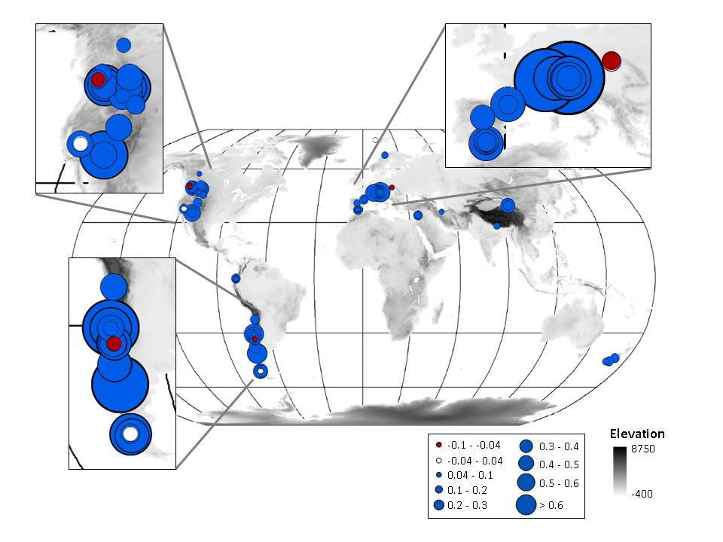

Figure 1.

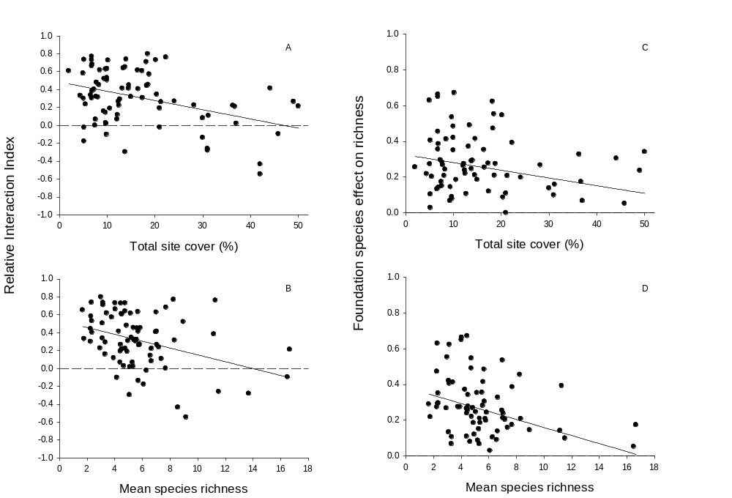

Figure 2.

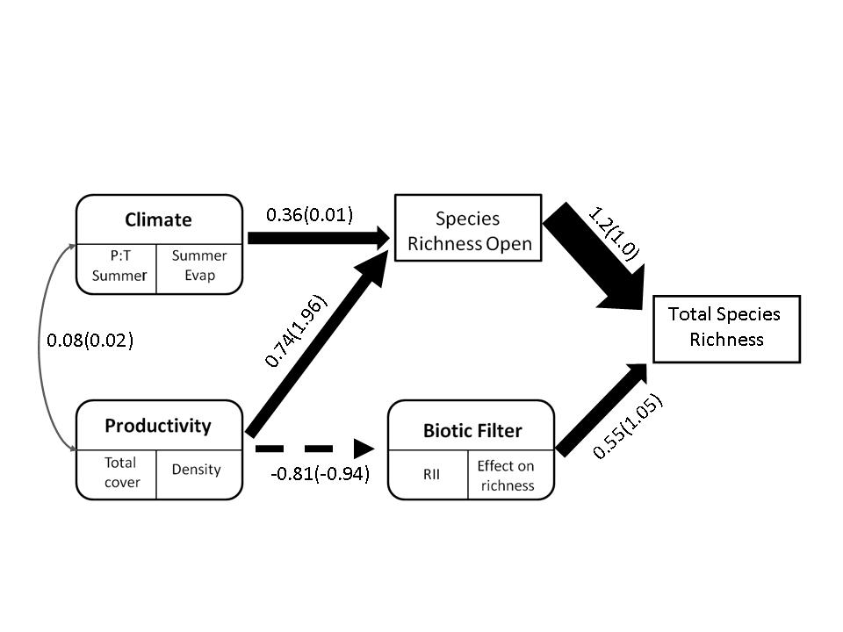

Figure 3.
METHODS SUMMARY

- Isbell, F. et al. High plant diversity is needed to maintain ecosystem services. Nature 477, 199-202 (2011).
- Allan, E. et al. More diverse plant communities have higher functioning over time due to turnover in complementary dominant species. Proc. Natl Acad. Sci. USA 108, 17034-17039 (2011).
- Ricklefs, R.E. Disintegration of ecological community. Am. Nat. 172, 741-750 (2008).
- Harrison, S. & Cornell, H. Toward a better understanding of the regional causes of local community richness. Ecol. Lett. 11, 969-979 (2008).
- Brooker, R.W. et al. Don’t diss integration: a comment on Ricklefs’s disintegrating communities. Am. Nat. 174, 919-927 (2009).
- Walther. G.R. et al. Ecological responses to recent climate change. Nature 416, 389-395. (2002).
- Hubbell, S. P. The Unified Neutral Theory of Biodiversity and Biogeography. Princeton Univ. Press, Princeton, NJ, (2001).
- Shipley, B., Vile, D. & Garnier, E. From plant traits to plant communities: a statistical mechanistic approach to Biodiversity. Science 314, 812-814 (2006).
- Ricklefs, R.E. A comprehensive framework for global biodiversity patterns in biodiversity. Ecol. Lett. (2004).
- Benton, M.J. The Red Queen and the Court Jester: species diversity and the role of Biotic and abiotic factors through time. Science 323, 728-732 (2009).
- Tilman, D. Community invasibility recruitment limitation, and grassland biodiversity. Ecology 78, 81-92 (1997).
- Allesina, S. & Levine, J.M. A competitive network theory of species diversity. Proc. Natl. Acad. Sci. USA 108, 5683-5642 (2011).
- Valiente-Banuet, A. et al. Modern Quaternary plant lineages promote diversity through facilitation of ancient Tertiary lineages. Proc. Natl. Acad. Sci. USA 103, 16812-16817 (2006).
- Valiente-Banuet, A. & Verdú, M. Facilitation can increase the phylogenetic diversity of plant communities. Ecol. Lett. 10, 1029-1036 (2007).
- Brooker, R.W. et al. The importance of importance. Oikos 109, 63-70 (2005).
- Kikvidze, Z., Susuki, M. & Brooker, R.W. Importance versus intensity of ecological effects: why context matters. Trends Ecol. Evol. 26, 383-398 (2011).
- Maurer, B.A. Macroecology and consilience. Glob. Ecol. Biogeo. 9, 275-280 (2000).
- Swihart, R. K., Dunning, J. B. and Waser, P. M. Gray matters in Ecology:
- dynamics of pattern, process, and scientific progress. Bulletin of the ESA 83,149-155 (2002).
- Ellison, A.M. et al. Loss of foundation species: consequences for the structure and dynamics of forested ecosystems. Front. Ecol. Environ. 3, 479-486 (2005).
- Körner, Ch. Alpine Plant Life, 2nd ed., Springer, NY (2003).
- Körner, Ch. Mountain biodiversity, its causes and function: an overview. In: Körner, Ch. & Spehn, E.M. (eds) Mountain biodiversity. A global assessment. Parthenon, Boca Raton, pp 3-20. (2002).
- Kikvidze, Z. et al. Linking patterns and processes in alpine plant communities: a global study. Ecology 86, 1395-1400 (2005).
- Cavieres, L.A. & Badano, E.I. Do facilitative interactions increase species richness at the entire community level? J. Ecol. 97, 1181–1191 (2009).
- Rauh, W. Über polsteriförmigenen Wuchs. Acta Nova Leopoldina 7, 267–508 (1939).
- Cavieres, L.A., et al. Microclimatic modifications of cushion plants and their consequences for seedlings survival of native and non-native plants in the high-Andes of central Chile. Arct. Antarct. Alp. Res. 39, 229-236.
- Antonsson, H., Björk, R.G. & Molau, U. Nurse plant effect of the cushion plant Silene acaulis (L.) Jacq. in an alpine environment in the subarctic Scandes, Sweden. Plant Ecol. Div. 2, 17-25 (2009).
- Haussmann, N.S., McGeoch, M.A. & Boelhouwers, J.C. Contrasting nurse plants and nurse rocks: the spatial distribution of seedlings of two sub-Antarctic species. Acta Oecol. 36, 299-305 (2010).
- Armas, C.,Ordiales, R. & Pugnaire, F.I. Measuring plant interactions: a new comparative index. Ecology 85, 2682-2686 (2004).
- Currie, D.J. et al. Predictions and tests of climate-based hypotheses of broad-scale variation in taxonomic richness. Ecol. Lett. 7, 1121-1134 (2004).
- Kreft, H. & Jetz, W. Global patterns and determinants of vascular plant diversity. Proc. Natl. Acad. Sci. USA 104, 5925-5930 (2007).
- Körner, Ch., Paulsen, J. & Spehn E.M. A definition of mountains and their bioclimatic belts for global comparisons of biodiversity data. Alp Botany (2011).
- Bertness, M.D. & Callaway, R.M. Positive interactions in communities. Trends Ecol. Evol. 9, 191-193 (1994).
- Brooker, R.W. & Callaghan, T.V. The balance between positive and negative interactions and its relationship to environmental gradient: a model. Oikos 81, 196-207 (1998).
- Callaway, R.M. Positive interactions among alpine plants increase with stress. Nature, 417, 844-848 (2002).
- Grace, J.B. Structural Equation Modeling and Natural Systems. Cambridge U. Press, Cambridge (2006).
- Laird, R.A. & Schamp, B.S. Competitive intransitivity promotes species coexistence. Am. Nat. 168, 182-193 (2006).
- Filotas, E. Grant, M., Parrot, L. & Rikvold, P.A. The effect of positive interactions on community structure in a multi-species metacommunity model along an environmental gradient. Ecol. Mod. 221, 885-894 (2010).
- Filotas, E. Grant, M., Parrot, L. & Rikvold, P.A. Positive interactions and the emergence of community structure in metacommunities. J. Theor. Biol. 266, 419-429 (2010).
- Bruno, J.F., Stachowicz, J.J & Bertness, M.D. Inclusion of facilitation into ecological theory. Trends in Ecology and Evolution, 18, 119-125 (2003).
- Brooker, R.W. et al. Facilitation in plant communities: the past, the present and the future. J. Ecol. 96, 18-34 (2008).
- Bastolla, U. et al. The architecture of mutualistic networks minimizes competition and increase biodiversity. Nature 458, 1018-1021 (2009).

METHODS
Study Sites
Data were collected from 78 alpine plant communities in North and South America, Europe, Asia and New Zealand. Sites were selected to include sufficiently large populations of cushion plants, which were located in generally low productivity habitats within alpine belts (i.e. above natural tree line). Forty eudicot cushion plant species were sampled across the 78 sites (see Supplementary Information).

Sampling
At each site we haphazardly selected a number of individual cushions (see Supplementary Information for details of sample size at each site) and all plants growing within these selected cushions were identified to species level and recorded. Since cushions are usually of elliptical form, we measured the maximum and minimum axes of each cushion to estimate its area. To obtain comparable samples of species richness in surrounding open areas, the size and shape of each sampled cushion was emulated on haphazardly selected points in open areas away from cushions and all plant individuals within these selected points in open areas were identified to species level and recorded. Further, the percentage cover of cushions and open areas was determined at each site with 50 m long linear transects. We sampled a mean (±1 SE) of 81 (±3) sets of paired plots per cushion species and site.

Climatic Data
For each site, estimates of the following monthly meteorological conditions were extracted from the archive of the Global Land Data Assimilation System (GLDAS): near-surface minimum, maximum, and mean air temperature, near-surface relative humidity, precipitation and actual evapotranspiration. GLDAS is a global, high-resolution, offline terrestrial modeling system that merges satellite and ground-based observations to produce optimal estimates of land surface states and fluxes1. GLDAS meteorological fields are a merged product of lapse-rate corrected Global Data Assimilation System (GDAS) atmospheric conditions2, NOAA Climate Prediction Center (CPC) operational global Merged Analysis of Precipitation (CMAP)3, and the Air Force Weather Agency’s (AFWA) Agricultural Meteorology modeling system (AGRMET)4. The GLDAS modeling system includes a suite of land surface models implemented at various spatial resolutions. In this application, data were drawn from the GLDAS 25km, Noah Land Surface Model5-7 simulations for the period 2001-2010.
Monthly vegetation indices were drawn from the Moderate Imaging Spectrometer (MODIS) 0.05° resolution normalized difference vegetation index (NDVI) product (MOD13C2)8 for the period 2001-2010. NDVI is commonly used as an indicator of vegetation cover and/or health. No further processing of MOD13C2 was performed in this study.

Data analyses
Interactions
We estimate the relative interaction intensity (RII) for each species in the community as RII = (# in cushion – # in open)/(# in cushion + # in open). Mean RII across all species within a community was used as an estimate of the average cushion effect at that site. It is important to note that RII measured the effect of cushion on species abundance.

Cushion effect on total species richness
Assessing the effects of facilitation on species richness at the entire community level relies on comparing the number of species that a community has because of the presence of nurses to the richness expected in the community without nurses (Cavieres & Badano 2009). To estimate species richness for the community with cushions, we generated synthetic datasets combining data of cushions and open areas in a single species x samples matrix for each study site and a rarefaction analysis was run for each site. Since our sampling protocol included samples of different areas we used sample-based rarefaction techniques to avoid biases due to the sequence in which samples were added to the curves. On each rarefaction, 500 resamples were randomly drawn with replacement for each sample size (from 1 sample to the maximum number of samples) and the Mau-Tao estimator of species richness (Colwell et al. 2004) at the asymptote was calculated. The expected species richness of the community without cushions was estimated from the asymptotes of rarefaction curves constructed using only open areas samples (Badano et al. 2006). To assess the magnitude of the increase in species richness at the community level due to the presence of cushions, we calculated the proportion of increase in species richness as: (S_{total} – S_{open}) / S_{total}, where S_{total} is the actual number of species in the community, including the species growing both within and outside nurses; while S_{open} is the number of species in the absence of nurses (i.e. open areas). All rarefaction analyses were performed with the software EstimateS v. 8 (Colwell 2006).

Effect sizes
Mean and 95% confidence intervals of foundation species effect sizes were calculated from based on the rarefaction results. For those environmental variables that were significantly correlated with total species richness (evapotranspiration and precipitation-to-temperature ration), the mean effect size was calculated as [range(x)*b]/[min(x)*b+a], where x is the environmental variable, b is the estimated slope of the regression of species richness on x, and a is the estimated species richness intercept of the regression. Confidence intervals were estimated through bootstrapping each regression 1000 times, using the “boot” and “boot.ci” functions in R (R Development Core Team 2011).

Structural equation modeling
Some environmental factors may affect local richness directly, while others may act indirectly, and still within both direct and indirect factors some could act on opposite direction on local richness. Structural equation modeling approach are on the most power tools to unravel the structure linking variables that are correlated in a multivariate way by providing an intermediate aprioristic–statistical approach (Shipley 2004, Grace 2006). This implies that the relationships between predictors need to be specifically defined based on hypothesized relationships between them. Congruence between observed and expected covariances under the causal relationships proposed is used to estimate the efficiency of the model. Since the foundation species effect, primary productivity and climate are unobserved variables with no unit of measurement we have included them as latent variables and a couple of indicators for each of them, namely actual evapotranspiration and precipitation:temperature ratio for the summer months as indicators of climate; total cover and density of individuals in open areas as indicators of productivity and the mean RII and the size of the effect of the foundation species on increasing total richness as indicator of the biotic filter of the foundation species. To solve the scale indeterminacy problem we made it equal to the unit of measurement of the indicator variable that best represented the latent construct (that with the largest standardized coefficient in a preliminary exploratory analysis) by fixing its path coefficient to 1 (Hatcher, 1994). Path coefficients were estimated by using the maximum likelihood algorithm, and the congruence between observed and expected covariances was assessed by χ2 goodness-of-fit test. A significant goodness-of-fit test indicates that our aprioristic model does not fit the data. Since this test may be affected by large data sizes, model fit was also evaluated by means of the goodness-of-fit index (GFI) and the Bentler and Bonett’s normed-fit index (NFI), which are often used in SEM. Values of these two indices range between 0 and 1, and values above 0.9 would indicate an acceptable fit of the model to the data or in other words an adequate congruence between observed and expected covariances. Our SEM model was built with AMOS 18 (Amos 19 Development Corporation 2009).

Rodell, M. et al. The global land data assimilation system. Bulletin of the American Meteorological Society 85, 381-+ (2004).
Derber, J. C., Parrish, D. F. & Lord, S. J. The new global operational analysis system at the National Meteorological Center. Weather Forecasting 6, 538-547 (1991).
Xie, P. P. & Arkin, P. A. Global precipitation: A 17-year monthly analysis based on gauge observations, satellite estimates, and numerical model outputs. Bulletin of the American Meteorological Society 78, 2539-2558 (1997).
Kopp, T. J. & Kiess, R. B. in AMS 15th Conf. on Weather Analysis and Forecasting 220-222 (Norfolk, VA, 1996).
Chen, F. et al. Modeling of land surface evaporation by four schemes and comparison with FIFE observations. Journal of Geophysical Research-Atmospheres 101, 7251-7268 (1996).
Ek, M. B. et al. Implementation of Noah land surface model advances in the National Centers for Environmental Prediction operational mesoscale Eta model. Journal of Geophysical Research-Atmospheres 108 (2003).
Koren, V. et al. A parameterization of snowpack and frozen ground intended for NCEP weather and climate models. Journal of Geophysical Research-Atmospheres 104, 19569-19585 (1999).
Huete, A. et al. Overview of the radiometric and biophysical performance of the MODIS vegetation indices. Remote Sensing of Environment 83, 195-213 (2002).

