Appendix S4 Results of phylogenetic signal analysis and distributions of net relatedness indices



Table 1. Tests of phylogenetic signal (Blomberg’s K) at different phylogenetic resolutions.

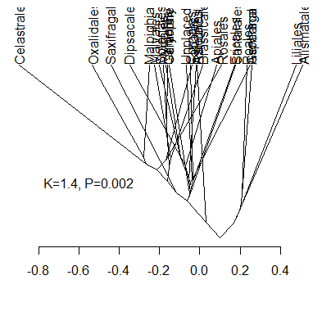

Figure 1. Trait evolution diagram for the order-level phylogeny. Node positions indicate mean relative interaction intensity, where ancestral states are reconstructed with phylogenetic independent contrasts.

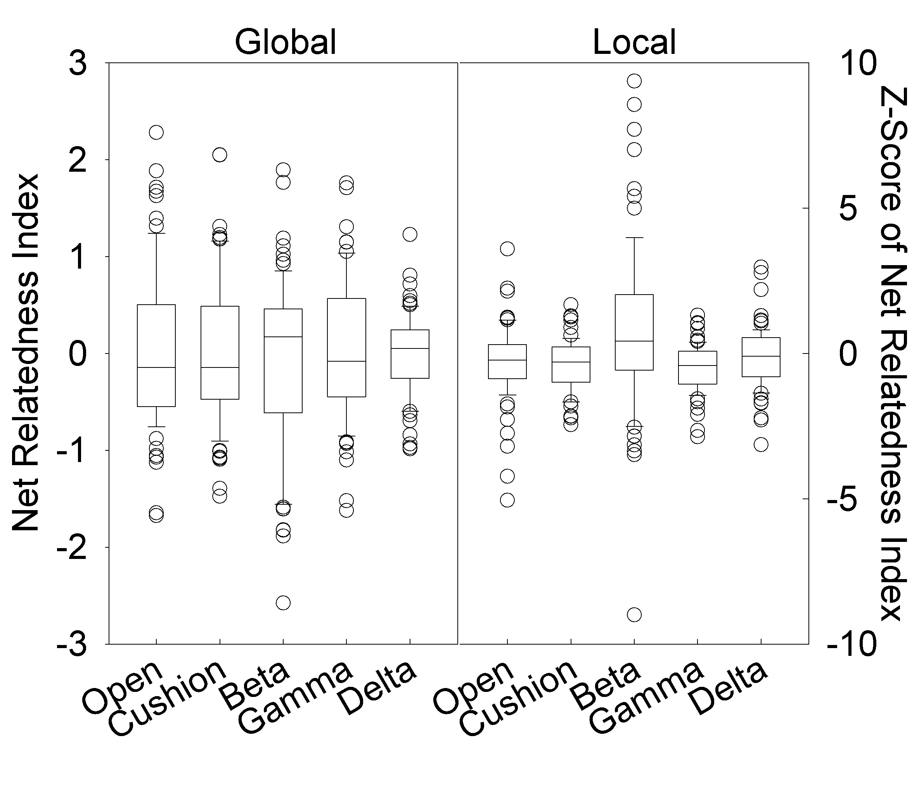

Figure 2. Box and whisker diagrams of NRI metrics at the global and local scales.