Pemphigus Removal Experiment -- Network Analysis

* Interactions among species contribute to the stability of ecological communities. Network modeling allows us to assess the correlative relationships among species
* Methods:
  + Co-occurrence analyses (Gotelli 2001 and Oksanan 2013) as an established test of presence-absence patterns among species using a conservative null modeling algorithm that preserves the species and observation totals. Tests were performed using 5000 iterations of the data for each year and treatment combination for a total of four tests.
  + Network modeling (Araujo et al. 2011) to explore the structure of significant co-occurrence patterns among species for each treatment in each year. Quadratic Assignment Procedure (QAP; Krackhardt 1987), a randomization test that takes into account the non-independence of observations in networks, was used with Euclidean distance between control and exclusion network pairs in each year to test for structural differences between the modeled networks based on 10000 permutations of the networks.
  + As *Pemphigus betae* was specifically targeted in this experiment, all tests were performed both with and without *P. betae*.
* Results:
  + Co-occurrence
    - All treatments in all years showed significant co-occurrence patterns. SES values were all less than zero, indicative of co-occurrences between species being more often than expected by chance (Table M1).
  + Network Models
    - Significant co-occurrence patterns among species were detected in all treatments in all years (Fig. M1).
    - Due to its ubiquity in controls and extreme absence in exclusions *P. betae* did not show significant co-occurrence patterns with any species.
    - QAP tests of the distance between control and exclusion networks were highly significant in both years (2008 distance = 55.924 , P < 0.001 and 2009 distance = 30.416, P = 30.416).
* The removal of *P. betae* significantly influenced the network structure of the cottonwood canopy arthropod community.

Tables

|  |  |  |  |  |
| --- | --- | --- | --- | --- |
| **Analysis** | **Year** | **Treatment** | **SES** | **P-value** |
| *P. betae* | 2008 | control | -10.77162 | <0.001 |
|  | 2008 | exclusion | -10.47465 | <0.001 |
|  | 2009 | control | -8.440988 | <0.001 |
|  | 2009 | exclusion | -8.204824 | <0.001 |
| No *P. betae* | 2008 | control | -8.808884 | <0.001 |
|  | 2008 | exclusion | -9.978448 | <0.001 |
|  | 2009 | control | -5.393312 | <0.001 |
|  | 2009 | exclusion | -5.624538 | <0.001 |

Table M1. The Co-occurrence Null Modeling results both with and without *Pemphigus betae* included in the analyses for both years and both treatments. The C-score Standardized Effect Sizes (SES) and lower tail P-values are based on 5000 permutations of the original data.

|  |  |
| --- | --- |
| **Number** | **Morphospecies** |
| 1 | pb |
| 2 | X7.spt.Lbb |
| 3 | Ambush.bug |
| 4 | Ant..unkn. |
| 5 | Anthicid..blk. |
| 6 | Anthocorid |
| 7 | Araniella |
| 8 | Asilidae |
| 9 | assassin |
| 10 | Assassin..brn. |
| 11 | Assassin..rd.blk. |
| 12 | Assilid |
| 13 | BEB |
| 14 | bee..brn. |
| 15 | Beetle..anobiid. |
| 16 | Beetle..blk.wht. |
| 17 | Beetle..sm.grn. |
| 18 | Beetle..unkn.blk. |
| 19 | Beetle..unkn.brn. |
| 20 | Beetle..unkn.nymph. |
| 21 | big.eye.fly..blk.wht. |
| 22 | Bp.Chalcid |
| 23 | Braconid |
| 24 | Braconid..blk.wht. |
| 25 | bronc.beetle |
| 26 | Bug..flat.blk.rd. |
| 27 | Calophorid |
| 28 | Calophoridae..gld. |
| 29 | Caterpiilar..unkn.big.brn. |
| 30 | Caterpillar..gnt.grn. |
| 31 | Cercopid..brn. |
| 32 | Cercopid..yllw. |
| 33 | Cercopid.brn. |
| 34 | Chait..rd. |
| 35 | Chait..grn. |
| 36 | Cicada |
| 37 | Clerid..blk. |
| 38 | Clerid..gry.blk. |
| 39 | Clerid..rd.blk. |
| 40 | Cocc..chkrd. |
| 41 | Cocc..lng.thin.nymph. |
| 42 | Cocc.nymph..blk.orng. |
| 43 | cocc.nymph..gry. |
| 44 | Coenagrionidae |
| 45 | Earwig |
| 46 | edge.mnr |
| 47 | egg.on.a.stick |
| 48 | Fly..blk.w.yllw.abdm. |
| 49 | Fly..blk.wngs. |
| 50 | Fly..brn.rnd. |
| 51 | Fly..fzzy.blk.w.drk.wngs. |
| 52 | Fly..gldn.Dolicho. |
| 53 | Fly..gry.brn.hyln. |
| 54 | Fly..hyln. |
| 55 | Fly..lng.rd. |
| 56 | Fly..lngthndip. |
| 57 | fly..sm.metallic. |
| 58 | Fly..tan. |
| 59 | Fly..tny. |
| 60 | Fly..unkn.sm. |
| 61 | Formica.spp.1 |
| 62 | Formica.spp.2 |
| 63 | Formica.spp.3 |
| 64 | Globuli |
| 65 | Hemipt..bg.brn. |
| 66 | Hymenoptera..unkn.. |
| 67 | Ichneumonid |
| 68 | Lacewing..grn. |
| 69 | Lbb..blk.w.2.orng.spt. |
| 70 | Lbb..many.spt. |
| 71 | Lf.tier |
| 72 | Lfhppr..brn. |
| 73 | Lfhppr..brnmtld. |
| 74 | Lfhppr..fisheye. |
| 75 | Lfhppr..grn. |
| 76 | Lfhppr..sknk. |
| 77 | Lfhppr..tan. |
| 78 | Lfhppr..turq. |
| 79 | lng.blk.paras |
| 80 | long.thin.nymph |
| 81 | mayfly |
| 82 | Melyrid..gry.blk. |
| 83 | membracid |
| 84 | Membracid..blk.wht. |
| 85 | Membracid..grn.blk. |
| 86 | midge |
| 87 | Mirid..blk.brn. |
| 88 | mirid..blk.wht. |
| 89 | Mirid..brn. |
| 90 | Mirid..brn.wht. |
| 91 | Mirid..rd.wht. |
| 92 | mite.gall |
| 93 | moth..unkn.wht. |
| 94 | Muscid |
| 95 | Myrm.ant |
| 96 | Nymph..unkn.sm.blk. |
| 97 | Nymph..unkn.yllw. |
| 98 | Paras |
| 99 | Paras..lng.thin. |
| 100 | Paras..rd. |
| 101 | Penta..blk.wht.red.nymph. |
| 102 | Penta..brachy. |
| 103 | Penta..nymph. |
| 104 | Penta..Podisus. |
| 105 | penta..rd.brn. |
| 106 | Penta.nymph..grn.brn. |
| 107 | Pentatomid..red.blk.wht. |
| 108 | pentatomid..gry. |
| 109 | Phylla |
| 110 | punkie |
| 111 | red.mite |
| 112 | Salticid..blk. |
| 113 | Salticid..blk.rd. |
| 114 | Salticid..brn. |
| 115 | Salticid..brnz. |
| 116 | Salticid..gry. |
| 117 | Salticid..zebra. |
| 118 | Salticid.wht.blk. |
| 119 | serp.lf.mnr |
| 120 | Snakefly |
| 121 | Spider..big.brn.w.blk.legs. |
| 122 | Spider..blk.gry. |
| 123 | Spider..blk.wht. |
| 124 | Spider..gry.crab. |
| 125 | Spider..lg.Clubionid.Thomisid. |
| 126 | Spider..rd.blk.Lycosid. |
| 127 | Spider..rd.wht. |
| 128 | Spider..sm.wht. |
| 129 | Spider..unkn. |
| 130 | Spider..yllw.brn.crab. |
| 131 | Spittle.bug |
| 132 | stem.borer |
| 133 | Syrhpid..blk.wht.big. |
| 134 | Syrphid..lttl.yllw. |
| 135 | Tabanid..blk.brn. |
| 136 | T.dip |
| 137 | Thec..aff. |
| 138 | Thrip..blk. |
| 139 | tingid..blk. |
| 140 | TinyT.dip |
| 141 | Tip..mnr |
| 142 | Tip.roller |
| 143 | Vespid |
| 144 | Wasp..digger. |
| 145 | Weevil..blk. |
| 146 | Weevil..brn. |
| 147 | Weevil..gry. |

**TableM2.** Table showing the numbers associated with morphospecies shown in Figure M1.

Figures

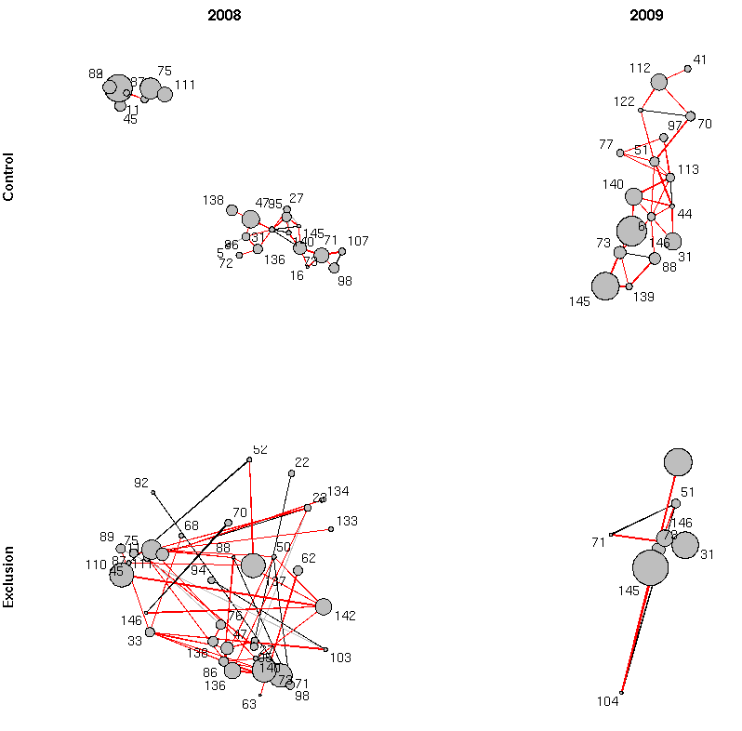

**Figure M1.** Plots of the networks for both treatments (Exclusion and Control) in both years (2008 and 2009). Only species with at least one connection are shown. Points for each species (scaled by the log of the total abundance) are positioned using a physical force algorithm that places points in order to minimize the distance of connections between nodes in the network. The positions are the same for all nodes within each year. Connections between nodes show the Bray-Curtis values for significant co-occurrence patterns between species colored black, grey and read for values that are less than, equal to or greater than 0.5. Species taxonomy associated with each number are shown in TableM2.