Databases

Queries for a Digital Game Store Database

1. The most expensive game. This query searches for games within the databases and their price, the query is sorted by most expensive to least expensive, the top result is the most expensive game in the store.

Query Code:

SELECT GameName, Price

FROM game

ORDER BY price DESC

LIMIT 3

Result:

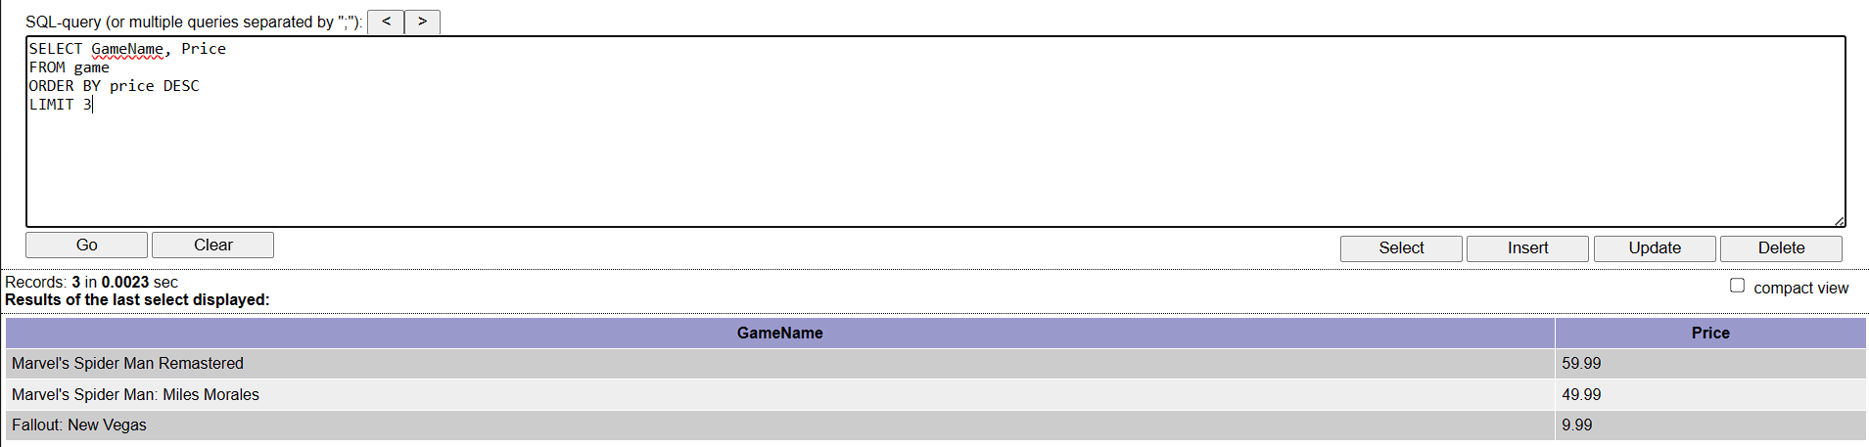

The most expensive game in the database is “Marvel’s Spider-Man Remastered” at $59.99.

1. Who published what? This query looks up a specific publisher and the game they published. The query uses the PublisherID to find its corresponding PublisherName and GameName and show them both together.

Query Code:

SELECT PublisherName, GameName

FROM game

INNER JOIN publisher ON game.PublisherID = publisher.PublisherID

WHERE game.PublisherID = 2

Result:

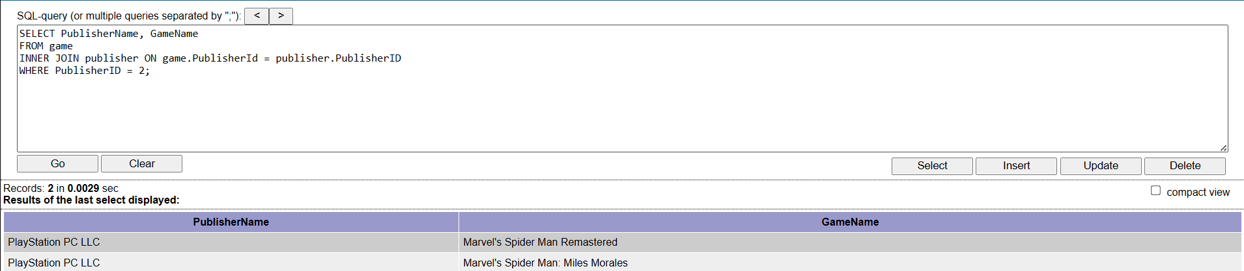

By specifying the publisherID, the query outputs the name of PublisherID 2 and the games they published.

1. What genre is this game? This query searches up a game and the genres it is associated with. The query uses the GameID to find the TagID it is associated with which will allow the query to output the Game and Genres.

Query Code:

SELECT g.GameName, gt.TagName

FROM game AS g

INNER JOIN tag_association AS ta ON g.GameID = ta.GameID

INNER JOIN genre_tag AS gt ON ta.TagID = gt.TagID

WHERE g.GameID = 4

Result:

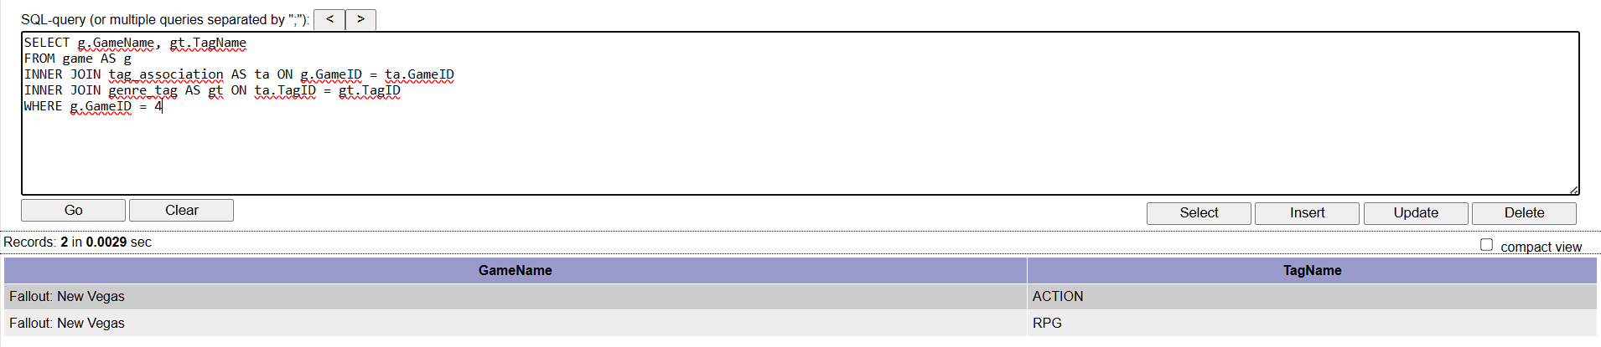

By specifying the GameID, I was able to find the Genre’s Fallout: New Vegas is associated with.

1. Latest Release. This query looks up the latest game release within the database.

Query Code:

SELECT GameName, ReleaseDate

FROM game

WHERE ReleaseDate = (SELECT MAX(ReleaseDate) FROM game)

Result:

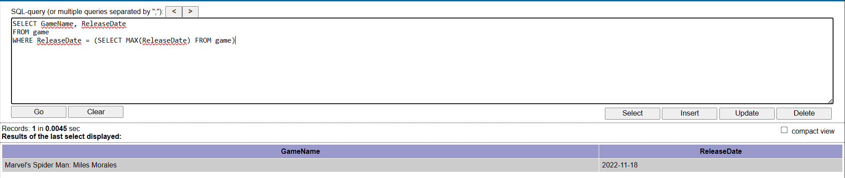

The latest release is Marvel’s Spider-Man: Miles Morales.

1. Recommended Sys Requirements. This query looks up the recommended Sys Requirements of a game.

Query Code:

SELECT GameName, CPU, GPU, RAM, Storage, StorageType, AdditionalNotes, OS

FROM game

INNER JOIN recommended_sr ON game.RSRID = recommended_sr.RSRID

Result:

