一、MySQL存储过程测试

1.新建一个表进行测试：

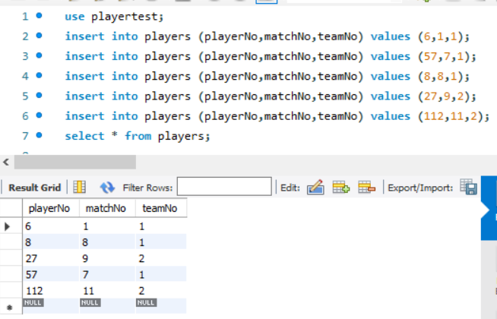

2.建立一个存储过程

mysql> delimiter $$

mysql> CREATE PROCEDURE delete_matches(IN p_playerno INTEGER)

-> BEGIN

-> DELETE FROM players WHERE playNO = p_playerno;

-> END $$

Query OK, 0 rows affected (0.02 sec)

执行该存储过程：

mysql> delimiter ;

mysql> call delete_ma(8);

Query OK, 1 row affected (0.01 sec)

mysql> select * from players;

+----------+---------+--------+

| playerNo | matchNo | teamNo |

+----------+---------+--------+

| 6 | 1 | 1 |

| 27 | 9 | 2 |

| 57 | 7 | 1 |

| 112 | 11 | 2 |

+----------+---------+--------+

4 rows in set (0.00 sec)

3.if语句使用：在结束后要加上 END IF;

mysql> CREATE PROCEDURE choose_m(IN p_no INT,OUT p_int INT)

-> BEGIN

-> IF p_no is null THEN

-> SELECT * FROM players;

-> ELSE

-> SELECT * FROM players WHERE matchNo = p_no;

-> END IF;

-> END $$

Query OK, 0 rows affected (0.01 sec)

mysql> delimiter ;

mysql> call choose_m(9,@p_int);

+----------+---------+--------+

| playerNo | matchNo | teamNo |

+----------+---------+--------+

| 27 | 9 | 2 |

+----------+---------+--------+

1 row in set (0.00 sec)