1.建立一个储存过程：

mysql> delimiter $$

mysql> CREATE PROCEDURE delete_matches(IN p_playerno INTEGER)

-> BEGIN

-> DELETE FROM players WHERE playNO = p_playerno;

-> END $$

Query OK, 0 rows affected (0.02 sec)

执行该存储过程：

mysql> delimiter ;

mysql> call delete_ma(8);

Query OK, 1 row affected (0.01 sec)

mysql> select * from players;

+----------+---------+--------+

| playerNo | matchNo | teamNo |

+----------+---------+--------+

| 6 | 1 | 1 |

| 27 | 9 | 2 |

| 57 | 7 | 1 |

| 112 | 11 | 2 |

+----------+---------+--------+

4 rows in set (0.00 sec)

2. 建立一个触发器，当向player表中添加数据时，向表record_p中添加数据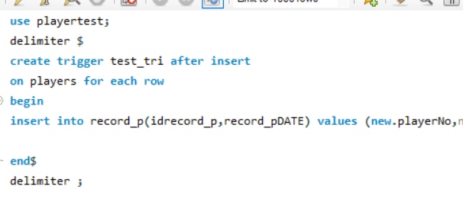

测试结果：

