
European Cloud for Heritage Open Science

Heritage Digital Twin Ontology in action
The Derynia Use Case
HORIZON-CL2-2023-HERITAGE-ECCCH-01
Horizon Innovation action

Responsible authors: Sorin HERMON (CyI), Maria THEODORIDOU (FORTH)

Project start | 1 June 2024
Project duration | 60 months
Document Identifier | 10.5281/zenodo.20445938

© 2025 by the authors, the ECHOES consortium. This work is licensed under a “CC BY 4.0” license

Executive Summary
The document presents the workflow of creating the Heritage Digital Twin (HDT) of the Derynia icon and it’s ingestion in the ECCCH’s Knowledge Base.
Currently, at the page https://isl.ics.forth.gr/ontology/echoes/html/HDT_v1.1.html you can navigate through the HDTO’s classes and properties.

Table of contents
Executive Summary 3
Table of contents 4
Lists of figures and tables 5
Figures 5
List of abbreviations 6
1. Introduction 6
2. The HDTO in action – the Deryneia icon 6
2.1. The Deryneia icon workflow to populate the KB 14

Lists of figures and tables

Figures
Figure 1. The Deryneia icon 29
Figure 2. The main components of the Deryneia icon's knowledge graph 30
Figure 3. The complete knowledge graph describing the research activities on the Deryneia icon 31
Figure 4. The heritage entity Deryneia icon as represented by the HDTO's main classes 32
Figure 5. The valuation of the HC1 heritage entity Deryneia icon 33
Figure 6. The study of the HDT Deryneia icon, with its main HDTO classes 33
Figure 7. The maintenance of the Deryneia icon, as represented by the HDTO classes 34
Figure 8. The maintenance of the Deryneia icon, as represented by the HDTO classes (cont. from Figure 7) 35

List of abbreviations
ECCCH | European Collaborative Cloud for Cultural Heritage
HDT | Heritage Digital Twin
HDTO | Heritage Digital Twin Ontology
CH | Cultural Heritage
crm | Conceptual reference model
crmpem | Conceptual reference model Parthenos extension

Introduction

The HDTO in action – the Deryneia icon
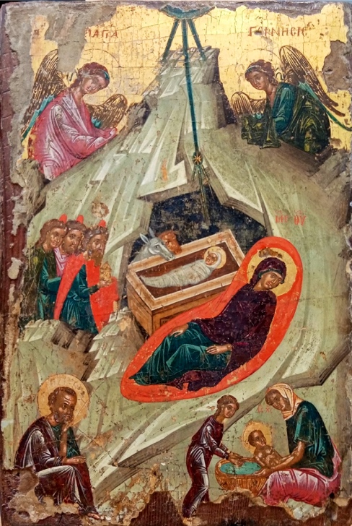
The text below demonstrates the applicability of the HDTO for documenting a multi-disciplinary study, published extensively here , and summarised below. The research focuses on the study of a linseed oil/tempera and gold on wood panel icon originating from Deryneia (Cyprus), measuring 23 x 34 x 6 cm. Its iconography depicts the birth of Christ and belongs to the broader “Nativity” theme. The icon was painted by an unknown author with an estimated date based on style, sometime in the 16th century. It comes from the Church of the Virgin Mary in Deryneia, Cyprus, with a possible alternative provenance of the small 15th-16th century church of St. George, in the same town. There are no written records on previous restorations or on its ownership history. The icon maintains most of the traditional features of a Byzantine “Nativity” icon, although it omits the depiction of the shepherds and the devil, common elements in other icons of the same type. It is part of a series of twelve icons representing the twelve Great Church Feasts in the liturgical calendar of the Orthodox Church (the so-called Dodekaorton).
Figure 1. The Deryneia icon
The main research questions were [a] art historical – to describe the materiality of the icon and assess its provenance, to understand the style of painting technique, to identify possible overpaints and to position the icon in the broader synthetic research on Byzantine icons in Cyprus; [b] conservation – to identify the pigments used, to identify possible restorations and positions them in a timeframe and to characterize the painting’s integrity and deterioration conditions. To achieve these goals, an art historical study, based on visual analysis, aimed to define its descriptive principles (its composition, organisational patterns, colours, light and symmetry), the history of the icon, in terms of history of its ownership and its possible mention in written sources, its historiography and social aspects related to its intangible attributes and to reconstruct the context of the icon, described through its style, typology, location. The interpretative process focused on providing explicatory narratives contextualizing in the present the 16th century icon, its cultural meaning and its intangible values.
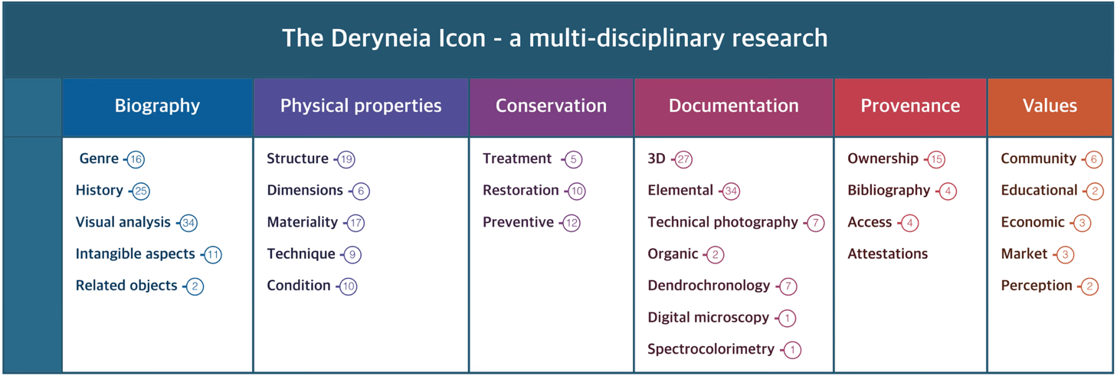
Figure 2. The main components of the Deryneia icon's knowledge graph
A complementary heritage sciences investigation, based on dendrochronology, to identify the wood species and its possible cutting date and on imaging techniques, namely hyper-spectral imaging (obtained with a multi-modal scanner, with x-ray fluorescence (XRF), reflectance imaging (RIS) and luminescence (LIS)), digital microscopy and infra-red imaging aimed to identify pigments used and to describe how they were applied by the painter and by conservator(s) / restorer(s) in recent times. A dedicated scientific visualization platform was built as well, to spatially position all analytical and imaging data collected within a single spatial xyz space, delineated by the 3D model of the icon.
The HDT provides a single semantic descriptive framework for documentation data related to the scientific processes described above. We define here a knowledge graph that helps navigate between interpretative statements on the investigated icon, the reasoning processes behind them and the data on which they were based. The base is a common descriptive framework (an extendable knowledge graph) for painted artworks, which includes six principal nodes and their components. These cover descriptions of the tangible as well as intangible aspects of the artwork, such as its biography and the related art historical research, its physical properties, aspects related to its conservation, the methods applied for its documentation and the generated data and results (representing in this way both the data provenance and the scientific processes for obtaining them), the provenance of the artwork, including history of its ownership, exhibitions, publications and other attestations and finally a category named values which aims at capturing its risks of being illegally trafficked, its religious and community values and its potential re-use in education or by creative industries.
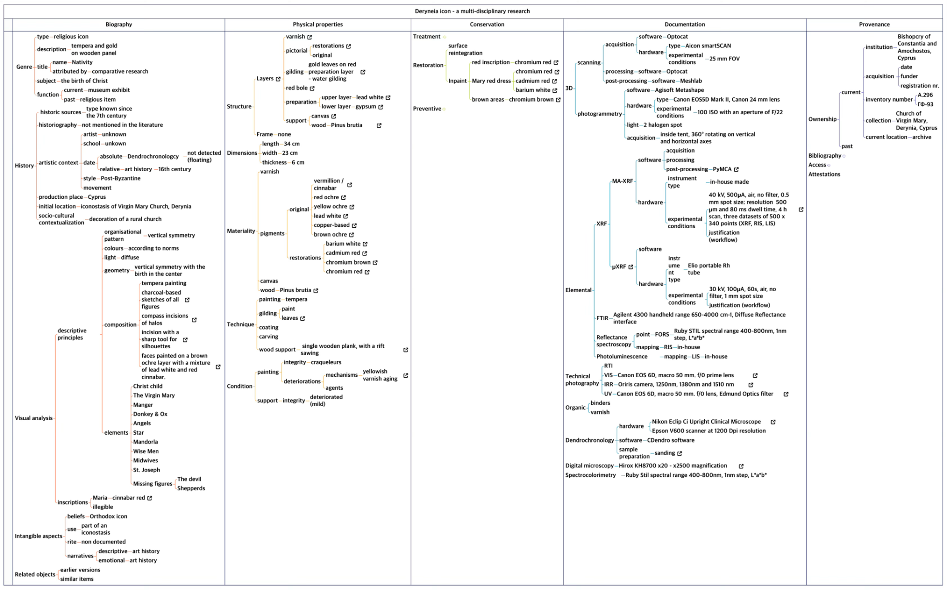
Figure 3. The complete knowledge graph describing the research activities on the Deryneia icon
The knowledge construction process builds on inferences deriving from formally described observations and the statements derived from them, based on reproducible workflows, using data that is presented in an accountable and transparent way and is described by the HDTO, as shown below.
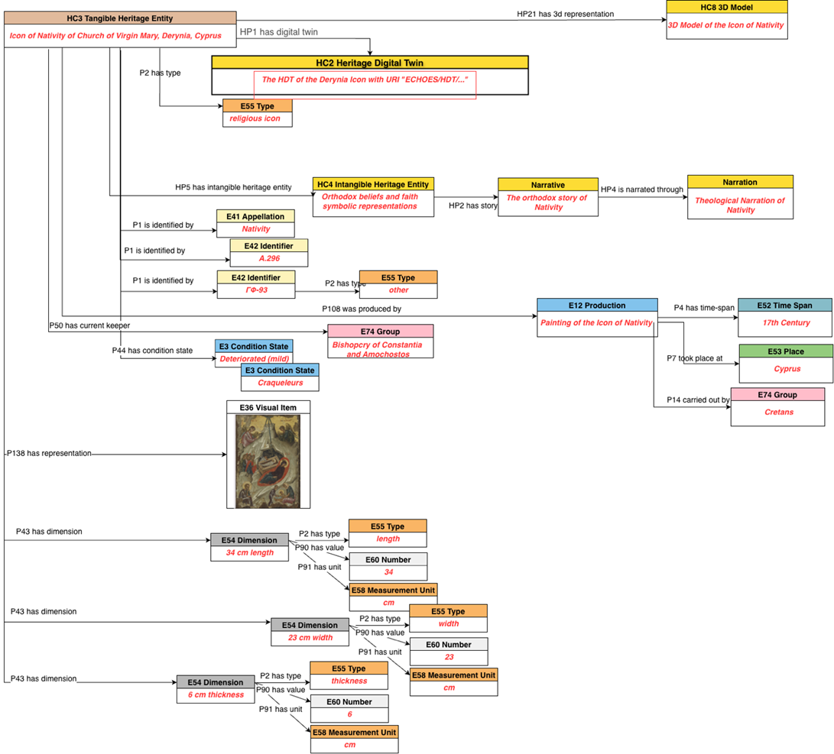
Figure 4. The heritage entity Deryneia icon as represented by the HDTO's main classes

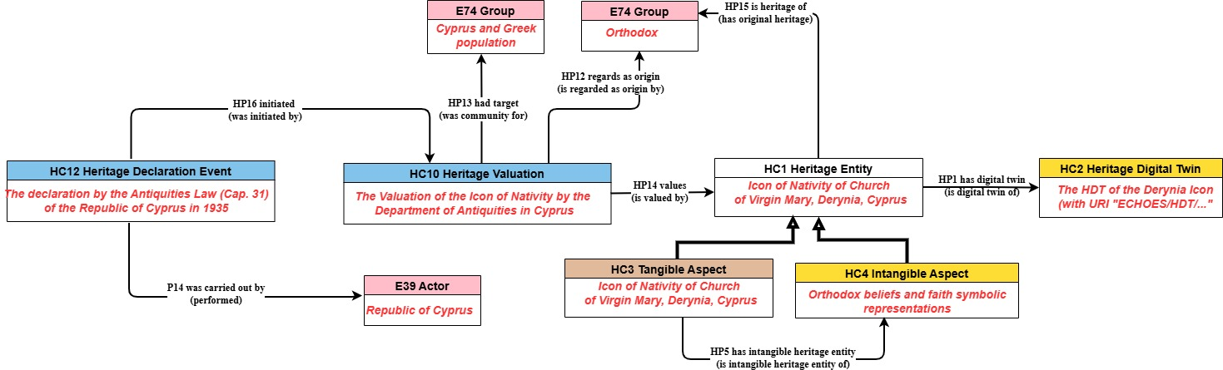
Figure 5. The valuation of the HC1 heritage entity Deryneia icon

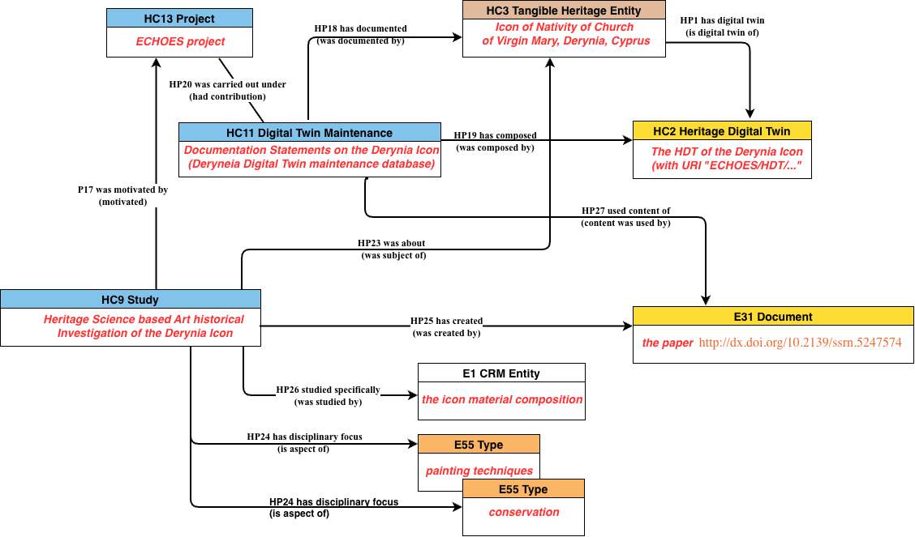
Figure 6. The study of the HDT Deryneia icon, with its main HDTO classes
Finally, the three consequent diagrams describe the entirety of the HDT of the Deryneia icon:
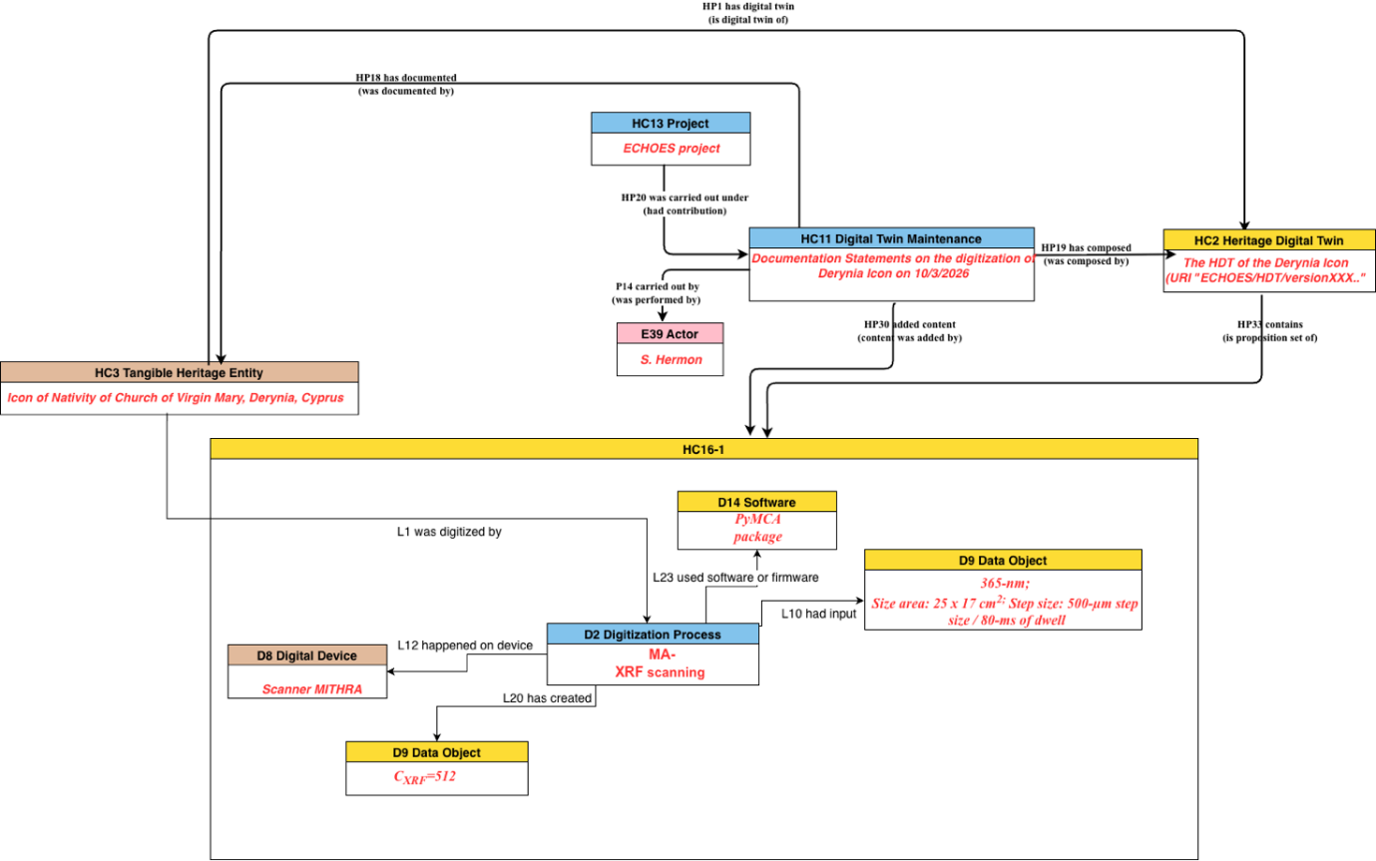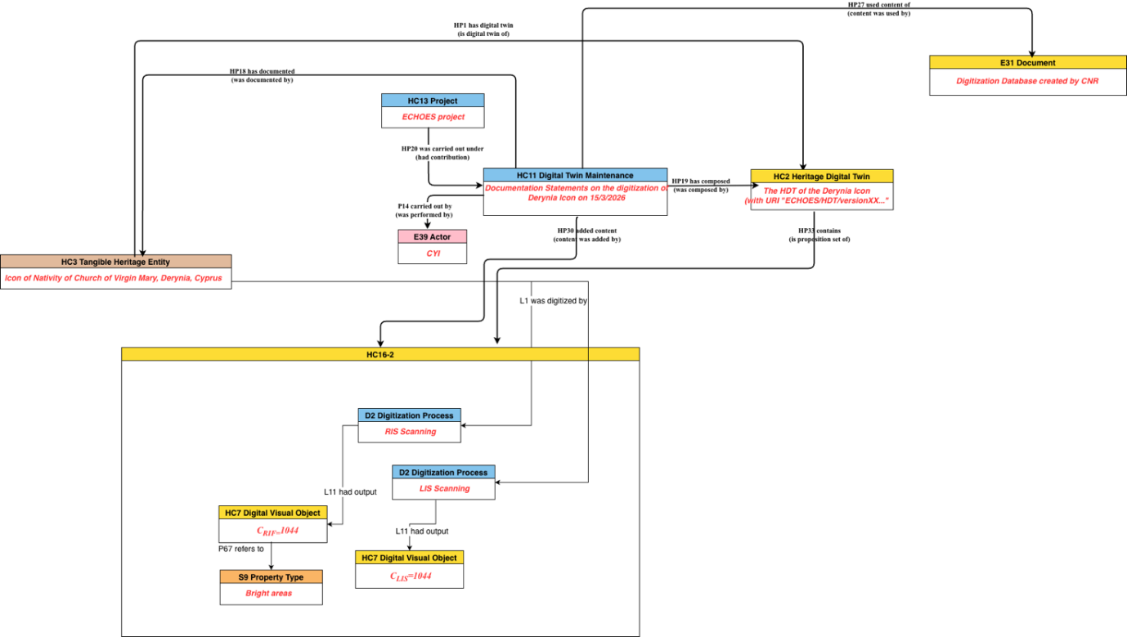
Figure 7. The maintenance of the Deryneia icon, as represented by the HDTO classes
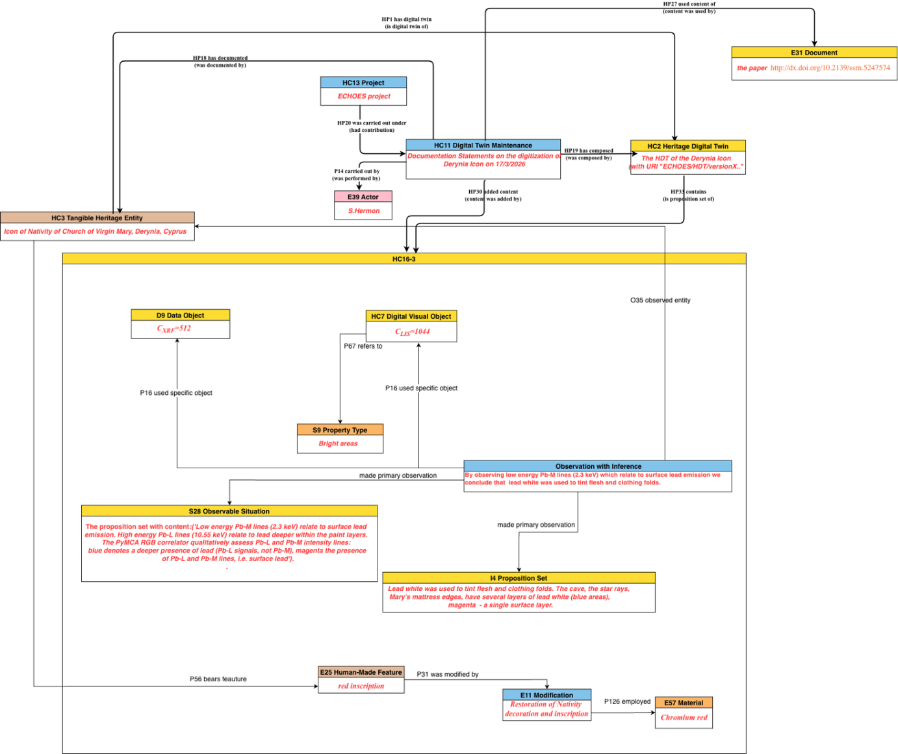
Figure 8. The maintenance of the Deryneia icon, as represented by the HDTO classes (cont. from Figure 7)

The Deryneia icon workflow to populate the KB

Prepare the input data
We started with the representation of Figure 3 (available as xmind file at Painted Artwork (and actors involved) .xmind) provided by S. Hermon, CyI. In the folder knowledge graphs there is also a pdf version of xmind.

We used a local installation of SYNTHESIS, a cultural information management system (https://www.ics.forth.gr/isl/synthesis-core) developed by FORTH, to input as much information as possible from the xmind representation.

Installation: http://139.91.183.118:8088/synthesis_echoes/
Credentials: Username: admin
Password: admin@9803

The export of SYNTHESIS is an xml representation. The files are available in xml-input.

Map the input data to the HDTO

These files were used as input in the 3M Mapping Memory Manager (https://www.ics.forth.gr/isl/x3ml-toolkit)

Installation: https://demos.isl.ics.forth.gr/3m/
Users can register to get access to the mapping:
HRID: 486597 ECHOES OFFICIAL Derynia A.296
This mapping uses the official HDTO definition HDT v1.1 and its RDFS implementation HDT_v1.1.rdf
Mapping HRID: 486597 ECHOES OFFICIAL Derynia A.296 consists of 10 mappings.
1. Select Mappings 1-5 (Physical properties) only and produce rdf.
2. Select Mapping 6 (Examinations) only and produce rdf. Split this rdf into two files, with the two examinations.
3. Select Mapping 7 (Conservations) only and produce rdf.
4. Select Mapping 9 and 10 (Valuation, Heritage Declaration Event) only and produce rdf.
The exported rdf files are available in

Use

