Human Resources Dataset Analysis Project

Prepared by:
- Abdelrahman Mohamed Ibrahim
- Ahmed Abdelazeem Ahmed
- Eslam Fadl Sayed
- Mohamed Mostafa Mohamed
- Yousef Mohamed Hussein

Data Analysis Project Documentation
Project Deadline: 4/11/2025
- Project Proposal
  - Overview:
This project focused on analyzing employee turnover and retention by leveraging data analytics. The goal was to identify the key factors influencing employee attrition within the organization and to provide actionable insights to help improve retention rates.
  - Objectives:
• The objective of this project was to create a comprehensive Employee Turnover & Retention Dashboard that analyzes key factors such as salary, promotion delays, age, education, and years with the current manager to identify trends and provide insights into improving retention strategies.
  - Scope:
The scope of work completed included:
- Data cleaning and preprocessing.
- Development of the Employee Turnover & Retention Dashboard in Power BI.
- Detailed analysis of factors influencing employee attrition, including salary, business travel, education field, and more.
- Creation of a final report and presentation that summarizes the findings and provides actionable recommendations.

- Project Plan
  - Timeline (Gantt Chart):
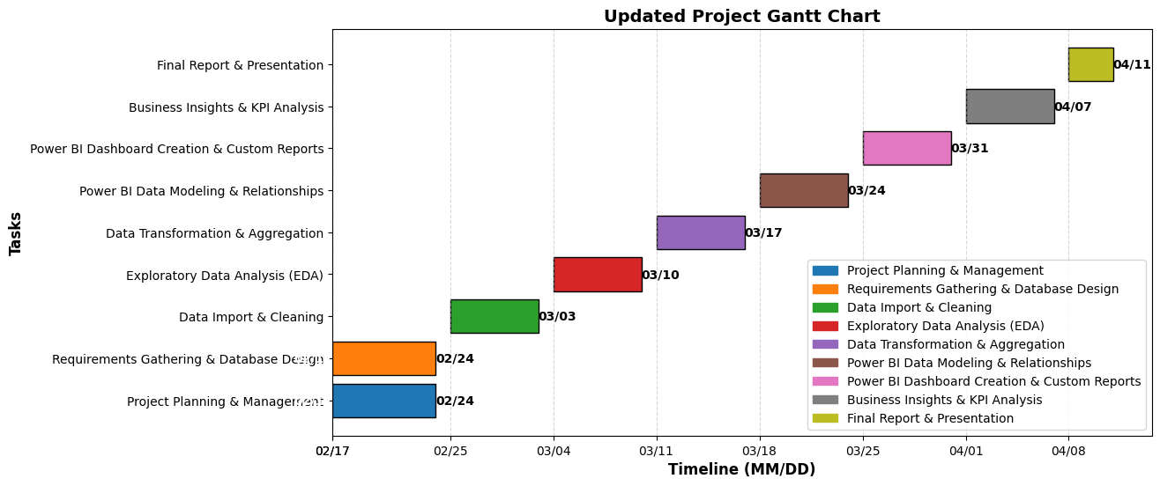
  - Milestones:
- Milestone 1: Data Cleaning & Preprocessing Completed.
- Milestone 2: EDA & Visualizations Developed.
- Milestone 3: Power BI Dashboard & KPI Insights Finalized.
- Milestone 4: Documentation & Final Report Ready.
  - Deliverables:
- Cleaned Dataset (Excel → SQL/Python Processed Data).
- SQL Queries & Python Scripts.
- Power BI Dashboard with Interactive Reports.
- Business Insights & KPI Reports.
- Final Documentation & Presentation.

  - Resources:
- Team Members: Data analysts.
- Tools & Technologies: Excel, Python, SQL, GitHub, Power BI, and data visualization libraries (Matplotlib, Seaborn).
- Hardware: Workstations capable of handling data processing tasks.

- Task Assignment & Roles
Week | Task Name | Start Date | End Date | Description | Assigned to | Tools | Deliverables
Week 1: Build Data Model, Data Cleaning and Preprocessing | Project Planning & Management | 2/17/2025 | 2/24/2025 | Planning and defining the scope. | Abdelrahman Mohamed Ibrahim  Ahmed Abdelazeem Ahmed | - | Project scope document
Week 1: Build Data Model, Data Cleaning and Preprocessing | Data Import & Cleaning | 2/25/2025 | 3/3/2025 | Load Excel files into Python, preprocess missing values, and ensure data consistency. | Yousef Mohamed Hussein  Abdelrahman Mohamed Ibrahim | - | Cleaned dataset, Data preprocessing notebook
Week 2: Analysis Questions Phase | Determine Data Analysis Questions | 3/4/2025 | 3/10/2025 | Identify analysis questions that can be derived from the dataset and are relevant for decision-making (e.g., relation between employee age and satisfaction level). | Ahmed Abdelazeem Ahmed  Eslam Fadl Sayed | Python (pandas, Matplotlib) | A set of analysis questions that can be answered via the dataset.
Week 2: Analysis Questions Phase | Exploratory Data Analysis (EDA) | 3/4/2025 | 3/10/2025 | Analyze data trends using Python, run descriptive statistics, and identify outliers. | Ahmed Abdelazeem Ahmed  Eslam Fadl Sayed | Python (pandas, Matplotlib) | Summary statistics and visual insights.
Week 3: Forecasting Questions Phase | Determine Forecasting Questions | 3/11/2025 | 3/17/2025 | Identify key forecasting questions and trends in the dataset. | Mohamed Mostafa Mohamed, Yousef Mohamed Hussein | Python (scikit-learn, pandas, Tableau) | A set of forecasting insights based on data trends.
Week 3: Forecasting Questions Phase | Data Transformation & Aggregation (SQL/Python) | 3/11/2025 | 3/17/2025 | Identify key forecasting questions and trends in the dataset. Merge and aggregate data to prepare for predictive modeling. | Mohamed Mostafa Mohamed  Yousef Mohamed Hussein | Python (pandas) | Standardized and aggregated dataset.
Week 4: Visualization Dashboard and Final Presentation | Power BI Data Modeling & Relationships | 3/18/2025 | 3/24/2025 | Establish relationships between tables, optimize performance using Power Query Transformations. | Abdelrahman Mohamed Ibrahim  Ahmed Abdelazeem Ahmed | Python (pandas, Matplotlib) | Optimized data model
Week 4: Visualization Dashboard and Final Presentation | Dashboard Creation & Custom Reports | 3/25/2025 | 3/31/2025 | Create interactive dashboards for employee performance trends, satisfaction levels, and attrition analysis. Add filters & slicers for user interaction. | Eslam Fadl Sayed  Mohamed Mostafa Mohamed | Python (pandas, Matplotlib), Tableau | Interactive dashboards and custom reports
Week 4: Visualization Dashboard and Final Presentation | Business Insights & KPI Analysis | 4/1/2025 | 4/7/2025 | Identify high vs. low-performing employees, compare education level vs. job performance, and create HR-friendly visual reports. | Yousef Mohamed Hussein, Ahmed Abdelazeem Ahmed | Python (pandas, Matplotlib), Tableau | Business insights & KPI reports
Week 4: Visualization Dashboard and Final Presentation | Final Report & Presentation | 4/8/2025 | 4/11/2025 | Prepare a report and presentation summarizing project work, including data analysis and visualization. | Abdelrahman Mohamed Ibrahim, Mohamed Mostafa Mohamed | Python (pandas, Matplotlib), Tableau | Final report and presentation

- Stakeholder Analysis
  - Key Stakeholders
- Project Sponsor: Executive leadership responsible for strategic decision-making.
- Human Resources Department: Primary beneficiary of the analysis to enhance employee management.
- Employees: Indirect stakeholders who benefit from improved HR practices.
  - Stakeholder Needs
- Project Sponsor: Clear, actionable insights and robust, reproducible analysis.
- Human Resources: Detailed analyses linking performance with education and satisfaction, leading to informed policy decisions.
- Employees: Transparent performance assessments and potential opportunities for career growth.

- ER Diagram
The ER Diagram below visually represents the data structure and relationships:
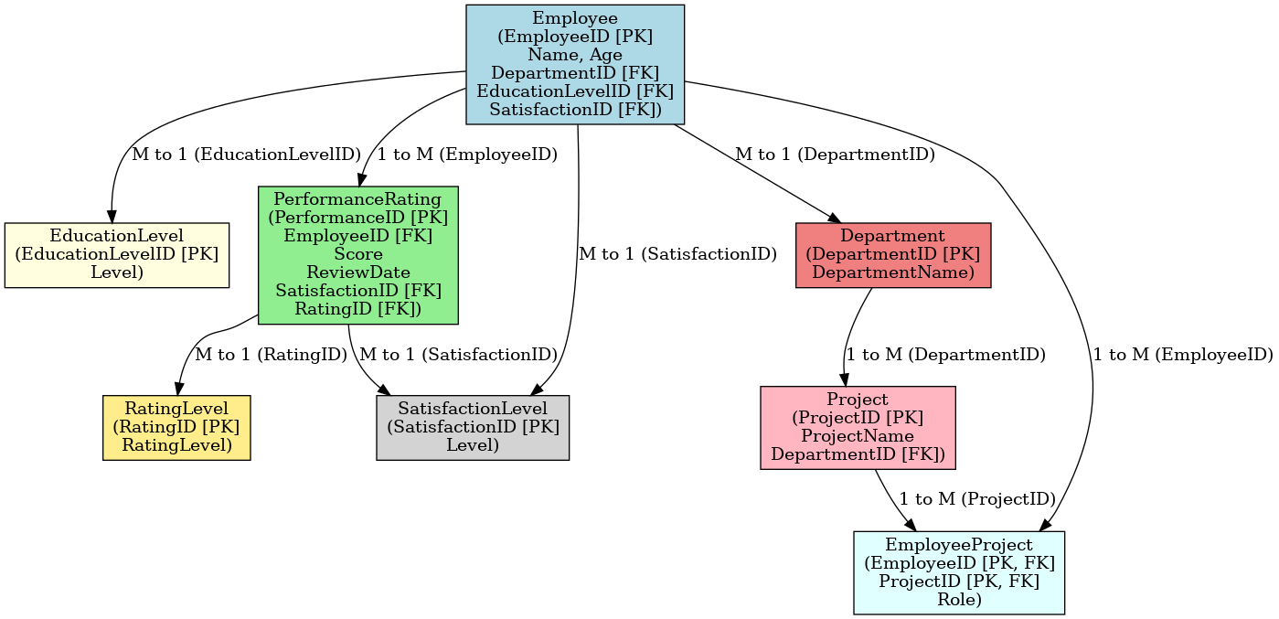
  - Entities & Relationships Covered:
- Employee (Linked to Department, Education Level, Performance, and Projects)
- Performance Ratings (Linked to Employee, Satisfaction, and Rating Levels)
- Department & Projects (Managing employee assignments)
- Satisfaction & Ratings (Tracking employee performance)
- Many-to-Many relationships (Employee-Project)

- Research Questions
To guide the data analysis, the following questions will be explored:
- Which age groups are most likely to leave the company?
- Is there a difference in attrition rates between male and female employees?
- What is the effect of frequent business travel (BusinessTravel) on employee retention?
- Is there a correlation between marital status (MaritalStatus) and overall attrition rate?
- Attrition Breakdown (General Overview)
- How does salary impact employee attrition rates?
- How do stock option levels (StockOptionLevel) affect employee retention?
- Is there a correlation between the distance from home (DistanceFromHome) and employee attrition?
- How does the number of years in the most recent role (YearsInMostRecentRole) relate to promotion opportunities?
- How does the delay in promotion (YearsSinceLastPromotion) affect attrition?
- How does the education field (EducationField) influence job roles and salary levels?
- Is there a correlation between the number of years with the current manager (YearsWithCurrManager) and employee attrition?
- Is there a relationship between education and the number of years in the current job role?

Data Analysis Project Plan
Project Phases & Tasks
Week 1: Build Data Model, Data Cleaning and Preprocessing
Task | Description | Tools | Deliverables
Data Preprocessing | Build a data model and clean and preprocess the data. | Python (pandas, Matplotlib) | Cleaned dataset ready for analysis.
Data Import & Cleaning | Load Excel files into Python, preprocess missing values, and ensure data consistency. | Python (pandas) | Data preprocessing notebook.
Week 2: Analysis Questions Phase
Task | Description | Tools | Deliverables
Determine Data Analysis Questions | Identify analysis questions that can be derived from the dataset and are relevant for decision-making (e.g., relation between employee age and satisfaction level). | Python (pandas, Matplotlib) | A set of analysis questions that can be answered via the dataset.
Exploratory Data Analysis (EDA) | Analyze data trends using Python, run descriptive statistics, and identify outliers. | Python (pandas, Matplotlib) | Summary statistics and visual insights.
Week 3: Forecasting Questions Phase
Task | Description | Tools | Deliverables
Determine Forecasting Questions | Identify key forecasting questions and trends in the dataset. | Python (scikit-learn, pandas, Matplotlib) | A set of forecasting insights based on data trends.
Data Transformation & Aggregation | Merge and aggregate data to prepare for predictive modeling. | Python (pandas) | Standardized and aggregated dataset.
Week 4: Visualization Dashboard and Final Presentation
Task | Description | Tools | Deliverables
Build a Visualization Dashboard | Develop a Tableau dashboard to visualize analysis insights. | Tableau | Interactive visualization dashboard.
Final Report & Presentation | Prepare a report and presentation summarizing project work, including data analysis and visualization. | Python (pandas, Matplotlib), Tableau | Final report and presentation.
This project plan ensures a structured approach to data cleaning, analysis, forecasting, and visualization, utilizing Python and Tableau for all tasks previously handled by SQL.

