Lecture Data Science for Electron Microscopy SS 25

Philipp Pelz

2025-06-14

Abstract

This is the website for the Data Science for Electron Microscopy Lecture

[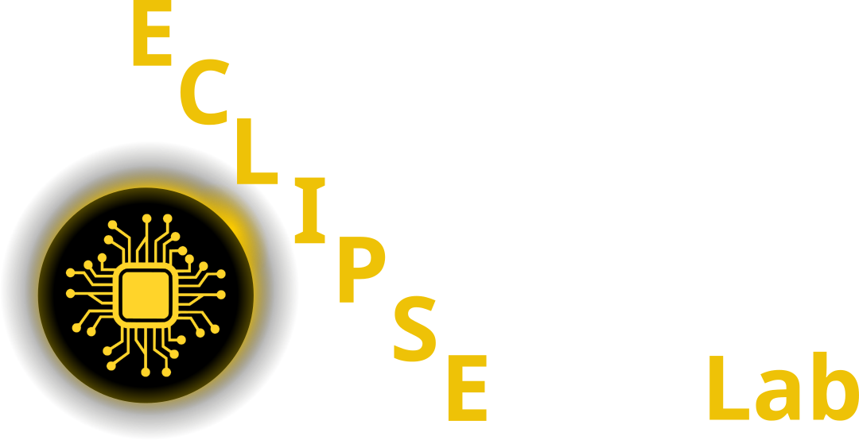](https://pelzlab.science)

[](https://github.com/ECLIPSE-Lab/DataScienceForElectronMicroscopy/tree/main/notebooks)

**Github Code**

[](https://www.studon.fau.de/studon/ilias.php?baseClass=ilrepositorygui&cmd=infoScreenGoto&ref_id=6252031)

**Studon Link**

## 1 Lecture 1: Intro (13.05.2025)

* Lecture slides: [Lecture 1: Introduction](https://pelzlab.science/public_presentations/data_science_for_em/01_intro/template.html)
* [d2l Chapter 2: Preliminaries](https://d2l.ai/chapter_preliminaries/index.html)

## 2 Lecture 2: Optimization, Regression, Sensor Fusion (20.05.2025)

* Lecture slides: [Lecture 2: Optimization, Regression, Sensor Fusion](https://pelzlab.science/public_presentations/data_science_for_em/02_regression/template.html#/title-slide)
* [d2l Chapter 3: Regression](https://d2l.ai/chapter_linear-regression/index.html)
* [d2l Chapter 12: Optimization](https://d2l.ai/chapter_optimization/index.html)

## 3 Lecture 3: CNNs (03.06.2025)

* Lecture slides: [Lecture 3: CNNs](https://pelzlab.science/public_presentations/data_science_for_em/03_cnns/template.html#/title-slide)
* [d2l Chapter 7: CNNs](https://d2l.ai/chapter_convolutional-neural-networks/index.html)
* [d2l Chapter 8: CNNs](https://d2l.ai/chapter_convolutional-modern/index.html)

## 4 Lecture 4: Classification, Segmentation, AutoEncoders (10.06.2025)

* Lecture slides: [Lecture 4: Classification, Segmentation, AutoEncoders](https://pelzlab.science/public_presentations/data_science_for_em/04_selfsupervised/template.html#/title-slide)
* [d2l Chapter 4: Classification](https://d2l.ai/chapter_linear-classification/index.html)
* [d2l Chapter 14.9: Segmentation](https://d2l.ai/chapter_computer-vision/semantic-segmentation-and-dataset.html)
* Segmentation
* Dimensionality Reduction
  + PCA
  + Autoencoder
  + Variational Autoencoder

## 5 Miniproject (10.6. - 24.6.2025) concurrent to lectures

In the miniproject, you will test multiple deep neural network architectures on one of four microscopy-related tasks. You should summarize your results in a short presentation (5 minutes + 2 minutes discussion) and deliver a Jupyter Notebook with your code and results. The miniproject will be graded and will count as 40% towards your final grade.

1. Segmentation Task

* We will use the HRTEM dataset from “A robust synthetic data generation framework for machine learning in high-resolution transmission electron microscopy (HRTEM)” by Rangel DaCosta et al. (2024) to implement a segmentation model. The goal is to segment nanoparticles in HRTEM images.
* Please use the article “A robust synthetic data generation framework for machine learning in high-resolution transmission electron microscopy (HRTEM)” by Rangel DaCosta et al. (2024) as a starting point for your implementation.
* The datast contains pairs of HRTEM images and ground truth segmentations.

1. VAE & Dimensionality Reduction

* We will use the dataset from “Uncovering material deformations via machine learning combined with four-dimensional scanning transmission electron microscopy” by Shi et al. (2022) to implement a dimensionality reduction model and cluster 4DSTEM data.
* The goal is to learn a mapping from 4DSTEM data to a lower-dimensional embedding where you can perform clustering to identify different deformation modes.
* Please use the article “Uncovering material deformations via machine learning combined with four-dimensional scanning transmission electron microscopy” by Shi et al. (2022) as a starting point for your implementation.

1. Denoising

* We will use the dataset from “Unsupervised deep denoising for four-dimensional scanning transmission electron microscopy” by Sadri et al. (2024) to implement a denoising model for 4DSTEM data.
* The goal is to learn a mapping from noisy to clean 4DSTEM data.
* Please use the article “Unsupervised deep denoising for four-dimensional scanning transmission electron microscopy” by Sadri et al. (2024) as a starting point for your implementation.
* The article contains pytorch code for the model.
* Learn how to adapt it to your needs and try to replicate the results on the SrTiO3_High_mag_Low_dose.npy and SrTiO3_High_mag_High_dose.npy datasets.

1. Image-to-Image Translation

* We will use a simulated X-ray image dataset with pairs of projected thickness and phase contrast images to implement an Image to image translation model.
* The goal is to learn a mapping from phase contrast images to projected thickness images.
* This is usually a task that is solved with multiple measurements and a physical model of the imaging process.
* Here we will try to learn this mapping from simulated data. Please use the article “Multi-resolution convolutional neural networks for inverse problems” by Wang et al. (2020) as a starting point for your implementation.

## 6 Lecture 5: Mixed Bag (24.06.2025)

* Lecture slides: [Lecture 5: Advanced AutoEncoder, GANs, and more](https://pelzlab.science/public_presentations/data_science_for_em/05_gan/template.html#/title-slide)
* Project presentations
* Generative Adversarial Networks

## 7 Lecture 6: Gaussian Processes Introduction (01.07.2025)

* Introduction to Gaussian Processes

## 8 Lecture 7: Gaussian Processes Applications (08.07.2025)

* Bayesian Optimization
* Active Learning
* Deep Kernel Learning

## 9 Lecture 8: TBD (15.07.2025)

* TBD

## 10 Lecture 9: Repetition (29.07.2025)

* Repetition and Preparation for the Exam

## References

Rangel DaCosta, Luis, Katherine Sytwu, CK Groschner, and MC Scott. 2024. “A Robust Synthetic Data Generation Framework for Machine Learning in High-Resolution Transmission Electron Microscopy (HRTEM).” *Npj Computational Materials* 10 (1): 165.

Sadri, Alireza, Timothy C Petersen, Emmanuel WC Terzoudis-Lumsden, Bryan D Esser, Joanne Etheridge, and Scott D Findlay. 2024. “Unsupervised Deep Denoising for Four-Dimensional Scanning Transmission Electron Microscopy.” *Npj Computational Materials* 10 (1): 243.

Shi, Chuqiao, Michael C Cao, Sarah M Rehn, Sang-Hoon Bae, Jeehwan Kim, Matthew R Jones, David A Muller, and Yimo Han. 2022. “Uncovering Material Deformations via Machine Learning Combined with Four-Dimensional Scanning Transmission Electron Microscopy.” *Npj Computational Materials* 8 (1): 114.

Wang, Feng, Alberto Eljarrat, Johannes Müller, Trond R Henninen, Rolf Erni, and Christoph T Koch. 2020. “Multi-Resolution Convolutional Neural Networks for Inverse Problems.” *Scientific Reports* 10 (1): 5730.