Seminar Machine Learning for Microscopy WS 25
Philipp Pelz
2025-09-07
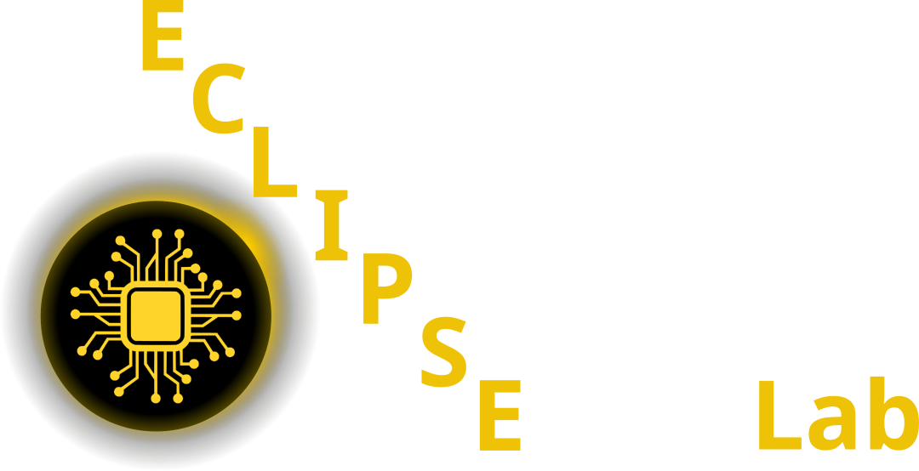

Github Code

Studon Link

1. Topics
- Intro
- Convolutional Neural Networks in Microscopy
- Generative Adversarial Networks in Microscopy
- Transformers in Microscopy
- Self-Supervised Learning in Microscopy
- Transfer Learning in Microscopy

2. Schedule

2.1 Session 1: Intro (17.10.2025)

2.2 Sessions 2-5: Journal Club 24.10.25 - 21.11.25

2.3 Session 6: 28.11.25 - Talks 1 - 2

2.4 Session 7: 05.12.25 - Talks 3 - 4

2.5 Session 8: 12.12.25 - Talks 5 - 6

2.6 Session 9: 19.12.25 - Talks 7 - 8

2.7 Session 10: 26.12.25 - Talks 9 - 10

References

