Seminar Machine Learning for Microscopy WS 26
Philipp Pelz
2026-09-27
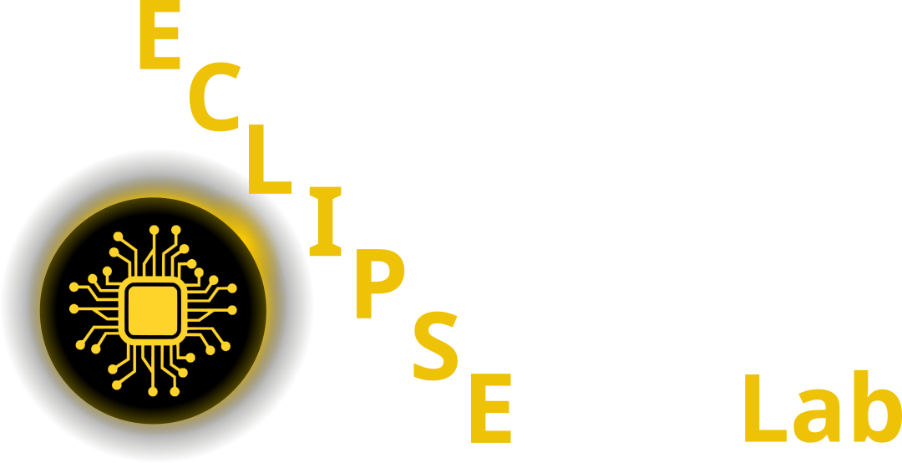

Github Code

Studon Link
Pelz Lab website
Wed 16:00h - 17:30h, IZNF Rm 01.140

1. Topics

2. Schedule

2.1 Session 1: Intro (21.10.2026)

2.2 Sessions 2-5: Journal Club 28.10.26 - 18.11.26

2.3 Session 6: 25.11.26 - Talks 1 - 2

2.4 Session 7: 02.12.26 - Talks 3 - 4

2.5 Session 8: 09.12.26 - Talks 5 - 6

2.6 Session 9: 16.12.26 - Talks 7 - 8

2.7 Session 10: 06.01.27 - Talks 9 - 10

2.8 Session 11: 13.01.27 - Talks 11 - 12

2.9 Session 12: 20.01.27 - Talks 13 - 14

2.10 Session 13: 27.01.27 - Talks 15 - 16

2.11 Session 14: 03.02.27 - Buffer / Wrap-up

References

