Weather

Data

time=0:1:23;

weather=[6,5,4,4,3,3,2,3,4,5,7,8,9,10,10,11,10,11,9,8,7,6,6,5];

WeatherFit1

Linear model Poly4:

f(x) = p1*x^4 + p2*x^3 + p3*x^2 + p4*x + p5

Coefficients (with 95% confidence bounds):

p1 = 0.0003801 (0.0001463, 0.0006138)

p2 = -0.02464 (-0.03548, -0.0138)

p3 = 0.4788 (0.3146, 0.6431)

p4 = -2.724 (-3.624, -1.824)

p5 = 7.086 (5.657, 8.515)

Goodness of fit:

SSE: 13.46

R-square: 0.9244

Adjusted R-square: 0.9084

RMSE: 0.8418

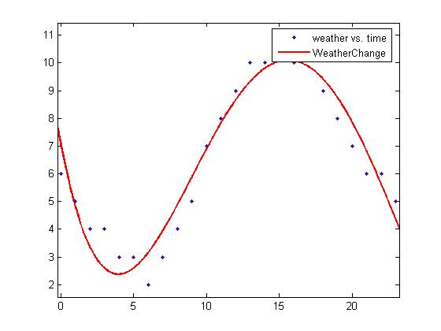

f(x) = 0.0003801*x^4 -0.02464*x^3 + 0.4788*x^2 -2.724*x + 7.086

WeatherFit2

General model Gauss3:

f(x) =

a1*exp(-((x-b1)/c1)^2) + a2*exp(-((x-b2)/c2)^2) +

a3*exp(-((x-b3)/c3)^2)

Coefficients (with 95% confidence bounds):

a1 = 3.868 (-9.503, 17.24)

b1 = 23.16 (-75.1, 121.4)

c1 = 11.58 (-49.99, 73.15)

a2 = 8.556 (-36.89, 54)

b2 = 14.24 (11.54, 16.94)

c2 = 6.194 (-4.121, 16.51)

a3 = 6.057 (-0.4316, 12.55)

b3 = -1.212 (-7.437, 5.013)

c3 = 5.069 (-5.022, 15.16)

Goodness of fit:

SSE: 3.607

R-square: 0.9797

Adjusted R-square: 0.9689

RMSE: 0.4904

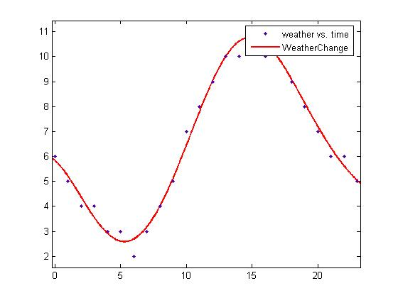

f(x) = 3.868*exp(-((x-23.16)/ 11.58)^2) + 8.556*exp(-((x-14.24)/ 6.194)^2) + 6.057*exp(-((x+1.212)/ 5.069)^2)

UserNumber

Data

|  |  |
| --- | --- |
| **time** | **number of user in building** |
| 7:00:00 | 4 |
| 7:10:00 | 20 |
| 7:20:00 | 26 |
| 7:30:00 | 38 |
| 7:40:00 | 72 |
| 7:50:00 | 136 |
| 8:00:00 | 228 |
| 8:10:00 | 332 |
| 8:20:00 | 424 |
| 8:30:00 | 484 |
| 8:40:00 | 516 |
| 8:50:00 | 570 |
| 9:00:00 | 662 |
| 9:10:00 | 705 |
| 9:20:00 | 716 |
| 9:30:00 | 724 |
| 9:40:00 | 727 |
| 9:50:00 | 732 |
| 10:00:00 | 734 |
| 10:10:00 | 735 |
| 10:20:00 | 734 |
| 10:30:00 | 730 |
| 10:40:00 | 728 |
| 10:50:00 | 731 |
| 11:00:00 | 732 |
| 11:10:00 | 732 |
| 11:20:00 | 726 |
| 11:30:00 | 716 |
| 11:40:00 | 706 |
| 11:50:00 | 683 |
| 12:00:00 | 505 |
| 12:10:00 | 422 |
| 12:20:00 | 353 |
| 12:30:00 | 256 |
| 12:40:00 | 283 |
| 12:50:00 | 410 |
| 13:00:00 | 508 |
| 13:10:00 | 586 |
| 13:20:00 | 650 |
| 13:30:00 | 713 |
| 13:40:00 | 725 |
| 13:50:00 | 732 |
| 14:00:00 | 734 |
| 14:10:00 | 732 |
| 14:20:00 | 736 |
| 14:30:00 | 734 |
| 14:40:00 | 731 |
| 14:50:00 | 728 |
| 15:00:00 | 735 |
| 15:10:00 | 729 |
| 15:20:00 | 730 |
| 15:30:00 | 733 |
| 15:40:00 | 738 |
| 15:50:00 | 735 |
| 16:00:00 | 733 |
| 16:10:00 | 709 |
| 16:20:00 | 699 |
| 16:30:00 | 682 |
| 16:40:00 | 674 |
| 16:50:00 | 658 |
| 17:00:00 | 639 |
| 17:10:00 | 589 |
| 17:20:00 | 536 |
| 17:30:00 | 485 |
| 17:40:00 | 440 |
| 17:50:00 | 400 |
| 18:00:00 | 391 |
| 18:10:00 | 357 |
| 18:20:00 | 325 |
| 18:30:00 | 293 |
| 18:40:00 | 260 |
| 18:50:00 | 236 |
| 19:00:00 | 212 |
| 19:10:00 | 197 |
| 19:20:00 | 186 |
| 19:30:00 | 167 |
| 19:40:00 | 162 |
| 19:50:00 | 157 |
| 20:00:00 | 149 |
| 20:10:00 | 145 |
| 20:20:00 | 139 |
| 20:30:00 | 133 |
| 20:40:00 | 127 |
| 20:50:00 | 122 |
| 21:00:00 | 111 |
| 21:10:00 | 106 |
| 21:20:00 | 94 |
| 21:30:00 | 85 |
| 21:40:00 | 70 |
| 21:50:00 | 68 |
| 22:00:00 | 67 |

UserNumberFit1

General model 7:

f(x) =

a1*exp(-((x-b1)/c1)^2) + a2*exp(-((x-b2)/c2)^2) +

a3*exp(-((x-b3)/c3)^2) + a4*exp(-((x-b4)/c4)^2) +

a5*exp(-((x-b5)/c5)^2) + a6*exp(-((x-b6)/c6)^2) +

a7*exp(-((x-b7)/c7)^2)

Coefficients (with 95% confidence bounds):

a1 = 634.6 (35.11, 1234)

b1 = 545 (510.3, 579.7)

c1 = 117 (49.84, 184.1)

a2 = 686.5 (503.8, 869.2)

b2 = 217.8 (203.4, 232.2)

c2 = 74.79 (0.4033, 149.2)

a3 = 366 (-202, 934.1)

b3 = 284.5 (279.5, 289.6)

c3 = 35.47 (15.86, 55.08)

a4 = 327.9 (-528.8, 1185)

b4 = 378 (369.9, 386.1)

c4 = 39.44 (8.681, 70.2)

a5 = 538.9 (78.4, 999.5)

b5 = 119 (91.48, 146.6)

c5 = 61.09 (48.75, 73.43)

a6 = 409.7 (-258.6, 1078)

b6 = 429.3 (360.6, 498.1)

c6 = 66.98 (-13.91, 147.9)

a7 = 151.4 (-44.01, 346.8)

b7 = 720.4 (317.9, 1123)

c7 = 200.5 (-117.4, 518.4)

Goodness of fit:

SSE: 2.038e+004

R-square: 0.9967

Adjusted R-square: 0.9958

RMSE: 17.06

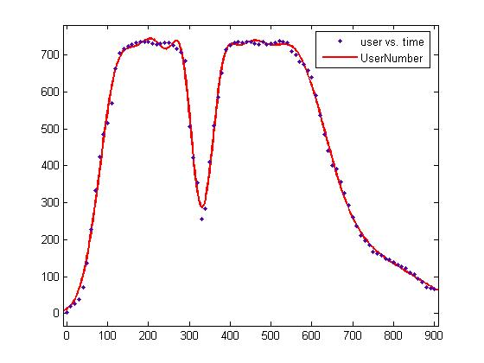

f(x) = 634.6*exp(-((x-545)/ 117)^2) + 686.5*exp(-((x-217.8)/ 74.79)^2) +

366*exp(-((x-284.5)/ 35.47)^2) + 327.9*exp(-((x-378)/ 39.44)^2) +

538.9*exp(-((x-119)/ 61.09)^2) + 409.7*exp(-((x-429.3)/ 66.98)^2) + 151.4*exp(-((x-720.4)/ 200.5)^2)

UserNumberFit2

General model Gauss7:

f(x) =

a1*exp(-((x-b1)/c1)^2) + a2*exp(-((x-b2)/c2)^2) +

a3*exp(-((x-b3)/c3)^2) + a4*exp(-((x-b4)/c4)^2) +

a5*exp(-((x-b5)/c5)^2) + a6*exp(-((x-b6)/c6)^2) +

a7*exp(-((x-b7)/c7)^2)

Coefficients (with 95% confidence bounds):

a1 = 636.2 (46.2, 1226)

b1 = 9.084 (8.509, 9.659)

c1 = 1.95 (0.8331, 3.068)

a2 = 686.4 (503, 869.8)

b2 = 3.631 (3.391, 3.87)

c2 = 1.246 (0.003467, 2.488)

a3 = 366.4 (-203.7, 936.4)

b3 = 4.743 (4.66, 4.825)

c3 = 0.5913 (0.2641, 0.9185)

a4 = 329 (-528.7, 1187)

b4 = 6.301 (6.165, 6.436)

c4 = 0.6582 (0.1469, 1.17)

a5 = 539.2 (77.95, 1001)

b5 = 1.984 (1.524, 2.445)

c5 = 1.018 (0.8121, 1.224)

a6 = 409.5 (-263.8, 1083)

b6 = 7.158 (6.01, 8.305)

c6 = 1.116 (-0.2368, 2.469)

a7 = 150.9 (-40.7, 342.5)

b7 = 12.03 (5.45, 18.61)

c7 = 3.321 (-1.894, 8.537)

Goodness of fit:

SSE: 2.037e+004

R-square: 0.9967

Adjusted R-square: 0.9958

RMSE: 17.06

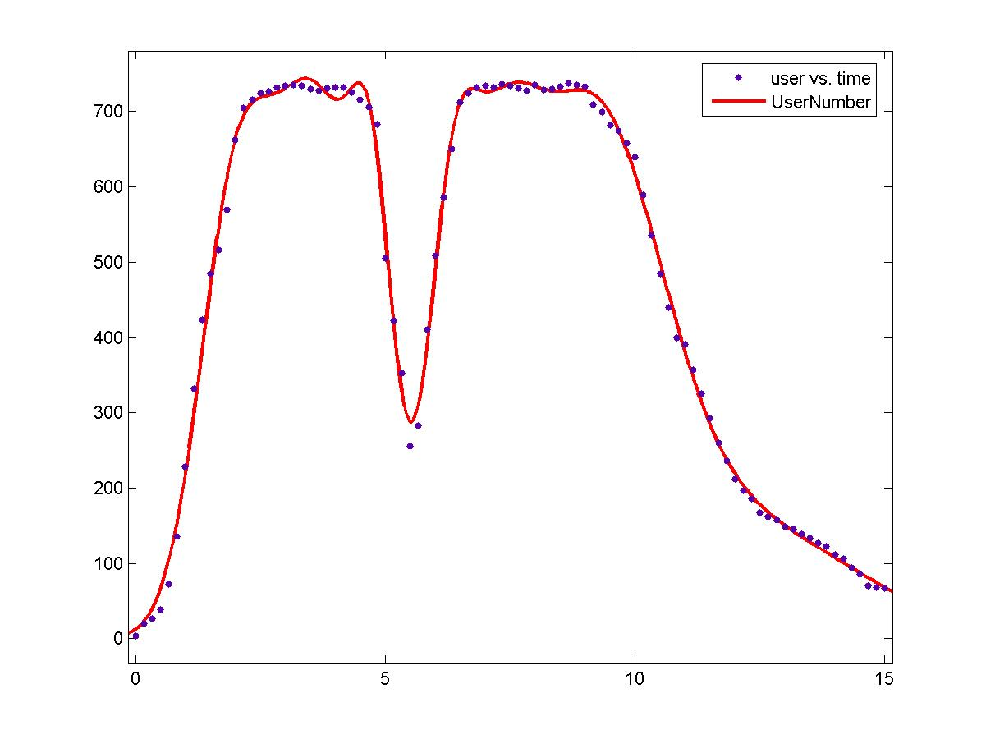

f(x) = 636.2*exp(-((x-9.084)/ 1.95)^2) + 686.4*exp(-((x-3.631)/ 1.246)^2) + 366.4*exp(-((x-4.743)/ 0.5913)^2) + 329*exp(-((x-6.301)/ 0.6582)^2) + 539.2*exp(-((x-1.984)/ 1.018)^2) + 409.5*exp(-((x-7.158)/ 1.116)^2) + 150.9*exp(-((x-12.03)/ 3.321)^2)