A spectral dependent machine learning technique for gap filling missing data and striping in thermal infrared data

Steffen Mauceri, JPL: Steffen.Mauceri@jpl.nasa.gov

1. Problem Description
ECOSTRESS thermal infrared data are degraded by a variety of artefacts: 1) missing scan lines in band 1 and 5 every 128 lines; 2) missing data at the edge of scanlines; 3) erroneously increased or decreased radiance in scanlines that can occur in any band and are randomly distributed. Artefacts 1) and 2) are reflected in the data quality indicator. Artefact 3) had not been flagged previously and was incorrectly labeled as good quality data (DQI_GOOD = 0). Most representations of these artefacts occur only in a subset of the instrument bands for a given scan line.
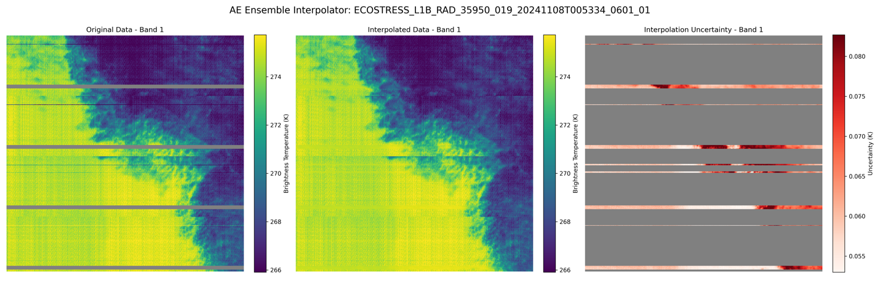 | Figure 1: ECOSTRESS scene from Band 1 converted to Brightness Temperature. Regular stripes of missing data every 128 lines are shown in gray and indicated by DQI_BAD_OR_MISSING = 3. Unregular stripes are visible as dark lines and erroneously labeled as DQI_GOOD = 0. The interpolation algorithm seeks to fill in these missing and erroneous values.

2. Methodology
While most ECOSTRESS observations contain 5 thermal bands, there is a subset of scenes that contain only 3 valid bands. The approach described below is applied to both.
2.1. Detecting Stripes
We detect horizontal stripes (artefact 3) by computing row-wise differences in the radiances of each band. First, we mask out all invalid or missing pixels, then average each row’s pixel-wise differences to obtain a single “difference score” per row. Next, we compute the median absolute deviation (MAD) of these row-wise scores. Rows whose difference score exceeds the MAD multiplied by a user-defined threshold (set to 5) are flagged as having stripes and the data quality indicator is updated accordingly (DQI_STRIPE_NOT_INTERPOLATED = 2).
2.2. Interpolating Missing Data
To address the three types of artefacts listed above, we use a machine learning model to interpolate missing data by leveraging the correlation across the TIR bands. Specifically, we train a small ensemble of autoencoder-based neural networks that operate independently on each pixel. Each autoencoder takes as input the radiances of available (non-missing) bands for a given pixel and outputs radiance estimates for all bands. For example, if band 5 is missing, we input bands 1 to 4 into the network and use the output for band 5 to fill the gap.
Each ensemble member independently predicts a mean radiance ($μ$) and associated variance ($σ^{2}$) for every pixel. The models are trained using the negative log-likelihood (NLL) loss function (Eq. 1), ensuring each network simultaneously learns an optimal prediction and an uncertainty estimate. During training, the loss is computed only for pixels flagged as missing (i.e., pixels the model must fill):
$-\log{p_{θ}}\left(y_{n} | x_{n}\right)=\frac{1}{2}\log\left(σ_{θ}^{2}\left(x\right)\right)+\frac{{\left(y-μ_{θ}\left(x\right)\right)}^{2}}{2σ_{θ}^{2}\left(x\right)}+\text{constant}$ (1)
After training, predictions from all $M$ ensemble members are combined to produce robust estimates of each pixel’s radiance and associated uncertainty. The mean predictions $μ_{*}\left(x\right)$ is obtained by averaging the ensemble outputs (Eq. 2), while the total variance $σ_{*}^{2}\left(x\right)$ accounts for both aleatoric (data) epistemic (model) uncertainty (Eq. 3):
$μ_{*}\left(x\right)=\frac{1}{M}\sum_{m}{μ_{θ_{m}}\left(x\right)}$ (2)
$σ_{*}^{2}\left(x\right)=\frac{1}{M}\sum_{m}{\left(σ_{θ_{m}}^{2}\left(x\right)+μ_{θ_{m}}^{2}\left(x\right)\right)}-μ_{*}^{2}\left(x\right)$ (3)
We then report interpolation uncertainty as the square root of $σ_{*}^{2}\left(x\right)$, giving a per-pixel standard deviation. A larger number of ensemble members generally yields more reliable uncertainties but increases computational cost; our tests showed that three ensemble members are sufficient.
For interpolation to be performed, we enforce a minimum of two valid input bands per pixel. Therefore, some pixels may remain unfilled if they do not meet this criterion, resulting in occasional residual missing data after the interpolation step.
3. Results
In Figure 2 we show an example of a an ECOSTRESS scene before and after interpolation and associated uncertainties. After the interpolation the “stripes” have been removed. Note that the interpolation cannot reconstruct instrument noise that is present in the data. Thus, larger interpolated patches might appear “blurred” compared to neighboring pixels that contain noise. The interpolation uncertainties are not uniform and highest for the transition area between the cold and warm areas within the scene.

Figure 2: Crop of an ECOSTRESS scene in Brightness Temperature. Left: before interpolation with missing data shown in gray; Middle: after interpolation; Right: 1 sigma uncertainties for interpolated pixels.

3.1 Interpolation Errors
To quantify interpolation errors, we randomly sampled test pixels from ECOSTRESS scenes where they contain good data over all bands. For the 3-band data this is restricted to the 3-bands available in the data. Then we randomly mask out one or multiple bands in the sampled pixel to simulate missing data in those bands. Next, we train the auto-encoder ensemble using pixels that are separate to the test pixels. Finally, we apply the trained model to the test pixels and compare the interpolation results to the observed (true) data. The RMSE for each band is shown in Table 1. Note that the RMSE intrinsically is a combination of the interpolation error and irreducible instrument noise.
A histogram of the interpolation errors is further shown in Figure 3 with the errors resembling a Gaussian distribution with a mean close to zero.
Table 1: RMSE of interpolation by band in brightness temperature. “5-band RMSE” shows average RMSE for scenes that contain all 5 ECOSTRESS TIR bands while “3-band RMSE” is calculated for scenes with only 3 TIR bands. Errors are calculated over a set of selected ECOSTRESS scenes.
TIR Band | 5-band RMSE (K) | 3-band RMSE (K)
1 | 0.52 | -
2 | 0.32 | 0.47
3 | 0.46 | -
4 | 0.36 | 0.61
5 | 0.72 | 0.98

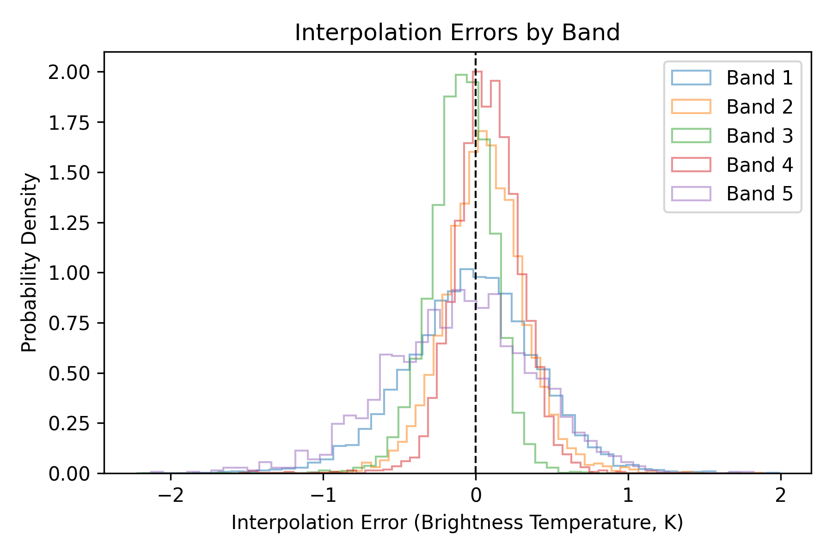
Figure 3: Interpolation error in brightness temperature by band over a set of selected ECOSTRESS scenes.

3.2 Uncertainty Quantification
To estimate how well the generated uncertainties represent the errors in the interpolation we show coverage calibration curves in Figure 4. The x-axis denotes the expected coverage (e.g., a 90% confidence interval is expected to contain the true value 90% of the time), and the y-axis shows the observed coverage based on test data. The model is slightly overconfident for both 5-band and 3-band scenes.
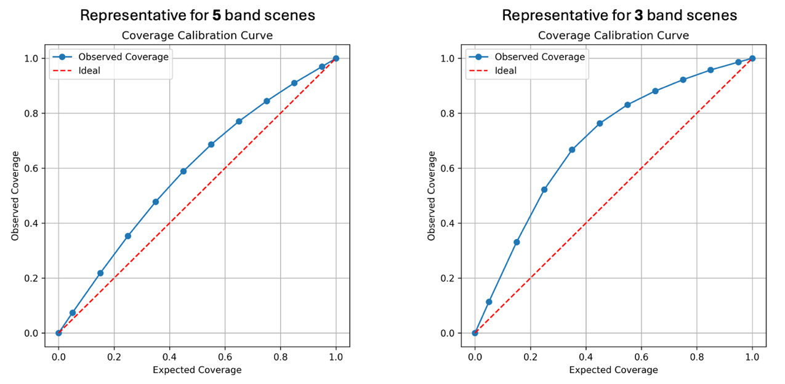
Figure 4: Coverage calibration curves comparing expected coverage (x-axis) to observed coverage (y-axis) for uncertainties quantified by the interpolation model. The red dashed line represents ideal calibration. Deviation below indicates underconfidence (intervals too wide), while deviation above indicates overconfidence (intervals too narrow). The left panel is for 5-band scenes, and the right panel is for 3-band scenes.

