Creating a Composite Image
ECOSTRESS Tutorials
This tutorial will show you how to create a composite image of ECOSTRESS data using a Python code. The code shows how to make a composite of Land Surface Temperature (LST) products, but it can be modified for other ECOSTRESS products.
Table of Contents
What is a Composite Image? 1
Creating a Composite Image 1

What is a Composite Image?
A composite image is an image made by combining multiple images into one. Composite images are commonly used in remote sensing to get the average or median of data for a certain time period. These images can also help compare changes over time.

Creating a Composite Image
- Download the Composite code from https://github.com/ECOSTRESS-Tutorials/ECOSTRESS-Composite.
- Open your finder. Create a project folder to store all the files for this project by right clicking and selecting New Folder. Name your new folder so that you know it is the main project folder.
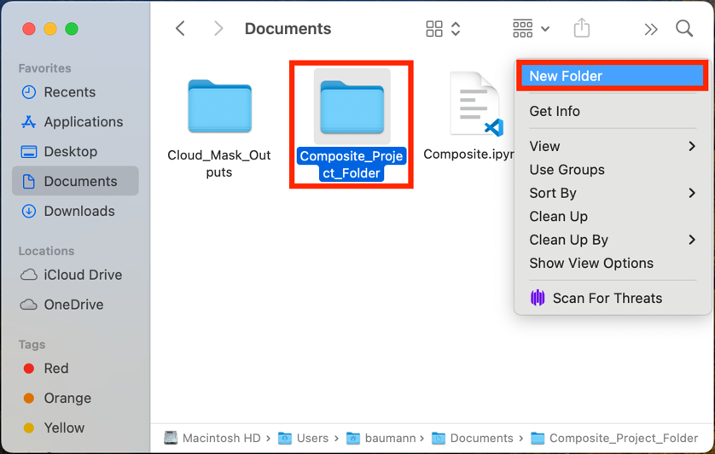
- Move the downloaded code file into the project folder.
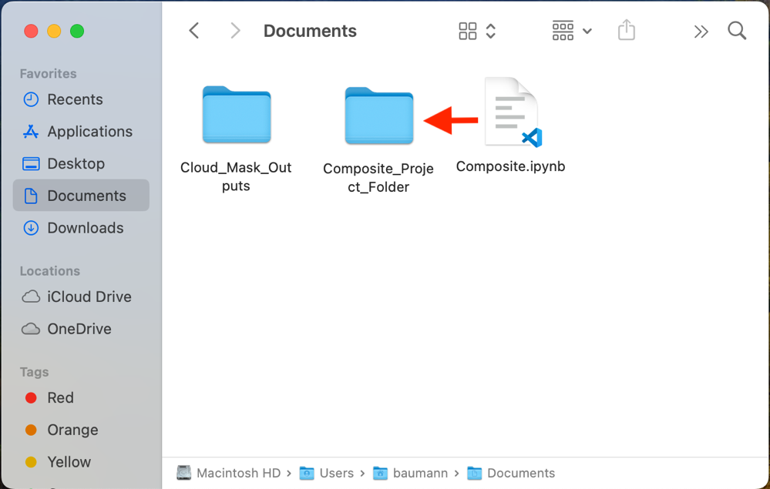
- Move the folder with your QCed or cloud masked ECOSTRESS data into the project folder.
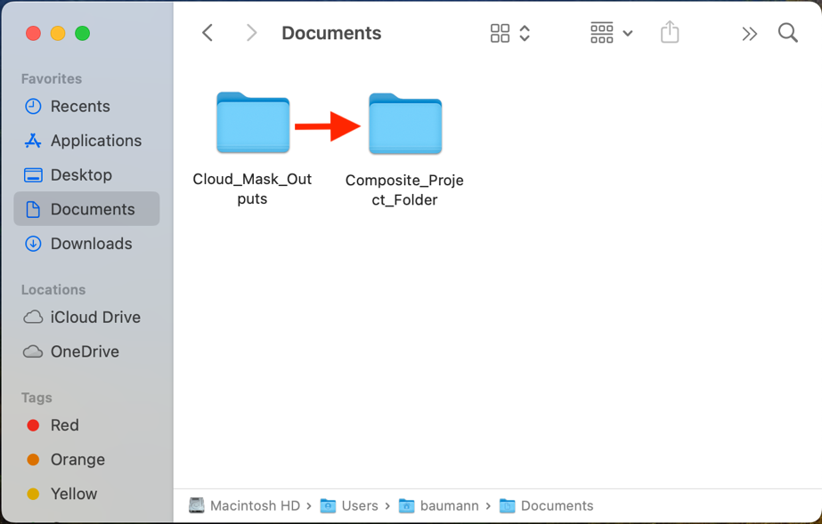
Tip: It is best practice to use input data that has already been QCed or cloud masked in order to improve accuracy. If your ECOSTRESS images are not QCed or cloud masked, follow the Applying QC Flags or Cloud Masking ECOSTRESS Products tutorial to set them up for this tutorial. If you used a different QC or cloud masking method, or chose to not to QC or cloud mask your images, you may need to change the datetime extraction parts of the code to match your input files’ naming structure.

- In the project folder, create a new sub folder to store the completed composite image.
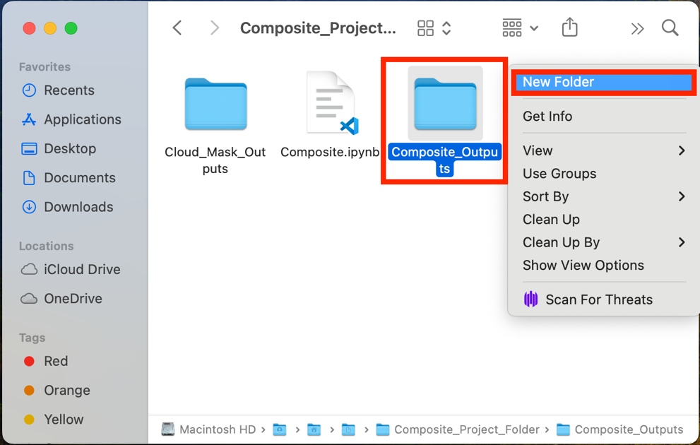
- Open Visual Studio Code and use File > Open Folder… to get connected to the main folder that contains the QCed or cloud masked ECOSTRESS files, the Composite code, and the output subfolder.
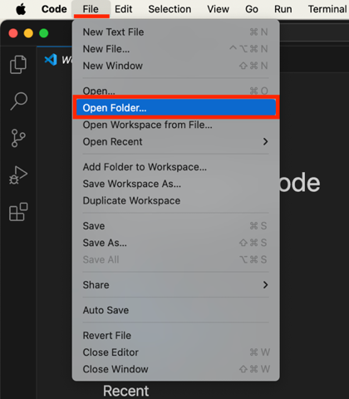 | 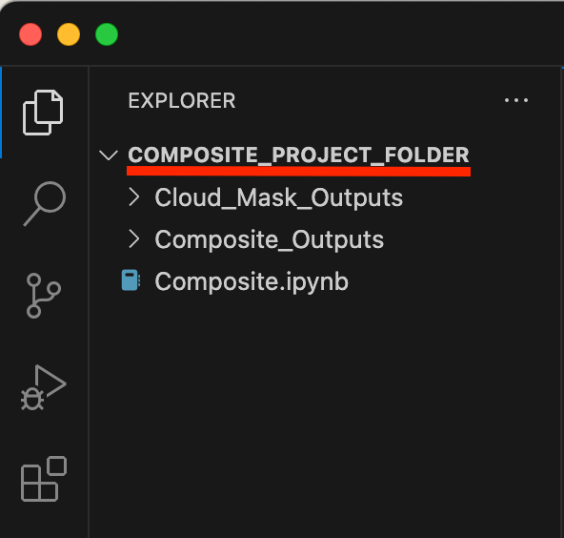

- In the EXPLORER tab, find the Composite code and click on it to open it.
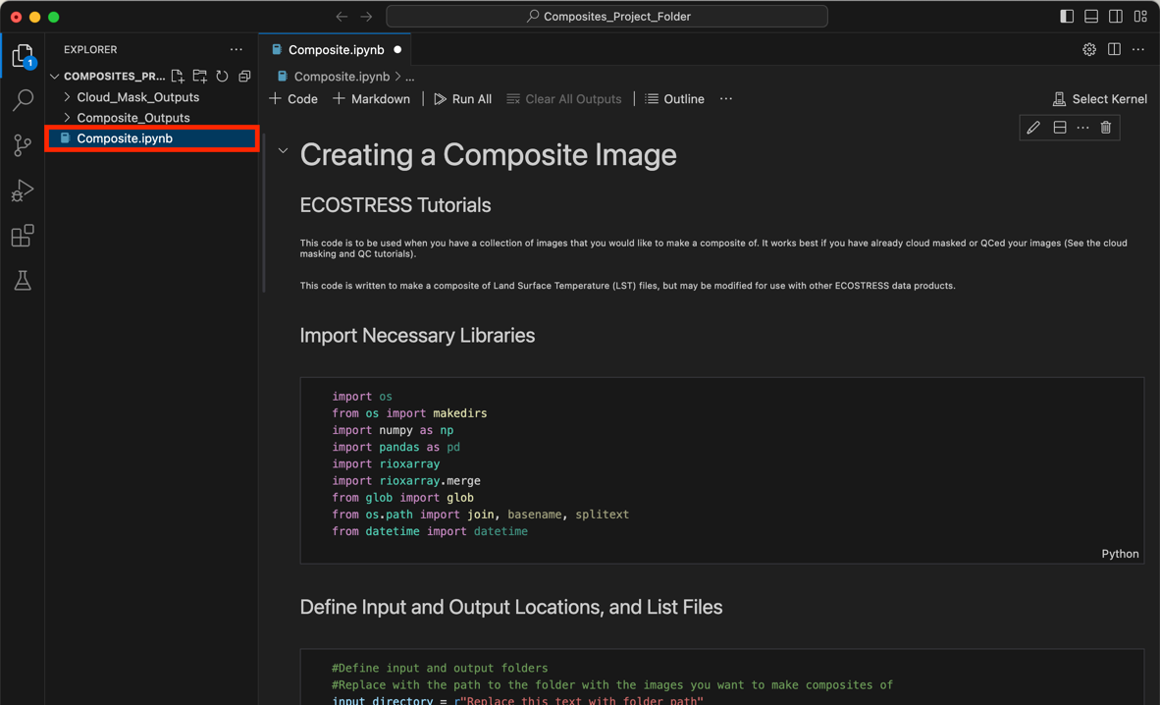
Tip: If you want to know more about what each line of the code does, read the comments in the code. Comments in the code are identified by #. These comments do not actually change how the code runs, but they can be helpful to put notes on how the code works for yourself or other users. This can also be helpful if you want to customize the code because it will guide you to which parts you may want to change!

Examples of comments (green text following the #):
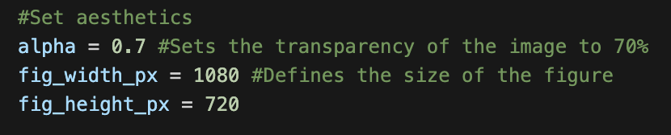

- Find the section of the code titled Define Input and Output Locations, and List Files. Find the variable called input_directory. Change the text that says "Replace_this_text_with_folder_path" to the path of the folder where your QCed or cloud masked ECOSTRESS files are.
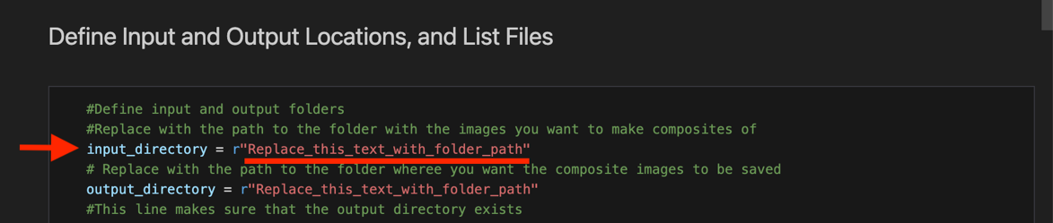
  - To copy the folder path, use the EXPLORER panel on the left side of Visual Studio Code to find the folder you are interested in. Once you have found it, right click on it and select Copy Path. Now you can paste the path into your code. Make sure it is still wrapped in quotes and has r outside the first quote.
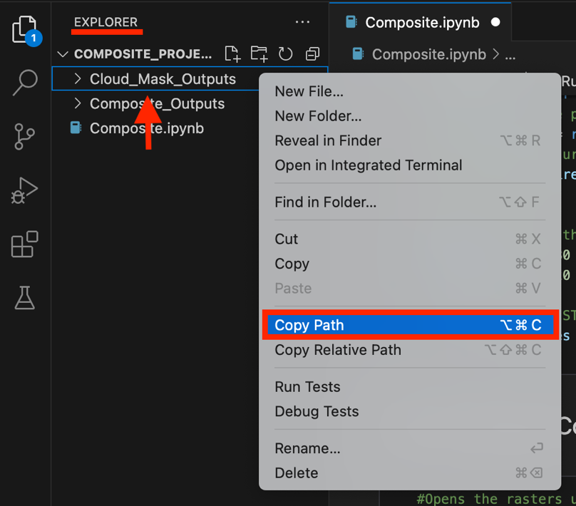
- Next, find the variable called output_directory. Change the text that says "Replace_this_text_with_folder_path" to the path of the folder where you want the output file to be stored. Make sure it is still wrapped in quotes and has r outside the first quote.
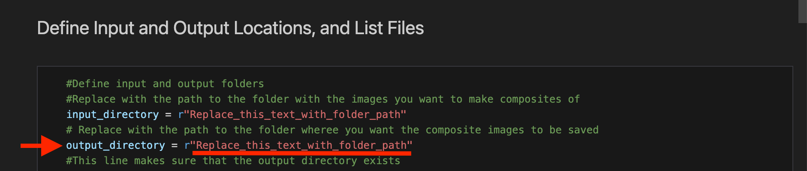
Example Directory Set-Up:
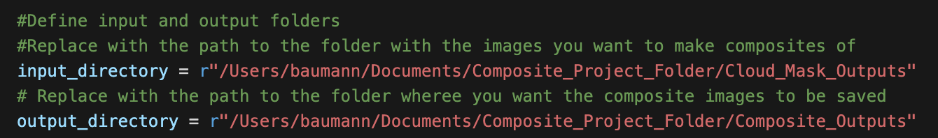
- Then, find the section of the code titled Create a Median Composite of the Images. Find the variable called output_file_path. Change the text that says "Replace_this_text_with_file_name" to whatever you would like the output composite image to be named. Make sure the file name is wrapped in quotes and ends in .tif.
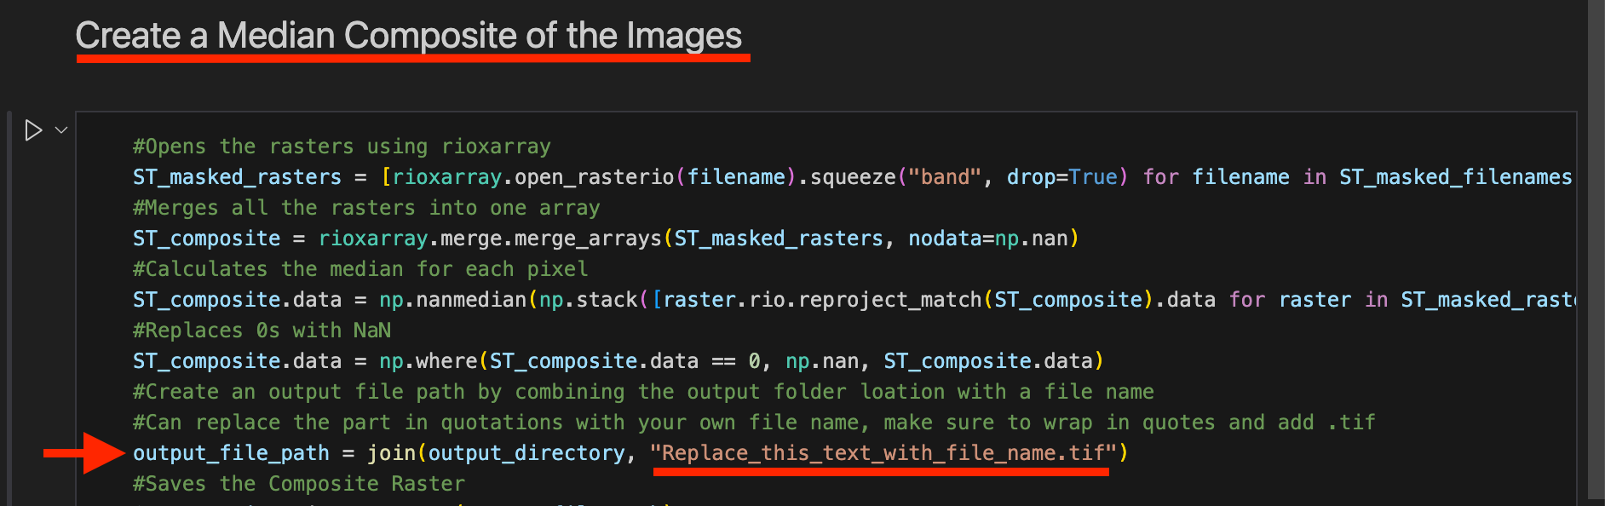
Example:
- Now the code should be set up to be run with your desired images. Scroll back to the top to the section titled Import Necessary Libraries. This is the first block of code we want to run. Click into the box with the library importing code and press Shift+Return to run it.
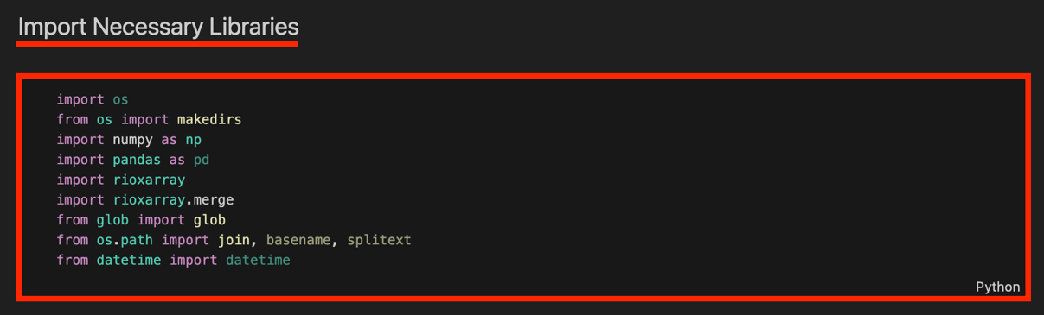
- At the top of the window, a pop up will appear prompting you to select a kernel to run your code with. Click on Python Environments …
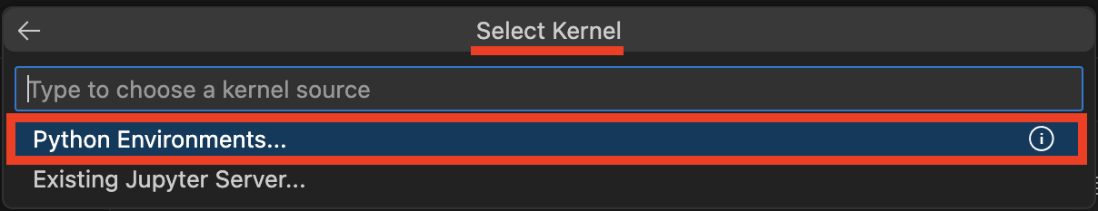
- Select the ECOSTRESS environment that you created, or another one if you have a different one you want to use.
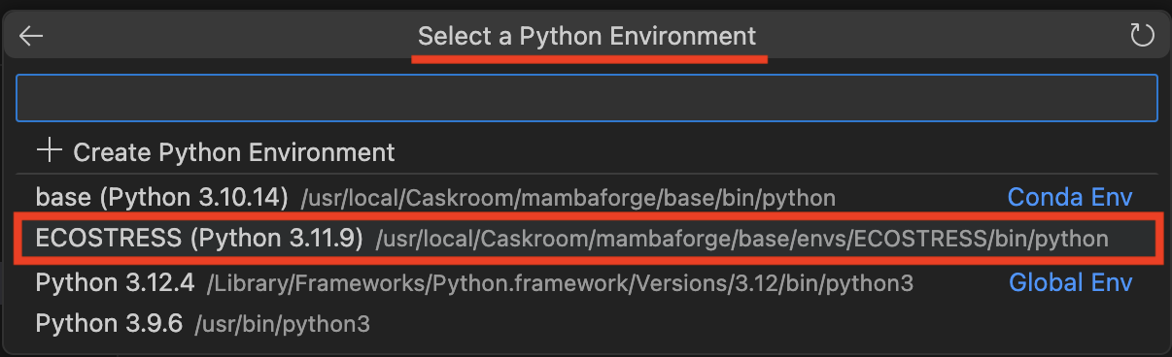
Tip: If you do not have an ECOSTRESS environment set up, follow the Creating an Environment tutorial to make one.

- Let the code run for a few seconds. You will see the seconds counting up in the bottom left of the cell. You will know it is done when a green check mark appears.
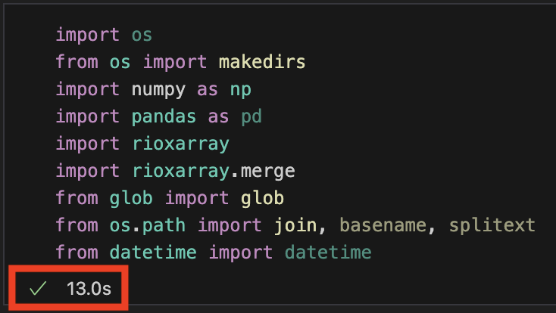
- Continue this process of running each block of code, in order from top to bottom, by clicking into the module with the code and pressing Shift+Return.
  - The final block of code will save the composite to your output folder, and display it in below the code for quick viewing.
Example:
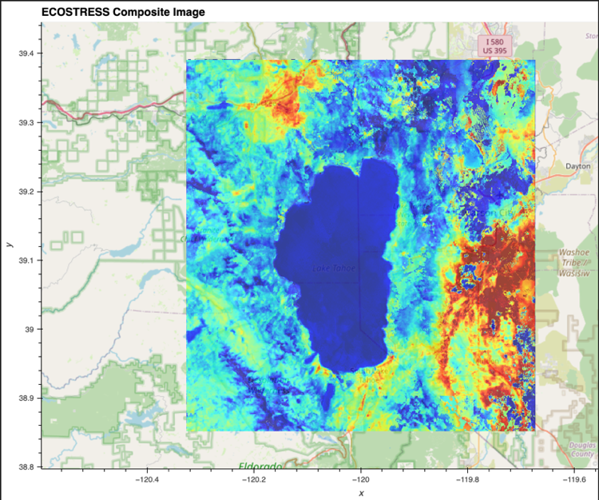
  - You can also check in your outputs folder to make sure the file was saved.
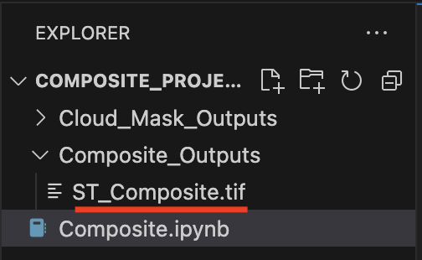
You now have a composite of all your ECOSTRESS images!

