Filtering for Good Images

ECOSTRESS Tutorials

This tutorial will show you how to use a Python code to filter downloaded ECOSTRESS images for those with good quality.

Table of Contents

What Makes an Image Good Quality? 1

Setting Up your Project Folder 2

Using the Filtering Code 5

# What Makes an Image Good Quality?

Good is subjective, but for this tutorial we will assume that a good quality image is one that is georeferenced, not very cloudy, and has limited no data values.

An image is considered georeferenced when it has been given coordinates that align with the part of the Earth that the image is from. This makes sure that every point on the map corresponds to a real-world location, which makes using it with other geographic data possible. When you download ECOSTRESS data from AppEEARS, a statistics CSV file from the metadata will give you information on if the image has been georeferenced or not. Most ECOSTRESS data over land is correctly georeferenced, however those images over the ocean are not always as accurate, so it is good to check.

Also, the QC files associated with the image that you downloaded will give you even more quality information related to cloud cover and missing data. While this code does not apply a cloud or QC mask, it does filter the images based on those metrics. You can even customize the code to decide how strict you would like to filter according to those quality metrics.

## Setting Up your Project Folder

1. First, let us create **an input directory** with all of the files we need for this code. Find your request on the **AppEEARS** website and go to the **download** page.

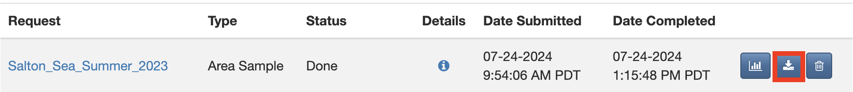

**Tip**: If you do not know how to make a request on the AppEEARS website, see the **Downloading from AppEEARS** tutorial. Make sure you have **QC** files requested in addition to your ECOSTRESS product files. Oftentimes, QC files are **automatically** included in your requested files because they are important for good research.

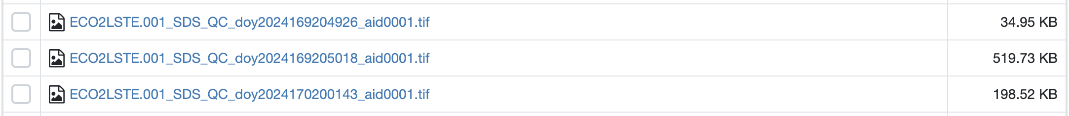

However, to **ensure** they will be present in your requested files on AppEEARS, you can add them as a requested layer. Whatever product you are downloading, scroll through the options and look for **QC**, then press the **plus** to add it to your requested layers.

1. First, under **Supporting Files**, look for the file that ends in **Statistics.csv**. Click on it to **download**.

**Example:**

**Tip**: The **statistics CSV** file contains a lot of information about the files you downloaded. We are specifically interested in the column titled **Orbit Correction Preformed**. The values in this column are either **True** or **False** for each row/file. **True** means that the image has been georeferenced. **False** means that it has not. We only want to use images labeled **True**.

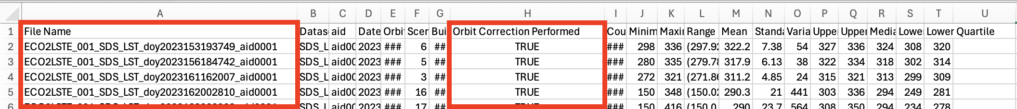

1. Then, **scroll down** to the main files section. Click on the empty box next to **Name** to select all files. A **checkmark** should appear next to all of the files, including your layer of interest (LST, ET, etc.) and your QC files. Then select the **Download** dropdown on the right and select **Download Files**. Wait for your files to finish downloading.

1. Next, open your **finder** and go to the **downloads** folder. Select all the files including your **layer of interest**, **QC files**, and the **Statistics CSV**. **Right click** on one of the selected files and select **New Folder with Selection**. Name the new folder so that you know it is the **input folder** for your filtering code.

1. Now, **move** the inputs folder into your **documents** folder. Then, **right click** and select **New Folder**. Name the new folder so that you know it is for your filtering code **outputs**.

1. Finally, **right click** and select **New Folder** one more time. This time we are creating a **project folder** for the code, so name it accordingly. Move the **inputs** and **outputs** folders into the project folder.

1. Finally, go to [**https://github.com/ECOSTRESS-Tutorials/ECOSTRESS-Filtering-for-Good-Images**](https://github.com/ECOSTRESS-Tutorials/ECOSTRESS-Filtering-for-Good-Images)and download the **Filtering_for_good_images** code. Move this code into the **project folder**.

Now, your project folder is all set up to use with your Filtering for Good Images code!

## Using the Filtering Code

1. First, open **Visual Studio Code** and use **File > Open Folder…** to get connected to the main **project folder** that contains the input folder, output folder, and the Filtering_for_good_images code.

|  |  |
| --- | --- |
|  |  |

1. In the **EXPLORER** tab, find the **Filtering_for_good_images** code and **click** on it to open it.

**Tip**: If you want to know more about what each line of the code does, read the **comments** in the code. Comments in the code are identified by **#**. These comments do not actually change how the code runs, but they can be helpful to put notes on how the code works for yourself or other users. This can also be helpful if you want to customize the code because it will guide you to which parts you may want to change!

**Examples** of comments (**green text following the #):**

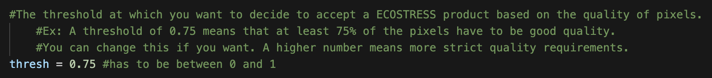

1. Find the section of the code titled **Set the Directories**. Find the variable called **input_directory**. Change the text that says **"Replace_this_text_with_folder_path"** to the path of the main folder where your ECOSTRESS files are stored.

* 1. To **copy the folder path**, use the **EXPLORER** panel on the left side of Visual Studio Code to find the folder you are interested in. Once you have found it, **right click** on it and select **Copy Path**. Now you can paste the path into your code. Make sure it is still **wrapped in quotes** and has **r** outside the first quote.

1. Then, find the variable called **output directory**. Change the text that says **"Replace_this_text_with_folder_path"** to the path of the folder where you want the output files to be stored. Make sure it is still **wrapped in quotes** and has **r** outside the first quote.

**Example Directory Set-up:**

1. Now the code should be set up to be run with your images. Scroll back to the top to the section titled **Import the Necessary Libraries**. This is the first block of code we want to run. Click into the box with the library importing code and press **Shift+Return** to run it.

1. At the top of the window, a pop up will appear prompting you to **select a kernel** to run your code with. Click on **Python Environments …**

1. Select the **ECOSTRESS** environment that you created, or another one if you have a different one you want to use.

**Tip**: If you do not have an ECOSTRESS environment set up, follow the **Creating an Environment** tutorial to make one.

1. Let the code run for a few seconds. You will see the **seconds counting up** in the bottom left of the cell. You will know it is done when a **green check mark** appears.

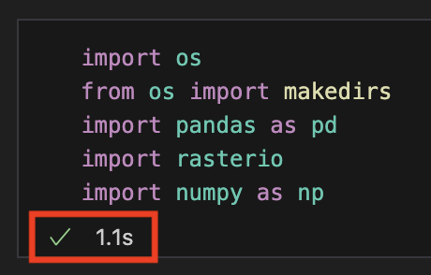

1. Continue this process of running each block of code, in order from top to bottom, by clicking into the module with the code and pressing **Shift+Return**.
   1. The code is set up to give you specific **warnings** based off certain things being **missing** from the input directory. If you get one of these warnings, **fix** what is wrong with your input directory and **run the code again**.

**Example of if you forgot to include the statistics CSV in the input directory:**

1. Once the code is done running, check in your **output directory** folder. Different **sub-folders** will be present with images in them. If one or more of these sub-folders are not present, it just means that none of the images you inputted fell into that category.

* 1. The **Cloudy** folder contains images that were filtered out for high cloud cover.
  2. The **Good** folder contains images that were deemed good by all three standards, based on the user defined threshold. Use the images in this folder for your **future analysis**.
  3. The **No Data** folder contains images that were filtered out for having high amounts of null pixels.
  4. The **QF** folder contains the processed versions of the QC files where specific flags for clouds and no data have been applied.
  5. The **Bad Georeference** folder contains images that were filtered out because they were not georeferenced.

You now know how to use code to automatically filter for good quality images! Make sure to use the images from the **Good** folder in future analysis!