Creating an Environment - Windows

ECOSTRESS Tutorials

This tutorial will show you how to create an Environment on Windows operating system.

Table of Contents

What is Miniconda? 1

Installing Miniconda 2

What is Mamba? 5

Installing Mamba 6

What is an Environment? 7

Creating an Environment 7

# What is Miniconda?

Miniconda is a simple tool used to install and manage software packages and environments. It is a lightweight version of Anaconda, which includes many different packages in its installation. Miniconda, however, only comes with Conda and Python, making it easier to download. We will use Miniconda to install Mamba and create an environment to work with our ECOSTRESS data.

## Installing Miniconda

1. There are many different package managers you can use to create an environment, so if you are more comfortable using another, you can do that. However, for this tutorial we are going to use **Miniconda** because it is a lighter version of the traditional Anaconda. Start by going to <https://docs.anaconda.com/miniconda/miniconda-install/> or searching the web for **Installing Miniconda** and clicking on the first link.

1. On the website, click on the link that says **Download the .exe installer**.

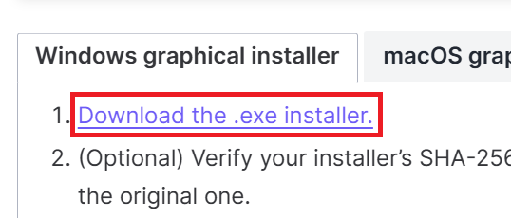

1. A new page should show up called **Latest Miniconda installer links**. Scroll down and **click the link** next to **Windows** to begin the download.

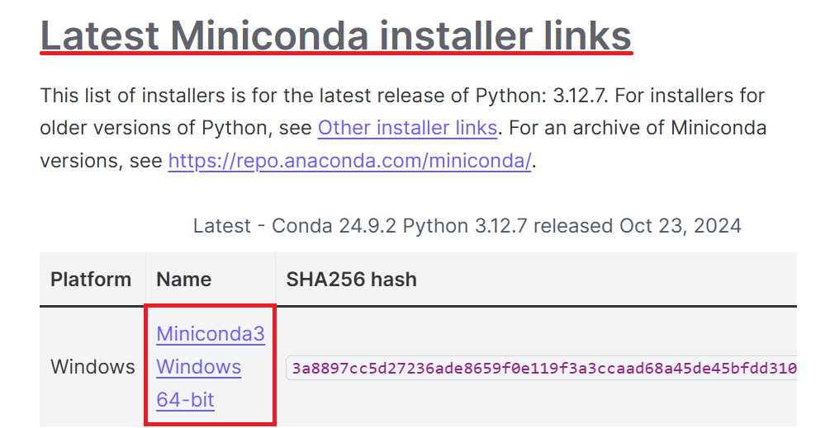

1. Open your **File Explorer** and go to your **Downloads** folder. There should be a download starting with **Miniconda**. Double click on it to open it.

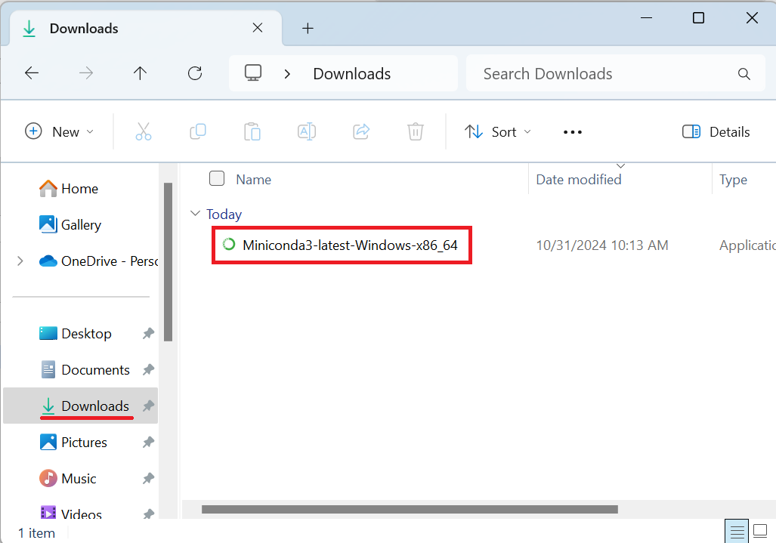

1. A **Miniconda Setup** window should appear. Click **Next**.

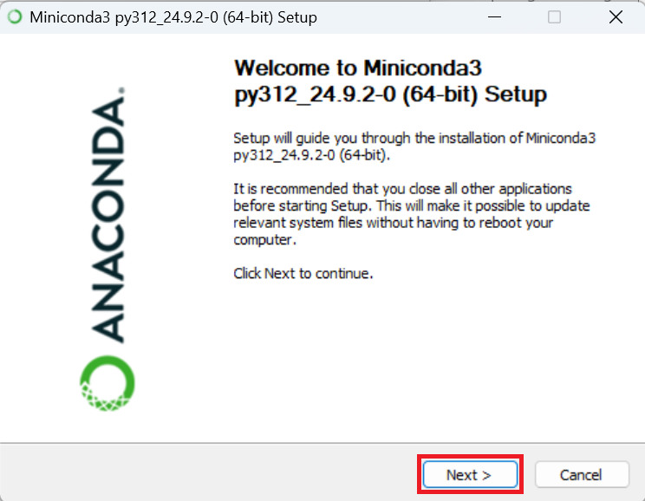

1. The next window will ask you to agree to the **License** **Agreement**. Click **I Agree**.

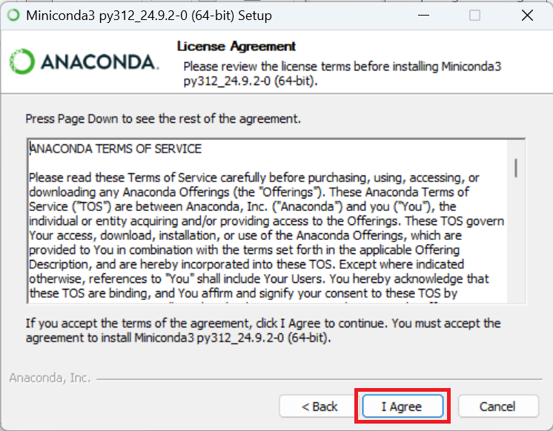

1. Next, select the **installation** **type**. You can leave this on **Just Me** and press **Next**.

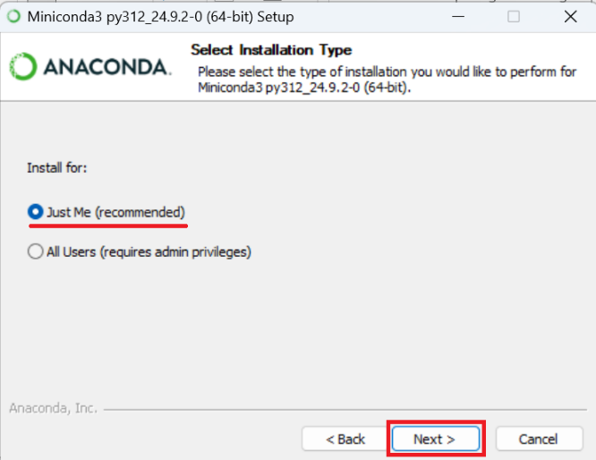

1. Next, you will need to select an **installation location**. It is best to leave the destination that they have recommended and just press **next**.

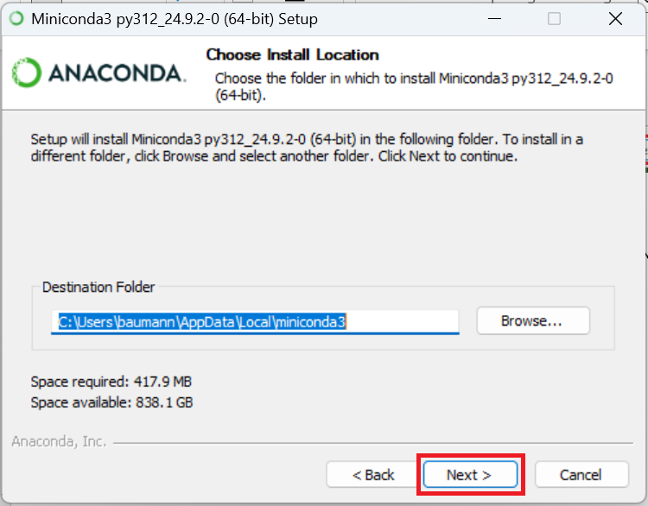

1. The next section is for **Advanced Installation Options**. You can leave the default options and select **Install**.

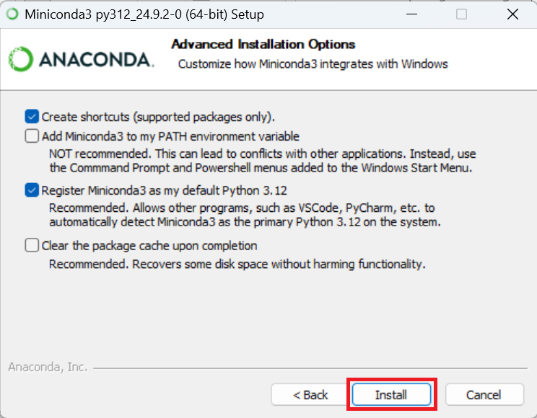

1. A green bar will appear showing the **progress** of the installation. Let it finish installing. Once it says **Installation Complete** you can click **Next**.

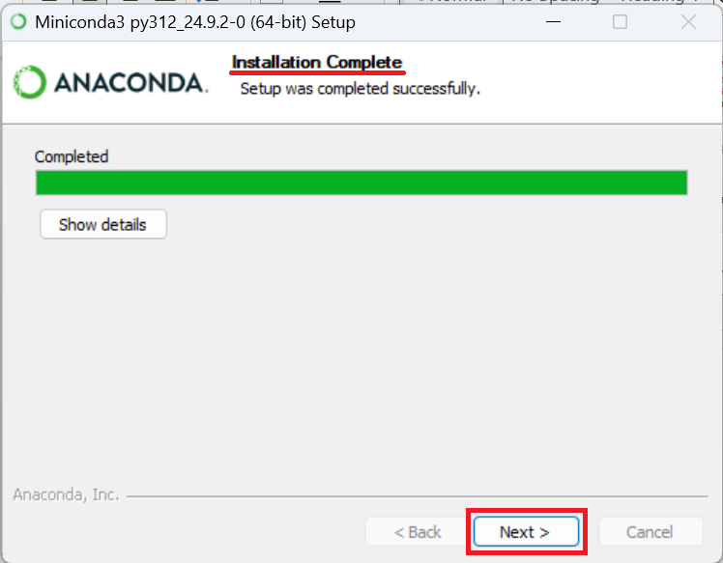

1. In the final window you can select **Finish**.

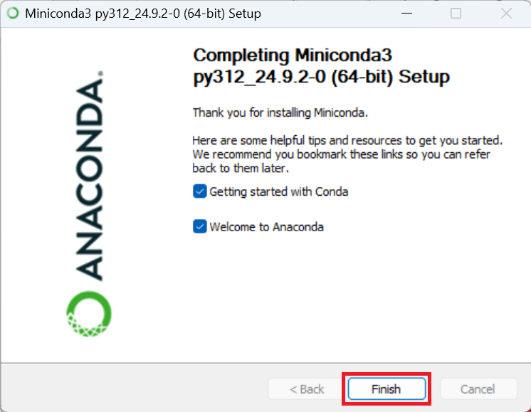

# What is Mamba?

Conda is a package management system used to install and manage software and it came with our Miniconda installation. Mamba is a new version of Conda that works even faster to manage environments. We will install Mamba so that we can easily create environments for different projects.

## Installing Mamba

1. Find your **Start Menu**, which is the **search box** at the bottom of your screen next to the **Windows logo**.

1. In the **Start Menu** search for **Anaconda Prompt** and click on the application to open it.

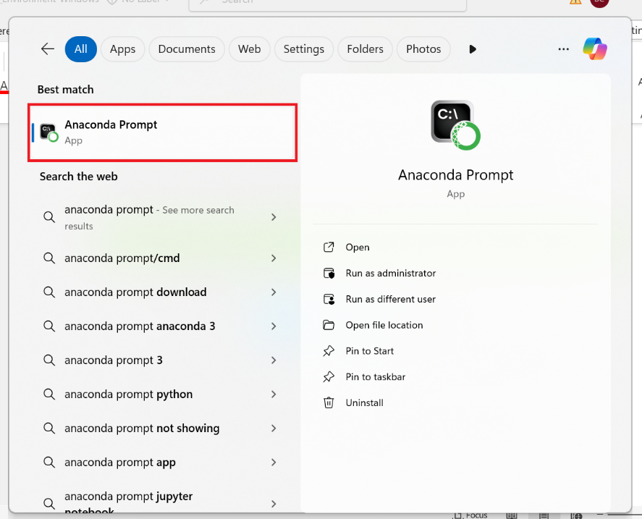

1. Now that we have the command prompt open, we need to install mamba. To do this, type **conda install -c conda-forge mamba** into the terminal and press **Enter** to run it.

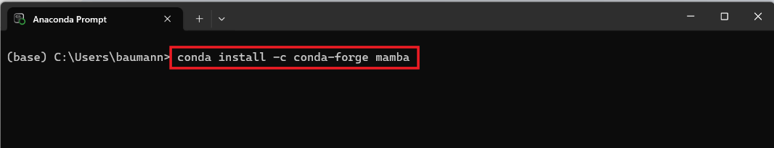

1. Let the command run for a bit. Eventually it will ask you to **Proceed ([y]/n)?**  Type **y** into the terminal and **Enter** to run it.

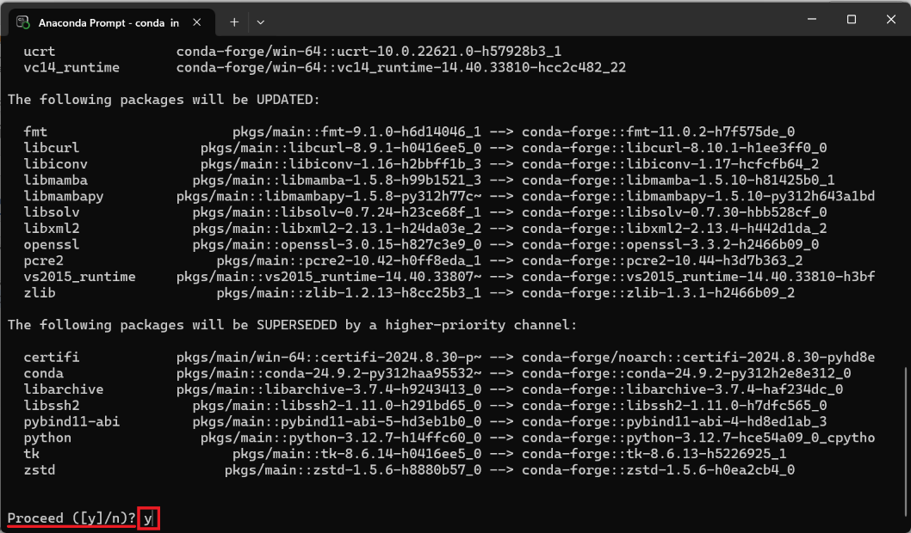

1. You will know it is done installing when you get the message **Executing transaction: done**. You now have mamba installed on your computer.

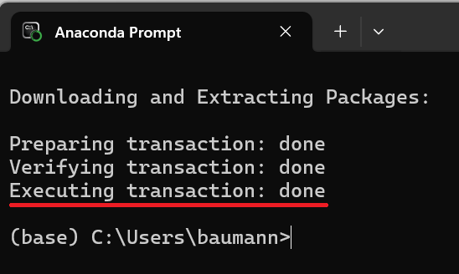

# What is an Environment?

An environment is a separate place on your computer where you can install software and libraries specific to the project you are working on. This allows you to have multiple projects all with their unique requirements. We need to create an environment that has all the tools we need to work with ECOSTRESS data.

## Creating an Environment

1. In the **Anaconda Prompt** type the command **mamba create -y -n ECOSTRESS -c conda-forge python=3.11 jupyter rioxarray hvplot** and run it. Here is an explanation of each part of the command:
   1. **mamba create** is the command to make the environment.
   2. **-y** confirms changes being made.
   3. **-n ECOSTRESS** is used to name our environment. In this case the environment is being named ECOSTRESS but if you would like a different name, you can change it. Just make sure to keep the **-n** and not use spaces or special characters in your name.
   4. **-c conda-forge** sets the channel where mamba will pull the packages from.
   5. For the end of the command, we list all of the **packages** we want. Here is a description of each one we will use in our tutorial:
      1. **python=3.12** connects to python, in this case setting it to version 3.12.
      2. **jupyter** allows us to use jupyter notebooks.
      3. **rioxarray** lets us open rasters.
      4. **hvplot** will allow us to create maps.

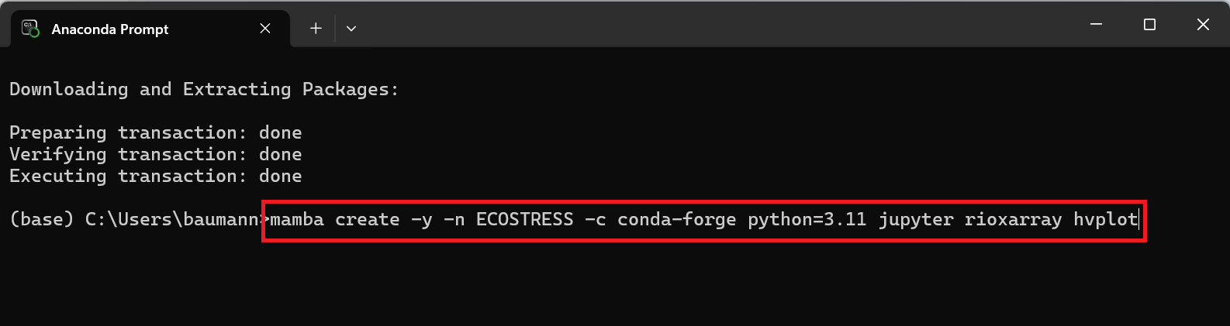

1. Let the command run. You will know it is **done** when you get these instructions on how to **activate** and **deactivate** the environment.

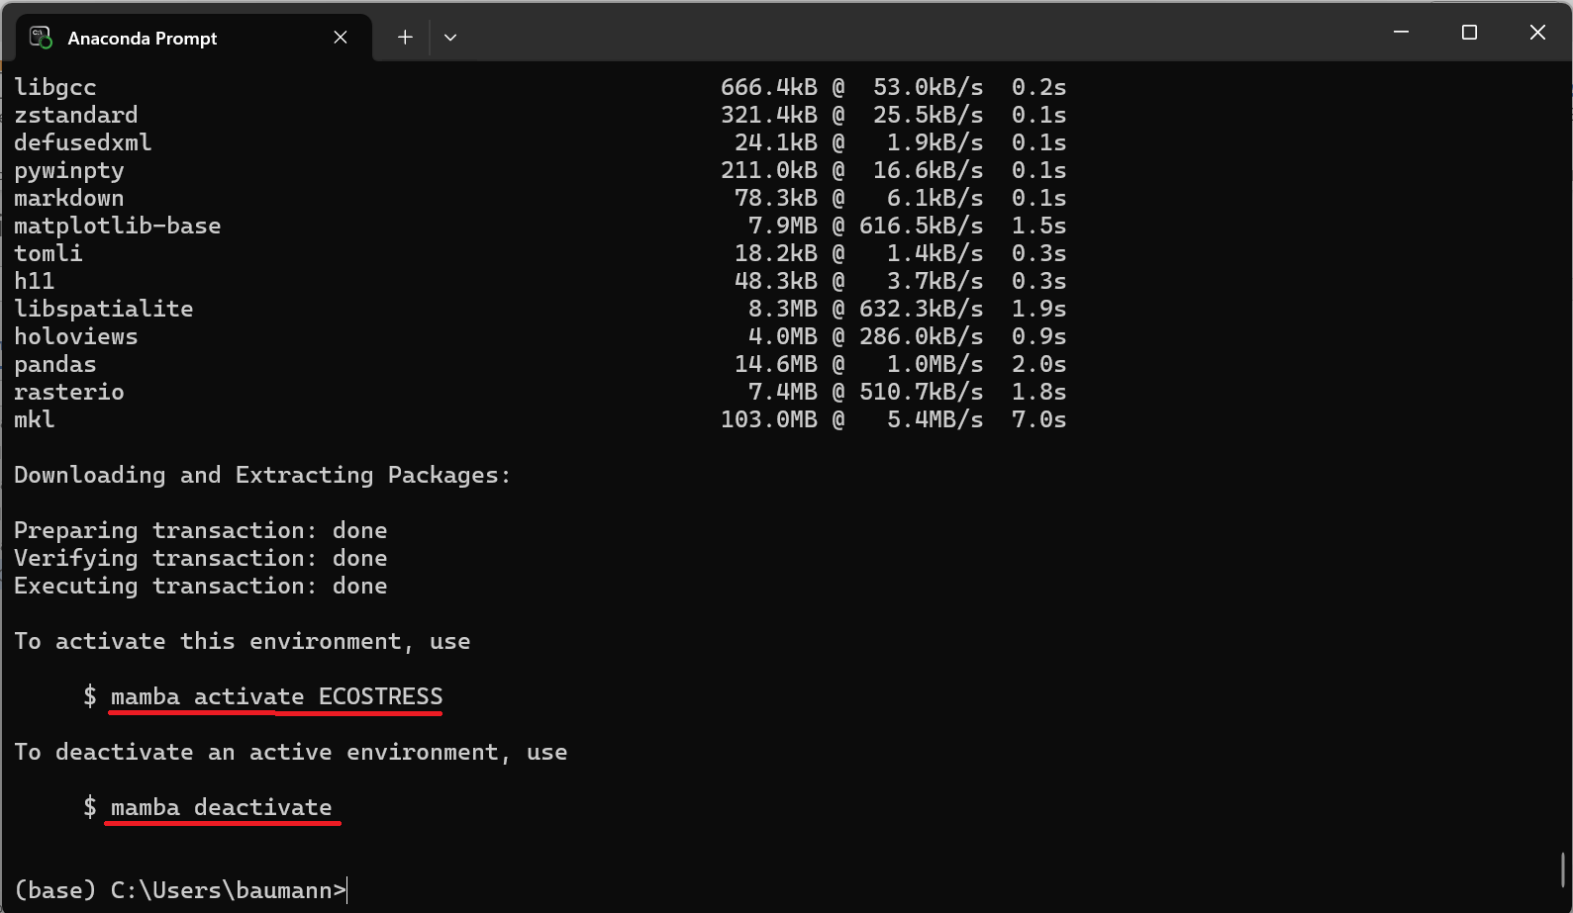

1. Finally, lets activate our environment by typing in **mamba activate ECOSTRESS** and running it.



1. You will know that your new environment has been activated when you see the environment name, in this case ECOSTRESS, in parentheses before your line of code instead of (base).



Now you have an environment set up to run your code with!