Suggesting Edits to GitHub - Windows

ECOSTRESS Tutorials

This tutorial will show you how to contribute to the ECOSTRESS tutorials GitHub by forking a repository, cloning it to your local machine, committing your suggested changes, pushing your changes back, and submitting a pull request. This allows for greater collaboration among the broader ECOSTRESS community. This tutorial is for Windows computers.

Table of Contents

Prerequisites 1

What is a forking? 2

Creating a Fork 2

What is Git? 4

Installing Git 4

What is a cloning? 6

Cloning the Forked Repository 6

What is a committing? 8

Making and Committing Edits 9

What does it mean to push changes? 12

Pushing Changes to the Forked Repository 12

What is a pull request? 13

Creating a Pull Request 13

# Prerequisites

To follow along with this tutorial, you must have a GitHub account. If you do not have one, you must create one before proceeding with this tutorial. Also, make sure you have Visual Studio Code downloaded on your computer. If you need help installing it, go to <https://ecostress.jpl.nasa.gov/tutorials> and follow along with the provided tutorial.

# What is a forking?

Forking creates a personal copy of someone else’s repository on your GitHub account. Think of a repository like a project folder containing all relevant documents. We need to fork when we want to make changes to a repository to later send back for review. The forked repository will live in your personal GitHub and will be separate from the original repository that you got it from. Any changes made in the original will not change your fork unless you explicitly update it.

## Creating a Fork

1. Start by **logging in** to your GitHub account and going to the **repository** that you would like to modify. You can view all the different ECOSTRESS tutorials repositories at <https://github.com/orgs/ECOSTRESS-Tutorials/repositories>. For this tutorial, I am going to use the ECOSTRESS-Single-Cloud-Mask repository because I found a typo there that I want to suggest a fix for.

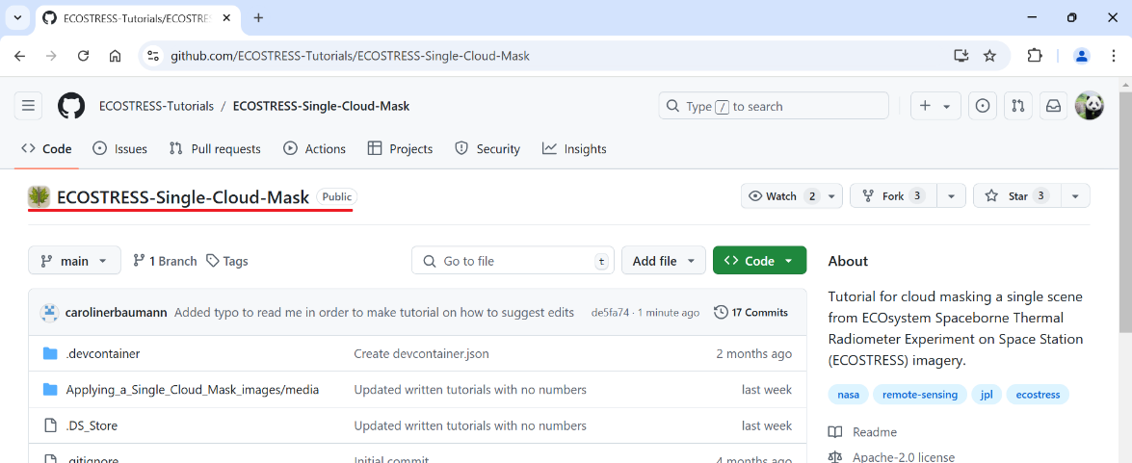

1. Once you are on the repository page, click **Fork** in the top right.

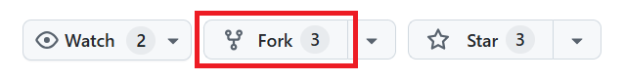

1. Click on the dropdown under **Owner** and select your GitHub username. It may automatically be selected for you. If you do not see it as an option, make sure you are logged into GitHub.

**Example**: My username is CarolineBaumannJPL

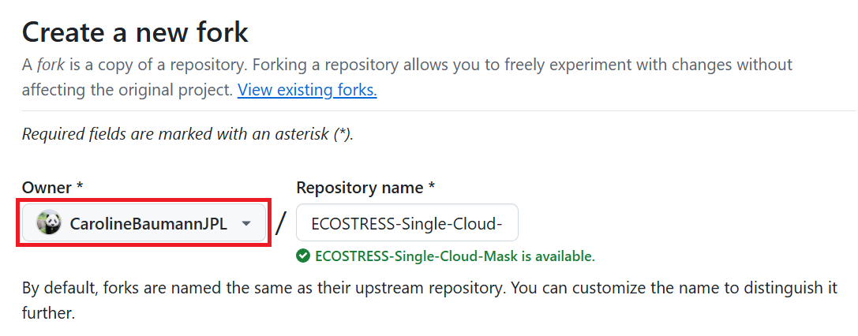

1. By default, the **Repository name** will be listed as the same name as the repository you are trying to fork. If you would like, you can modify this name. However, most of the time we can leave it as is.

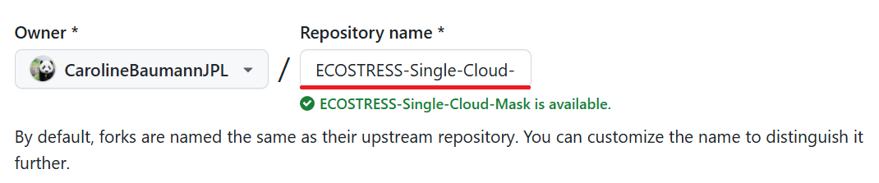

1. The **Description** will also be the same as the description of the repository that you are forking. If you want to change it, you can do that now.

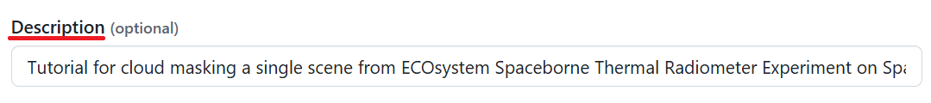

1. By default, **Copy the main branch only** is selected. Most of the ECOSTRESS tutorials only have a main branch, so it is okay to **leave this as is**. However, if there are sub-branches that you would like to include, you may choose to uncheck this box.



1. Finally, click the green **Create Fork** button. This will take you to your new forked repository.

# What is Git?

While GitHub is an online platform used to share Git repositories, Git itself is a tool used for tracking changes in code and collaborating on projects. Installing Git on Windows computers allows us to use Git commands in order to manage our code locally and sync it with GitHub.

## Installing Git

1. Next, we need to install git. Go to <https://git-scm.com/> or search the web for Git and click on the first link. Click on the button that says **Download for Windows**.

1. Then, on the new page, select **Click here to download**. A download should begin.

1. In your downloads folder**, double click** on the download to open it. It may ask you to **allow this app to make changes to your device** in which you can select **yes**.

1. In the installer window that pops-up, select **Next**. You can continue to select **Next** through all the windows to accept the default options until you get to a page that says **Install**.

1. Click **install** and allow Git to install.

1. When you get to this final page, select **Finish**.

# What is a cloning?

Cloning is the process of copying a repository from yours or someone else’s GitHub to your local machine (i.e. computer). This makes it easy to work with locally for testing, editing, and development. The changes you make in your cloned repository will only exist on your computer until you chose to push them back to GitHub. We need to clone the repository we just forked so we can make edits and later suggest them back to the original project.

## Cloning the Forked Repository

1. Start by opening **Git Bash**, which is what we just downloaded. You can do this by typing **Git Bash** into the **Start Menu** next to the **Windows logo** and pressing enter**.**

1. We need to set the directory to the place on your computer where we want the clone of this repository to exist. For me, I want this in the documents folder, so I am going to **copy the path** to my documents folder.

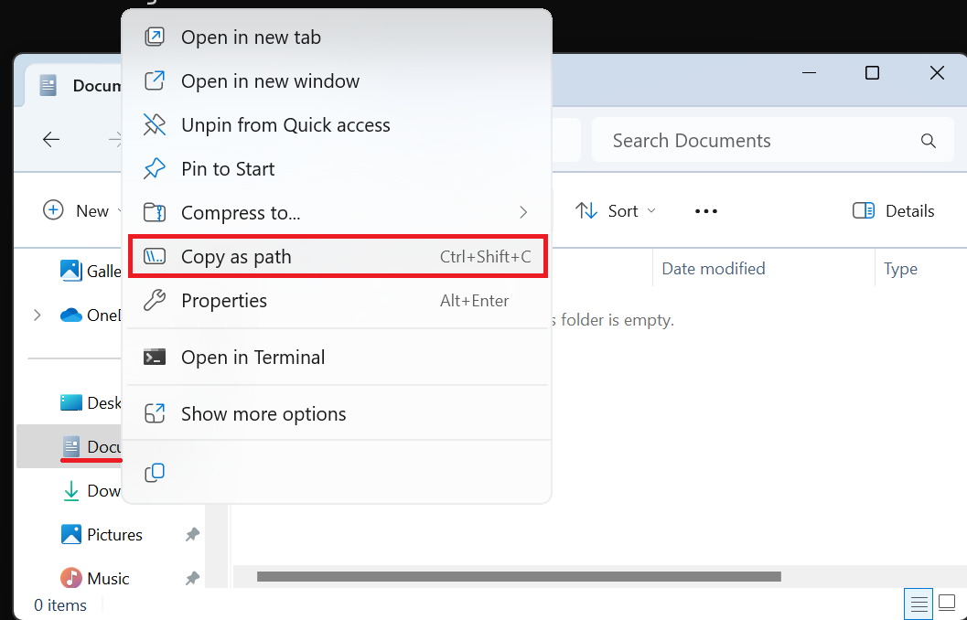

1. Then, in **Git Bash**, type **cd** followed by the **path** to where you want the clone to be saved. Press **Enter** to run it. Leave the Git Bash window open.

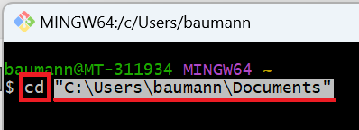

1. Next, go to your browser and make sure you are on the forked repository page that you just created. Click the green **<> Code** button.

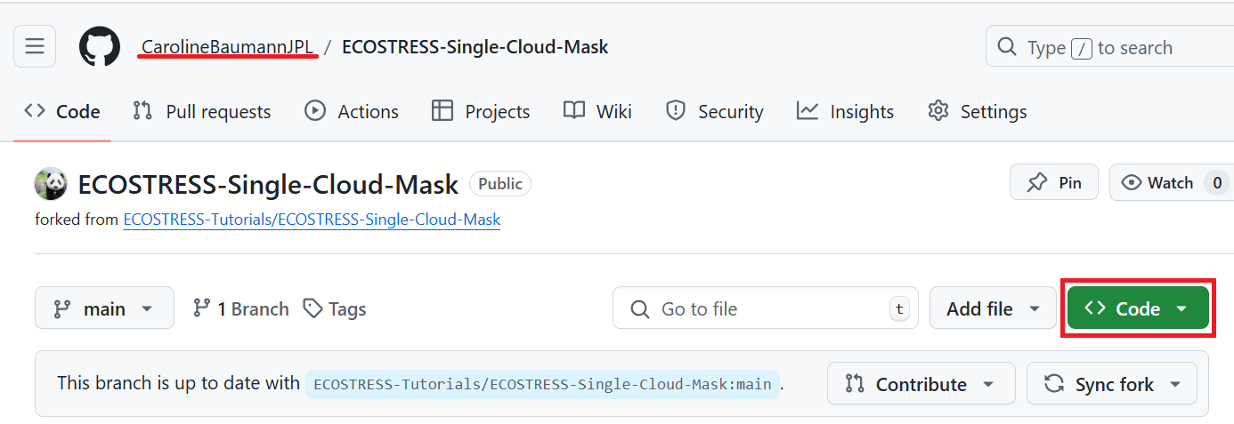

1. In the drop down you will see three options: **HTTPS**, **SSH**, and **GitHub CLI**. HTTPS is the most beginner friendly, so we are going to use that. However, you can use one of the other options if you are more comfortable with them. While on the **HTTPS** option, click the **clipboard** icon to **copy** the URL.

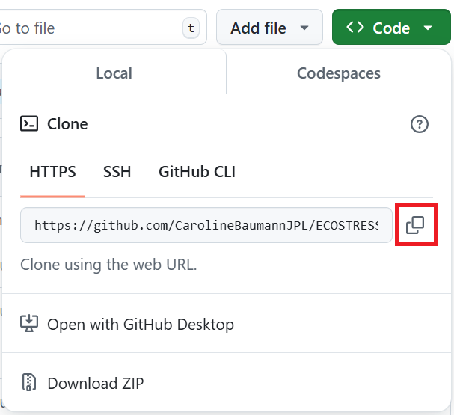

1. Go back to your Git Bash window, type **git clone,** and paste the URL you copied from GitHub. Press **Enter** to run it. Now you should have a clone of the repository on your local machine.

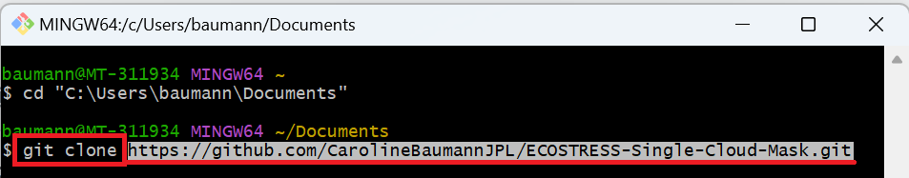

1. Next, lets change the directory to our new cloned repository by typing **cd** followed by the path to the repository folder on your computer. Press **Enter** to run it.

**Example:**



1. Finally, we need to let Git Bash know what our GitHub username and email is. In order to do this we need to initialize Git by typing **git init** and pressing **Enter** to run it.

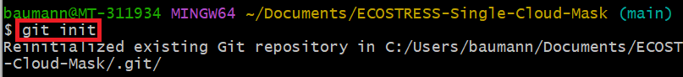

1. First, type the command **git config user.name "Your User Name"** into Git Bash, replacing “Your User Name” with whatever your user name is. Press **Enter** to run.

**Example:**



1. Then, type **git config user.email "your-email@example.com"** and replace “your-email@example.com” with whatever email you created your account with. Press **Enter** to run.

**Example:**



# What is a committing?

Now that we have a clone of our forked repository, we can make whatever edits we want. Once these edits are made, we need to commit them, or save the changes to our local repository. Every time we commit changes, we leave a message describing what we edited. This allows us to track changes and versions of our work so we can go back if we ever need to.

## Making and Committing Edits

1. Open **Visual Studio Code**. Select **File > Open Folder…** and open the folder of the cloned repository that you made in the previous section.

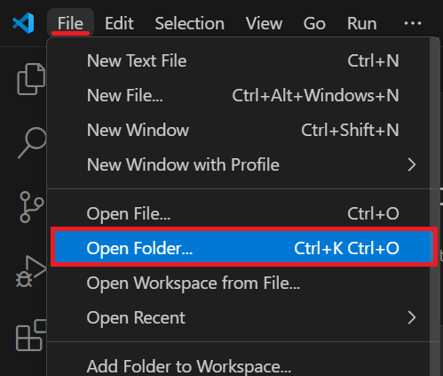

1. Once the folder is open, you will see all the files from that repository in the **EXPLORER** pane. Click on the file you want to edit to **open it**. For example, I noticed a typo in the Read Me file, so I am going to click on that one to open it.

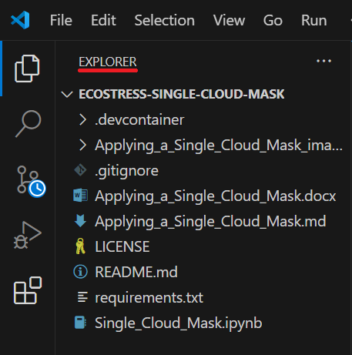

* 1. Alternatively, you can add an entirely new file to the folder by hovering your mouse over the folder name in the EXPLORER tab and selecting the **New File** icon.

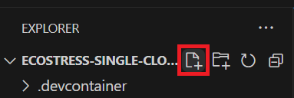

1. Make the **changes** that you would like in the document you opened. You can open and edit as many documents as you would like. Once you are done making edits, make sure to select **File > Save** to save your edits. The next step will not work unless your edits are saved.

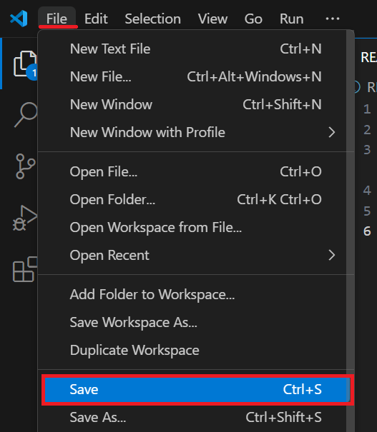

**Tip**: If you have unsaved edits in any of your files, a blue number will appear next to the file icon in the top left with the number of saves that need to be made. Once you have saved everything, this number will disappear, and you know you are good to proceed to the next step.

1. Once all your edits are saved, a blue circle with a number will appear on the **Source Control** icon. The number will correlate with the number of changes you made. Click on the Source Control icon to open the **Source Control panel**.

1. In the new panel, look for the dropdown that says **Changes**. If you hover your mouse over this, a plus sign will appear. Click the plus sign to **Stage** your changes. Staging your changes just means that you want to include them in the next version of the project. We stage our changes to later be committed back to the repository.

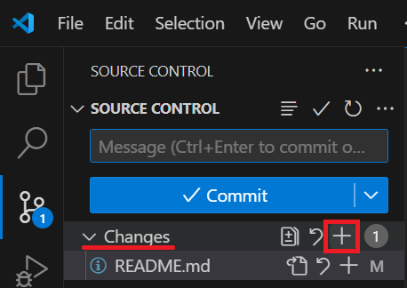

* 1. Alternatively, if you want to stage just **some** changes, but not all, you can hover over individual files under **Changes** and select the plus sign to add just that file’s changes to the **Staged Changes**. In my case, I only made one change, but if you made multiple changes, this is how you can decide which ones you want to commit.

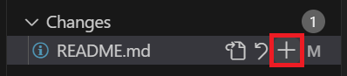

1. At the top of the panel, you should see a box that says **Message**. Here is where you need to type your commit message. A commit message is just a brief description of the changes that you made in order to remind you and others of what is different in this version compared to the previous one. Based on your change, type in your brief message.

**Example:**

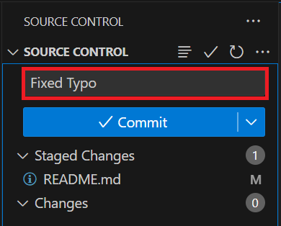

1. Finally, press the blue **Commit** button. By pressing commit, you are saving your staged changes as a new version in your local cloned repository.

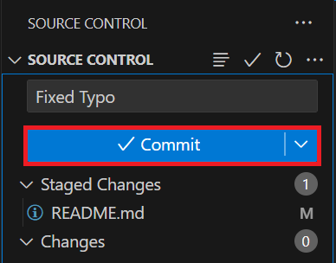

# What does it mean to push changes?

Previously, we forked a repository to our own GitHub, cloned it to our computer, and made and committed edits to the clone on our computer. Now, we need to push our changes, which means we save the changes we made on our local computer to our forked online GitHub repository.

## Pushing Changes to the Forked Repository

1. There are multiple ways to push changes to a forked repository. One way is using the command **Git Push**, however if it is just you making changes, the easiest thing to do is just press the blue **Sync Changes** button in Visual Studio Code that shows up when you commit changes.

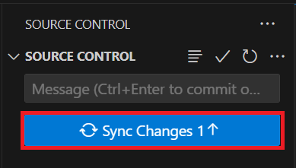

1. You may get a pop up warning saying that **This action will pull and push commits from and to “origin/main”.** You can press **OK**. Furthermore, if a pop-up shows up asking you to log into GitHub, you can follow those steps to do so.

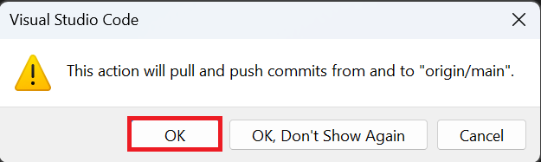

1. Open a **web browser** and go to the **GitHub** page with your **forked** repository. Double check to make sure that **all changes** were made.

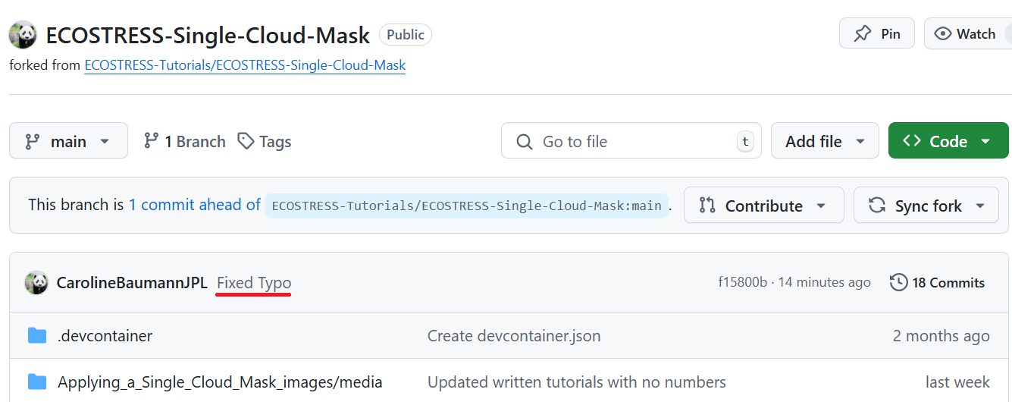

# What is a pull request?

The final part of this tutorial is creating a pull request. A pull request is a way to suggest changes back to the original repository that we created our fork from. This allows the owners of the ECOSTRESS tutorials repository be able to review your changes and decide if they want to implement them in the main repository.

## Creating a Pull Request

1. In a browser window, open the **forked repository** on your **GitHub** account.

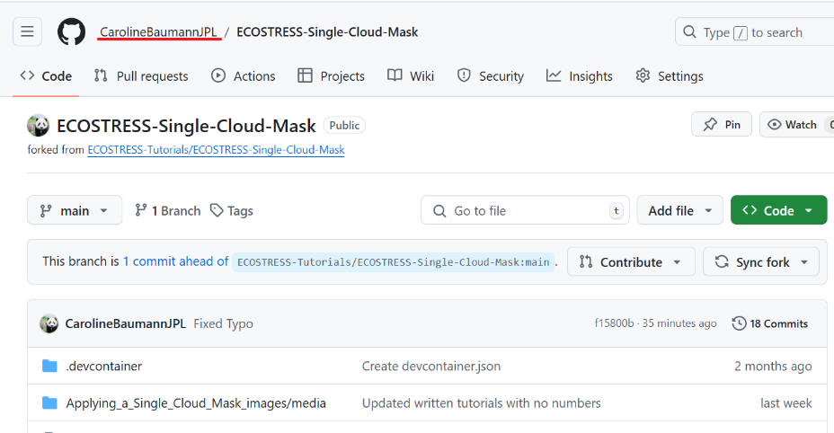

1. You should see a message at the top that has a dropdown that says **Contribute**. Click the dropdown and then select **Open Pull Request**.

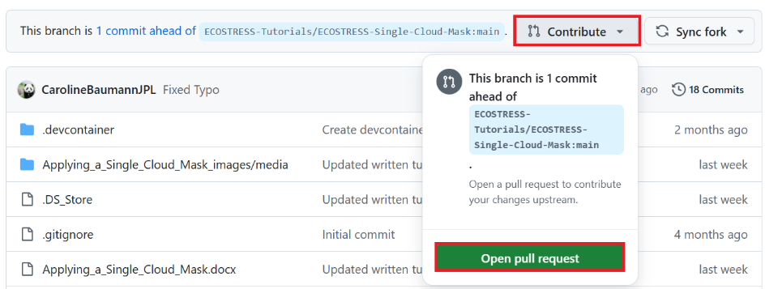

* 1. Alternatively, at the top of the page, **click** on the option that says **Pull requests.** On the new page, click the green **New pull request** button.

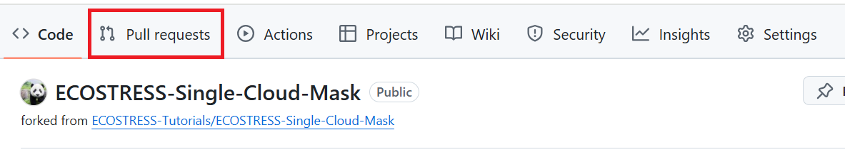

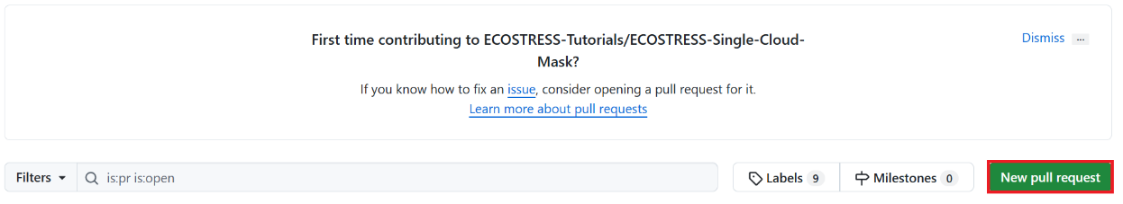

1. A new page titled **Comparing changes** should appear. At the top, you will see two sections with dropdowns. The first represents the main tutorial repository where you want to suggest changes. Make sure the **base repository** listed is the original one that you first created your fork from. The next drop down should say **base: main**, with “base” for the repository and “main” for the branch. If you are working with a branch **other than main**, you should have that listed after the colon.

**Example:**

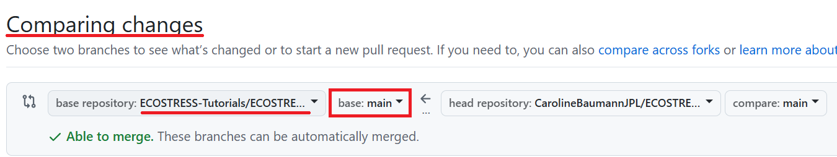

1. The second section represents your forked repository that you made changes to. The first drop down should say **head repository** with your personal forked repository listed after it. The second drop down should say **compare: main**. It is most likely that your branch will be **main**, but if you are working with another one, make sure to select the correct one from the dropdown.

**Example:**

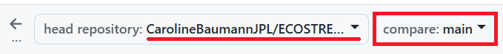

1. The first text box is the **title** of your request. This should **automatically** generate based on your **commit message**, however if you want to change it you can do that now.

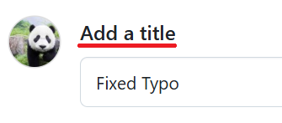

1. Under **Write** you should see a text box that says **Leave a comment**. Here you can type out a longer and more detailed message of the changes you made.

**Example:**

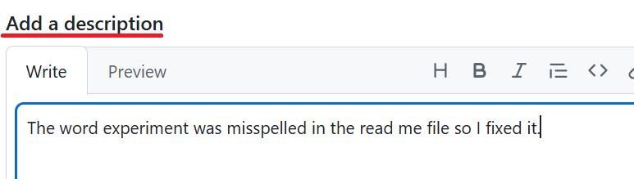

1. When you are done, press the green **Create pull request** button.

Now you have made your pull request! Your suggestions will be reviewed by the current owner of the ECOTRESS tutorials GitHub. Thank you for contributing!