ECOSTRESS Geolocation Jupyter Notebook: Documentation

ECOSTRESS Document

This document explains the mechanics of the ECOSTRESS Geolocation Jupyter Notebook

Table of Contents

ECOSTRESS Geolocation Accuracy 2

Where to obtain ECOSTRESS Data? 2

Necessary File(s) 2

What is this Code’s Approach? 3

Edge Detection 3

Edge Alignment 3

Potential Errors: 4

Jupyter Notebook Code 5

Import Module Cell 5

GDAL Exceptions 6

Functions Cell 6

def Clip_Parent_Water_Mask 6

def Clipping_LST_and_Water_Mask 7

def Sort_Shorelines 7

def Endlines 8

def MatchingOverlay 8

def Matching_Shift 8

File Selection Cell 9

Customizable Variables & Supplementary Files 9

Opening Rasters 9

Water Mask Processing 9

Determining Acceptable Edges from QC file 9

Removing Image Edges Detected in Water Mask 10

Cloud Masking Cell 11

Applying Cloud Mask to LST and Water Mask 11

Cloud Mask on LST 11

Cloud Mask on Water Mask 12

Image Cropping and Preliminary Line Selection Cell 12

Identifying the Longest Shoreline 12

ECOSTRESS Edge Area Clip 12

ECOSTRESS Edge Detection and Line Selections 12

Acquiring Possible Shifts Cell 13

Selection of Top ECOSTRESS Edges 13

Acquiring Eligible Shifts 14

Shift Check for Combined Top Lines 14

Final Shift Test Cell 15

Testing X and Y Shifts 15

Applying the Shift Cell 15

# ECOSTRESS Geolocation Accuracy

ECOSTRESS relies on information from the International Space Station (ISS) for geolocation coordinates, which could be off by as much as 7km. Within ECOSTRESS geolocation processing, image matching is used to improve geolocation, although this is not always successful. ECOSTRESS scenes located near bodies of water have noticeable errors as observers can easily find discrepancies between a base map and the ECOSTRESS scene. This code aims to use ECOSTRESS’s water mask product to correctly place the ECOSTRESS file.

The work uses the method developed by Soszynska, van der Werff, Hieronymus, and Hecker, "A New and Automated Method for Improving Georeferencing in Nighttime Thermal ECOSTRESS Imagery", 2023, <https://doi.org/10.3390/s23115079>

# Where to obtain ECOSTRESS Data?

ECOSTRESS data is available on AppEEARS which requires an account to download images. Please refer to JPL’s ECOSTRESS Tutorials ECOSTRESS Tutorial [06-Downloading_From_AppEEARS](https://github.com/ECOSTRESS-Tutorials/ECOSTRESS-Getting-Started/blob/main/06-Downloading_from_AppEEARS.md) for steps on setting up your account and downloading data. This code primarily works best with Collection 2 data as Collection 2 provides personalized water masks for each scene. AppEEARS provides each of the necessary files to a bounding box based on the user’s Region of Interest (ROI).

# Necessary File(s)

This code was built to process ECOSTRESS Collection 2 from [AppEEARS](https://appeears.earthdatacloud.nasa.gov/). There are two versions of ECOSTRESS LST Collection 2 data with Swath and Tiled. To obtain Swath tiled products you may search for the product: “ECOSTRESS Swath Land Surface Temperature and Emissivity Instantaneous” or search for the tiled product using: “ECOSTRESS Tiled Land Surface Temperature and Emissivity Instantaneous”. Below are the essential files with an optional cloud mask for additional edge removals.

* Land Surface Temperature (LST)
* Quality Control (QC)
* Water Mask
* Cloud Mask **(optional)**

Note: Running the python batch code with the single water mask option for a folder that has swath and tiled scenes with their native projections will result in errors. Please request your scenes from AppEEARS in any projection besides “Native”. The projection can be set under the “Projection: box under Output Options. If you plan on using Swath only or Tiled only, then this should not be an issue.

# What is this Code’s Approach?

This code aims to match the ECOSTRESS LST shorelines with the ECOSTRESS water mask. The ECOTSTRESS water mask is based on Shuttle Radar Topography Mission (SRTM) data which has higher geolocation accuracy, and has been resized to ECOSTRESS’s 70-meter pixel resolution.

## Edge Detection

The main process to detect the shorelines of a scene is done by using canny edge detection via python’s *skimage* package. In most images, it is visually clear where the shoreline of each scene is based on your GIS program’s default color gradient and temperature values. Before edge detection is conducted, the image will have a gaussian blur applied to aid in identifying strong pixel differences and also to help reduce noise within the scene. Skimage’s canny edge detection identifies the most significant changes in values between pixels based on the gradient magnitude. The gradient magnitude is calculated by obtaining the pixels Sobel kernels for the x and y directions, compute the gradients on the images and finally applying the Pythagorean theorem using the resulting products. This process is shown below.

Sobel Kernels

Compute Gradients

Gradient Magnitude

## Edge Alignment

There is a process of hysteresis thresholding allowing for edges to be present based on if gradient values are either under, between, or above two thresholds. Automating this step is in development, as each image requires unique thresholds to isolate the LST shoreline. For this Jupyter Notebook version, no low or high thresholds will be set which will keep all edges found during edge detection.

After edge detection for the LST is computed, the edges go through a process of filtering to remove some unwanted edges. After edge filtration, the *best* edges are clipped by their own extended bounding box. The bounding box is expanded by 100 pixels in the x and y direction to match the 7km error. This bounding box will be used to clip the isolated ECOSTRESS edge and the associated Water Mask image. By rolling the ECOSTRESS image along the Water Mask, the best overlapping position is found and the shift is stored for calculation. For large scenes with multiple isolated shorelines, like Hawaii, each shoreline will be calculated individually. The final shift from every shoreline will be stored and used to find the best overall shift for the entire image.

## Potential Errors:

ECOSTRESS data, depending on the scene, may be noisy, cloudy, or have stripes in the LST image that may mask or breakup the shoreline present in the LST. Additionally, the water mask sometimes has issues where sections of the shoreline have been clipped resulting in suboptimal base map matching. If these scenes passed all set checks in the code, the image may be shifted incorrectly. Below are some visuals showing each potential error.

**Noisy Scenes**

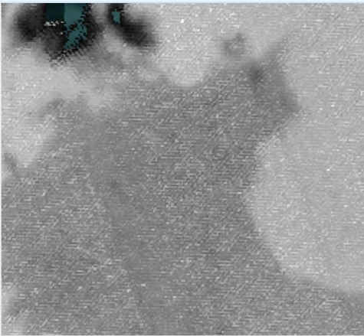

ECO_L2T_LSTE.002_LST_doy2023012222450_aid0001_30N

**Cloudy Scenes**

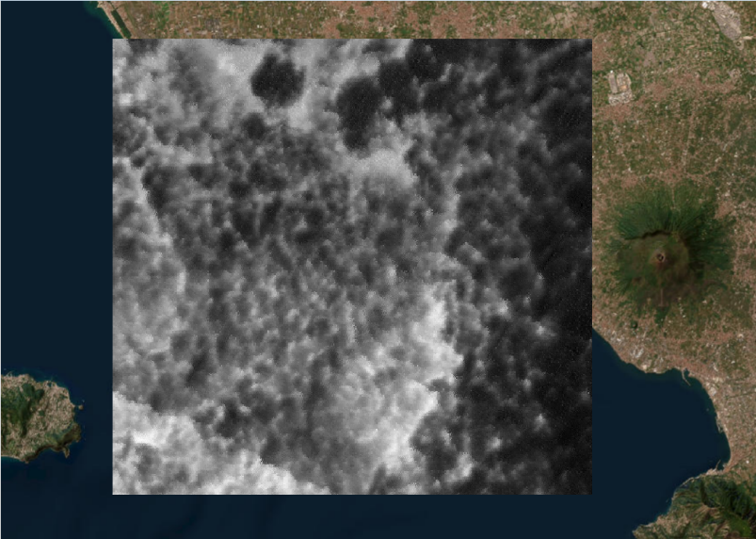

ECO_L2_LSTE.002_doy_2023360082254_aid0001

**Image Striping**

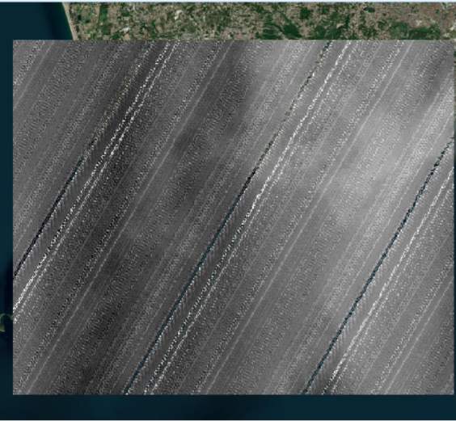

ECO2LSTE.001_SDS_LST_doy2023101144022_aid0001

**Water Mask quality (Empty Segments)**

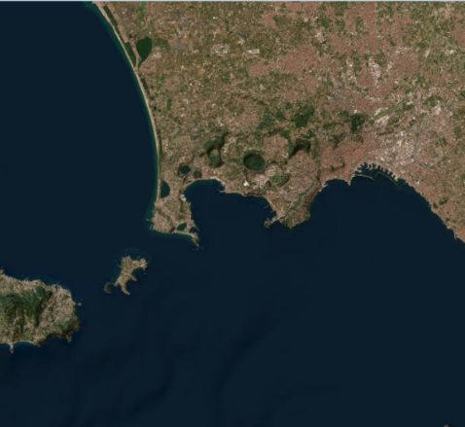 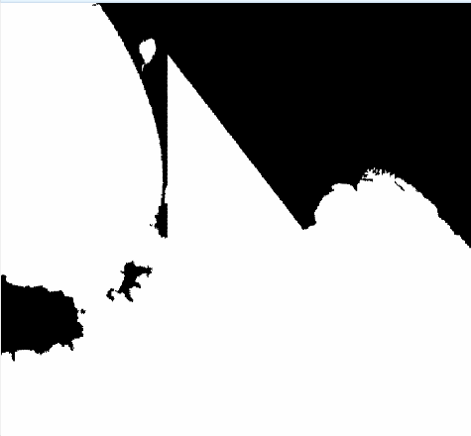

QGIS ESRI Imagery Base map ECO_L2_LSTE.002_water_mask_doy2019040110918_aid0001

For the best results, all LST images and water masks being processed should have 1) Connected shoreline, 2) Enough clear sky above the shoreline, and 3) an Ideal water mask. For the Jupyter notebook, the water mask will automatically be the one assigned to your specific LST. If the user prefers, the water mask may be a different water mask with a complete shore. The code will be able to read the “ideal” water mask and clip itself and the other files to the overlapping section between the “ideal” water mask and the LST image. If the LST does not overlap with the “ideal” water mask, then the LST image will not be corrected. Although this code works best with large shorelines, this code can work with inland bodies of water but may need to be large enough for matching to occur.

# Jupyter Notebook Code

## Import Module Cell

import os

import cv2

import numpy as np

from osgeo import gdal

from scipy.ndimage import binary_hit_or_miss

from skimage import feature, morphology, measure

from pandas import DataFrame

from matplotlib import pyplot as plt

Please refer to this code’s [GitHub](https://github.com/Andrew-Alamillo/ECOSTRESS_Geolocation_Correction_tool) page for the User Guide of each module as well as ways to import the modules to your own environment using Anaconda command prompt.

## GDAL Exceptions

In versions of GDAL before GDAL 4.0, there will be a “Future Warning” appearing in your output. To address this the following lines are used:

gdal.UseExceptions()

gdal.PushErrorHandler('CPLQuietErrorHandler')

These two lines of code help raise gdal errors when encountered and also suppress them when they appear. When GDAL 4.0 is released, exceptions will be enabled by default.

## Functions Cell

This part of the documentation explains the custom functions used in the code. Each function will be described in detail with descriptions for each input variable. Please refer to the next section of the code to continue with the main shifting processes.

### def Clip_Parent_Water_Mask

This function requires 5 inputs.

* **Parent_Image**: Main water mask specified by the user
* **Temp_Eco_File:** The filename for the current ECOSTRESS image that is being shifted for
* **Temp_Water_File:** The water mask that is associated with the ECOSTRESS image
* **Temp_QC_File:** The QC file that is associated with the ECOSTRESS image
* **Temp_Cloud_File:** The cloud mask that is associated with the ECOSTRESS image

Note: Although this code has two inputs for water mask, this function will only return the parent water mask as this function will only be used if the user specifies a single water mask for their shift calculations.

The first step in this code is to open the Parent Image so that information such as its top right corner coordinates, height, width and resolution are extracted. From these values, the coordinates of the width and height based on the top right corner are found. Using the height and width of the parent image, there will be four zero matrices for the 4 necessary files. These zero matrices are created so every image has the same height and width. Having different array shapes will give errors when computing arrays.

After the zero matrices are created, the ECOSTESS image is opened and it’s information is extracted. By comparing the limits of both the Parent and ECOSTRESS scene, the coordinates of an overlapped segment can be calculated. These values are represented in the overlapped variables using max and min. Once that is calculated, the coordinates of the overlapped segments are compared to the resolution of each Parent and ECOSTRESS scene. These values are later used to only read the overlapped segments of their respective images.

Once all images are read by their overlapped sections, the clipped ECO, Water, QC and Cloud are positioned in their zeroed arrays based on the overlapping area location. Finally, this function returns the ECOSTRESS, QC, Cloud, and Parent Water mask in the same sized arrays and in their specific locations.

### def Clipping_LST_and_Water_Mask

Clipping_LST_and_Water_Mask requires the following variables to work

* **Line_Number:** A number referring to a line’s labeled value. This value comes from an image that has been labeled through some sort of labeling function. This number is used to isolate the line within “Ref_Img”
* **Ref_Img:** This image will be known as the reference image and will have a line identified and isolated which will be used to clip the other images in the function. *
* **Og_Ref_Img:** This image is used when “Ref_Img” is a labeled image and not a binary image. If step value is 1, the Og_Ref_Img will be an empty 2x2 matrix. *
* **Img_to_Clip:** This image will be known as “Image_to_Clip” and will simply be clipped based on the bounding box calculated from the “Reference_Image”
* **Expand:** This variable can be customized, but by default it is set to 100. This 100 is based on ECOSTRESS’s 70-meter pixel size resulting in a 7 km error window.
* **Step:** The step option has two valid inputs: 0 and 1. Step 0 is used for clipping the large total shoreline to the ECOSTRESS LST image. Step 1 is used for the individual lines in the canny edge detected ECOSTRESS image to the water mask’s shorelines.

* Note: Ref_Img is the **labeled** **version** of Og_Ref_Img. This is implemented for step 0. In step 1 Og_Ref_Img is ignored with a filler matrix

The “Clipping_LST_and_Water_Mask” function’s goal is to clip “Image_to_Clip” to the specific line’s bounding box in Img1 that was identified using “Line_Number”.

The Clipping_LST_and_Water_Mask function first pads the “Reference_Img”, “Image_to_Clip” and the “Og_Ref_Img” matrices to the “expand” variable on all sides. Expanding the image size is essential as moving the image along the image boundary will cause the image to loop around instead of stopping at the edge. The Reference_Img is placed into skimage’s measure.region_table to calculate the bounding box coordinates and their bounding box area. These areas are sorted by size and filtered by bounding box areas greater than 1000 pixels. This statement eliminates images which contain small shorelines that have a higher chance of finding an incorrect shift.

The “Line_Number” variable is used mainly for step 1 as it helps isolate single lines and its water mask counterpart. Both steps create a mask keeping the desired shoreline(s) and removing the smaller shorelines due to the 1000 bounding box area limit.

For both steps, the bounding box area is split into Start and End values for both Column and Rows. These values are manipulated by the “expand” value to ensure the correct shift is within this expanded bounding box. This bounding box is now applied to all possible images and are returned to the user.

Example: ECOSTRESS LST was the “Img_to_Clip” and the waterWater Mask was the “Ref_Img”. The Reference Image was reduced to its own adjusted bounding box. This adjusted bounding box was then applied to the ECOSTRESS LST image

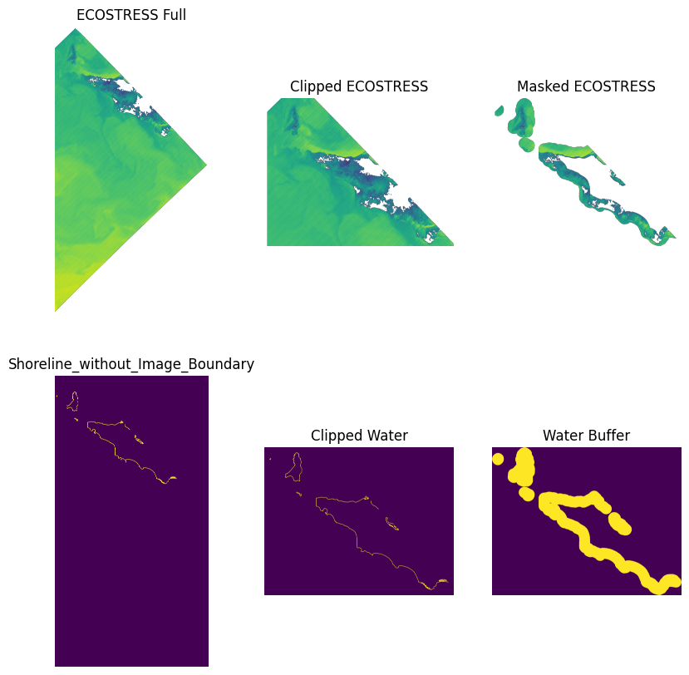

### def Sort_Shorelines

Sorted Shorelines needs a single image to work:

* **Img:** Will be the ECOSTRESS edge detected image. This image is used to determine longest two lines.

The ECOSTRESS image is labeled using “measure.label”. After labeling, the image’s bounding box values and area are calculated using “measure.regionprops_table”. The “length” of each isolated line is not provided with “measure.regionprops_table”. In order to calculate the “length” of the line, the frequency of each label is calculated and used as the length of the line. This line length is then added to the table of values for all the lines within the image and is used to sorted the table by line length. This function returns the new “Sorted_Table” and the “Labeled_img” for further processing.

### def Endlines

The goal of Endlines is to identify the position of pixels that have one neighboring pixel within the eight pixels around the center pixel.

The EndLines function is applied to an ECOSTRESS image the contains a single line. This function first uses skimage’s “morphology.skeletonize” to reduce the amount of stray branches in the ECOSTRESS line. This function will apply the scipy.ndimage’s “binary_hit_or_miss” function to detect pixels with only one connecting pixel in the surrounding 8 directions. Each “binary_hit_or_miss” is summed into one result named “Combined_Results”. The locations where there is a value of 1 is where the endpoints are located. The locations of all endpoints are zipped into a list. Circular lines will not work with this method so for these cases, the top left most pixel will be used. This function returns the skeleton image and the locations of all the eligible endpoints.

### def MatchingOverlay

Matching overlay requires 4 items:

* **Eco:** Isolated ECOSTRESS line. This step involves simplifying the line to eliminate stray branches.
* **Water:** Clipped water mask based on ECOSTRESS image
* **Expand:** 100-pixel buffer
* **Endpoints:** Location of all the lines endpoints. These endpoints could be from anywhere on the line where the line terminates.

The first step in this function is to extract the endpoint value. This endpoint usually is the top left most endpoint. This endpoint will have a buffer box with the endpoint at its center. This buffer box will be expanded by 100 pixels in the cardinal directions. The location of all shoreline pixels within this box are extracted and altered to shift values using the endpoint’s location and the expansion value. This option was used in order to use np.roll() in the Matching_Shift.

### def Matching_Shift

Matching_Shift is the main step in calculating the best position for the ECOSTRESS edge detected lines. This function uses 3 inputs:

* **Shift_Coordinates**: Shift values for the top left most endpoint to match with the water shoreline pixels
* **Eco:** The specific ECOSTRESS line that is the focus of matching
* **Water:** The clipped water mask with respect to the ECOSTRESS line expanded bounding box

The idea for this function is to add the shifted binary ECOSTRESS image and binary Water mask image to count how many “2’s” appear in the resulting matrix. The Shift_Coordinates values are unpacked based on the looped value “i”. Using these values with np.roll(), the image is able to shift into a new positions. At every position, the summed count of each overlapping pixel is calculated and placed as the “Best_Position”. This value remains the best position until a new calculated shift contains a higher overlap and will be replaced. When the “Best_Position” is the initial position, the “Best_Position” value is 0 and requires an if statement to specify the X and Y shifts.

## File Selection Cell

### Customizable Variables & Supplementary Files

For the file setup section, a folder must be defined with forward slashes to allow reading by the os module. Simply adding the LST name into the variable “lst_name” will automatically obtain available qc, water, and cloud tiffs within the specified folder. This code works best with collection 2 data as collection 2 provides custom water, qc, and cloud masks. Collection 2 also has two version, swath and tiled. Swath products have a slightly different water mask filename compared to tiled products. Swath water mask files contain “_water_mask_” while tiled products simply contain “_water_” in their naming. This block of code accounts for this variability and checks if the Tiled product exists first and based on this logic, the Swath product may be used.

When the user specifies to have a single water mask used for matching, the code will clip each image to the overlapped area between the “parent” water mask and the current LST image. This process will be conducted using the “Clip_Parent_Water_Mask” function that was created. Any image that is not overlapping with the user defined water mask will be ignored. For this branch to work, the user must change the “Parent_Water_Mask” variable to a file that exists within your folder. This images needs to be the same projection as the images that are being corrected.

### Opening Rasters

The LST and QC files are opened using GDAL as an array with float data type. The Opening Raster section also checks the existence of cloud masks and opens the raster if possible. The Water Mask and Cloud Masks are not interpreted as float type due to some errors with cv2.bitwise_not in the Water Masking process section. The cloud mask is not a required file due to some issues with misclassifying land as clouds during cloudy or noisy scenes.

## Water Mask Processing

### Determining Acceptable Edges from QC file

The QC’s purpose function in this code is to obtain the limits of the image. The acceptable QC are selected by identifying the values that are not equal to -99999, 65535, and 0. These values provide a mask that will have its edge erased by a few pixels using cv2.erode. * This eroded segment doesn’t include the edges detected in the water mask.

### Removing Image Edges Detected in Water Mask

Like most satellite products, ECOSTRESS files are rotated and provide empty sections around the edges to fill up the array in python. These empty segments are filled with the value 255 which are converted to 0 to blend in with other 0 values in the file. This is important for the water mask as the land values are classified as 0 while water is 1. Setting 255 to 1 will cause slightly more issues with uniquely compiled areas from the AppEEARS ROI so setting this value to 0 works best for this case.

The Inverse_Water variable is a switching the classification of land from 0 to 1 and vice versa for water. This matrix will need to be multiplied by 255 to allow cv2.distanceTranform to work. The cv2.distanceTransform calculated the distance one value is to another value. In this case, it will compute the distance 255 is to 0. Once calculated, we isolate the values equal to 1 resulting in our shoreline. Finally, the Eroded_QC mask and the Water mask’s Shoreline are multiplied to obtain a matrix containing the actual shoreline.

Note: Both the QC mask and the Water mask edges can be calculated with “measure.feature.canny()” however when running this file in batch with large swath tiles, this step takes nearly a minute per iteration. Using these unique steps instead of canny edge detection reduces the computation time.

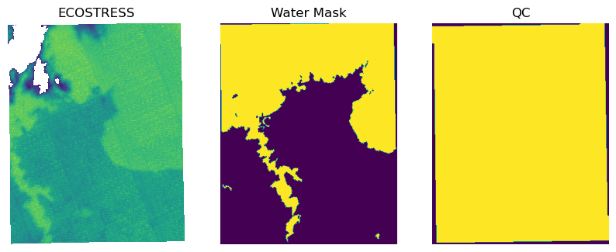

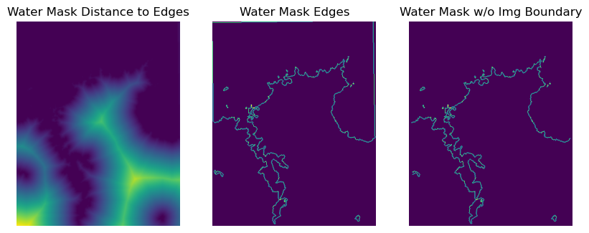

## Cloud Masking Cell

### Applying Cloud Mask to LST and Water Mask

As stated in previous sections, the cloud mask is optional. This block starts with a conditional statement which checks to see if “CloudFile” exists. If the “CloudFile” exists, the code will compute the distance transform. This process is similar to the water mask however two masks will be produced. As an added option, in the beginning of the cell, the Cloud_File variable is written again. This variable can be uncommented to act as a flag. If the user decides to uncomment this variable, the Cloud Mask will no longer be applied to the LST Image

### Cloud Mask on LST

In the LST canny edge detection, the edges of the clouds are found due to the clipped images. This is present in tiled products as this product has the cloud mask applied when downloaded. In some cases, the cloud mask outlines the actual land. The edges of the clouds could be beneficial but the noise within the cloud is not desirable. In this case a 5-pixel buffer is used as a threshold for the cloud distance transform. This 5-pixel mask is applied to the LST image

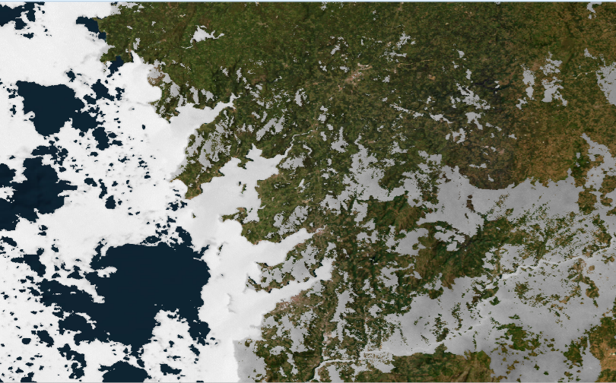

Spain Tiled: ECO_L2T_LSTE.002_LST_doy2023018190822_aid0001

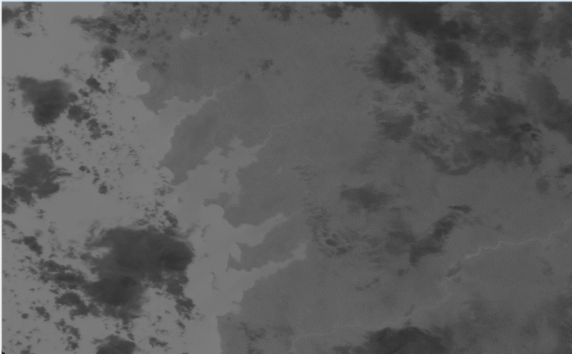

Spain Swath: ECO_L2_LSTE.002_LST_doy2023018190822_aid0001

### Cloud Mask on Water Mask

The cloud mask cannot be applied to the water mask directly due to the cloud mask having the same geolocation as the LST file. To apply the cloud mask to the water mask, the cloud mask will erased by a radius of 100 pixels. Clipping the water mask to this erased cloud mask removes shorelines that are covered by clouds based on the 7km error.

Both the LST and Water Mask are masked by the Cloud mask in different ways based on the specific issues with the cloud mask. Regardless if the cloud mask is not existent, the unmasked LST and Water Mask are renamed to match the cloud mask altered arrays.

## Image Cropping and Preliminary Line Selection Cell

### Identifying the Longest Shoreline

When calculated the edges form the water mask, there are cases in which the shoreline is not connected by a single pixel or two. To combat this issue the shoreline is dilated using “morphology.binary_dilation”. This new dilated shoreline is used to find the largest bounding box that includes each shoreline. The Clip_Water output is used to label the lines and find their area using cv2.connectedCompoenentsWithStats. The shorelines are sorted by area so the code can run the large segments first.

### ECOSTRESS Edge Area Clip

The Clip_Water image is expanded by 100 pixels in all directions representing the max shift error. This dilated water mask is applied to the LST image to avoid calculating unnecessary LST edges over empty water or inland.

### ECOSTRESS Edge Detection and Line Selections

Canny edge detection is applied to the masked ECOSTRESS LST image. A blur applied to the ECOSTRESS is needed to help reduce noise and help highlight areas with higher than normal temperature gradients. This blur effect is applied to the same LST image but with a higher magnitude of 6 to further isolate the lines however there will be reduction in accuracy in the higher order blur. The higher order blur is used to help isolate the lines in the 2.5 blurred LST image by labeling each line in LST, then multiplying the images together. The unique values in this multiplied matrix, excluding 0, are the label values kept in the final “Distinct_Line_Selection” matrix.

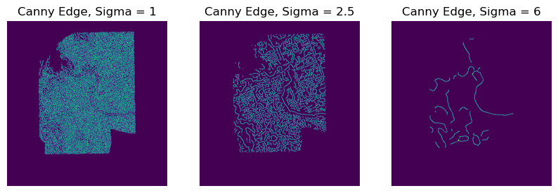

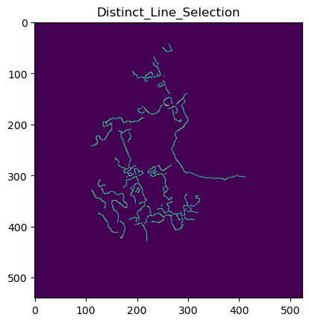

## Acquiring Possible Shifts Cell

### Selection of Top ECOSTRESS Edges

A shift is applied to every individual shoreline within the Water Mask. Each shoreline has its own bounding box and will clip the ECOSTRESS Edge image. Splitting up the shifts by shoreline and not the entire scenes is meant for faster calculations as large scenes tend to have empty space. Lines identified in the LST image could all be short, however in some cases where an entire scene is clear, a long shoreline can be identified. This long shoreline can be used to speed up the matching process as it can be the only line used to geolocate the entire scene. For this step to be used, the difference in length between the top 2 lines are identified. If the longest line is greater than the second row by more than double its length as well has have a shoreline length of 50,000 pixels the top 5 lines will be considered for edge matching. If the top two lines do not satisfy this condition, the top 100 lines will be considered for matching.

### Acquiring Eligible Shifts

This section of the loop uses the Clipping_LST_and_Water_Mask function to clip the isolated shorelines with the individual ECOSTRESS line. Once these two images are clipped to the new bounding box, the EndlLines of the ECOSTRESS image are calculated and used to avoid clustered lines. Lines are considered clustered if the line has more than 6 endpoints. If the line has less than 6 endpoints then the line is dilated by a radius of one. This dilation is used to account slight inconsistencies with water mask and ECOSTRESS edge lines due to temperatures. This new dilated line is implemented into the MatchingOverlay function. This function will find the best overlapping position between the ECOSTRESS line and the water mask by identifying the number of overlapped pixels within a maximum 100-pixel shift. This 100-pixel shift is shown as the blue box in the figure below. The returned values from this function are the Col_Shift (x-axis), Row_Shift (y-axis), and a ratio between overlapping pixels and the total number of pixels in the individual ECOSTRESS image. This ratio is used with Row and Column shifts to have some order in shift possibilities.

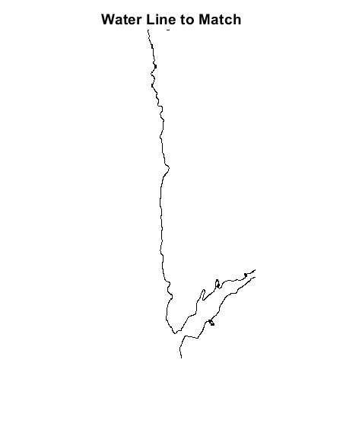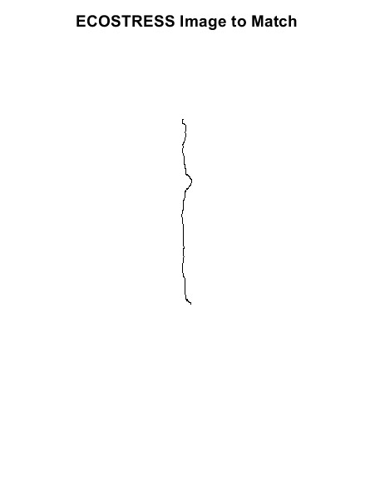

### Shift Check for Combined Top Lines

Once each ECOSTRESS line is shifted for each clipped individual water mask, the temporary shifts are used to match the total individual water mask. These shifts are ordered by the “ratio*area” value. The shifts are inserted, Matching_Shift function to test the viability of each shift. The best shift for the individual shoreline is stored in the “Main_Matching_Stats”. The “Main_Matching_Stats” table will be used on the entire water mask and Distinct_Lines_Selection ECOSTRESS image.

## Final Shift Test Cell

### Testing X and Y Shifts

Similar to the previous subsection. The best shift found from each individual water line will be used for the overall water mask shift test. The final shifts are returned from the Matching_Shift function and may be used in the following section “Applying the Shift”

## Applying the Shift Cell

This section is commented out to avoid any unwanted file creation without approval from the user. This section first creates a new subfolder within your current defined folder. It first checks to verify if this custom “Shifted_Folder” exists before creating it. The LST image is opened once again with GDAL and creates a “New_File” with the original LST name but with “Shifted_” in front. The reason why the name alteration is in the front of the file name and not the end is due to visibility of file names in programs such as QGIS and ArcGIS due to their length. If the user decides to alter the naming convention they can do so at their own preference. Once this file is created, the file is opened with the “Shift_File” variable name. This file obtains the set of coordinates and pixel resolution via “ .GetGeoTransform()”. The shifts found from running the code are multiplied by the resolution of the pixel. The shifts found are based on matrix values. Once updated to the pixel resolution, the shifts are added to the initial x and y starts. The new values are now added to the variable “gt_update” which is applied to the “Shift_File” file. Lastly all files are set to None to free up so memory.