ECOSTRESS Geolocation Jupyter Notebook: User Guide

ECOSTRESS TUTORIALS

This tutorial will show you how to use the base ECOSTRESS Geolocation Shift Jupyter Notebook.

Table of Contents

ECOSTRESS Geolocation Accuracy 1

Where to obtain ECOSTRESS Data? 2

Necessary File(s) 2

ECOSTRESS Geolocation Setup 2

Where to Download ECOSTRESS Geolocation Jupyter Notebook 2

Setting up a Geolocation Python Environment 3

Running the Jupyter Notebook – Demo Example 4

Running the Jupyter Notebook – User Defined 5

Jupyter Notebook – Steps Overview 6

File Setup 7

Water Mask Processing 7

Image Cropping 7

Primary Line Selection 8

Acquiring Possible Shifts 9

Final Shift Test 9

Applying the Shift 10

# ECOSTRESS Geolocation Accuracy

The ECOSTRESS sensor aboard the International Space Station (ISS) provides hundreds of scenes every day and geolocating these scenes is crucial. The ECOSTRESS team at NASA JPL have algorithms to match scenes to their correct location using ground truth points. However, there are still scenes that may have geolocation errors of up to 7km. ECOSTRESS scenes located near bodies of water have noticeable errors as observers can easily find discrepancies between a base map and the ECOSTRESS scene. This code aims to use ECOSTRESS’s water mask file to correctly place the ECOSTRESS LST scene.

The work uses the method developed by Soszynska, van der Werff, Hieronymus, and Hecker, "A New and Automated Method for Improving Georeferencing in Nighttime Thermal ECOSTRESS Imagery", 2023, <https://doi.org/10.3390/s23115079>

# Where to obtain ECOSTRESS Data?

ECOSTRESS data is available on AppEEARS which requires an account to download images. Please refer to JPL’s ECOSTRESS Tutorials ECOSTRESS Tutorial [06-Downloading_From_AppEEARS](https://github.com/ECOSTRESS-Tutorials/ECOSTRESS-Getting-Started/blob/main/06-Downloading_from_AppEEARS.md) for steps on setting up your account and downloading data. This code primarily works best with Collection 2 data as Collection 2 provides personalized water masks for each scene. AppEEARS provides each of the necessary files to a bounding box based on the users Region of Interest (ROI).

# Necessary File(s)

This code was built to process ECOSTRESS Collection 2 from [AppEEARS](https://appeears.earthdatacloud.nasa.gov/). There are two versions of ECOSTRESS LST Collection 2 data with Swath and Tiled. To obtain Swath tiled products you may search for the product: “ECOSTRESS Swath Land Surface Temperature and Emissivity Instantaneous” or search for the tiled product using: “ECOSTRESS Tiled Land Surface Temperature and Emissivity Instantaneous”. Below are the essential files with an optional cloud mask for additional edge removals.

* Land Surface Temperature (LST)
* Quality Control (QC)
* Water Mask
* Cloud Mask **(optional)**

Note: Running the **python** **batch code** with the single water mask option for a folder that has swath and tiled scenes with their native projections will result in errors. Please request your scenes from AppEEARS in any projection besides “Native”. The projection can be set under the “Projection: box under Output Options. If you plan on using Swath only or Tiled only, then this should not be an issue.

# ECOSTRESS Geolocation Setup

## Where to Download ECOSTRESS Geolocation Jupyter Notebook

1. Start by accessing ECOSTRESS Tutorial [Github repository](https://github.com/ECOSTRESS-Tutorials). This page should look like this:

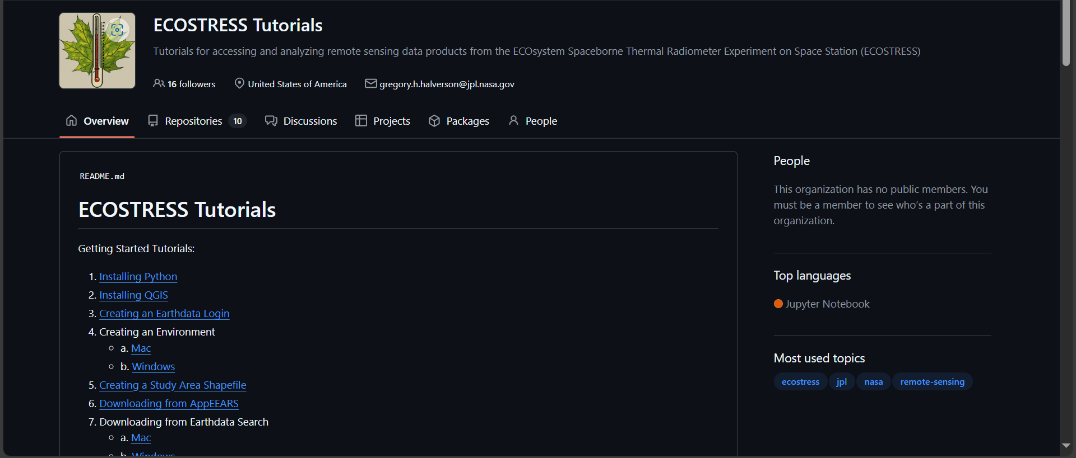

1. Select the **ECOSTRESS Geolocation Shift Correction** link under “Python Tutorials:”
2. Navigate to **Jupyter Notebook Geolocation Code Folder** and download the files
3. Unzip the folder and open the .ipynb files with Visual Studio Code.

Note: If you do not have Visual Studio Code installed in your computer, please follow ECOSTRESS Tutorial [*08 – Downloading Visual Studio Code*](https://github.com/ECOSTRESS-Tutorials/ECOSTRESS-Getting-Started/blob/main/08-Downloading_Visual_Studio_Code.md) to set up your Visual Studio Code application.

## Setting up a Geolocation Python Environment

1. If you are unfamiliar with setting up Python Environments, please follow Tutorial Lesson [04-Creating_an_Environment](https://github.com/ECOSTRESS-Tutorials/ECOSTRESS-Getting-Started/blob/main/04-Creating_an_Environment-Windows.md) to set up a python environment up until the **CREATING AN ENVIRONMENT** segment. This Tutorial has a Window and Mac version.
2. In the Anaconda Prompt: type the command **mamba create -y -n Geolocation -c conda-forge python= 3.12**
   1. **mamba create** is the command to make the environment.
   2. **-y** confirms changes being made.
   3. **-n Geolocation** is used to name our environment. In this case the environment is being named Geolocation but if you would like a different name, you can change it. Just make sure to keep the **-n** and not use spaces or special characters in your name.
   4. **-c conda-forge** sets the channel where mamba will pull the packages from.
   5. For the end of the command, we list the most recent python version as of January 29th, 2024:
      1. **python=3.12** connects to python, in this case setting it to version 3.12.
3. Let the command run. You will know it is done when you get these instructions on how to activate and deactivate the environment

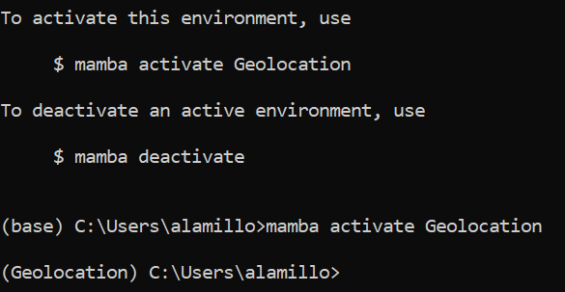

1. Next we will activate the Geolocation environment using **mamba activate Geolocation**. This will replace (base) with (Geolocation)

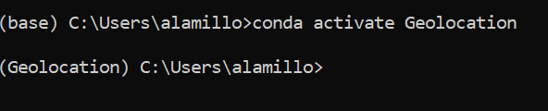

1. With the Geolocation environment active, copy and paste the following commands after each is complete:



**pip install numpy opencv-python scikit-image pandas matplotlib ipykernel**



**conda install gdal**

1. Once each line has finished running, the environment is ready for the ECOSTRESS Geolocation Jupyter Notebook or Python Batch

# Running the Jupyter Notebook – Demo Example

1. With the ECOSTRESS_Geocorrection Notebook in Visual Studio Code, locate the **Select Kernel** button in the top right of the application





1. Once selected the search bar in the top of the screen will provide two options. We will select **Python environment**

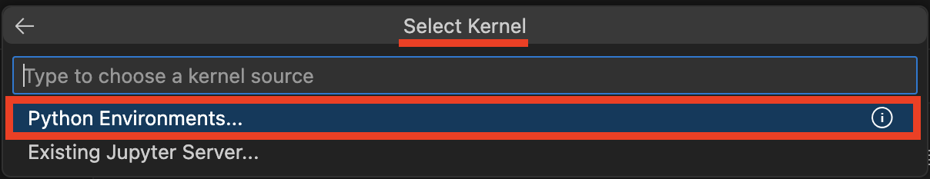

1. This will lead to another dropdown menu where you can select our **Geolocation** environment

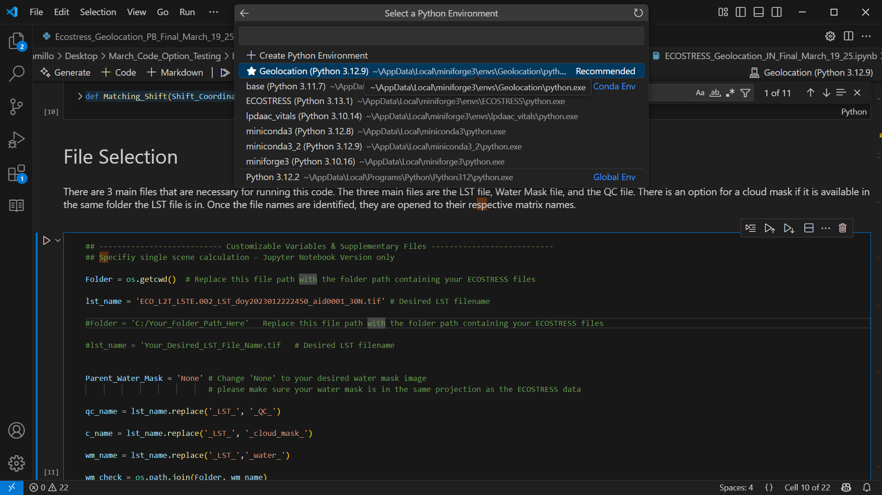

1. This will now appear in the top right where the **Select Kernel** button was





1. With this active, the code is ready to run by selecting the **Run All** button or by running each cell individually

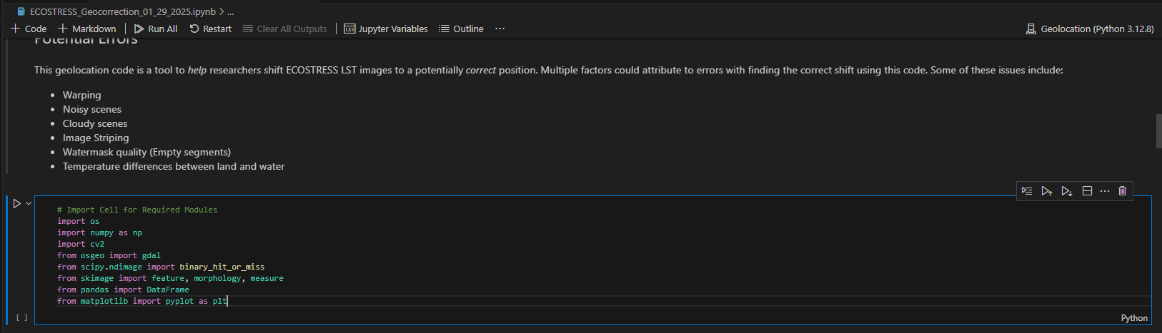

# Running the Jupyter Notebook – User Defined

1. If you wish to run your own image for this Geolocation code, you may use the LST, Water mask, and QC masks from [AppEEARS](https://urs.earthdata.nasa.gov/oauth/authorize?client_id=ZAQpxSrQNpk342OR77kisA&response_type=code&redirect_uri=https://appeears.earthdatacloud.nasa.gov/login&state=/task/point).

Note: When requesting your scenes from AppEEARS, request the Land Surface Temperature, Water Mask, QC Mask, and an optional Cloud Mask from either “ECOSTRESS Swath Land Surface Temperature and Emissivity Instantaneous” for Swath images or search for the tiled product using: “ECOSTRESS Tiled Land Surface Temperature and Emissivity Instantaneous”.

1. Once your AppEEARS request is finished and downloaded, you may alter the **File Selection** section of the Jupyter Notebook to specifiy the Folder your desired ECOSTRESS images are in.

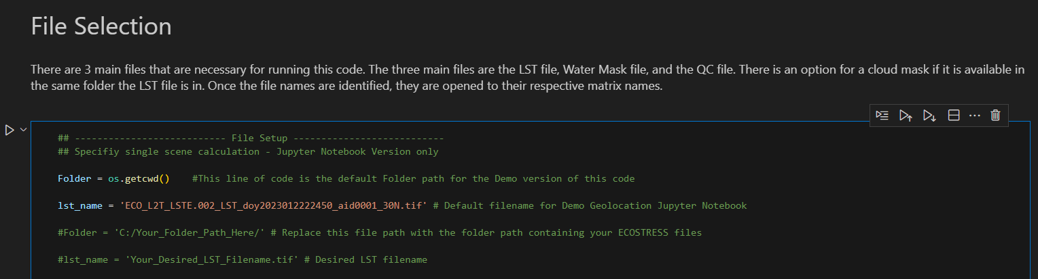

1. Once these file paths are written into the code, then the notebook can be ran.



# Jupyter Notebook – Steps Overview

This section shows each step taken in the Jupyter Notebook visually with images and brief explanation. Any additional information for each step or function can be found in the Jupyter Notebook Documentation.

## File Setup

Your Land Surface Temperature, Water Mask, and QC Mask images will be read and opened using gdal.Open() and read as an array.

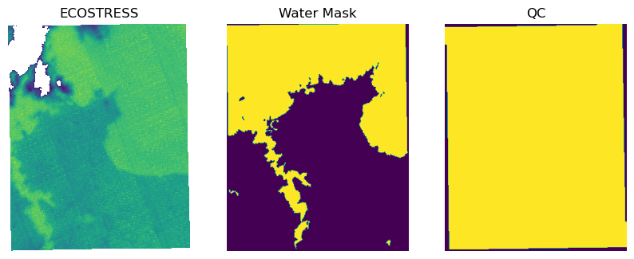

## Water Mask Processing

Thecv2 function distanceTransform is used to identify the distance of the water mask pixels to another pixel (proximity of 0’s to 1’s). This step will give a shoreline with the scene border. The QC mask is used to eliminate the scene border (Seen in the top right section of Water Mask Edges and Water mask w/o Img Boundary).

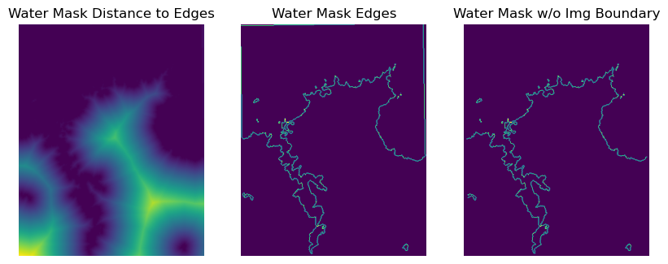

## **Image Cropping**

Using the new water mask shoreline, both the water mask and LST can be clipped to their bounding box with a 100-pixel buffer on all sides. Additionally, the LST image will be masked using a 100-m buffer of the water mask shoreline. This reduces the area of interest within images, especially in large scenes.

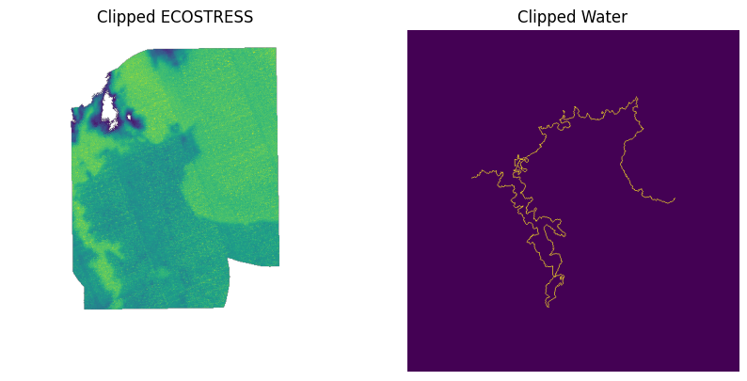

## Primary Line Selection

The LST image will have edge detection applied to identify all the edges in the scene. A gaussian smoothing of 2.5 (known as sigma) is applied to the scene to help reduce noise and help identifying noticeable change in values within a certain pixel distance from the pixel of interest.

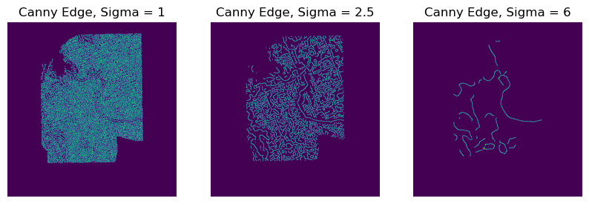

Using a gaussian smoothing of 6, the edge detection process has less noise reducing the number of lines, but decreasing the shoreline accuracy. The 2.5 sigma smoothed scene and 6 sigma smoothed scenes are compared for overlapping lines. The lines that overlapped are used for match selection.

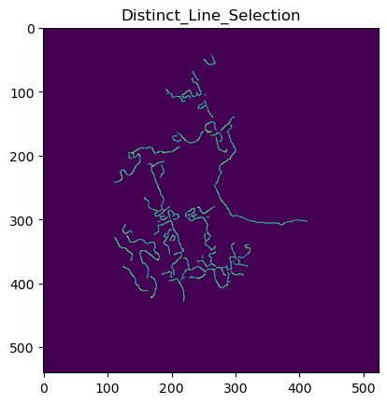

## Acquiring Possible Shifts

Each line will be isolated and will be used to clip their water mask counter parts. Using the top right most point of the ECOSTRESS line, the line will travel along the water mask (right). The shift values will be limited to water mask pixel within a box resembling the 100-pixel error (7km error) shown below as the blue box:

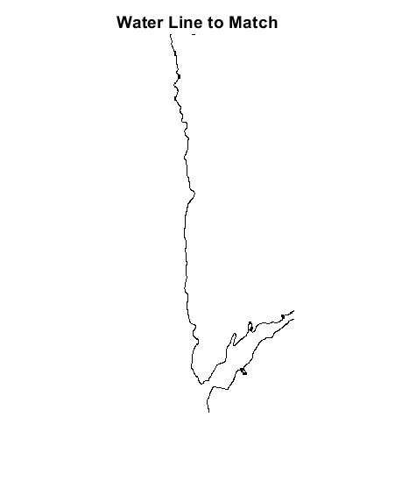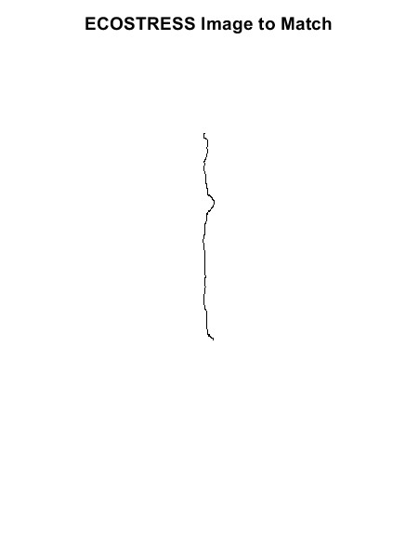

## Final Shift Test

This step is done for individual water mask shorelines (in the case of islands). Once this step is done for every water mask shoreline, the final image can be used for matching using the best shifts calculated from every individual water mask shoreline shift tests.

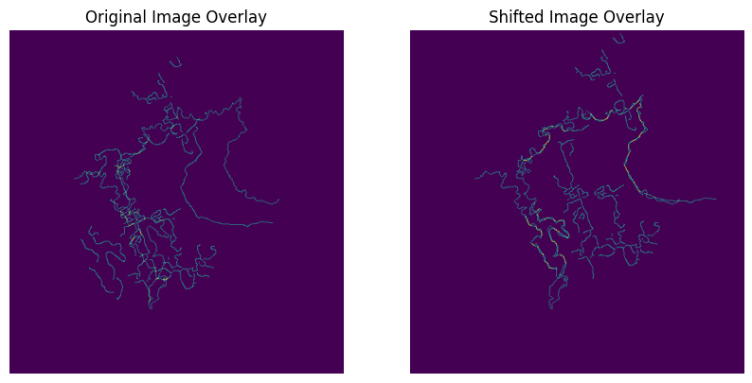

## **Applying the Shift**

The final shift will be applied to a **copy** of your original LST image within a subfolder named “Shifted_Folder”.

Note: This step is commented out to avoid any creation of a file without the user’s approval. To run this code block, remove the #’s by highlighting the code block and pressing “ctrl + /” to uncomment (Windows) or “Command + /” (Mac).