ggplot2 缂佸啩绡<84>

2019-06-27

> library(ggplot2)  
> data(diamonds)  
> knitr::kable(head(diamonds),caption="数据概要")

数据概要

|  |  |  |  |  |  |  |  |  |  |
| --- | --- | --- | --- | --- | --- | --- | --- | --- | --- |
| carat | cut | color | clarity | depth | table | price | x | y | z |
| 0.23 | Ideal | E | SI2 | 61.5 | 55 | 326 | 3.95 | 3.98 | 2.43 |
| 0.21 | Premium | E | SI1 | 59.8 | 61 | 326 | 3.89 | 3.84 | 2.31 |
| 0.23 | Good | E | VS1 | 56.9 | 65 | 327 | 4.05 | 4.07 | 2.31 |
| 0.29 | Premium | I | VS2 | 62.4 | 58 | 334 | 4.20 | 4.23 | 2.63 |
| 0.31 | Good | J | SI2 | 63.3 | 58 | 335 | 4.34 | 4.35 | 2.75 |
| 0.24 | Very Good | J | VVS2 | 62.8 | 57 | 336 | 3.94 | 3.96 | 2.48 |

> ggplot(diamonds, aes(carat,price)) +  
+ geom_bin2d() +  
+ facet_wrap(~cut, nrow = 2)

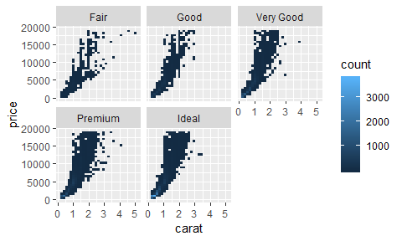

> ggplot(diamonds, aes(log(carat),price)) +  
+ geom_point() +  
+ facet_wrap(~cut, nrow = 2)

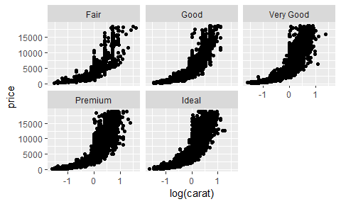

> ggplot(diamonds, aes(carat,log(price))) +  
+ geom_bin2d() +  
+ facet_wrap(~cut, nrow = 2)

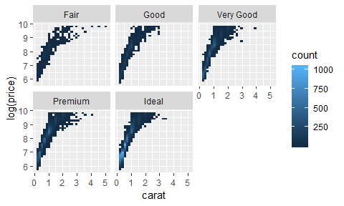

> ggplot(diamonds, aes(log(carat), log10(price))) +  
+ geom_bin2d() +  
+ facet_wrap(~cut, nrow = 2)

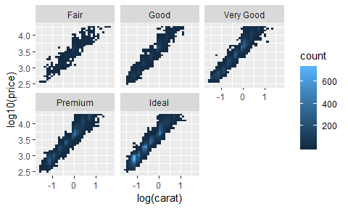

> i <- ggplot(economics, aes(date, unemploy))  
> i + geom_area()

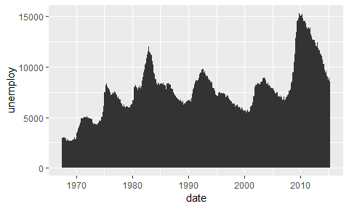

> i + geom_line()

