DAG 4 - reworking - High SR, Low RR

Evelyn Tay

2023-07-12

## 0.1 Assumptions for the generative model

We denote age as a binary variable, $A_{i}∈0,1$ for participant $i=1,2,...,N$, where $A_{i}=0$ indicates an individual $<$50 years of age and $A_{i}=1$ indicates an individual $$50 years of age. Similarly, severity of vaccine reaction is denoted as $S_{i}∈0,1$ for participant $i=1,2,...,N$, where $S_{i}=0$ indicates no or a mild vaccine reaction and $S_{i}=1$ indicates a moderate or highly severe vaccine reaction.

Younger people are more likely to react to a vaccine and have an immune response than older people. Moderate to highly severe reactions, i.e. $S_{i}=1$  were reported more often by younger vaccine recipients ( 16 to 55 years) than by older ($/gt$55 years) in a phase II-III trial of a COVID19 vaccine. We are assuming the following prevalances of a moderate to highly severe vaccine reaction.

P(S = 1| A = 0) = 0.9

P(S = 1| A = 1) = 0.6

We are assuming whether an individual responds to a survey or not is dependent upon both the age of an individual and the severity of their vaccine reaction. Here, we denote responded to a survey as $R_{i}∈0,1$ for participant $i=1,2,...,N$, where $R_{i}=0$ indicates an individual did not respond to a survey and $R_{i}=1$ indicates that they did. People $<$50 years of age have a lower response rate to health surveys than those $/gt$50 years (ref) and this, together with the assumption that those $<$50 years are more likely to have a moderate to highly severe vaccine reaction are incorporated in the following assumptions:

P(R = 1| A = 1, S = 1) = 0.5

P(R = 1| A = 1, S = 0) = 0.25

P(R = 1| A = 0, S = 1) = 0.35

P(R = 1| A = 0, S = 0) = 0.1

We are assuming that younger people are less likely to seek medical attention than older people.[@RN18] Here, seeking medical attention is denoted as $M_{i}∈0,1$ for participant $i=1,2,...,N$,where $M_{i}=0$ indicates an individual did not seek medical attention and $M_{i}=1$ indicates that they did. Together with making the assumption that an individual is less likely to seek medical attention if they have no or a mild vaccine reaction, we make the following assumptions about the prevalence of seeking medical attention:

P(M = 1| A = 1, S = 1) = 0.15

P(M = 1| A = 1, S = 0) = 0.05

P(M = 1| A = 0, S = 1) = 0.05

P(M = 1| A = 0, S = 0) = 0.005

The outcome D (disclosed or reported as having sought medical attention) is dependent upon whether an individual responds (R) to a survey and whether they sought medical attention (M) for a reaction to the vaccine. Whether an individual reports that they have sought medical attention is deterministic on whether they responded to a survey or not, however, if they did not seek medical attention there may be probability very close to zero that they reported as having sought medical attention (?).

P(D = 1| R = 1, M = 1) = 0.999

P(D = 1| R = 1, M = 0) = 0.001

P(D = 1| R = 0, M = 0) = 0

## 0.2 Simulation results from the generative model

The ages of 2,000 individuals were simulated by sampling from a truncated Normal distribution to ensure positive values with a mean age of 43.5 years and sd of 18.6 to ensure an even and plausible spread over the threshold age of 50 years.This was based upon fitting a Normal distribution to age data from participants vaccinated with COVID-19 vaccines.

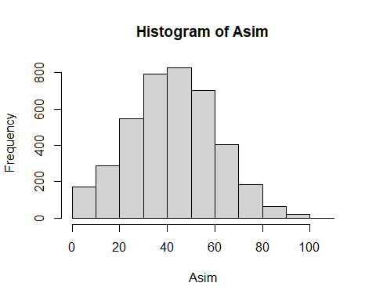

## Min. 1st Qu. Median Mean 3rd Qu. Max.   
## 0.0 30.0 43.0 42.9 56.0 105.0

## [1] 0.9051181

## [1] 0.6054795

## [1] 0.09958506

## [1] 0.3527621

## [1] 0.2638889

## [1] 0.4977376

## [1] 0.004149378

## [1] 0.04697695

## [1] 0.03819444

## [1] 0.158371

## [1] 1

## [1] 0.365

## [1] 0.79575

## [1] 0.8766643

## [1] 0.35675

## [1] 0.06775

## [1] 0.0295

## [1] 0.08269096

Histogram and summary of simulated ages (A sim).

Individual response to a survey and probability of an individual seeking medical attention were modeled as binary outcomes and sampled from Bernoulli distributions conditional on the age category and severity of reaction of an individual. Whether an individual responded as having sought medical attention for a reaction was also modeled as a binary outcome from a Bernoulli distribution dependent upon whether an individual responded to a survey and also sought medical attention

Table of probabilities derived from the simulated data.

|  | **Probability** |
| --- | --- |
| P(S = 1| A = 0) |  |
| P(S = 1| A = 1) |  |
| P(R = 1| A = 0, S = 0) |  |
| P(R = 1| A = 0, S = 1) |  |
| P(R = 1| A = 1, S = 0) |  |
| P(R = 1| A = 1, S = 1) |  |
| P(M = 1| A = 0, S = 0) |  |
| P(M = 1| A = 0, S = 1) |  |
| P(M = 1| A = 1, S = 0) |  |
| P(M = 1| A = 1, S = 1) |  |
| P(D = 1| R = 1, M = 1) |  |

## 0.3 Bayesian logistic regression models

Model 1: For effect of age and degree of reaction on response and also on seeking medical attention. For effect of response and seeking medical attention on responding that an individual sought medical attention for a reaction to a vaccine

A -> S, A -> R <- S, A -> M <- S, R -> D <- M

$$\begin{matrix}R_{i}∼\text{Bern}\left(p_{i}\right) \\ S_{i}∼\text{Bern}q_{i}) \\ M_{i}∼\text{Bern}\left(g_{i}\right) \\ \text{If R_i then}D_{i}∼\text{Bern}\left(h_{i}\right) \\ logit\left(p_{i}\right)=α_{p}+β_{AR}*A_{i}+β_{SR}*S_{i} \\ logit\left(q_{i}\right)=α_{q}+β_{AS}*A_{i} \\ logit\left(g_{i}\right)=α_{s}+β_{AM}*A_{i}+β_{SM}*S_{i} \\ logit\left(h_{i}\right)=α_{h}+β_{MD}*M_{i} \\ α_{p},α_{q},α_{g},α_{h}∼Normal\left(0.5,σ\right) \\ β_{AR},β_{SR},β_{AS}∼Normal\left(0,2\right) \\ β_{AM},β_{SM}∼Normal\left(0,2\right) \\ β_{SD}∼Normal\left(0,2\right) \\ σ∼Exponential\left(1\right)\end{matrix}$$

Where:

$i$ = 1 to 4000

$R_{i}$ = whether an individual responded to the survey or not

$S_{i}$ = severity of reaction to a vaccine of an individual

$A_{i}$ = age group of individuals

$M_{i}$ = whether an individual sought medical attention or not

$D_{i}$ = whether an individual responded that they sought medical attention or not

$p_{i}$ = P(R = 1) of an individual conditional on S and A

$q_{i}$ = P(S = 1) of an individual conditional on A

$g_{i}$ = P(M = 1) of an individual conditional on S and A

$h_{i}$ = P(D = 1) of an individual conditional on R and M

$α_{p}$ = log of baseline survey response rate of individuals <50 years who got no or a mild reaction

$α_{q}$ = log of baseline rate of mod-high severe reaction in individuals <50 years

$α_{g}$ = log of baseline rate of seeking medical attention of individuals <50 years who got no or a mild reaction

$α_{h}$ = log of baseline rate of reporting medical attention of individuals <50 years who got no or a mild reaction

$β_{AS}$ = log odds ratio of age group on severity of reaction

$β_{AM}$ = log odds ratio of age group on seeking medical attention

$β_{SM}$ = log odds ratio of severity reaction on seeking medical attention

$β_{MD}$ = log odds ratio of seeking medical attention on reporting medical attention

## 0.4 Validating the model

### 0.4.1 No stratification

## mean se_mean sd 2.5% 25% 50%  
## ap -1.77398212 2.399170e-03 0.105203962 -1.974890225 -1.84072914 -1.77130541  
## bAR 0.65997675 1.461916e-03 0.074502299 0.513549023 0.60906255 0.65995611  
## bSR 1.14821682 2.169416e-03 0.101312301 0.948300316 1.08136534 1.14678485  
## aq 2.25136171 1.381476e-03 0.068887900 2.121591153 2.20466603 2.24983249  
## bAS -1.82205155 1.829216e-03 0.087598302 -1.996557592 -1.87971803 -1.82009302  
## ag -4.59724557 5.229201e-03 0.236883087 -5.083436143 -4.75850395 -4.59340561  
## ah -5.87966352 9.960299e-03 0.494497932 -6.974015419 -6.18550151 -5.83852327  
## bAM 1.34395044 2.346359e-03 0.131698801 1.092708750 1.25385282 1.34362127  
## bSM 1.58162652 4.673666e-03 0.219190859 1.156524157 1.43592334 1.57516511  
## bMD 9.91074258 1.650623e-02 0.809486640 8.508546325 9.31935467 9.86497510  
## qA0 0.90460273 1.188966e-04 0.005929352 0.892984081 0.90066774 0.90463609  
## qA1 0.60563685 2.099270e-04 0.012753775 0.580965522 0.59698908 0.60542002  
## pA0S0 0.14553385 2.985727e-04 0.013060827 0.121864600 0.13696508 0.14538006  
## pA0S1 0.34853600 1.775934e-04 0.009852242 0.329901895 0.34185587 0.34845319  
## pA1S1 0.50854307 3.034751e-04 0.016134371 0.477370231 0.49766429 0.50880731  
## pA1S0 0.24747087 2.909423e-04 0.015958266 0.216947925 0.23652571 0.24713945  
## gA0S0 0.01025230 5.266367e-05 0.002412782 0.006160388 0.00850547 0.01001699  
## gA0S1 0.04691269 7.397364e-05 0.004301043 0.038780629 0.04394137 0.04677733  
## gA1S0 0.03790905 1.432747e-04 0.007456056 0.024626012 0.03267636 0.03734661  
## gA1S1 0.15858300 2.348692e-04 0.012218827 0.135378412 0.15030809 0.15829346  
## hR1M1 0.97863847 2.062295e-04 0.013420490 0.945692430 0.97181011 0.98163110  
## 75% 97.5% n_eff Rhat  
## ap -1.70486496 -1.56560248 1922.835 0.9998658  
## bAR 0.71034114 0.80420098 2597.136 1.0001436  
## bSR 1.21379122 1.35044144 2180.914 0.9998655  
## aq 2.29752650 2.38988539 2486.562 0.9995903  
## bAS -1.76311874 -1.64993620 2293.302 0.9994512  
## ag -4.43604873 -4.14364986 2052.095 0.9997576  
## ah -5.53671281 -5.03639004 2464.814 0.9995149  
## bAM 1.43184117 1.60879166 3150.464 0.9997070  
## bSM 1.72639130 2.02911644 2199.528 0.9995933  
## bMD 10.42157177 11.68853173 2405.046 0.9995544  
## qA0 0.90867198 0.91605275 2487.000 0.9995831  
## qA1 0.61451695 0.62985740 3690.972 0.9994393  
## pA0S0 0.15383094 0.17284420 1913.556 0.9998612  
## pA0S1 0.35494559 0.36859216 3077.629 0.9999179  
## pA1S1 0.51923228 0.54070458 2826.558 0.9998943  
## pA1S0 0.25837052 0.27901802 3008.554 1.0002633  
## gA0S0 0.01170403 0.01561708 2099.007 0.9996696  
## gA0S1 0.04977924 0.05582048 3380.599 0.9998418  
## gA1S0 0.04250572 0.05384241 2708.190 0.9998526  
## gA1S1 0.16647884 0.18313859 2706.494 1.0000190  
## hR1M1 0.98836054 0.99626265 4234.821 1.0010808

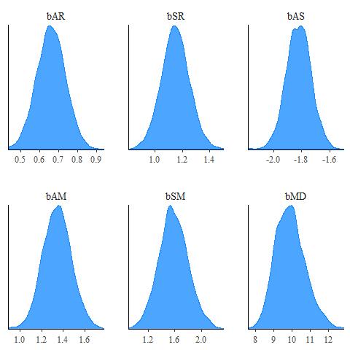

Figure 1: Posterior distributions for $β$ showing mean and 80% interval.

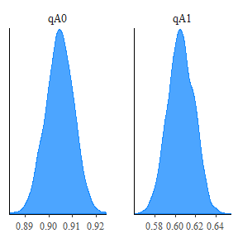

Figure 2: Predictive probability distributions for P(S = 1| A = 0) and P(S = 1| A = 1) showing mean, 80% interval.

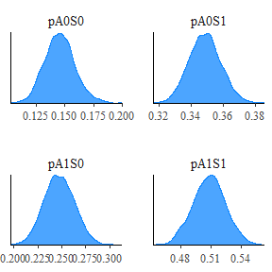

Figure 3: Predictive probability distributions for P(R = 1| A = 0, S = 0), P(R = 1| A = 0, S = 1), P(R = 1| A = 1, S = 1), and P(R = 1| A = 1, S = 0) showing mean, 80% interval..

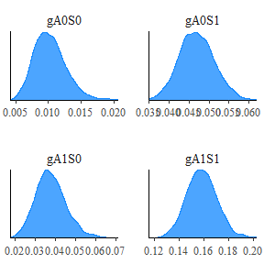

Figure 4: Predictive probability distributions of P(M = 1| A = 0, S = 0), P(M = 1| A = 0, S = 1), P (M = 1| A = 1, S = 0), and P(M = 1| A = 1, S = 1) showing mean, 80% interval.

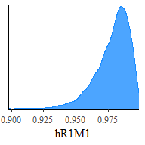

Figure 5: Predictive probability distribution of P(D = 1|R = 1, M = 1) showing mean, 80% interval.

### 0.4.2 A = 1

## mean se_mean sd 2.5% 25% 50%  
## ap -1.0086254 0.0024746847 0.098036609 -1.20312648 -1.07486499 -1.00636243  
## bSR 0.9980806 0.0029854478 0.119651983 0.76509900 0.91264638 0.99888954  
## aq 0.4234080 0.0011120497 0.054594018 0.31597145 0.38550697 0.42367939  
## ag -3.1849466 0.0054256041 0.211122541 -3.61135331 -3.32348992 -3.17623302  
## ah -5.3159317 0.0143483186 0.627437055 -6.67086232 -5.68738756 -5.25856455  
## bSM 1.5075468 0.0057336390 0.231778385 1.06973776 1.35050652 1.50606230  
## bMD 9.0545494 0.0214793448 0.873821179 7.36920499 8.43137615 9.03384907  
## qA 0.6042244 0.0002661218 0.013048668 0.57834215 0.59520063 0.60436336  
## pS1 0.4973667 0.0003354669 0.016768841 0.46421287 0.48618726 0.49723701  
## pS0 0.2676855 0.0004832282 0.019181537 0.23091950 0.25447901 0.26769233  
## gS0 0.0405155 0.0002068194 0.008139907 0.02630465 0.03477408 0.04006998  
## gS1 0.1578284 0.0002586177 0.012270155 0.13432717 0.14994779 0.15775917  
## hR1M1 0.9716997 0.0003449090 0.017711532 0.92705683 0.96227251 0.97573248  
## 75% 97.5% n_eff Rhat  
## ap -0.94485797 -0.81570391 1569.412 1.0000099  
## bSR 1.07689742 1.23125102 1606.278 0.9994808  
## aq 0.46020778 0.52582988 2410.137 1.0002439  
## ag -3.04176315 -2.78438313 1514.164 1.0005665  
## ah -4.86506931 -4.29922389 1912.222 0.9996880  
## bSM 1.65972168 1.97249203 1634.125 1.0002419  
## bMD 9.65224020 10.83739205 1655.019 1.0004414  
## qA 0.61306347 0.62850997 2404.206 1.0002215  
## pS1 0.50892506 0.53018928 2498.658 0.9992537  
## pS0 0.27992010 0.30667637 1575.659 1.0000432  
## gS0 0.04557442 0.05817395 1549.017 1.0004894  
## gS1 0.16579045 0.18336833 2251.042 0.9991887  
## hR1M1 0.98478575 0.99461798 2636.958 1.0004658

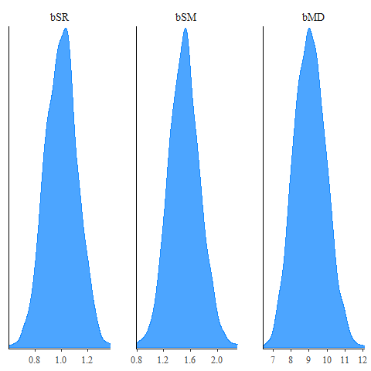

Figure 6: Posterior distributions for $β$ showing mean and 80% interval.

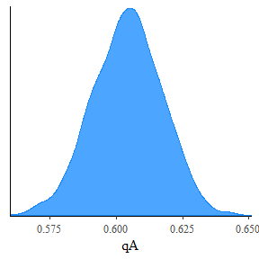

Figure 7: Predictive probability distributions for P(S = 1| A = 1) showing mean, 80% interval.

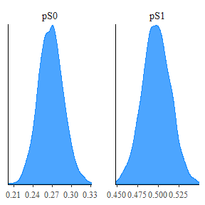

Figure 8: Predictive probability distributions for P(R = 1| A = 1, S = 1), and P(R = 1| A = 1, S = 0) showing mean, 80% interval..

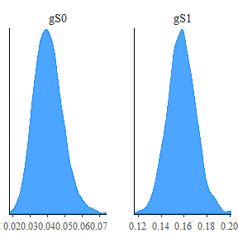

Figure 9: Predictive probability distributions of P(M = 1| A = 1, S = 0), and P(M = 1| A = 1, S = 1) showing mean, 80% interval.

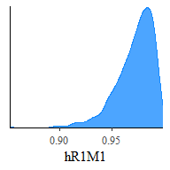

Figure 10: Predictive probability distribution of P(D = 1|R = 1, M = 1) showing mean, 80% interval.

### 0.4.3 A = 0

## mean se_mean sd 2.5% 25%  
## ap -2.145072870 0.0067568230 0.214734696 -2.578365934 -2.28212130  
## bSR 1.536491400 0.0068821640 0.220071847 1.109261534 1.38455158  
## aq 2.252776777 0.0016480842 0.069396288 2.121265427 2.20425695  
## ag -4.885047916 0.0250129368 0.707525968 -6.344286685 -5.34386418  
## ah -5.471891199 0.0139341090 0.531477897 -6.630289065 -5.79951384  
## bSM 1.866754142 0.0250966764 0.710867083 0.608299824 1.37955084  
## bMD 8.546769350 0.0239852523 0.845890412 7.022934504 7.95760427  
## qA 0.904722320 0.0001414620 0.005966027 0.892952949 0.90063114  
## pS0 0.106483223 0.0006331984 0.020111176 0.070543797 0.09261453  
## pS1 0.352444358 0.0002272078 0.009756640 0.333455643 0.34563603  
## gS0 0.009349756 0.0001915038 0.006386411 0.001753675 0.00475466  
## gS1 0.046796765 0.0001031264 0.004321973 0.038390280 0.04385015  
## hR1M1 0.946210886 0.0006873375 0.034232076 0.858479331 0.92894064  
## 50% 75% 97.5% n_eff Rhat  
## ap -2.13334230 -1.99952215 -1.73104166 1009.9953 1.0013492  
## bSR 1.52568599 1.68305288 1.99037367 1022.5368 1.0011235  
## aq 2.25479862 2.29744727 2.39206839 1773.0203 1.0004803  
## ag -4.81315314 -4.40842093 -3.65321554 800.1205 1.0002094  
## ah -5.41932814 -5.10652230 -4.55252815 1454.8292 1.0010607  
## bSM 1.79973711 2.32110707 3.32174815 802.3140 1.0000488  
## bMD 8.49159273 9.11076342 10.32734426 1243.7687 1.0009504  
## qA 0.90506365 0.90866540 0.91622048 1778.6514 1.0004109  
## pS0 0.10589811 0.11925310 0.15045439 1008.7773 1.0013616  
## pS1 0.35243374 0.35922695 0.37174316 1843.9703 1.0003041  
## gS0 0.00805677 0.01202797 0.02525343 1112.1392 0.9991717  
## gS1 0.04676270 0.04970845 0.05545785 1756.4023 0.9995350  
## hR1M1 0.95358204 0.97125654 0.99056484 2480.4269 0.9992943

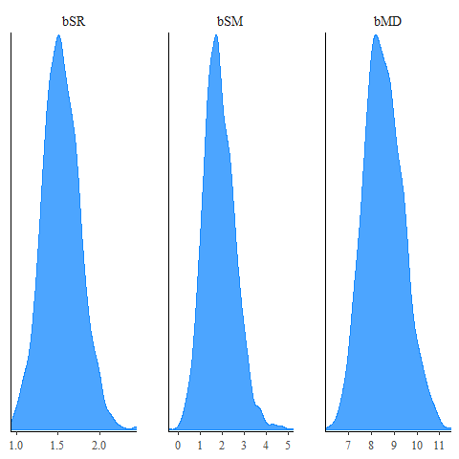

Figure 11: Posterior distributions for $β$ showing mean and 80% interval.

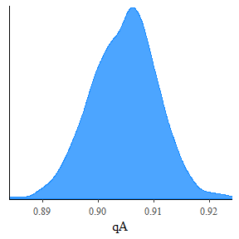

Figure 12: Predictive probability distributions for P(S = 1| A = 0) showing mean, 80% interval.

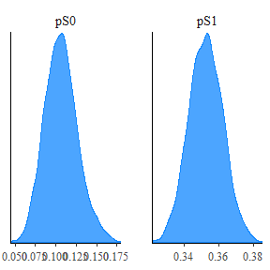

Figure 13: Predictive probability distributions for P(R = 1| A = 0, S = 0) and P(R = 1| A = 0, S = 1) showing mean, 80% interval..

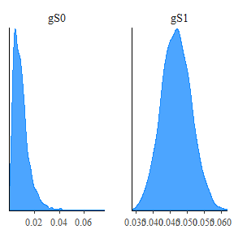

Figure 14: Predictive probability distributions of P(M = 1| A = 0, S = 0) and P(M = 1| A = 0, S = 1) showing mean, 80% interval.

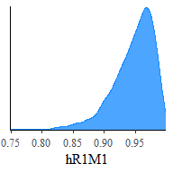

Figure 15: Predictive probability distribution of P(D = 1|R = 1, M = 1) showing mean, 80% interval.

Prior predictive checks in the form of ROC curves of outcomes simulated from the priors compared to the outcomes in the simulated data were conducted to validate the prior specifications. In each ROC curve, control = 0, case = 1.

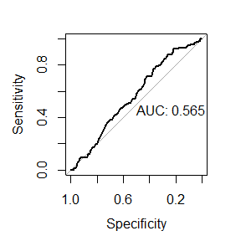

##   
## Call:  
## roc.formula(formula = dat$D ~ Dsim, plot = TRUE, print.auc = TRUE)  
##   
## Data: Dsim in 3882 controls (dat$D 0) < 118 cases (dat$D 1).  
## Area under the curve: 0.5653

Dsim - simulated binary outcome whether an individual responded as having sought medical attention or not.

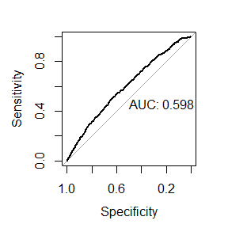

##   
## Call:  
## roc.formula(formula = dat$R ~ Rsim, plot = TRUE, print.auc = TRUE)  
##   
## Data: Rsim in 2573 controls (dat$R 0) < 1427 cases (dat$R 1).  
## Area under the curve: 0.5982

Rsim - simulated binary outcome whether an individual responded to the survey or not.

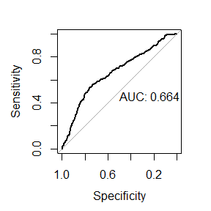

##   
## Call:  
## roc.formula(formula = dat$M ~ Msim, plot = TRUE, print.auc = TRUE)  
##   
## Data: Msim in 3729 controls (dat$M 0) < 271 cases (dat$M 1).  
## Area under the curve: 0.664

Msim - simulated binary outcome whether an individual sought medical attention or not.

## 0.5 References