**Appendix: Simulation results**

$δ$**= log(1.0) $δ$ = log(1.1) $δ$ = log(1.2)**

**Scenario B: OR = 2.0 for AE37**

**Scenario C: OR = 2.0 for AE37 and 1.5 for remaining AEs in SOC8**

**Scenario D: OR = 2.0 for all AEs in SOC8**



**Figure 5.** Power curves comparing Bayesian decision criteria (logistic regression) with the adjusted and unadjusted Fisher’s exact tests for detecting a vaccine-AE association at each interim: control AE risk = 5% , OR = 2.0 & sample size = 10,000 per arm.

AE: adverse event; SOC: systems organ clas

$δ$**= log(1.0) $δ$ = log(1.1) $δ$ = log(1.2)**

**Scenario B: OR = 2.0 for AE37**

**Scenario C: OR = 2.0 for AE37 and 1.5 for remaining AEs in SOC8**

**Scenario D: OR = 2.0 for all AEs in SOC8**



**Figure 6.** Power curves comparing Bayesian decision criteria (logistic regression) with the adjusted and unadjusted Fisher’s exact tests for detecting a vaccine-AE association at each interim: control AE risk = 1% , OR = 2.0 & sample size = 2,000 per arm.

AE: adverse event; SOC: systems organ class

$δ$**= log(1.0) $δ$ = log(1.1) $δ$ = log(1.2)**

$p_{thresh}$**= 0.95**

****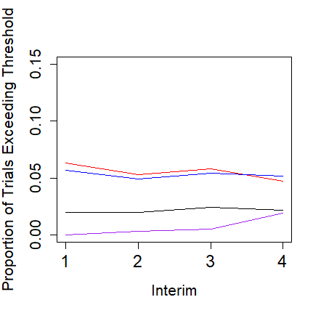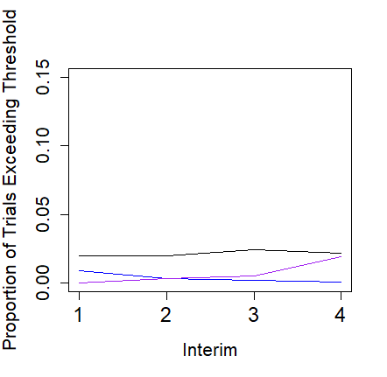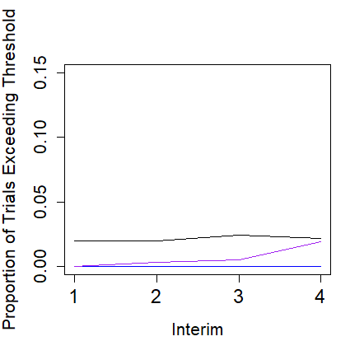

**= 0.975**

***

**= 0.99**

***

**Figure 7.** Type I error curves comparing the different Bayesian decision-making criteria with the adjusted and unadjusted Fisher’s exact tests at each interim: control AE risk = 5% & sample size = 10,000 per arm. In some instances, the logistic and Poisson models have almost identical curves may be represented by a single blue line.

$p_{thresh}$: posterior exceedance probability threshol

$δ$**= log(1.0) $δ$ = log(1.1) $δ$ = log(1.2)**

**Scenario B: OR = 1.5 for AE37**

**Scenario D: OR = 1.5 for all AEs in SOC8**



**Figure 8.** Power curves comparing Bayesian decision criteria (logistic regression) with unadjusted and adjusted Fisher’s exact tests for detecting a vaccine-AE association at each interim: control AE risk = 1% , OR = 1.5 & sample size = 2,000 per arm.

AE: adverse event; SOC: systems organ class