# Readme

*Hi there! This document contains a helpful table of where accession data is in AT vs where to find it in AS. It was created specifically for the Manuscripts Unit at East Carolina University as they undergo their migration and check data mapping, etc. It is very “homemade” with a few screenshots and such, but we hope that, by sharing it, it is a starting point for you to create something useful for your repository.*

# Accessions

**Archivists’ Toolkit**

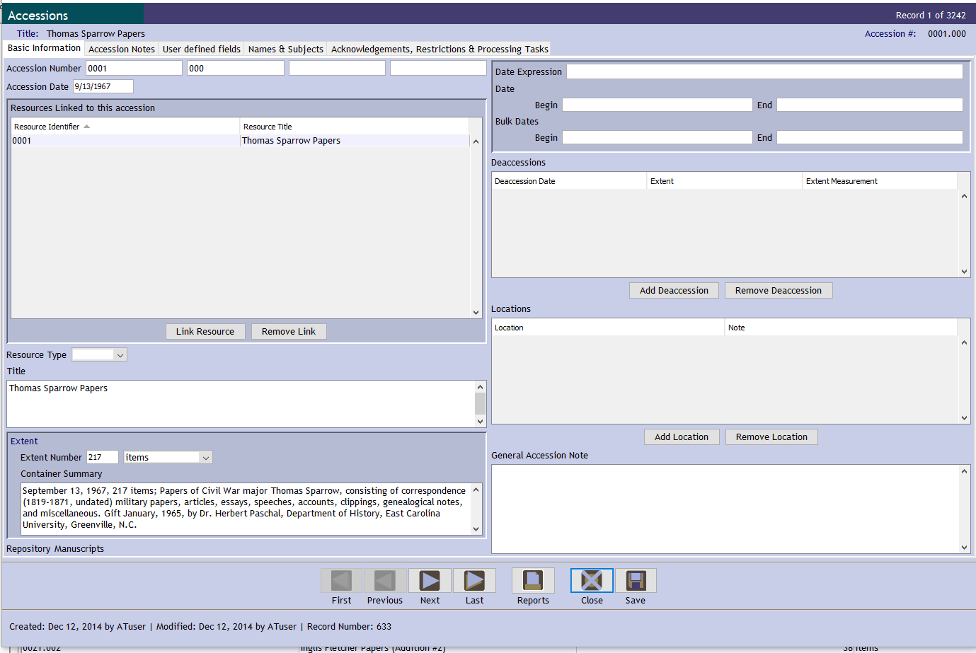

**ArchivesSpace**

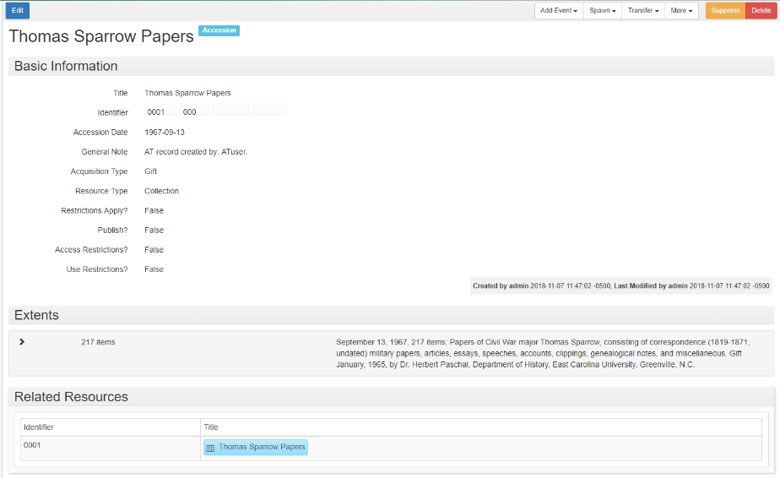

**Accessions Field Name** (anything empty in AT will not show up in AS)

|  |  |
| --- | --- |
| **Where is it in Archivists Toolkit?** | **Where is it in ArchivesSpace?** |
| ***Basic Information Tab*** |  |
| Accession Number | Basic Information: Identifier |
| Accession Date | Basic Information: Accession Date |
| Resources Linked to this accession | Related Resources (scroll down) |
| Resource Type | Basic Information: Resource Type |
| Title | Basic Information: Title |
| Extent | Extents (below Dates): |
| Extent Number | (click on >) Number + Type |
| Container Summary | Container Summary |
| Date Expression | Dates: |
| Date: Begin/End | (click on >) Begin/End |
| Bulk Dates: Begin/End | (click on >) Begin/End (look for Type = Bulk Dates) |
| General Accession Note | Basic Information: General Note |
|  |  |
| ***Accession Notes Tab*** |  |
| Acquisition Type | Basic Information: Acquisition Type |
| Description | Basic Information: Content Description |
| Condition | Basic Information: Condition Description |
|  |  |
| ***User defined fields tab*** |  |
| Donation received date | User Defined: Date 1 |
| Donation receipt signed on date | User Defined: Date 2 |
| Donation received by | User Defined: Text 1 |
| Special Notes About Contract (super rare!) | (Still looking for an example. If you find one, you’ve won the golden ticket!) |
| *This space intentionally left blank.* | *This space intentionally left blank.* |
| ***Acknowledgements, Restrictions & Processing Tasks Tab*** |  |
| Acknowledgement Sent checkbox  Acknowledgement Date | Events: (you’ll see a table, click on View for Acknowledgement Sent to access the information)    (it will take you to another page)    (Look at Event Date/Time to see if the data mapped correctly. Click your browser’s back button to return to the accession.) |
| Agreement Sent checkbox  Agreement Sent Date | Events: (you’ll see a table, click on View for Agreement Sent to access the Agreement information)    (it will take you to another page)    (Look at Event Date/Time to see if the data mapped correctly. Click your browser’s back button to return to the accession.) |
| Agreement Received checkbox  Agreement Received Date | Events: (you’ll see a table, click on View for Agreement Signed to access the Agreement information)    (it will take you to another page)    (Look at Event Date/Time to see if the data mapped correctly. Click your browser’s back button to return to the accession.) |
| Rights Transferred checkbox  Rights Transferred Date | Events: (you’ll see a table, click on View for Copyright Transfer to access the Rights information)    (it will take you to another page)    (Look at Event Date/Time to see if the data mapped correctly. Click your browser’s back button to return to the accession.) |
| Restrictions Apply checkbox | Basic Information: Restrictions Apply? (True/Fasle) |
| Access Restrictions checkbox  Access Restrictions Note | Basic Information: Access Restrictions? (True/False)  Basic Information: Access Restrictions Note |
|  |  |
| Processing Priority | Collection Management: (click on >) Processing Priority |
| Processing Status | Collection Management: Processing Status |
|  |  |

**Accessions**

Basic Information

Accession Number

Accession Date

Resources Linked to this accession

Resource Identifier

Resource Title

Resource Type

Title

Extent

Extent Number

Container Summary

Repository

Date Expression

Date

Bulk Dates

Deaccessions {Not used by Manuscripts}

Deaccession Date

Extent

Extent Measurement

Locations {Not used by Manuscripts}

Location

Note

General Accession Note

Accession Notes

Acquisition Type

Retention Rule {Not used by Manuscripts}

Description

Condition

Inventory {Not used by Manuscripts}

Disposition Note {Not used by Manuscripts}

External Documents {Not used by Manuscripts}

HREF

Type

Title

Content

User Defined Fields

Donation received date

Donation receipt signed on date

User Defined Boolean 1 {Not used by Manuscripts}

User Defined Boolean 2 {Not used by Manuscripts}

User Defined Integer 1 {Not used by Manuscripts}

User Defined Integer 2 {Not used by Manuscripts}

User Defined Real 1 {Not used by Manuscripts}

User Defined Real 2 {Not used by Manuscripts}

User Defined String 1 {Not used by Manuscripts}

User Defined String 2 {Not used by Manuscripts}

User Defined String 3 {Not used by Manuscripts}

Donation received by

Special Notes About Contract

User Defined Text 3 {Not used by Manuscripts}

User Defined Text 4 {Not used by Manuscripts}

Names

Name

Name Link Function

Name Link Creator/Subject Role

Subjects {Not used by Manuscripts}

Acknowledgements, Restrictions & Processing Tasks

Acknowledgements & Restrictions

Acknowledgement Sent

Acknowledgement Date

Agreement Sent

Agreement Sent Date

Agreement Received

Agreement Received Date

Rights Transferred

Rights Transferred Date

Rights Transferred Note

Restrictions Apply {Not used by Manuscripts}

Access Restrictions {Not used by Manuscripts}

Access Restrictions Note {Not used by Manuscripts}

Use Restrictions {Not used by Manuscripts}

Use Restrictions Note {Not used by Manuscripts}

Processing Tasks

Processing Priority

Processors {Not used by Manuscripts}

Processing Plan {Not used by Manuscripts}

Processing Started Date {Not used by Manuscripts}

Processing Status

Processed

Processed Date

Cataloged {Not used by Manuscripts}

Cataloged Date {Not used by Manuscripts}

Cataloged Note {Not used by Manuscripts}