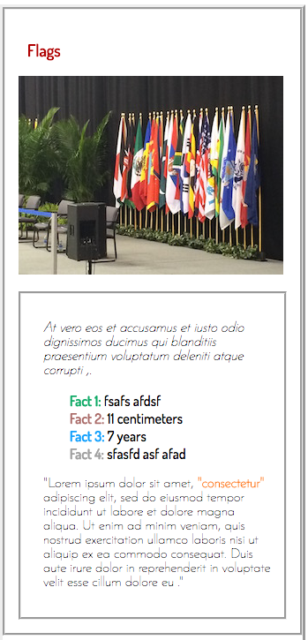

Trading Card

Make an exact copy

Choose any image and text

Width 340px

Height 750px

Color: #af0000

#12ab68

#aa6b68

#12a0fd

#a0a0a0

Fonts: Josefin Sans', sans-serif

'Dosis', sans-serif

Use Google fonts to find the right font and weight

Please use one of the following sites to clean up and properly format your code

<https://www.dirtymarkup.com/>

<http://jsbeautifier.org/>