**WATSON FOR HEALTHCARE**

**NUTRITIONIST SLACKBOT**

POWERED BY

**WATSON CONVERSATION** AND **DISCOVERY**

INDEX

1. SETTING UP APP ON BLUEMIX
2. CONFIGURING WATSON CONVERSATION
3. CONFIGURING WATSON DISCOVERY
4. CONFIGURING NODERED
5. CONFIGURING SLACK

**SETTING UP APP ON BLUEMIX**

**CONFIGURE WATSON CONVERSATION**

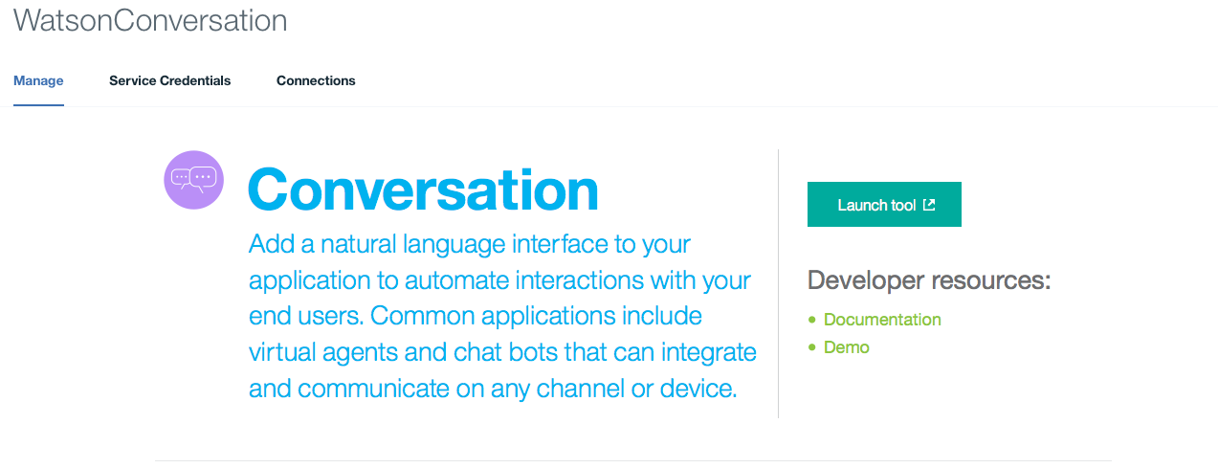

1. Click on Watson Conversation service and **Launch Tool**

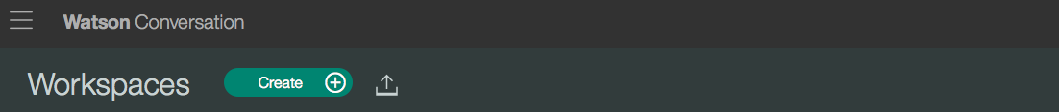

1. In workspaces, click on ../../../Desktop/Screen%20Shot%202017-02-20%20at%2011.35.16%2 to import workspace

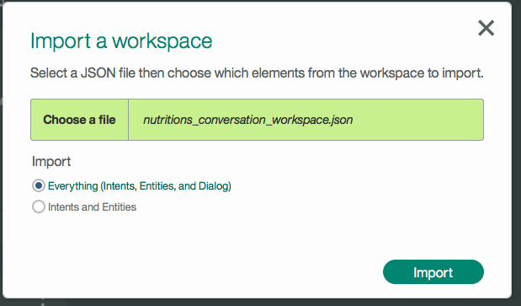

1. Choose file nutritions_conversation_workspace.json from <https://github.com/ECoDIndia/Watson_Healthcare_Conversation/tree/master/Nutritions_Slackbot_discovery> and Import **Everything** and Click **Import**

**CONFIGURE WATSON DISCOVERY**

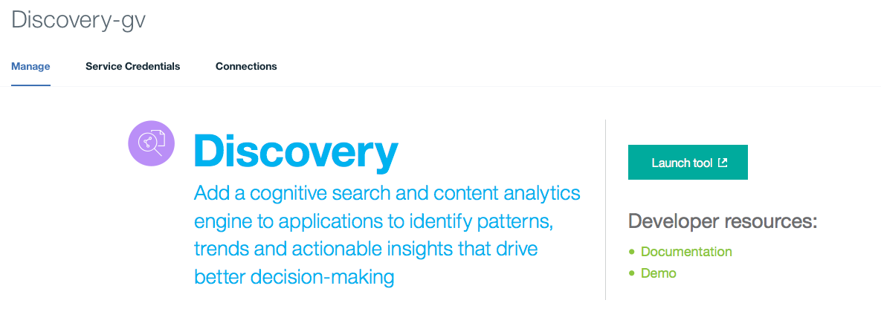

1. Click on Watson Discovery service and **LAUNCH TOOL**

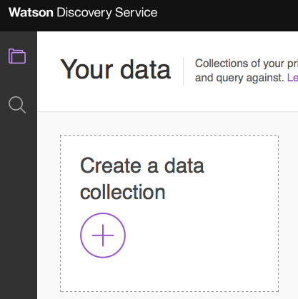

1. Click on **CREATE A DATA COLLECTION**

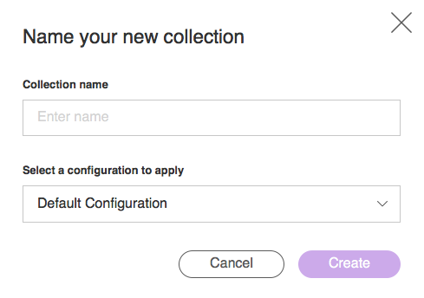

1. Enter Collection name and click on **CREATE**

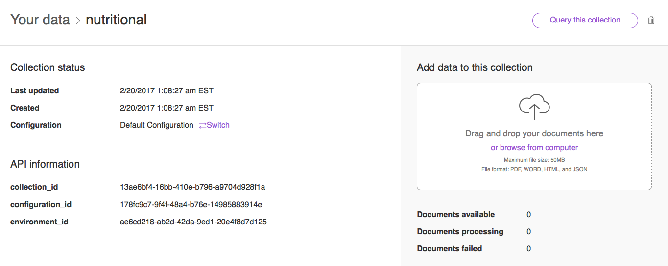

1. Upload collections from <https://github.com/ECoDIndia/Watson_Healthcare_Conversation/tree/master/Nutritions_Slackbot_discovery/collections> .Take a note of collection_id and environment_id ( required in later steps)

**CONFIGURE SLACK**

1. **CREATE NEW TEAM IN SLACK**

* Create a new team in slack <https://slack.com/create#email> by entering your Email ID.
* Enter 6-digit confirmation code that you have received in your Email ID.
* Create new username and password.
* Enter details about your team and company name.
* Choose the address you’ll use to sign into Slack (Address has to be unique) and Click on **CREATE TEAM.**
* Review and agree the Terms and Conditions.
* If required, send invitations to your friends or skip it for now.
* Your team is set up! You can enter into your team with the address you had set. For Example: nutritionistgroup.slack.com

1. **Configure Slash Command in Slack**

**CONFIGURE NODERED**

Import nodes from <https://github.com/ECoDIndia/Watson_Healthcare_Conversation/blob/master/Nutritions_Slackbot_discovery/conversation_nutritionist_nodered.txt> into NODE-RED flow editor

Configure nodes with your credentials.

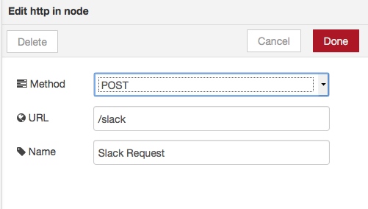

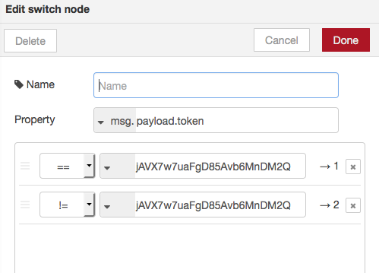

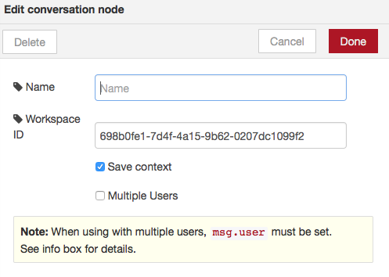

1. Enter your conversation **Workspace ID** ( Shown in the Conversation tool in Bluemix🡪Workspace🡪View Details)

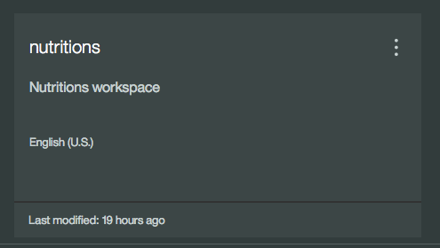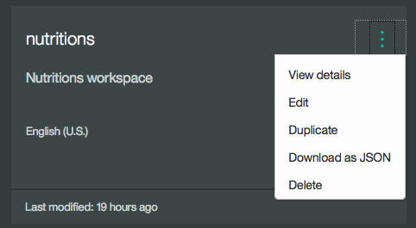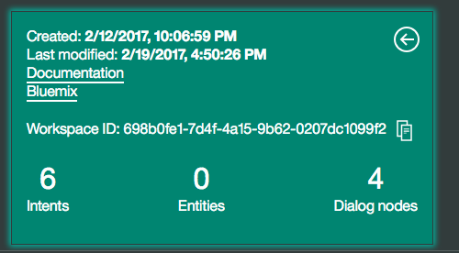

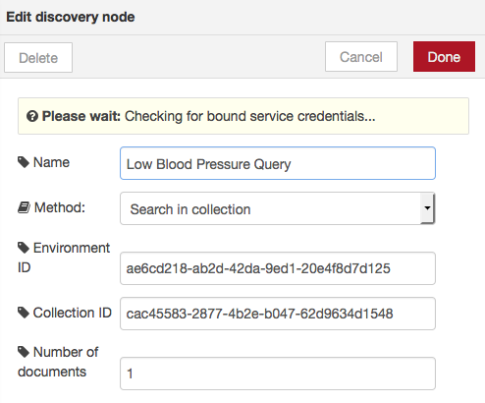

1. Enter your **Environment ID** & **Collection ID** in the **discovery node** (noted in the earlier steps).