STEPS:

1. In BoilerPlates choose the Internet Of Things Foundation Starter.

CreateApp -> Web -> BoilerPlates

2.Create the app by giving unique name, then it will restage.

3. Then click on that app, You will get into this page. In this click the Add a service or API which will go to catalog page, where you have to choose again the Internet Of Foundation, then create and restage it.

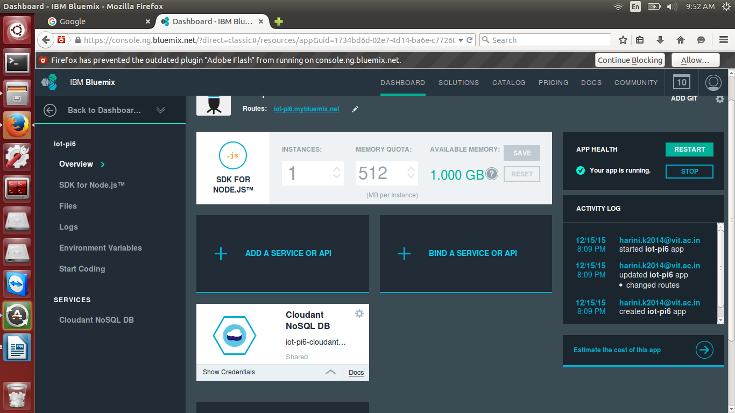

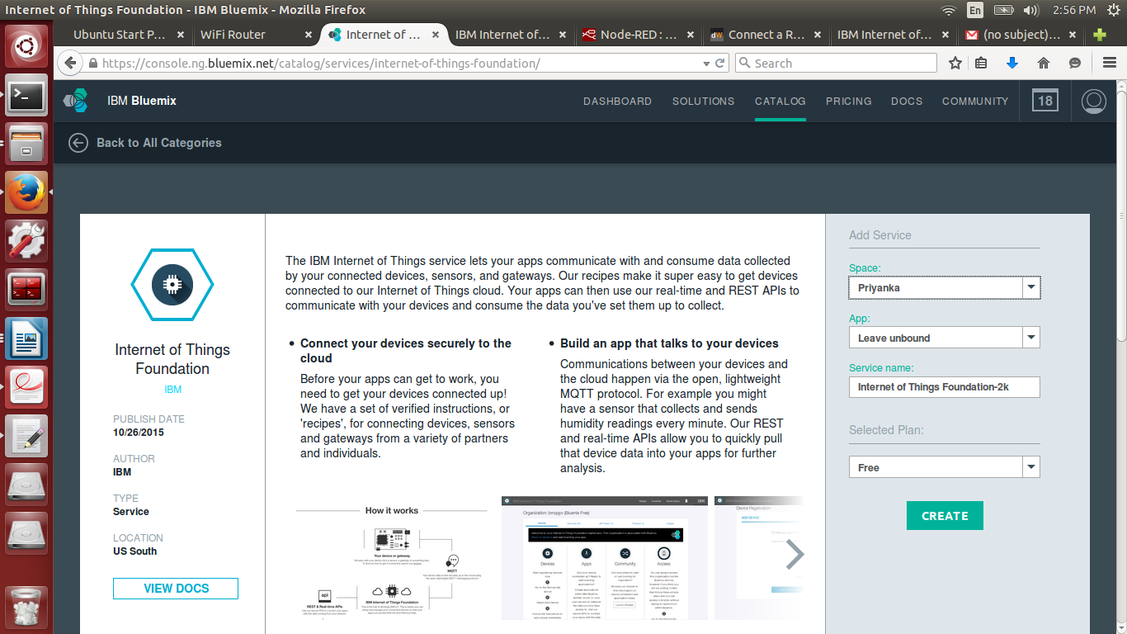

4. Click the IoT services, you will get this page, then click Launch dashboard.

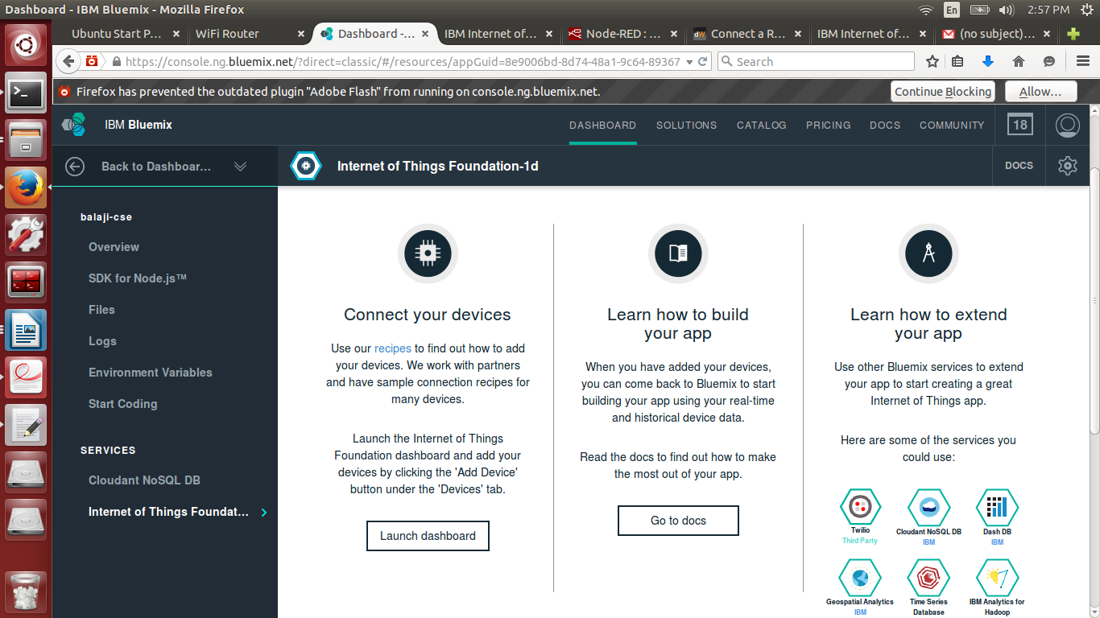

5. Then Click on Add a device.

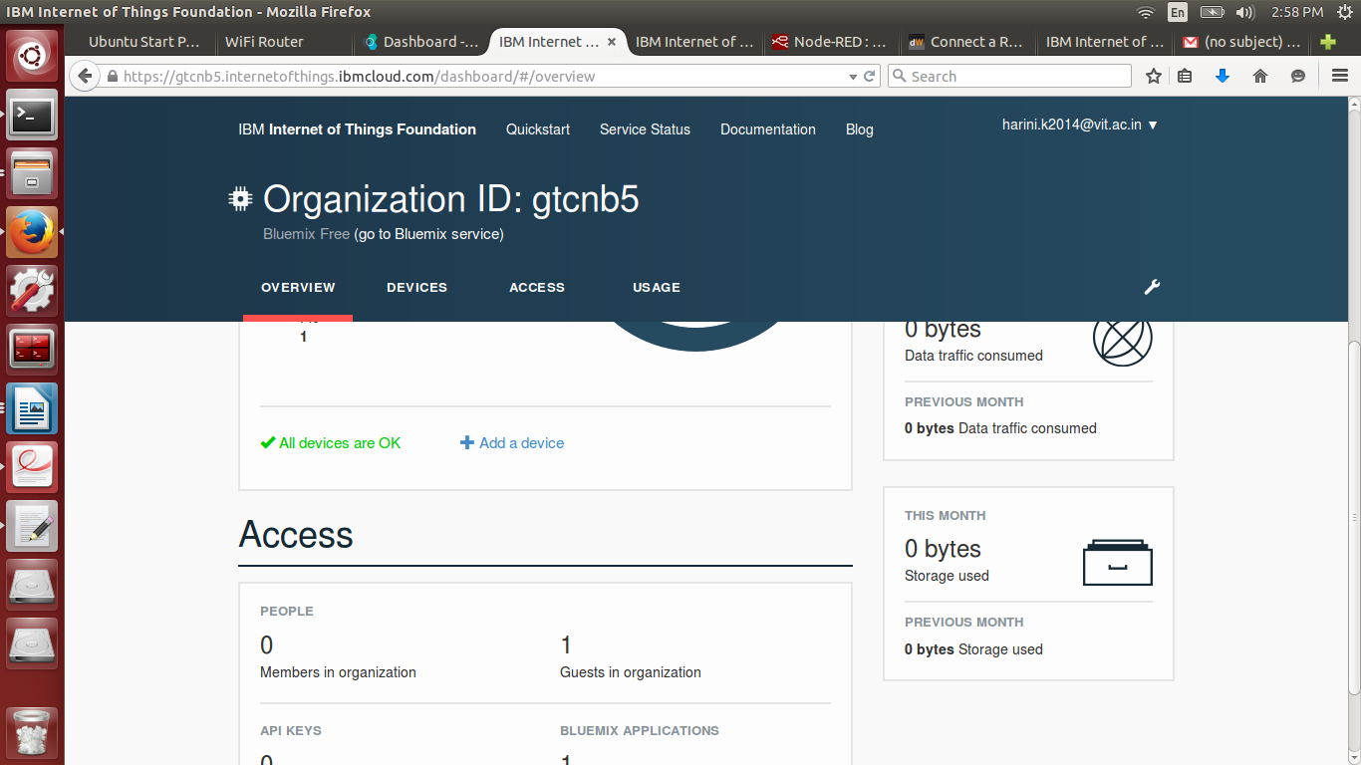

6. Here click the Create device type – where you have to give the device name, device description, then click next, create. Then you have the give the device MAC address for the device token, then click Add.

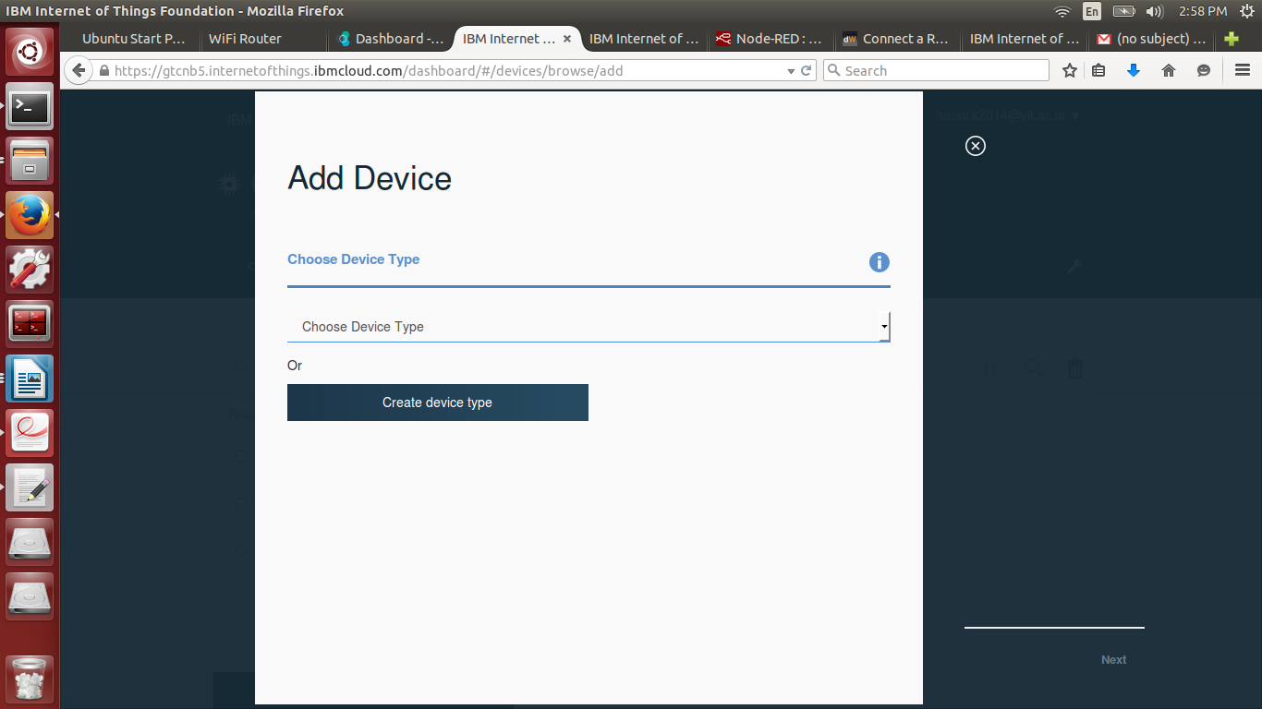

7. You wil get the output like Device ID, Device Type, Authentication Token, Authentication Method, make note of it for future use and close it.

8. Then open the device which you have created – the output will be like this.

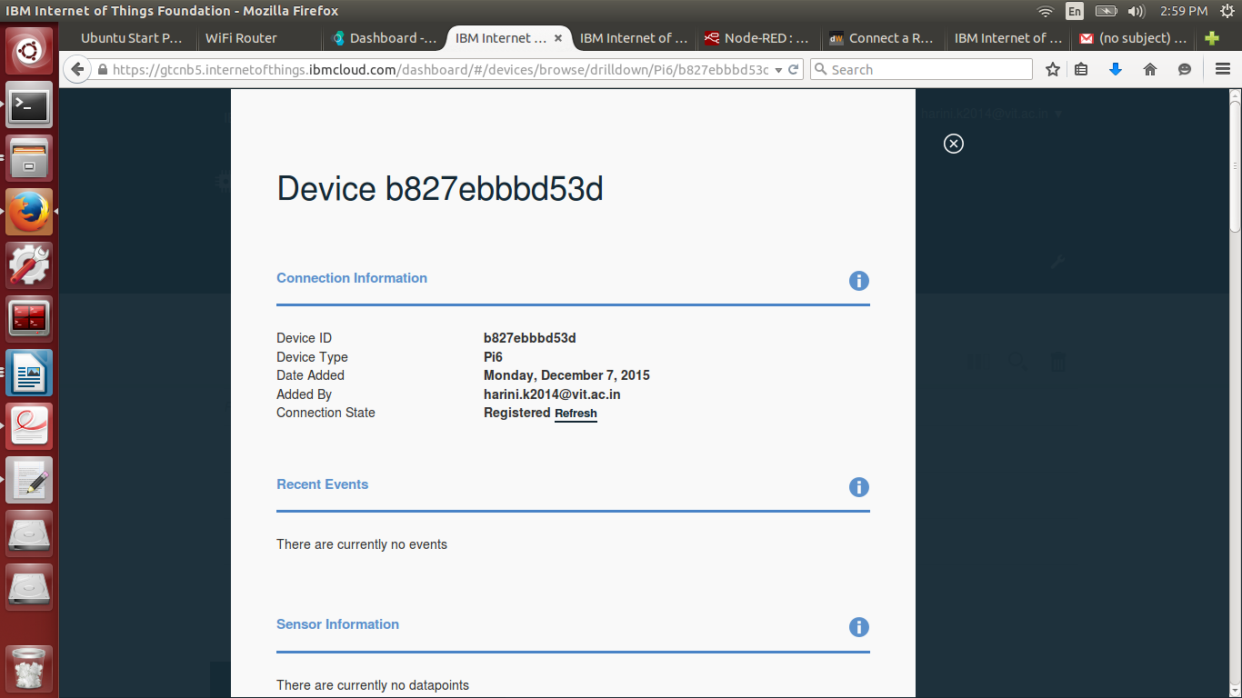

9. Get the description about that device.

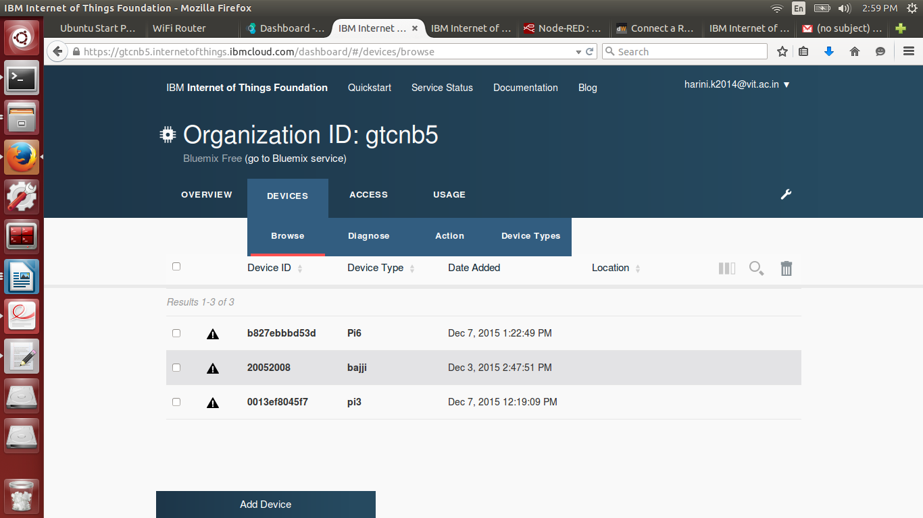

10. In terminal login with your device IP address ang then give the following commands.







11. Check the status of IOT by giving this command.



**12.** Open the Recipes page and give the MAC address of your device and click Visualize your data.

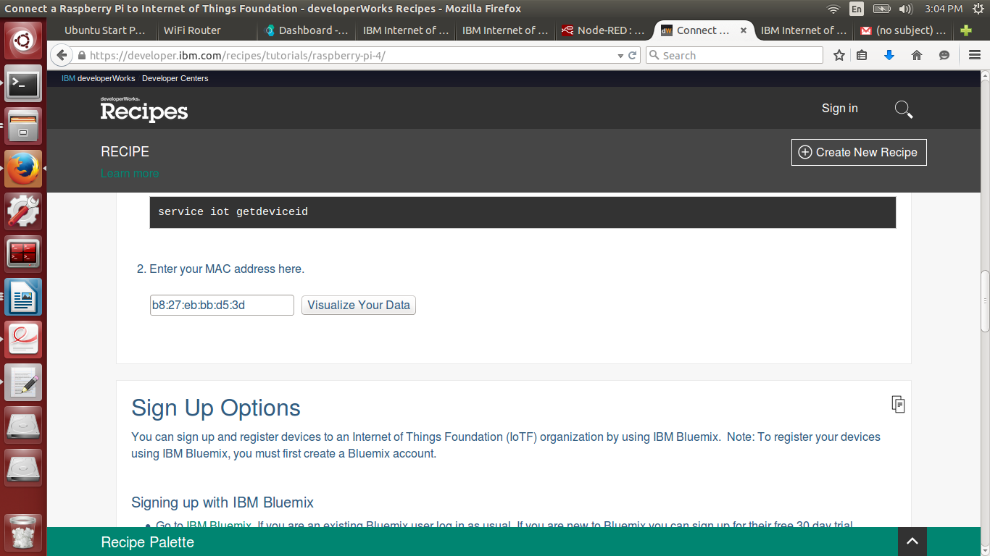

**13. The data is being displayed here.**

